April 20, 2004

Group 4

Clint Edgar
Matt McCarter
Michael Williams
Shane Wilson
Haiely Zhou

Table of Contents

- Executive Summary 3
- Dividends 4
- Spin-Off 7
- Appendices
  - Company Overview 13
  - EPS & Dividends 14
  - Financial Strength 15
  - Total Debt & ROE 16
  - Income Statement 17
  - Balance Sheet 18
  - Statement of Cash Flows 19
  - Insider Stock Percentage 20
Works Cited 21

Executive Summary

Newell was incorporated in 1970 in Delaware as Newell Companies, Inc. Newell acquired Rubbermaid in 1998, at which time they became Newell Rubbermaid. Newell Rubbermaid focuses on manufacturing consumer products and appeals mostly to volume purchasers. Newell is divided into four different segments: The Rubbermaid Group, The Sharpie Group, The Irwin Group, and the Calphalon Home Group (Appendix A).

Newell Rubbermaid has encountered problems with there stock price. In early 1999, there stock price was over $50. As of April 19, 2004, their stock price has fallen to $24.32. Newell’s net income fell drastically in 2002 to a negative $203.4 million, when in 2001 they reported net income of $264.4 million. This poor performance is related to poor order patterns, high raw material costs, and a weak euro (the-daily-record.com). Newell also said recently that their poor performance is because of product line exits, margin reductions related to tornado damage, and lower sales of Sharpie office supplies (marketwatch.com).

There has been an increase in net income in 2003, but it is still at a negative $46.6 million. Their cash position has been steadily increasing, starting at $6.8 million in 2001 and rising to $144.4 million in 2003, which is a sign that Newell is already attempting to correct its problem. Under the investing activities section of Newell’s cash flow statement, it shows that they are expanding despite their financial difficulty, which is a sign the company is still trying to grow.

Despite these few signs of improvement, Newell is still on the verge of entering financial distress. They are starting to feel the effects of indirect costs. One suggestion is for Newell to continue divesting its non-core business assets to continue having a stable free cash flow. By having the free cash flow, they are able to retire there short term debt.

Another recommendation is for Newell to cut dividends and to repurchase stock. This will allow more financial freedom as they continue to restructure the company. The cash savings from the repurchase will be returned to the stockholders in the form of a stock repurchase.

Our second recommendation is that Newell spin-off the Sharpie Group. A spin-off allows the parent firm, Newell and subsidiary, Sharpie to focus on their core business, resulting in more intensive and specialized management leadership in each of the two firms. Having a separate stock price for the spun-off entity provides a more visible criterion for evaluating managerial performance, thereby allowing for a more direct linking of managerial rewards with performance. Posted spin-off consolidated results will be better for the firm by lifting operating profits and stimulating stock performance in both short and long run. Spinning-off Sharpie will allow Newell to do this at a tax-free basis.

Dividends
Newell Rubbermaid is beginning to have a problem with their long-term debt. Their interest coverage ratio, their ability to cover their interest payments, has plummeted to a dangerously low 1.14. To compare, in 1998 Newell Rubbermaid had an interest coverage ratio of 12.34. At the end of the 4th quarter 2002, this ratio was at 5.24. NWL’s total debt at the end of 2003 was 2,882,100,000, up from 2,280,600,000 in 2002 (Mergent Online). This can also be seen in Appendix F. Much of this excess debt was incurred with the acquisition of the American Saw & Mfg. company which was completed in January of 2003. This acquisition was funded through commercial paper (2003 NWL 10-k).
A highly leveraged company offers many advantages. Interest payments are tax deductible, thus providing a tax shield. However, when expected tax savings fall below the corporate tax rate, you inherently lose this shield. As companies draw nearer to not being able to cover their debt, the firm enters into the early stages of financial distress (“Capital Structure”, Rich). While NWL is not on the verge of bankruptcy, it is close to feeling some effects of indirect problems. Disgruntled employees, disappointed with the financial state of the company, are posting on a Yahoo message board. Some of these employees are even looking to leave the company. Even former executives now with other companies are speaking of the relief of working for a financially sound company (Yahoo Finance). As Newell Rubbermaid continues to streamline its production facilities in accordance with its restructuring plan, it will continue to incur charges. In 2003 restructuring costs were $245,000,000 (Mergent Online).
Despite its struggling financial situation, Newell has maintained its dividend. In 2003, the dividend payout was .84, and cash dividends paid was $230,900,000, as seen in Appendix G (ProVestor Plus Company Report). It is often common for companies with cash flow problems to cut their dividend because they have no choice. Through the recent sales of three product lines, Newell has upgraded their projected free cash flow from an estimated $200 million to $250 million, to $225 to $275 million (Forbes.com). Newell does not necessarily have a free cash flow problem, but cutting the dividend and repurchasing stock shares will allow them more financial flexibility as they continue their restructuring. The cash savings from this cut will be returned to the stockholders in the form of a stock repurchase. Dividend payments increase individual taxes paid by investors in the year they receive the dividend. However, by cutting the dividend, the individual investor will not receive as much of a payout, but will receive profits in the form of capital gains that will not be taxed until the shares are later sold (Chew, 217).
One theory published in the 1960’s by Miller and Modigliani suggests that dividend policy is simply a decision on how to divide up the firm’s earnings. One option is to pay low dividends and finance themselves with retained earnings. In theory, while the stockholders would not be getting current income, they are rewarded as the value of the firm increases. A second option is to pay high dividends and finance this payment by issuing securities. Traditional stockholders want current income because it is less risky than potential future capital gains. However, this theory suggests that stockholders are largely indifferent because of the different benefits each option possesses (Chew, 256).
However, as the financial situation at Newell decreased, they did nothing to change the way they divided up their earnings. They continued to pay a high dividend despite having a drop in earnings per share from 1.71 in 1999, to 1.49 in 2003, which can be seen in Appendix B. Analysts project a further drop in EPS down to 1.4 in 2004 (Value Line). Continuing to pay a high dividend is not consistent with the direction the company is going. By cutting the dividend and reinvesting the earnings into the company, they can focus on the long run. This will free up cash the company can use to retire debt, something they are already in the process of doing, and pay off their expensive restructuring costs. One possible reason for Newell maintaining such a high dividend is the effect of signaling. Managers are generally not very willing to cut the dividend because it signals a dark forecast for the company. Investors realize that managers have a better view of how the company is performing, and a dividend cut might scare investors into believing the company may soon do even worse. For this reason, Newell should announce a stock repurchase at approximately the same time as the dividend cut. Stock repurchases generally have an opposite signal, indicating that management feels confident about the future of the firm (Chew, 256).
The main advantage of a stock repurchase for investors is the tax benefit. Stockholders that choose to go ahead and sell their stock back pay taxes on proceeds only and those that hold on to their shares will defer their taxes until they realize a capital gain in the future. The changing tax rates are a variable to this advantage. In the past marginal tax rates for dividends have been much higher than those on capital gains (Chew, 260.) However, in the years 2003 through 2008 dividends will be taxed at the new capital gains rate (New Tax Acts). Newell should conduct this stock repurchase by the issuance of transferable put rights. To do this, the company would issue 1 put for every set amount of shares. The stockholders may then sell the puts for a gain, or exercise the put and sell back a certain amount of shares at a fixed price. The benefit of transferable put rights is that there is no wealth redistribution amongst stockholders, and it is easier to control the number of shares that will be bought back by the company (“Dividends”, Rich). With the money left over after the stock repurchase, Newell Rubbermaid should retire more of its debt. Citing an earlier reference above and Appendix C, one can see that Newell Rubbermaid’s interest cover ratio is 1.5. The average for the industry is 20, and the S&P 500 is 11.9. Appendix D shows that Newell Rubbermaid’s Total Debt/Total Capital ranks amongst the highest in the industry, while they have a negative Return on Equity (ProVestor Plus Company Report). This evidence supports the high debt level they currently have, and their inability to finance their company with debt. Newell Rubbermaid is currently paying off some of its short term debt from recent divestures, and a portion of the money received from the dividend cut should also be used for this purpose (Wall Street Journal).

Spin-off
Newell Rubbermaid has been divesting many of its non-core business assets. However, shedding non-strategic product line has so far not made a significant effect on their profits and stock performance. Their Newell Rubbermaid in a press release on March 15, 2004 said that the company will report five business segments in its earnings reports. The segments include cleaning and organization, tools and hard ware, and home fashions, to be led by Chief Operating Officer of Rubbermaid/Irwin group James Roberts. The remaining two office products and other segments will be overseen by Chief Operating Officer of Sharpie/Calphalon group Robert Parker (Wall Street Journal). We can tell from this news that the consumer products giant has actually divided its operations into two divisions. We suggest that they further spin off its ownership interest in Office Products. That is, we recommend that Newell spin-off its ownership interest in The Sharpie Group.
This spin-off will create value for Newell Rubbermaid in several ways. Newell is already involved in an extensive divesting activity that we mentioned above and recommended they continue. However, there are many restructuring costs that go along with those divestures. In an effort to continue focus on a core product, spinning off The Sharpie Group at a tax-free basis seems reasonable. A spin-off is the only way to divest assets on a tax-free basis. Tax-free corporate spin-offs is the distribution of 80% or more of the shares in subsidiaries to the parent firm’s stockholders (Chew, 592 ).
The United States does not have a perfectly efficient capital market. The market is unable to evaluate conglomerate structures with unrelated businesses. Newell is a company that was founded on finding small companies, acquiring them, and turning them around into successful companies. However, with the change in management, this is no longer in their business model. Still, the company consists of many different types of products. Spinning a subsidiary off to share-holders will allow their shares to trade separately and will enable investors to value them more accurately.
The Sharpie Group, one segment of Newell, includes the Sanford, Sanford International and Parker markers and writing instruments divisions; Goody, leading manufacturer and marketer of hair accessories and bath and travel storage products. The Sharpie Group is the world leader in writing instruments with 6,000 different products. For Newell, Sharpie Group is apparently unrelated business to other product lines like cleaning and organization, tools and hard ware. In 2001, Sharpie Group’s operating income was 278.3 millions, an increase of 11.1%, while other segments had a negative growth. In 2002, its operating income was 323.3 million, an increase of 16.2%, also the largest growth in the corporation. The operating income for the nine months ending September 30, 2003 for the Sharpie Group was 200.2 million, the highest among four segments in the corporation (Newell Rubbermaid Annual Meeting of Stockholders). From the above information, the sharpie group’s performance is much higher than that of the other three segments which mainly produce home products. Therefore, the current stock price of Newell is not an accurate reflection of the performance of the office products section. Having a separate stock price for the spun-off entity would better match its value.
Another advantage of a spin-off is the greater operating efficiency it can provide the company. A spin-off grants complete operational decision-making authority to the subsidiary’s management team. A spin-off allows the parent firm and subsidiary to focus on their core business, resulting in more intensive and specialized management leadership in each of the two firms(Chew 594). This is very consistent with Newell’s business model. In their annual report they speak of a renewed focus on innovation and research and development. Having a separate stock price for the spun-off entity provides a more visible criterion for evaluating managerial performance, thereby allowing for a more direct linking of managerial rewards with performance.
As cited in Appendix H, Robert Parker, Chief Officer of Sharpie, held 29,653 shares by June 2003. Compared with the CEO Joseph Galli, who holds 106,800 shares, director, William Alldredge, who holds 157,370 shares, and director, Robert L Katz, who holds 117524 shares, Robert Parker holds a relatively low proportion of ownership interest (Wall Street Journal, Company Research). This could possibly reflect the fact that he is less confidence about the firm’s whole performance including the stock price. If Sharpie could be listed as an independent stock, directly reflecting Sharpie’s excellent performance, Robert Parker might be willing to hold a greater percentage of outstanding shares in The Sharpie Group, thus greatly increasing his incentives. It would be the same for other management in Sharpie. It is reasonable to predict the increase in the effort in management will result in better firm performance and will stimulate the stock price.
At the same time, the Newell could focus on their core business- home products, which would increase managerial efficiency, lower the operating expense in coordinating unrelated business, and improve managerial accountability and incentives.
This spin-off would have an immediate impact on the struggling stock price of Newell, currently trading at $24.32 (Yahoo Finance). Corporate spin-offs are often part of a sequence of transactions in a larger, ongoing restructuring program. It is largely for this reason that by the time many spin-offs are announced, the stock market has already anticipated the eventual improvement that should come out of this restructuring activity. Historical records evidenced that spin-offs have a significant impact on both parents and subsidiaries’ stock market performance. Common stock returns for 142 parents of spin-offs from 1965 to 1990 shows that the parent firms experienced an average return of about 31% in excess of the market for the two years before the spin-off ex-date, which is consistent with investor expectations that the restructuring will improve performance. For the periods one, two, three years after the spin-offs, the mean return were 23.1%, 54%, 67.2% respectively, while the mean of matched firms’ return were 12.5%,26.7%, and 18.1%. For spun-off firms, the mean of common stock returns for one, two, three years were 19.9%, 52%, and 76% while the mean of matched firms were 4.5%,25%, and 33.6% respectively (Chew, 596).
Therefore, it is reasonable to expect that the stock price of Newell would increase even before the spin-off actually takes place. As a result, the spin-off would be a win-win situation for both the parent firm, Newell, and the subsidiary, The Sharpie Group. Posted spin-off consolidated results would stimulate stock performance in both short and long term.

Appendix A
Newell Rubbermaid Overview
Newell was incorporated in 1970 in Delaware as Newell Companies, Inc. Throughout the 1980’s and 90’s Newell Companies, Inc acquired many different companies. The present name of Newell Rubbermaid, Inc., was adopted in 1998 with the acquisition of Rubbermaid, Inc. Newell Rubbermaid is a manufacturer of consumer products and appeals most to volume purchasers (Mergent Online). Their basic strategy is to merchandise everyday consumer products, backed by excellent customer development and product development. Newell is run by Chief Executive Officer Josheph Galli, who was hired in 2001. Newell is grouped into four different segments: The Rubbermaid Group, The Sharpie Group, The Irwin Group, and The Calphalon Home Group (Newellco.com).
The Rubbermaid Group consists of the following: Rubbermaid Home, Rubbermaid Commercial, Graco, a manufacturer of products for small children such as swings and strollers, and Little Tikes, a manufacturer of children’s toys and furniture. The Rubbermaid Group accounts for over one third of the Newell Rubbermaid’s sales, and thinks of itself as a market leader in product development.
The Sharpie Group includes the different companies of Sanford, which includes the Sharpie marker, Parker, and Goody, manufacturer of hair accessories. The Sharpie Group is the leader in writing instruments with 3,000 different products, and makes up over a quarter of the Newell’s annual sales. Some power brands in this group are Sharpie, Paper Mate, and Colorific.

The Irwin Group consists of the divisions Irwin Tools, Levolor Kirsch window furnishings, Amerock cabinet and door hardware, Shur-Line paint applicators, and Lenox power tools. This segment possesses very high growth potential, and has risen significantly over the past few years. This segment represents almost one quarter of the company’s sales. Some power brands in this segment include Vise-Grip, and Lenox power tools.
The Calphalon Home group consists primarily of Calphalon cookware and bakeware. However, in 2002, the company acquired American Tool Companies which has diversified the company into the hand tools and power tool accessories market. The Calphalon segment also possesses a high potential for growth, both from internally producing new products and acquiring new products in the home furnishings industry. This segment represents about one sixth of the company’s sales.

Appendix B

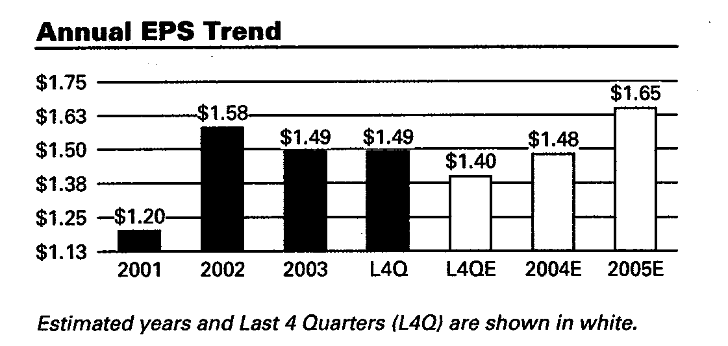

DIVIDENDS
 | NWL | Industry Average | Industry High | Industry Low | S&P 500
Dividend Yield | 3.5% | 1.7% | 6.2% | 0.0% | 2.1%
5 Year Average Yield | NM | 1.6% | 6.3% | 0.0% | 1.5%
5 Year Dividend Growth Rate | 2.0% | 7.4% | 12.0% | -100.0% | 4.1%
Payout Ratio (TTM) | NM | 36.2% | 107.2% | 0.0% | 26.4%

Appendix C

FINANCIAL STRENTH
 | NWL | Industry Average | Industry High | Industry Low | S&P 500
Quick Ratio | 0.8 | 0.7 | 12.3 | 0.0 | 1.3
Current Ratio | 1.5 | 1.2 | 12.9 | 0.0 | 1.8
LT Debt/Equity | 1.4 | 1.1 | 309.0 | 0.0 | 0.7
Total Debt/Equity | 1.4 | 1.4 | 309.3 | 0.0 | 0.9
Interest Coverage | 1.5 | 20.0. | 648.3 | (173.3) | 11.9

Appendix D

Industry Comparison of Total Debt to Total Capitalization and Return on Equity

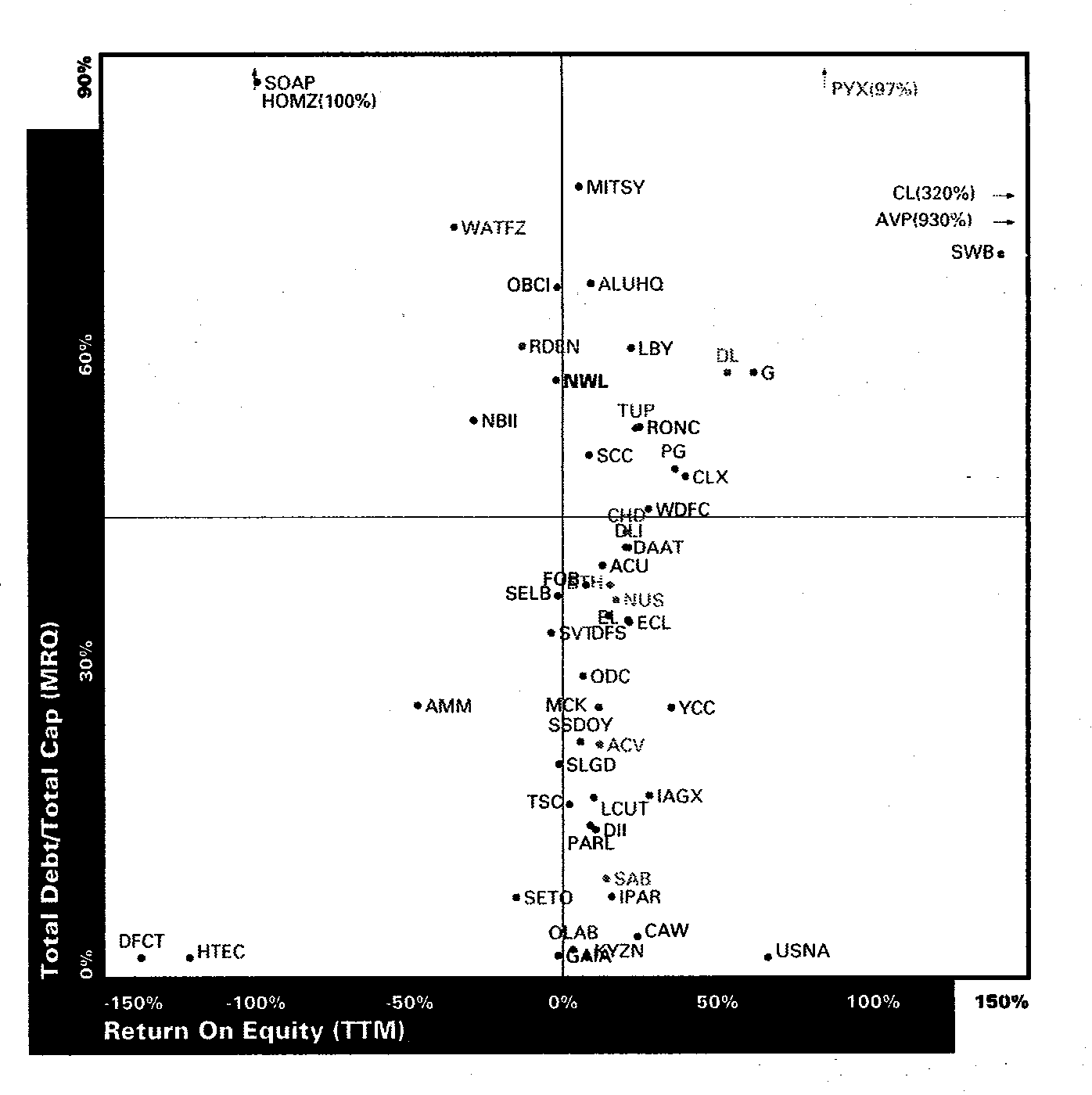

Appendix E

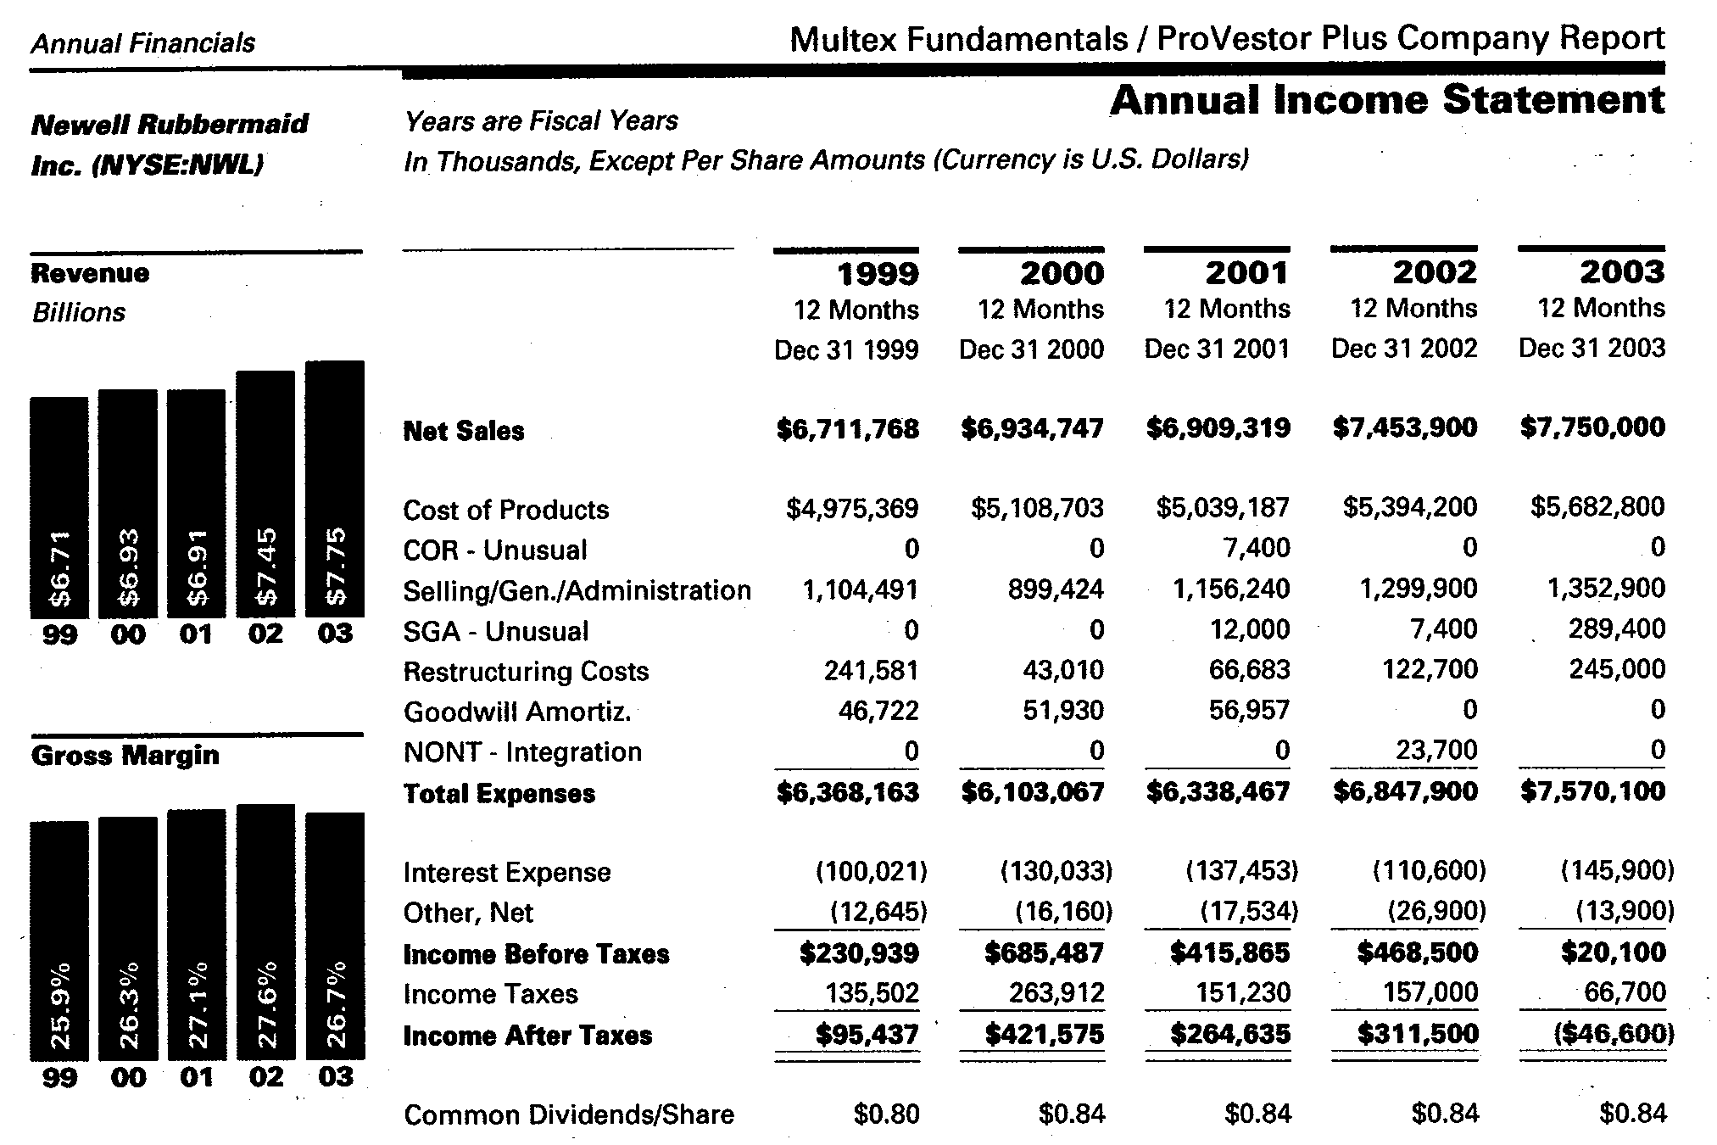

Appendix F

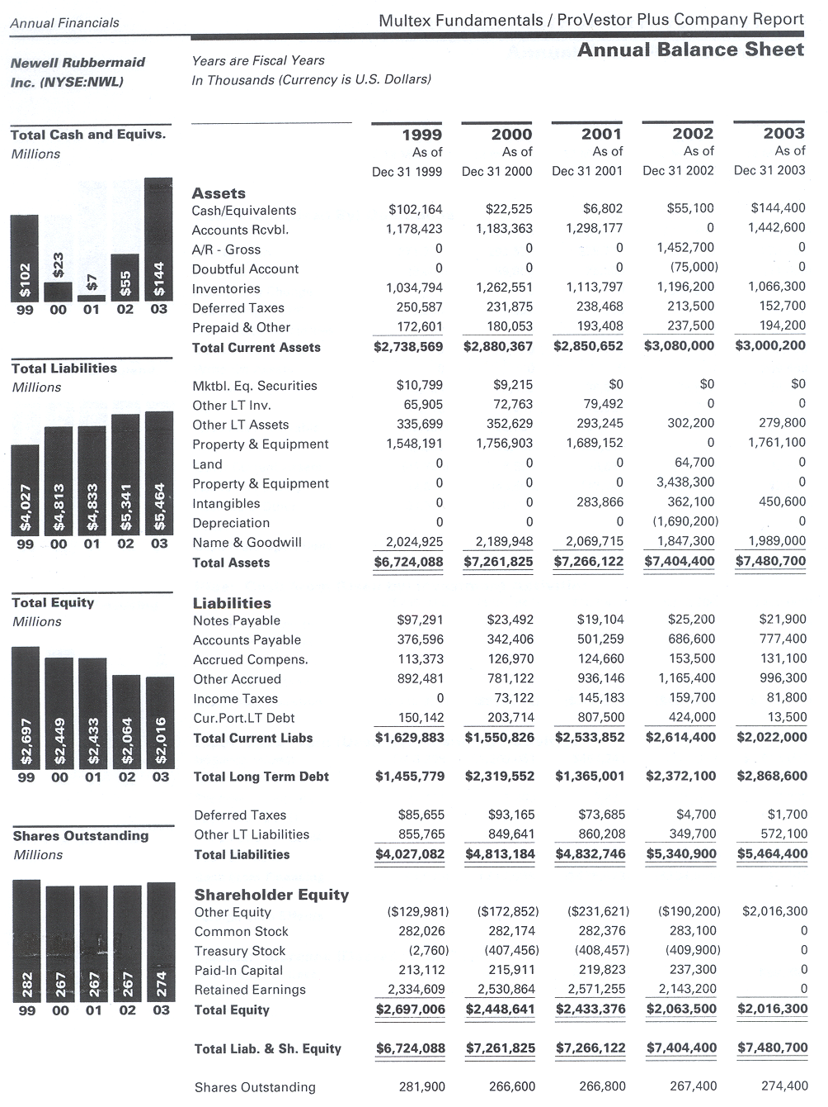

Appendix G

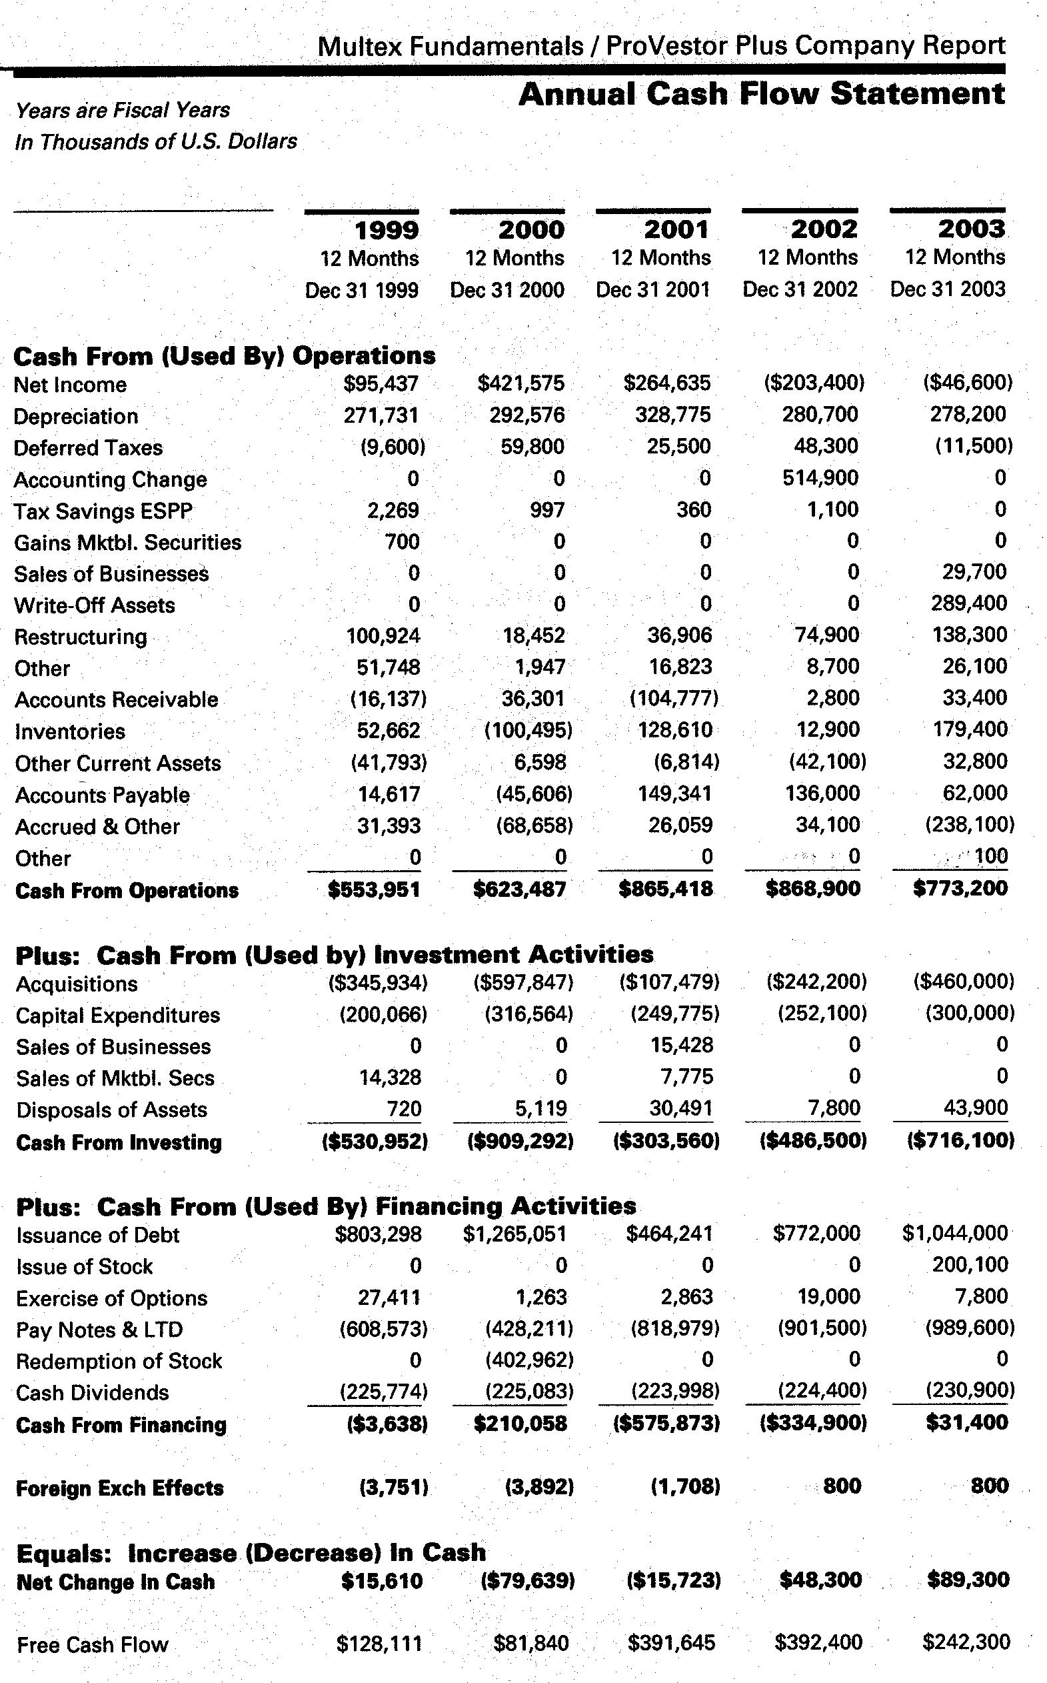
Appendix H

Top 10 Insiders based on Percentage of Shares Held
Position | Name | Shares Held | Date*
CEO | Joseph Galli | 106,800 | 2/20/2004
Officer | William T Alldredge | 157,320 | 12/16/2002
Officer | Robert S Parker | 29,653 | 6/27/2003
Officer | Timothy J Jahnke | 15,000 | 2/17/2004
Director | Robert L Katz | 117,524 | 12/16/2002
Director | Elizabeth C Millett | 140,541 | 5/16/2003
Director | Allan P Newell | 1,940,280 | 6/19/2003
Director | William Sovey | 337,712 | 5/7/2003
Director | William D Marohn | 6,905 | 5/7/2003
Director | Scott Cowen | 4,047 | 5/7/2003
*Date reflects when the individual most recently disclosed ownership interest

Works Cited
2003 Annual Report. Newell Rubbermaid Corporation. <http://www.newellco.com>.
2003 NWL 10-k. Newell Rubbermaid Corporation. <http://www.newellco.com>.
Bagley, Chris. “Newell Rubbermaid warns on earnings.” CBS Market Watch. 19 April 2004. <http://www.cbsmarketwatch.com>.
Balance Sheet, Income Statement, Statement of Cash Flows. Mergent Online. 15 April 2004. <http://www.mergentonline.com>.
Barclay, Michael J, et al. “The Determinants of Corporate Leverage and Divided Policies.” The New Corporate Finance Second Edition. New York: Irwin McGraw-Hill, 1998.
Chew, Donald H. The New Corporate Finance. New York, NY: McGraw-Hill Irwin, 2001.
Kovac, Mark. “Stock ticker likes Galli.” The Daily Record. 19 April 2004. <http://www.thedailyrecord.com>.
“Newell Rubbermaid Inc.: Affiliate of Cerberus Capital Will Buy Three Product Lines.”
“Newell Rubbermaid Inc.” ProVestor Plus Company Report. 12 March 2004.
“Newell Rubbermaid raises cash flow outlook.” Reuters. 15 April 2004. <http://www.forbes.com>.
“Newell Rubbermaid.” Mergent Online. Mergent Company Information. 15 April 2004. <http://www.mergentonline.com>.
“Newell Rubbermaid.” Value Line. 15 April 2004. <http://www.valueline.com>.
“Newell Rubbermaid.” Yahoo Finance. 15 April 2004. <http://finance.yahoo.com>.
“Newell Rubbermaid Company Research.” Reuters. 30 March 2004. <http://online.wsj.com>.
Rich, Steve. “Capital Structure.” Spring 2004, Baylor University
Rich, Steve. “Dividends.” Spring 2004, Baylor University
Soter, Dennis, et al. “The Dividend Cut ‘Heard ‘Round the World’: The Case of FPL.” The New Corporate Finance Second Edition. New York: Irwin McGraw-Hill, 1998.
The New Corporate Finance Third Edition.Wall Street Journal. 15 March, 2004. <http://proquest.umi.com>.
Willis, Betsy. “New Tax Acts.” Spring 2004, Baylor University.

