finance 4360
dr. rich
spring 2004

Group 4

Graham Carter
John Connors
Jason Kenoyer
Lauren Koenig
Nathaniel Peneguy
Nicole Smeenk

Table of Contents

Executive Summary……………………………..………………………………………..…3

Intro to Recommendations…………………………………………………………………4

Recommendation #1………………………………………………………………………...5

Recommendation #2………………………………………………………………………..10

Conclusion………………………………………………………………………………..…12

Appendix 1 – Overview…………………………………………………………………….14

Appendix 2 …………………………………………………………………..………….…..17

Appendix 3 ………………………………………….………………………………………18

Appendix 4………………………………………………………………………….……….19

Appendix 5 ……………………...……………………………………………………….....20

Appendix 6 …………...……………………………………………………………....….....21

Appendix 7 ………………………………………………………………………………....22

Appendix 8 …………………………………………………………………………………23

Appendix 9 …………………………………………………………………………………24

Appendix 10..…………………………………………………….…………………………25

Appendix 11………………………………………………………………………………....26

Works Cited…………………………………………………………………………………27

Executive Summary

The Newell Rubbermaid name has been associated with quality household and office products for over 100 years. Newell Company manufactures and markets consumer brand products to an assortment of outlets including discount stores, department stores, warehouse clubs, hardware stores, and grocery/drug stores. They are one of the largest distributors on consumer durables in the world, with major centers in Europe, South America, and Mexico. In fact, approximately 29% of their sales in 2003 were from their foreign assets.

Today, the company is facing many challenges as they strive to keep up in an increasingly competitive and saturated market. With profits and margins approaching all-time lows, Newell’s management has been forced to look at new strategies for retaining market share and growth rates. The last few years have brought about monumental changes at Newell Rubbermaid. In 2001, the company began a massive restructuring movement aimed at streamlining its product lines, and strengthening its global position. Under the plan, Newell expects to exit 84 facilities and lay-off 12,000 people. This plan will, in theory, save them $150-175 million per year. To date, the company has exited 78 facilities and let go 10,800 people, while spending $417 million on the restructuring plan. The restructuring plan, although nearing the end, has not performed according to expectations.

There are tremendous opportunities available to Newell Rubbermaid. The retail industry is improving steadily according to reports, as shown by consumer confidence measures and increases in manufacturing. Newell Co. also has a solid core of high-margin, name brand companies that they will build their future on. There are many challenges facing Newell Rubbermaid, but the opportunities are limitless.

Newell has many plans for 2004, most importantly the completion of its Restructuring Plan. To succeed as a company, they must continue to divest their non-strategic businesses, rationalize low-margin product lines, and cut costs even further. In order to maintain their progress, Newell must not become complacent in their market position, but take steps to increase revenue and stay competitive. Therefore, we recommend they take the following steps: Use the money earned from divestitures to pay off part of their debt load. In effect, would lead to increased cash flows of $16-18 million per year and be beneficial to them in the long run. However, Newell would have to slow down their acquisitions for the current period. Our second recommendation is to use the money saved from divesting off of low margin product segments from paying off the debt load (derived in the form of avoided interest expense) to begin new marketing and research and development (R&D). The initiative of R&D is to innovate and expand the new-market product lines. In addition, we suggest that Newell increases brand awareness and loyalty. We feel that this is very important to the future success of the company as they strive to stay competitive in today’s global marketplace.

Newell Rubbermaid, producer of household goods and products, is suffering against its top competitors in a market and industry that has become increasingly competitive over the past few years. Although the company saw an increase in sales in the year 2003 as a result of the acquisition of American Saw and Manufacturing Company and growth in Sharpie and Irwin, it experienced a $448 million drop in net income before taxes (Appendix 1). Not only is Rubbermaid itself suffering, but they are experiencing the effect of losses from some of the smaller companies included under their corporate umbrella. There are several factors that have contributed to the company’s overall loss, including a suffering economy, a decrease in gross profit margins, and the restructuring program that they have undertaken. Under this restructuring program, which began in 2001, the company plans to exit 84 facilities and reduce their employee count by about 12,000 people over a period of three years. As of this year, the company has exited 78 facilities and reduced the head count by about 10,800 people (Appendix 1). Although the restructuring program is likely to help the company out in the future, currently it has not been as successful as Newell had hoped. The company has had to take significant losses through the divestiture of these less profitable companies.
Looking at several companies in Newell’s industry, it quickly becomes apparent that its performance does not even come close to matching its rivals. As compared to the company’s top nine competitors, Newell is ranked last in total debt/EBITDA. This indicates that they have more debt relative to cash flow than any other company. As Newell’s business was increasing in 2000, the company issued a large amount of debt. This hurt the company the next year when the market experienced a loss, which created a need for Newell to issue more debt simply to stay alive and make payments. Newell’s EBITDA/ interest expense is ranked number eight out of the top ten companies in its industry. The company is having trouble covering its interest expense with cash flows, which puts them at a high risk for default, especially if their margins continue to decrease.
Although Newell is currently suffering, there are many opportunities available for them to increase their Net Income and make the company successful again. Overall, the retail industry is improving tremendously as observed by consumer confidence measures and increases in manufacturing. This industry is moving towards higher margin products.
If Newell were to make a few significant changes in the company, it would be possible for them to increase their earnings, making them a stronger more profitable brand. We believe that the company’s first step should be to continue with their current restructuring program by divesting in their non-core companies that are not profitable. Newell should then use the proceeds from these sales to pay down their current debt load. The next big step for Newell is to use the new cash flows, saved on interest payments, to increase marketing and research and development on new, higher-margin products. Although these changes may face a few risks and potential downsides, we think that these are the best recommendations for the company to take if they want to be successful in the long run.
Recommendation 1: We recommend that Newell use all of the proceeds it receives from divesting its non-core competency assets to pay down its debt load. By doing this, the company will improve its long-term solvency condition and generate a higher annual cash flow. The ramifications of improving the company in both of these areas are extremely significant because the effects positively influence many parts of the firm.
Newell’s fiscal year 2003 produced the worst long-term solvency ratios of the last three years, with a few slight exceptions (Appendix 2). There are two recent, significant increases in the amount of long-term debt issued by the company. In 2000 and 2003 Newell’s long-term debt totals increased by $1,265.1 million and $1,044.0 million respectively (Appendix 3). In 2000, the company was performing well and the U.S. economy was flourishing, which gave indication to the company that taking on new debt to expand would be a good idea. However, the US economy soon took a severe downward turn with the events of September 11, 2001. Since 2000, Newell overextended itself into retail areas that it was previously unfamiliar with, which had negative effects on the company. Gross profit increased slightly over the next three years, operating expenses continued to increase, and net profit declined. The company took a bet by issuing debt and expanding their product offering, which failed and its long-term solvency prospects suffered greatly as a result.
In 2003, the company sold 6.67 million shares of common stock at an offering price of $30.10. After expenses incurred during the transactions, the company obtained approximately $200.1 million in net proceeds. The proceeds were then used to pay down the company’s commercial paper borrowings, which is a good indication that the company recognizes that its debt load is currently too high. Also in 2003, the company issued $400 million of medium term notes which were also used to pay down commercial paper. Finally, the company was able to complete a $1,300 million Syndicated Revolving Credit Facility in June 2002, but the availability of the “Revolver” is contingent upon the company’s ability to maintain certain interest coverage and total indebtedness/total capital ratios. All of these examples evidence the fact that the company has taken on too much debt and needs to reduce it quickly (Appendix 4).
Newell has realized that it overextended its business into non-core competency areas and is divesting those assets that produce low-margin products. Because much of the debt the company took on was used to fund these expansions, it follows that the company should retire some of this debt and improve its long-term solvency prospects. Although it is unlikely Newell will receive what it paid for the businesses it is divesting, Prudential Investments estimates that Newell will be able to pay down $435-440 million in debt with the divestiture proceeds (Appendix 5).
If no more debt is retired, the company will have $921.5 million in debt coming due in three to five years (Appendix 6). Using the proceeds from divestitures in any other manner would leave the company extremely vulnerable to default because the company has proven that its strategic expansion and reinvestment over the past five years has been highly unsuccessful. However, paying down the debt load will not only increase the company’s long-term solvency position (reduce likelihood of default), it will give the company time to refocus its efforts on its high-margin products. Furthermore, decreasing the company’s total debt load by $435-440 million will have significant positive effects on the company’s long-term solvency ratios, as will the annual decrease in interest expense of $16-18 million (Appendix 5).
Adjusting 2003’s long-term solvency ratio calculations by decreasing the total amount of debt by $440 million and the annual interest expense by $18 million before taxes improves Newell’s solvency position dramatically (Appendix 2). Not only do Newell’s solvency prospects improve as a company, its position relative to its competition becomes better as well.
The second benefit of using the proceeds from divestitures to pay down debt is that it will increase Newell’s annual cash flows as a result of the decrease in annual interest expenses of $16-18 million. Increasing the company’s cash flows is critical to the success of the company because those cash flows will be used to further the restructuring process. Most investment analysts will concur that management’s ability to run a company successfully can be shown through their ability to produce strong, positive cash flows. By improving cash flows, management will have more freedom to reinvest money into other areas of the company, as will be explained later.
Net changes in cash flow have been negative in three of the past six years. However, 2002 and 2003 reported small, positive increases in cash flow which were mostly the result of large increases in long-term debt ($772 million and $1,044 million respectively), an equity issuance leaving net proceeds of $207.9 million in 2003, and an ambiguous account “Other non-cash items” totaling $599.6 million and $483.6 million respectively. Without these three irregular, positive additions to the company’s cash flow, 2002 and 2003 would have also produced negative cash flows, totaling five negative years out of the last six. Clearly, the company is struggling to produce strong, positive cash flows. (Appendix 3)
Further evidence of a company struggling to produce positive cash flows can be found in the cash flows generated from operations. Of the $352.8 million cash flow generated by operations in 2003, $224 million of it came from inventory reduction, leaving only $128.8 million from actual operations. This is well below the free cash flows of $200-$225 previously estimated for the company in 2003 (Appendix 7). As compared to its industry competitors, Newell is the worst when measuring free cash flow (FCF) as a % of sales at just 2%. Also, when comparing total debt/FCF, Newell is again the worst of its competitors at 17.5x. This amounts to nearly three times more debt to FCF than the ninth ranked competitor, Maytag, at 6.4x (Appendix 8).
Obviously, the company is struggling to produce positive cash flows and one of the primary reasons for that is because the company took on large amounts of debt in the hopes that expansion into new retail markets would produce positive margins and profits. However, the company was unable to successfully perform within many of these new markets. Combining large interest payments with the inability to generate competitive profit margins left the company in a cash flow crisis. Therefore, in conjunction with its asset divestitures, the company should, and is, paying down its debt load to decrease its interest payments and increase its positive cash flows.
Ultimately, the increase in positive cash flows should be used by the company to reinvest in itself and expand those product segments that are performing well, such as Irwin and Sharpie. However, it’s important that the company gives itself time to both complete the restructuring process and to prepare thorough plans for reinvestment and expansion. By lowering the likelihood of default through debt repayment and freeing future cash flows that can be used properly for expansion, the company is setting up a solid base for its future prospects.
One of the arguments against using the proceeds from divestitures to pay down debt is that the proceeds could be used to reinvest in new assets or fund the expansion of the company in its high-margin product right now. Although expansion in these areas is an excellent suggestion and should necessarily occur, the proper plans to implement expansion will take time to devise. Clearly, the company was quick to expand itself in 2000 when all signs seemed to be positive. Unfortunately, the company had not done enough research and preparation as to what type of products would be successful nor in which markets would the company be successful. Further, because the company is currently undertaking a massive restructuring process and it has taken unsuccessful and mistimed steps toward expansion in the past, it is better for the company to reduce its debt load now. This will both free up cash flows in the future and give the company the time it needs to prepare the proper expansion of its profitable, high-margin product lines.
Recommendation 2: We recommend that the company use the new cash flows saved on interest payments, as a result of the debt repayment, to increase marketing and research and development (R&D) on new, higher-margin products segments.
One of Newell’s largest lost opportunity costs has derived from their lack of a marketing strategy. In the last two years, it has finally begun to realize how important marketing is to sales, but it has not fully explored the possibilities of increased marketing. Newell Company will have $16-18 million more dollars, annually, to spend after its debt is lowered, and a new marketing campaign should be one of its main focuses. Newell has failed to capitalize on some of its biggest assets: household names such as Sharpie and Irwin. These brands set the standards for their industry, but have not been marketed in a way that allows Newell to realize capital gains on their popularity. Newell recently started advertising Sharpie on television, and saw a 23% increase in sales in 2002 (www.newellco.com).
Last year, Newell spent $195 million on cooperative advertising expenses, which was down over $20 million from the previous year. This reflects a negative trend. Newell has stated that it is attempting to increase its brand awareness, yet it is cutting marketing dollars. Sales were $7.75 billion last year, which indicates that advertising was a mere 2.5% of sales. This number is ludicrously low when compared to industry leaders such as Proctor and Gamble, who had net sales of $43.3 billion and advertising expenses of $4.3 billion; this calculates to over 10% of sales being spent on advertising. Colgate Palmolive, another industry front-runner, also ranked above Newell in total revenues and EBITDA, and incurred advertising expenses of $486.6 million. Compared to $9.2 billion in sales, this works out to 5.25% of sales. As demonstrated by these two industry leaders, a healthy advertising budget as a percent of sales is crucial for increasing sales, revenues and EBITDA. Newell cannot expect to compete in such a large, international market without distinguishing its brand names through advertising. A marketing strategy aimed at developing brand names and increasing brand loyalty will benefit Newell Rubbermaid greatly.
The majority of the remaining $16-18 million saved in annual interest expenses should be spent on R&D. One of the major industry trends currently evolving in the retail sector is that companies are moving toward a focus on high-margin products (Appendix 1). Although Newell does have some product segments that generate high profit margins, it should continue to spend money to develop further product segments that will produce margins that remain competitive in the retail industry. Currently, Newell struggles severely when comparing its gross margin percentage to its nine main competitors. Newell ranks eighth by this measure over the last twelve months (Appendix 9). However, despite a company total of 27% gross margin profit, Newell has two product segments, Irwin and Sharpie, which far exceed this amount.
Because marketing and R&D are vital to Newell’s remaining competitive and because it has a limited budget to increase expenses, it must focus its efforts on those brands with the highest profit margins and potential growth prospects: Irwin and Sharpie. Prudential Equity Group, LLC estimated that in 2003, Irwin and Sharpie had gross margin percentages of 32.5% and 40.0% respectively (Appendix 10). These numbers far exceed the company average of 26.9%. Furthermore, Irwin and Sharpie were estimated to have accounted for $3,665.0 million or 47.3% of Newell’s total sales revenue. Therefore, the company should focus its marketing and R&D increases on these two product segments because the company will generate the highest profit after expenses. Clearly, the company is more efficient in producing and selling Irwin and Sharpie products, which means that when trying to increase sales, it should focus on those product segments it generates the most efficiently.
The second major issue that should be taken into consideration is in which market should the increased marketing and R&D be focused. Newell should increase its efforts in those markets where it is currently having success and where there is high potential growth prospects for the future. In 2002, the company generated 73.2% and 17.8% of its total revenues in the US and Europe respectively (Appendix 11). In the US, revenues have been increasing since 2000 and more importantly, operating profit has improved tremendously since 2000 as well. However, the company’s European segments have been decreasing since 2000 and had an operating profit of –1.33% in 2002. This is one of the major reasons that the company is currently divesting much of its assets in Europe. Of the two market locations, Newell should obviously focus its marketing and R&D increases in the US.
One of the arguments against a focused increase in marketing and R&D in the US is that the market is saturated. We disagree. Newell has been able to generate more than $5 billion in revenues in the US with minimal money spent on marketing and R&D. Therefore, by spending money researching the right products for the right market segments, we feel that Newell will be able to find appropriate market segments within the US generate higher sales revenues.
Another argument against using this recommendation would indicate that there are better ways to use those funds to improve the company. Again, we must disagree. Newell must improve both its operating margins and cash flows relative to its competitors because if it continues these negative trends, it will result in default. The two best ways to improve both of these measures is to decrease interest expenses and expand those product segments that generate the company’s highest profit margins. The only way to ensure that the proper steps are taken to expand those high-margin product segments is to research and devise a plan of implementation, which costs money spent on R&D to do.

Conclusion
The real question here is how can Newell best use the funds from divestitures to begin a cycle of improvement for the company. The first, most obvious step is to pay down unnecessary debt loads. Because Newell does not need the debt, the interest expenses are merely reducing cash flows. Reducing cash flows disallows the company from improving itself because it has even less funds to do so.
Issuing more debt would exacerbate the problem because it would increase interest expenses and decrease cash flows. Although, one might argue that taking on more debt would provide the necessary funds for marketing and R&D. However, it takes time to properly allocate funds and Newell has shown an impressive ability to misallocate excessive funds over the past five years. Therefore, issuing new debt would put pressure on the company to use the funds too quickly. By using the annual increase in cash flows resulting from the decrease in interest expenses, the company would both have a reasonable amount of funds to allocate and the time it needs to properly allocate them. Issuing more equity, in addition to the $200 million plus that was issued in 2003, would further dilute the value of the current equity holders.
The next major question is what to do with the new, free cash flows so that we again can improve the company. Using the cash flows on marketing and on R&D so that proper expansion of its high-margin product segments can be executed is essential to the company’s success. By expanding the company’s highest-margin products, it will receive the highest after-expense returns per sales dollar. This, in turn, leads to even higher cash flows for the company, which again can be used for further marketing and R&D. The process can be repeated. Thus, a planned cycle of improvement has been created.

Appendices
Appendix 1

Company Overview

Newell Rubbermaid is a multi-national company competing in the manufacture and distribution of cutting edge consumer products distributed worldwide. Newell Company focuses on the production of name-brand consumer products designed to meet the need of large volumes of customers. Their strategy is based on the idea of providing everyday consumer products at affordable prices with an emphasis on customer service, new product development, and shareholder wealth maximization. Newell Rubbermaid focuses on five business segments: Cleaning and Organization, Office Products, Home Fashions, Tools and Hardware, and Other. Each of these segments reflects Rubbermaid Newell’s new strategic direction: focusing on streamlining the company.
Newell Rubbermaid has also focused on developing brand name products in order to increase customer recognition and loyalty. They have succeeded in producing brand names known around the world for their superior quality. These brands include Rubbermaid Cleaning and Organization products; Sanford Office products, which include well known names like Sharpie, Rolodex, Paper Mate, Accent, Vis-à-vis, Liquid Paper, and Parker; Home Fashion brand names such as Levolor/Kirsch, Home Décor Europe, and Swish UK; Tools and Hardware Products under the name Irwin and Lenox; and other products, such as Calphalon and Panex cookware and bakeware.
Recently, Newell Rubbermaid has begun the implementation of a company wide restructuring effort. They have targeted six major processes for the company’s new direction. First, Newell Co. wants to increase productivity by lowering manufacturing and distribution costs. They also want to streamline Newell Rubbermaid to remove excess costs by proceeding with a series of divestitures of low margin business units. Newell has increased their new product development efforts to meet demands for new technology and better products. For the first time in the company’s history, Newell is launching ad campaigns across the nation altering the company’s marketing agenda from a “push” to “pull” method. They have gone from $0 to $40 million spent on advertising in the last 2 years. One of the most important aspects of Newell’s rebuilding plans is their focus on strategic account management. This part of the plan focuses on current Newell retailers who show the most promise for growth and productivity. Finally, Newell will focus on collaborating within the current company to spark internal growth. These facets comprise Newell Rubbermaid’s goals for restructuring the company to produce a conglomeration that will be able to compete in today’s competitive global marketplace.
Thus far, 2004 has brought mixed results for Newell Rubbermaid. Net sales for the full year 2003 showed an increase of 4.0%, totaling $7.8 billion compared to $7.5 billion in 2002. Foreign currency translation was a benefit to sales of 3.1% for the year, even though pricing declined 1.9%. Excluding charges, gross margins declined to 26.9% from 27.8%. Internal sales were flat for the full year 2003, one of the reasons that Newell hopes to increase its internal sales in 2004. In 2003, the year-end results showed a net income loss of $46.6 million, or $0.17 loss per share, compared to a net loss of $203.4 million, or $0.76 loss per share in 2002.
Competitive Analysis:
Within the retail industry Newell-Rubbermaid has several competitors spanning many different product segments. Unlike Newell, most of its competitors focus their efforts on one segment within the retail industry. Therefore, because Newell has so many product lines, they face competition within several segments of the retail industry. Proctor & Gamble (P&G), the leader in the retail industry is structured much like Newell in that its business focuses on many segments within the industry. With over $44 billion in revenue for the last twelve months, and a profit margin of 50%, P&G dominates the retail industry. Unlike P&G, Fortune Brands produces annual revenues of over $5 billion, which is more comparable to Newell’s $7 billion in annual revenues. (Barclays 23)
Newell is struggling in comparison to competitors within the market due to their total debt to cash flow (debt/EBITDA). With a multiple of 3.0x, Newell has nearly twice the debt to EBITDA than the industry average of 1.7x. Because Newell has similar amounts of total debt to its competitors, the debt to EBITDA shows that the cash flow side is where Newell is struggling. (Barclays 23, 26)
Industry Trends:
The upcoming year within the retail industry looks to have more prospects than the last few years. Same store sales and increasing consumer confidence are two of the major indicators of the market improvement. As trends improve materially for high end products, consumer product companies will benefit, due to the consumer trend to look at more factors than price. Further research indicates that the economy is strengthening. A study at the University of Michigan shows the consumer confidence measure has jumped 10.6 points to 103.2. This is the largest increase since November of 1992. (Barclays 8). Like Newell, most firms within the retail industry are worldwide operations. This tendency to manufacture all over the world reduces overhead costs from labor and production costs. Selling worldwide obviously increases the market size exponentially and allows the manufacturer to expand into several market segments that other, single-nation competitors cannot. Factory production is expected to increase by 6% this year alone. (8) The retail industry looks promising for the current year. Consumer confidence, high end product sales, and a strengthening economy lend itself to a hopeful year. Newell looks to make infinite advancements with the improvements of the total retail industry.

Appendix 2

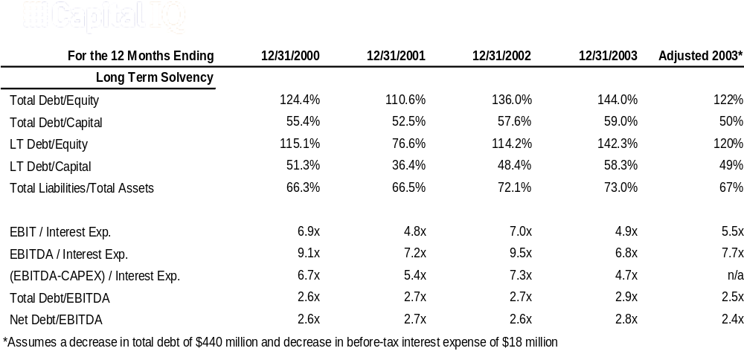

Appendix 3
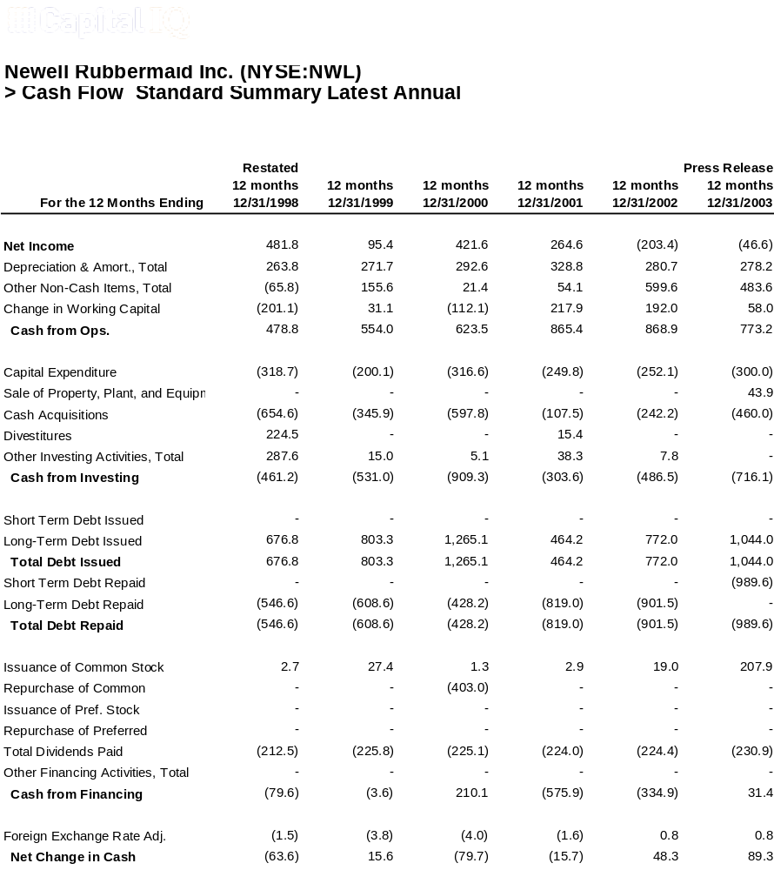

Appendix 4

December 31, 2003 10-K – Liquidity and Capital Resources

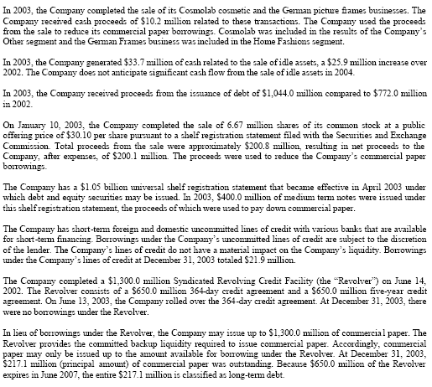

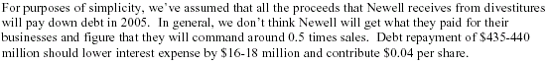

Appendix 5


Appendix 6

December 31, 2003 10-K – Item 7

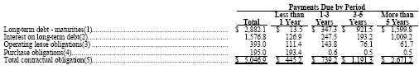

Appendix 7
Prudential Equity Group
Consumer Discretionary Report
(February 11, 2004)

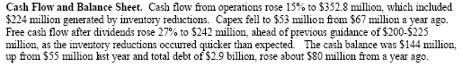

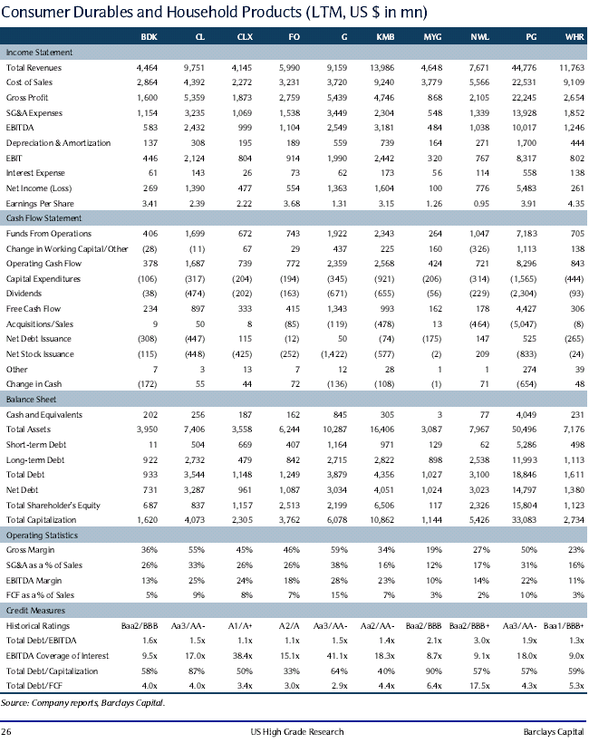
Appendix 8

Appendix 9
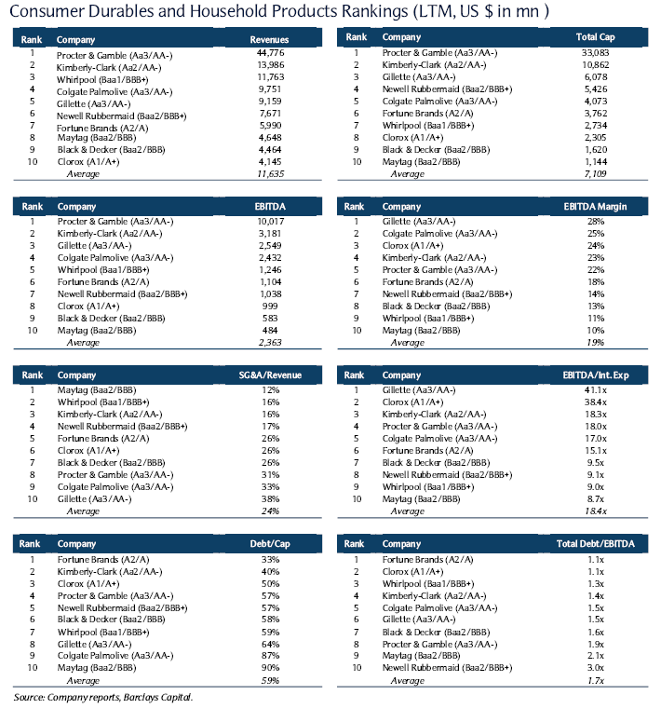

Appendix 10
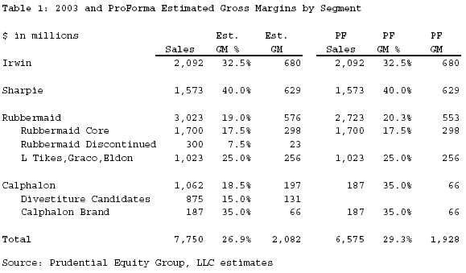

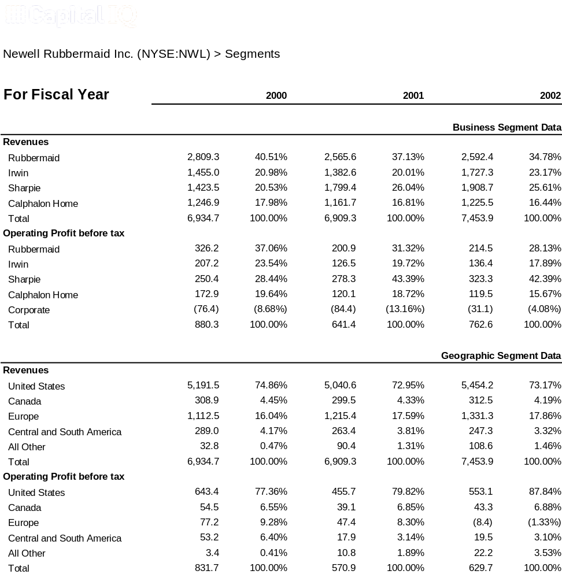Appendix 11

Works Cited

Colgate Palmolive 2003 Form 10-K. 31, Dec 2003. 15, Feb. 2003.
<www.colgate.com>.

“Event Brief of Q4 2003 Newell Rubbermaid Earnings Conference Call – Final.” Baylor University Business and Resource Center. 24, Jan. 2004. 31, Feb. 2003. <http://galenet.galgroup.com/servlet/BCRC?locID>.

Newell Rubbermaid 2003 Form 10-K. 31, Dec 2003. 15, Feb. 2003.
<www.newellco.com>.

“Newell Rubbermaid Reports Fourth Quarter and Full Year 2003 Results.” 24, Jan. 2004.
20, Feb. 2003. <www.newellco.com>.

“Newell Rubbermaid: Cutting Estimates; Unexpected Additional 1Q04 Charges.”
Oppenheimer Funds. 16, March 2004.

“Newell Rubbermaid Inc.” Citigroup Smith Barney. 16, March 2004.

“Proctor and Gamble 2003 Form 10-K.” 31, Dec. 2003. 15, Feb. 2003.
<www.PG.com>.

