Newell Rubbermaid

April 21, 2004

Group 5

Ronald Chan
Brett Howell
Blenda Lozano
Scott Rogers
Roger Young

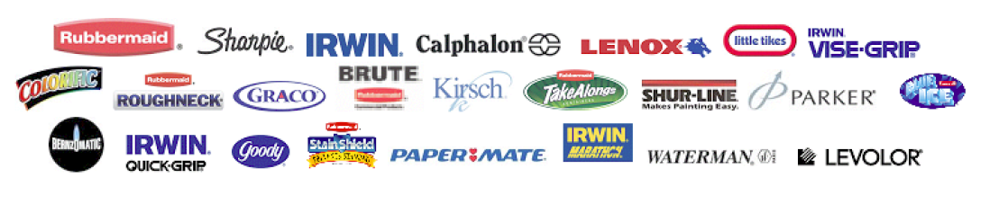

Table of Contents

- Executive Summary 3
- Recommendation #1 4
- Recommendation #2 7
- Appendix A 10
- Appendix B 16
- Appendix C 18
- Works Cited 20

Executive Summary
Newell Rubbermaid is a manufacturer of numerous products. The company is divided into four divisions: Rubbermaid, Calphalon, Sharpie, and Irwin.
Through these divisions, Newell Rubbermaid makes everyday products and maximizes its profits by providing quality items and quality service to customers. Together, these divisions brought the company a loss of $46,600,000 for the year 2003 (Newell Rubbermaid IS 2003). Sales for the company have steadily increased throughout the years and in 2003 they reached a total of $7,750,000. The company has recognized gains; however, they started loosing money in 2003. The losses are due to the fact that Newell Rubbermaid has over-expanded its divisions, encountered fierce competition in low margin products, and experienced substantial restructuring costs.
Some restructuring attempts have been implemented by Newell Rubbermaid since Joseph Galli Jr. became its CEO. Being a multidivisional company, Newell Rubbermaid has many operations in low growth and low margin products. One of Newell Rubbermaid’s attempts to restructure and streamline its business is by exiting its low margin products (Appendix A). Another attempt by Newell to recover is divesting its non-strategic assets. In order to gain a better focus of its core competencies, Newell is planning to divest 200 to 300 million dollars worth of assets. In further attempts to restructure, Newell combined different divisions of the company in order to unify management. For example, Rubbermaid Cleaning Products have been fused with the Rubbermaid Commercial Product division. In addition, North America Tool group was formed by combining IRWIN Hand Tools, IRWIN Power Tool Accessories, Lenox Cutting Tools, Shur-Line, and BernzOmatic. Newell also relocated it’s headquarters to Atlanta, GA in order to provide better management focus and decision making. (Appendix A).
We have suggested two recommendations in order for Newell Rubbermaid to be more competitive and profitable. The first recommendation is a tax-free corporate spin-off. NWL resembles an “All-Weather Growth Company” that is too divested with its multidivisional segments. Companies that fall into this category generally experience capital allocation inefficiencies, division of management incentives, and centralized decision making. Spin-off is a restructuring method that distributes the shares from one entity of a business to the parent corporation’s stockholders. The benefits of spinoff are improved corporate focus, easier access to capital, and increased accountability and incentives for management (Corporate Finance).
The second recommendation we propose is outsourcing. Foreign outsourcing allows a company to contract others to perform work that it would normally perform itself. With already high and increasing labor costs in the United States, Mexico provides an excellent, cost-effective alternative for the high-priced manufacturing jobs Newell currently supports in the U.S. Many other companies in the United States have already taken advantage of foreign outsourcing and the benefits it offers. By sending a significant amount of manufacturing jobs to Mexico, it would help Newell to improve its financial position by lowering its costs and increasing margins thus benefiting shareholders.

Recommendation 1:
Newell Rubbermaid owns and operates four different business segments: Rubbermaid, Irwin, Calphalon, and Sharpie. For the past five years the average sales growth is a modest 5%, but the segments reported a -3.5% earnings growth (Value Graph, Ford Equity Research, Appendix C, Chart 2). The largest subsidiary, the Rubbermaid Group, accounts for one third of Newell Rubbermaid’s annual Sales (www.newell.com). With the current restructuring cost and slow growth of sales from Rubbermaid, there has been a major reduction in Newell’s profit. From this current financial stage, a spin-off on Rubbermaid will help Newell decrease or eliminate its loss. Spin-off was a popular restructuring practice used in the early 1990’s and is now a more popular option for companies experiencing problems with a struggling division.
Rubbermaid is clearly a struggling segment at Newell. Before purchasing Rubbermaid, Newell was performing well and their stock price was worth twice as much. Rubbermaid has had positive sales growth for the past three years, but increasing manufacturing costs and heavy competition in a low margin business has resulted in negative profits.
In an effort to force Rubbermaid to fix its weaknesses and inefficiencies we recommend that Newell spin-off Rubbermaid. To spin-off Rubbermaid, Newell will distribute at least 80% of Rubbermaid’s value to the stockholders on a pro-rata basis (Corporate Finance). This will result in an independent corporation with a publicly traded stock.
This spin-off will help alleviate some conflicts between the stockholders and managers. Since Rubbermaid will no longer have Newell’s support, its management will have pressure to perform. If the management does not perform, unemployment will become an issue for them. This will cause the management to recognize the need to fix various problems in the firm and establish a more sound financial position. Since Rubbermaid’s management will no longer be under the centralized decision-making authority of Newell, it will leave them in control and directly responsible for the firm’s performance. Also, Rubbermaid will now have stock that reflects the management’s performance, giving them incentive to perform well. Its stock price will directly reflect how management is performing. This provides Rubbermaid with a more visible and direct method to link rewards to the management’s performance (Corporate Finance).
Management will make decisions more carefully after the spin-off. They will eliminate inefficient operations, exert more effort, and be free to implement policies that act in Rubbermaid’s best interest. Lack of strategic fit or synergy between Rubbermaid and its parent, Newell, will no longer be a factor (Corporate Finance). Rubbermaid will have a more decentralized decision-making process that will provide better access to capital because the market, instead of the senior management, will decide if the company is worth investing its capital.
Adolph Coors Co. is an excellent example illustrating benefits of spin-off. Over the course of time, Coors had ventured into many businesses unrelated to its core business of beer production. In 1992, Coors spun-off part of its business, ACX Technologies, a company that produces ceramic and consumer product packaging. The spin-off allowed the management to concentrate on the specific business objectives, which stockholders benefited from. As a result of the spin-off, ACX was able to acquire the necessary capital to increase growth and development. Within 18 months, ACX’s stock nearly tripled, from $10 to $36. Coors also benefited after the spin-off when it developed a niche strategy; its stock increased by 25% (Corporate Finance).
Not only does spin-off improve management effort, care, and focus; it also, as historical evidence has proven, helps the firm’s profit and growth rate. Newell fell upon hard times after its acquisition of Rubbermaid in 1998. Before the purchase of Rubbermaid the stock price ranged from the upper $40s to $50; compared to $24 as of April 19th, 2004. With reduced management efficiency and an overly-broad company-wide focus, the profits of Newell Rubbermaid fell. Because of its reduced profits and the broad goals of the management, a spin-off of Rubbermaid creates potential for larger gains resulting from division specific goals and focus. After the spin-off, Rubbermaid will be able experience an increased sales growth rate, higher return on sales, and more operating income than other comparable firms over the same time period (Corporate Finance). Recent studies from Penn State University indicated that of 176 spin-offs, the new entity’s stock price generally increased by 76%. Additionally, the new entity usually outperformed the market by 31% after three years (Los Angeles Times).
After evaluating the evidence supporting spin-offs, we recommend that Newell Rubbermaid spin-off the Rubbermaid segment into its own corporation by giving shareholders shares of Rubbermaid. Due to the extreme pressure to succeed, Rubbermaid will be likely to experience significant improvements from its depressed value and newly motivated management. The spin-off will force Rubbermaid management to solve problems within the company, allow Rubbermaid to make decisions specifically based on the company’s self-interest, and experience high growth from recovery. The stockholders of Newell, who will also be stockholders of Rubbermaid, will benefit from the rapid growth of Rubbermaid, the increased growth and stock price of Newell, and the additional effort by management. It has been shown that for each one percent growth in sales, the spun-off firm provides its shareholders with stock return of .68 percent more than the return achieved by the overall market (Corporate Finance). It is in the best interest of stockholders to spin-off Rubbermaid and take advantage of the value that the spin-off will provide.

Recommendation 2:
Outsourcing occurs when a company contracts others to perform work that it would normally perform itself. Because the United States is a capital intensive country, its cost of labor has been inflated for years. This has prompted many companies to send more jobs to labor abundant countries such as Mexico or the newly industrializing economies (NIEs) in Asia. Because the cost of labor in the U.S. has historically been higher than the labor costs of other nations, manufacturing jobs have been outsourced for some time (Sparks, Bikoi and Moglia, U.S. Bureau of Labor Statistics). It is time for Newell Rubbermaid to intensify its foreign outsourcing in order to fully recognize the benefits that can be provided.
Over the past twenty-five years, the cost of labor in the United States has steadily increased. In 2000, the cost of labor in the United States reached nearly $20 per hour for each worker. Labor costs were equally high in Japan, Canada, and Europe, but countries like Mexico and the Asian NIEs offer cheaper labor, reducing manufacturing costs. For instance, Asian NIEs such as Hong Kong, Korea, Singapore, and Taiwan have an average cost of labor that is less than seven dollars per hour for each worker. By closing more factories in the United States and outsourcing many of the jobs, Newell can save approximately thirteen dollars of labor cost per hour for each worker. The savings would be even greater by moving jobs to Mexico where the labor cost per hour per worker is less than five dollars, providing a savings of approximately fifteen dollars per hour per worker (Appendix C, Chart 3).
Foreign outsourcing has been a common trend for United States companies, and it proves to be successful at reducing labor costs, especially in the manufacturing sector. Goldman Sachs claims approximately one million manufacturing jobs have been outsourced since 2001 (Hilsenrath, Wall Street Journal). Some companies, such as the Boeing Corporation, have been very successful through their use of outsourcing. In fact, Boeing, which manufactures satellites, commercial jetliners and military aircraft argue that “outsourcing goes beyond the provision of cheap labor; it allows companies to reduce risks by spreading work across a larger foreign base.” Boeing also claims this larger foreign base allows the company to expand sales to new markets (Brewer, California Patriot). Coca-Cola has been so impressed with the outsourcing of manufacturing jobs, that it outsources almost all of its manufacturing, and fulfills mainly the marketing and operation aspects of the business (Computergram Weekly).
These benefits will last beyond the short term. By examining the trends of the labor costs in the Mexico and the Asian NIEs as a percentage of the United States’ cost of labor, one finds that the labor costs in these labor intensive countries has not been more than a small fraction of the United States’ labor costs for the past twenty five years. In fact, the Asian NIEs’ cost of labor was only one third of the United States in 2000, and Mexico’s was less than one quarter of the United States’ cost of labor. While Asian NIEs have an increasing cost of labor, the cost of labor in Mexico actually decreased between 1975 and 2000. According to economists with the Bureau of Labor Statistics, “Over the past quarter-century, hourly compensation costs in the United States have tripled, and costs in competitor economies have risen nearly four-fold in U.S. dollar terms” (Sparks, Bikoi and Moglia, U.S. Bureau of Labor Statistics). Given the United States’ fairly constant increase in the cost of labor and the moderate or even decreasing cost of labor in Mexico and the Asian NIEs, the outsourcing of manufacturing jobs would be a promising, long-term possibility for decreasing the costs Newell-Rubbermaid incurs from labor expenses.
The Irwin, Calphalon, and Sharpie divisions of Newell, which will remain after Rubbermaid is spun-off, involve significant amounts of manufacturing costs. By outsourcing manufacturing jobs, Newell can reduce production costs, increase product margin, and improve overall net income. These factors have brought us to recommend that Newell outsource a substantial amount of manufacturing to Mexico. We feel Mexico is the best choice because it provides the lowest labor cost and is also the most accessible from the United States.

Appendix A
Overview
Newell Rubbermaid is a multi-divisional firm which produces name-brand consumer products. It focuses on everyday consumers and offers them a multi-product line to select from. In order to maximize their business success and customer satisfaction, Newell Rubbermaid provides strong customer support and extensive product development. Products are distributed in large volume sales to distribution purchasers or other high quantity customers. (Standard & Poors)

Customers
The customers of NWL are usually large scale distribution companies which make purchases in volume and then distribute the products to office supply centers, home supply stores, hardware retailers, and other warehouse clubs. (Standard & Poors) NWL’s largest customer is Wal-Mart which makes up around 15% of total sales. (Hoover’s Company Profile – NWL, 2004) The most basic customers of NWL are households and individuals buying products like pens, home tools, pans, or plastic containers. NWL is focusing on quality products paired with a good price providing considerable value to the customer. (Business Week Jan. 12, 2004)

History
Newell was a strong company with returns in excess of the S&P 500 in the 10 years prior to the purchase of Rubbermaid. Since the purchase for $5.8 billion in stock in 1998, the stock market value for the firm has been reduced to half. (Business Week Oct. 20, 2003) Currently NWL is still trying to get value out of the Rubbermaid purchase. (Business Week Jan. 12, 2004) While NWL is still working on Rubbermaid the other segments of the corporation still have stable profits, slow growth, and renowned brand names. Additionally, strong cash flows and debt levels around half of NWL’s capital suggests that there is hope. (Business Week Oct. 20, 2003) NWL is also now making a big change in the direction as a firm that was once based on acquisitions to one that now hopes to expand using new branded products. (Investor Relations Business Dec. 22, 2003)

Leadership
Three years ago Joseph Galli Jr. was hired as CEO with the challenge of turning around the company. Over this time he has strengthened research and development and enlarged the sales force. These are the basic factors that he believes will help the firm. His goal is “to maintain premium prices through innovation.” (Business Week, Jan 12, 2004)

Corrective Measures
Exit Low Margin Products
Products that have been low margin and highly competitive for NWL are being cut away to help focus on profitable product lines. By exiting low margin products NWL feels that its financials will become more stable. By concentrating on high growth products NWL will add value to the corporation. (Home Furnishing Network Jan. 12, 2004, Mergers & Acquisitions Report Dec. 15, 2003)

Divest Non-Strategic Assets
NWL is also selling off its non-strategic assets and focusing on innovation in core products. NWL stated on October 30, 2003 that $200 to $300 million worth of assets based around low margin products will be divested. This project has no set deadline but is hoped to be completed by the middle of 2004. (Mergers & Acquisitions Report Dec. 15, 2003) By narrowing the scope and focusing on innovation and quality NWL hopes to make a product that is worth paying a little extra for. (Business Week Jan.12, 2004)

Improve Efficiencies
In order for NWL to be successful in some product lines it is essential that they efficiently produce their product. The company is currently looking into the Rubbermaid division to find ways to improve production and design efficiencies. (Business Week Jan. 12, 2004) By improving efficiencies NWL plans to improve its profit margin on its Rubbermaid products.

Restructure Management
A major restructuring of NWL paired with the relocation of their headquarters to Atlanta, GA is expected to help define managers’ responsibilities as products are eliminated, divisions combined, and assets sold. The Rubbermaid Cleaning Products division has been dissolved and is now been combined with the Rubbermaid Commercial Products Division. (Home Furnishing Network Jan12, 2004) Another combination that has taken place is in Investor Relations. IR has been called to take on PR and control of the Leadership Development Program. (Investor Relations Business Dec. 22, 2003) A third restructuring occurred in the IRWIN Tool Group. Several individual tools groups including IRWIN Hand Tools, IRWIN Power Tool Accessories, Lenox Cutting Tools, Shur-Line, and BernzOmatic were reorganized into the newly form North American Tool Group. (PR Newswire Feb. 2, 2004) Another restructuring move that is being made is relocating around 400 executives and management positions within the company. (Home Furnishing Network Jan12, 2004) By relocating and restructuring NWL hopes to unify managements voice and have a closer working relationship within the firm. (Investor Relations Business Dec. 22, 2003)

Employees and Facilities
Currently Newell Rubbermaid has over $1.8 billion worth of property, plant, and equipment. (Newell Rubbermaid Financials) These facilities are located throughout the United States and various other parts of the world. The NWL headquarters were recently relocated to Atlanta, Georgia as part of the restructuring. Recently factories have been shut down in Cleburne, Texas and Wooster, Ohio. These factories though having strong roots with the company were manufacturing a high percentage of products that were to be eliminated. It was in the best interest of NWL to close these factories rather than run them with large amounts of excess capacity or spending the funds to modernize them. The close of these factories resulted in a loss of about 850 employees. (Home Furnishing Network Jan.12, 2004) Currently NWL has approximately 47,000 employees working in the United States and various other parts of the world.

Segments and Segment Trends
IRWIN
The IRWIN Group is comprised of all tools and hardware divisions on NWL. The group has recently been reorganized into the North American Tool Group. (PR Newswire Feb. 2, 2004) In previous years the IRWIN group has accounted for 23% of NWL sales mainly through retailers such as Home Depot and Lowe’s. (Hoover’s Company Profiles NWL 2004) The IRWIN Group produces hand tools, small propane torches, window blinds, locking pliers, clamps, saw blades, paint brushes, and power tool accessories. (Newellco.com April 5, 2004) With a stable market and a larger product line the IRWIN group looks to continue its growth. With material costs remaining constant and a good market for tools, IRWIN will be a substantial income producer for Newell Rubbermaid next year.

Sharpie
Sharpie is a worldwide seller or pens and markers with over 3000 different products. (Newellco.com April 5, 2004) They make up 26% of the NWL sales each year. The Sharpie Group includes brand names such as Paper Mate and Parker. (Hoover’s Company Profiles NWL 2004) Sharpie is one of Newell Rubbermaid’s best divisions, having stable sales and a healthy bottom line it is a cornerstone of the company. Markets look optimistic and expectations for Sharpie are good.

Calphalon
The Calphalon Group makes various quality kitchen products ranging from glassware to cookware. It has relationships with quality sellers and specialty stores. (Newellco.com April 5, 2004) It currently makes up about 16% of the NWL sales. (Hoover’s Company Profiles NWL 2004) Calphalon is one of Newell Rubbermaid’s fastest growing areas, but it is making this gain by diminishing the reputation of the Calphalon name. Selling lower quality products with the Calphalon name is hurting the high quality Calphalon products image and ability to bring a premium. (Crain’s Chicago Business March 24, 2003)

Rubbermaid
Rubbermaid is NWL largest contributor to sales bringing in about 35% of sales per year. (Hoover’s Company Profiles NWL 2004) Rubbermaid makes plastic containers, storage solutions, children’s toys, as well as many other plastic goods. Brand names such as Graco and Little Tikes fall under the Rubbermaid Group. (Newellco.com April 5, 2004) The plastic industry has outsourced most of its labor over the past 10 years lowering labor costs. Rubbermaid is said be about six years behind its competitors in regard to outsourcing. By having competitors as the low cost producer in such a low margin industry it puts Rubbermaid a big competitive disadvantage.

Appendix B
Income Statement
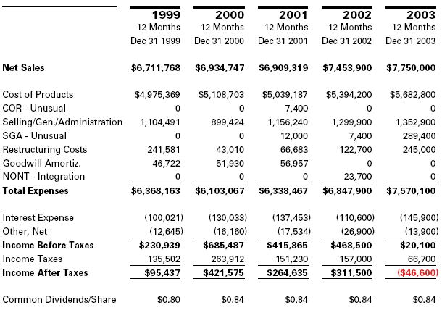

Balance Sheet
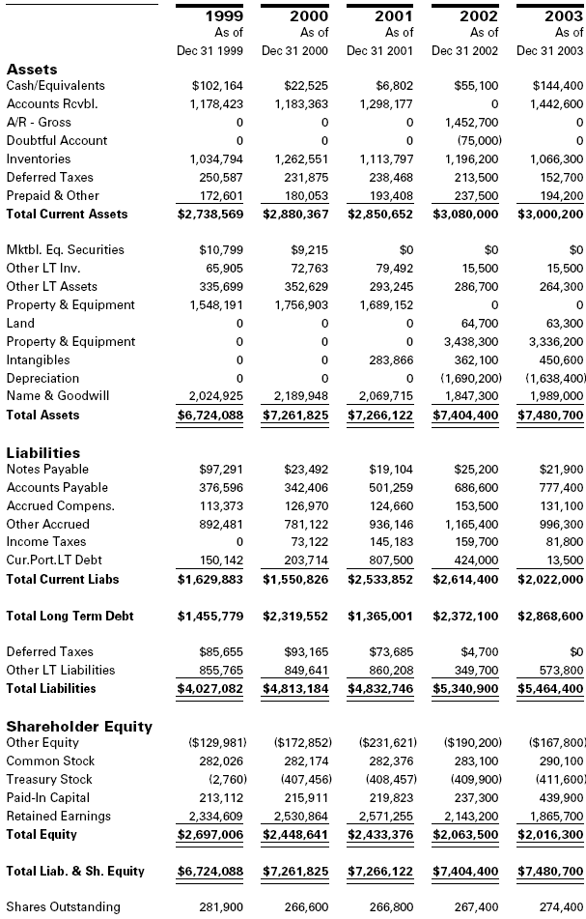
Appendix C

Chart 1

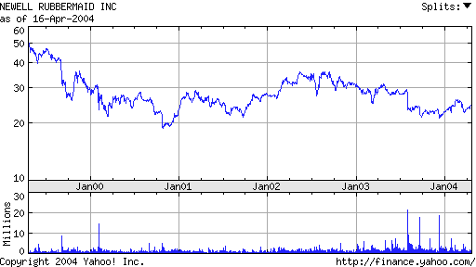

Chart 2



Chart 3

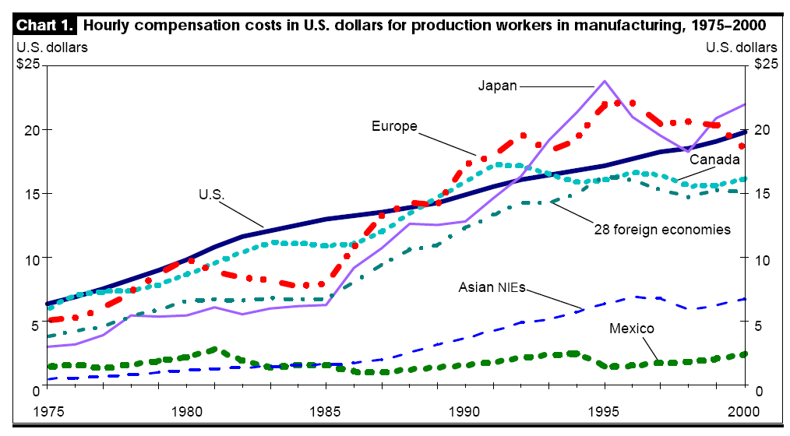

Chart 4

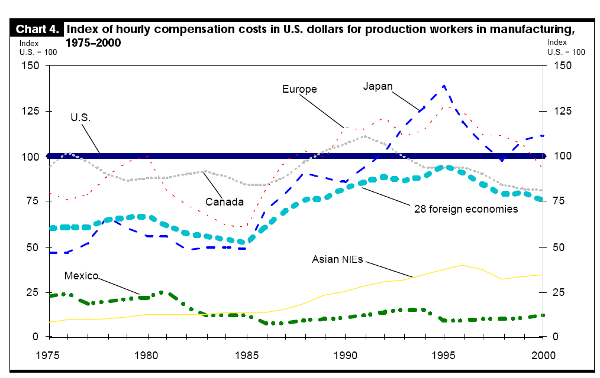

Works Cited

- Miles and Woolridge. “Some new evidence that spin-offs create value.” The New Corporate Finance: Where theory meets practice. Pgs 592-599.

- Rich, Steve. “Agency” spring, 2004, Baylor University.

- Chew, Donald H. The New Corporate Finance. St. Louis: McGraw-Hill Companies, Inc, 2001.

- Http://www.mergentonline.com

- Http://www.netadvantage.standardpoor.com. Newell Rubbermaid Inc. March 6, 2004

- Http://www.newellco.com/

- Press release February 9, 2004. PRNewswire. Newell Rubbermaid Update Divestiture Progress.

- Business Week. October 20, 2003. Newell Rubbermaid: Why it’ll bounce back.

- Investor Relations Business. December 22, 2003. Herron Takes on IR at Newell Rubbermaid.

- Business Week. January 12, 2004. Joe Galli; Newell Rubbermaid.

- Mergers and Acquisition Report. December 15, 2003. Newell Continues to Divest Assets.

- The Weekly Newspaper for the Home Furnishing Network. January 12, 2004. Rubbermaid: Shuttering plant will be beneficial in long run.

- Crain’s Chicago Business. March 24, 2003. Cookware Capers: Selling the sizzle; Newell trying to broaden market for Calphalon.

- Press release February 2, 2004. PRNewswire. Newell Rubbermaid Strengthens Management structures at Rubbermaid/IRWIN group.

- Los Angeles Times. March 4, 1999. Laggard companies trying spinoffs to unleash stock value.
- California Patriot. April 2004. Pros and cons outsourcing.

- Wall Street Journal. April 18, 2004. Few data on jobs moved overseas.

- Computergram Weekly. December 12, 2003. Manufacturers Increase Outsourcing Spend in 2003.

- U.S. Department of Labor. Monthly Labor Review – June. A perspective on U.S. Foreign compensation cost on manufacturing.

