Baylor University
Department of Economics

Professor | Dr. Scott Cunningham (scott_cunningham@baylor.edu) | Teaching Assistant | Joshua Thomas (Joshua_thomas@baylor.edu
Class location | Cashion, 305 | Office location | Hankamer, 365
Phone/text | 254-307-2059 | Fax | 254-710-6142
Class times | TR, 2:00 – 3:15 | Office hours | MWF 9:30am – 10:30am or by appointment

Course description:
This course will introduce you to the foundations of microeconomics, which is the study of the allocation of scarce resources, the tradeoffs involved in those decisions, and the functioning of markets under different market structures and property right regimes.

Teaching Philosophy:
My teaching philosophy is simple: I aim to take you into the field of economics, and through this experience, change your life. I do this by engaging the curiosity that is within every human being, nudging you towards competency (and for some, mastery) over the concepts and material, and develop a web of relationships connecting us through regular group activities.

Course Goals:
The overarching goal of this class is to teach you how to think like an economist. To be concrete, I define this as two connected goals:

- Develop the ability to learn from an economic model
- Gain competency in applying economic models to new situations and circumstances

Course Objectives:
To accomplish these two goals, you will engage in the following activities.

- Come to every lecture with your full attention – in other words, always be physically, mentally and emotionally present
- Take a quiz at every Tuesday and Thursday (due at 2:15pm, no exceptions)
- Be a good colleague by working with another student regularly on in-class problem solving group assignments
- Complete and submit your weekly homework assignment by the assigned due date (no exceptions)
- Take two mid-term exams and one cumulative departmental final throughout the semester
Required Textbooks
The following are mandatory purchases for this course.

- Case, Fair and Oster Principles of Microeconomics, Prentice Hall Publishers
- MyEconLab (see end of syllabus for instructions)

Grading
Your grade is based on the number of points that you accumulate throughout the semester, and points are available to you in the form of daily quizzes, weekly problem sets, three exams (including one departmental final), and on your attendance to class.

Category | Points | Percent of  final grade
Daily Quizzes | 150 | 0.15
Weekly Problem Sets | 300 | 0.30
Exam 1 | 150 | 0.15
Exam 2 | 150 | 0.15
Final Exam | 250 | 0.25
Total | 1,000 | 1.00

The final letter grade you earn will be based on the following scale:

Grade | Points
A | 900 – 1,000
B+ | 870 – 899
B | 800 – 869
C+ | 770 – 799
C | 700 – 769
D | 600 – 699
F | 599 and below

Daily Quizzes (150 points)
At the start of every class, I will distribute a scantron on which you will write your entire name and Baylor identification number in #2 pencil. Use the scantron to record your answers to a quiz consisting of multiple choice and/or true/false answers. I will collect these at 2:15pm. If I do not have your scantron at 2:15, there are two consequences:

- You will receive zero points for that quiz grade
- You will be counted absent for that class

There are no makeups for daily quizzes. Each question will be worth 1 point, and no partial credit.

Problem Sets (300 points)
You will have numerous homework assignments, or “problem sets”, due over the course of the semester. These are applications of the material in class requiring significant practice. You will not get a second chance at the questions, and I do not accept problem sets that are late. You must submit your answers electronically to the myeconlab servers by the designated duedate. If you are late, even by one minute, myeconlab will not allow you to submit them, and consequently you will not receive any points for the assignment.

Exams (550 points)
The majority of your grade in the class comes from your performance on exams. The best preparation for the exams is to allocate time regularly each day working on problems. If you wait until the last minute to begin preparing, you will most likely fail. Class averages for exams typically center around a low C or high D range, but students who work hard in the class are regularly in the upper distribution.

- Midterm 1: Tuesday, September 22, 2011
- Midterm 2: Thursday, October 27, 2011
- Final: Tuesday, December 13, 2011 11:30am – 1:30pm

A few more points to be made about the exams

- Bring a calculator. All exams require the use of a calculator, so you should invest in one now. You do not need a scientific calculator; a simple calculator that handles exponents is all you will ever need for this course.
- Bring a #2 pencil. You must bring a number 2 pencil, along with your own calculator (i.e., no sharing) to each exam.
- No phones. Under no circumstances can you use your phone during the exam. Previously, the economics department learned of students using their phones or other devices to cheat during an exam. Therefore, a phone cannot substitute for a calculator.

Attendance
If you have 7 absences, you fail the class. This is a Baylor policy over which I have no control. I use the quizzes partly to take daily attendance, and if you do not submit a quiz by 2:15pm, you are counted absent, no exceptions.

The second component of attendance is a one-on-one meeting with me in my office. These are to last 15 minutes and no longer. Their purpose is solely to get to know you better, and allow you to get know me better. Please contact my TA Josh about setting this up.

In-class policy: no laptops
For the most part, I am tolerant of just about everything. I cannot make you learn this material. It is ultimately your own choice. But after observing patterns in students over the last four years, I have decided to adopt a new rule: I no longer allow students to take notes on their laptops in class. I do this primarily for your benefit, because what I have observed is that while many students do take notes on their laptops, many area also using social media, writing emails, or surfing the Internet. I want to help you avoid the mistake of being physically present but mentally absent. The other reason, though, is practical: while laptops may be useful for taking notes in some classes, it will most likely be a limitation to most of you because of the sheer volume of mathematical exposition involved in the lecture. You will need to draw curves, calculate slopes, estimate area, solve equations, and so on – all of which is easier to do longhand than on a computer.

Makeup Exam Policy
I do not give makeup exams. If you are unable to take a scheduled midterm, and have an acceptable excuse (see below for what constitutes “acceptable”), then the weight of that midterm will be applied to your final grade. Your decision must be made before the midterm begins. You cannot take the midterm or part of the midterm and later choose to drop it.

Two exceptions to this “midterm policy” are if you are sick and/or there is a tragedy in your family (e.g., death, grave illness). In those circumstances, you must provide advance notice (preferably within 24 hours of the exam), including documentation verifying this is a legitimate excuse. If such conditions are met, your final exam will count both for itself and for the missed exam.

Regarding final, departmental exams. You cannot under any circumstances reschedule the final exam. University policy requires all students to take the departmental exam at the scheduled time. Failure to take the final exam at the scheduled time will result in a grade of zero.

Students with Disabilities
Any student who needs learning accommodations should inform me immediately at the beginning of the semester. The student is responsible for obtaining appropriate documentation and information regarding needed accommodations from the Baylor University Office of Access and Learning Accommodation (OALA) and providing it to the professor early in the semester. The OALA phone number is (254) 710-3605 and the office is in Paul L. Foster Success Center - Sid Richardson - Room 190.

Fall 2011 Semester – ECO 2306, Professor Cunningham
Principles of Microeconomics Required Materials

Index
This document includes the following directions:
- Options for Purchasing your course materials, page 1
- System Requirements and Browser Tune-up, page 1
- Purchase access to MyEconLab Online, page 3
- Register with an Access Code and Enroll in a MyEconLab Course, page 6
- Purchase Print Upgrade, page 8

Options for Purchasing your course materials:
This semester, you will be required to purchase the Hubbard & O'Brien, Microeconomics, 3/E textbook and access to MyEconLab. Below are some purchasing options that are available.
Note: Prices may vary. The purpose of this information is to provide options.

Option 1 (Bookstore) - Purchase a ValPack, Estimated Retail Price $187
ECON 2306, Microeconomics Value Pack contains:
Case/Fair/Oster: Principles of Microeconomics 10e textbook
Access code for MyEconLab

Option 2 (Online) –MyEconLab + Print Upgrade, Total Price $105
Purchase MyEconLab access online (myeconlab.com): $50 (NO eText)
Once in MyEconLab, purchase a print upgrade – which will be mailed to you: $55
Note: See directions below on How to Purchase Access to MyEconLab Online. If a purchase a used book, you must buy access to myeconlab separately.
Option 3 (Online) – MyEconLab + eText, Total Price $100
Purchase MyEconLab access online (myeconlab.com): $100 (WITH eText)

System Requirements and Browser Tune-Up
Everyone needs to follow these directions prior to using MyEconLab.

- Go to www.myeconlab.com.
Click Support on the menu bar and select System Requirements.
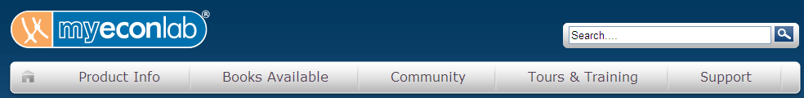
- Read through all of the system requirements.
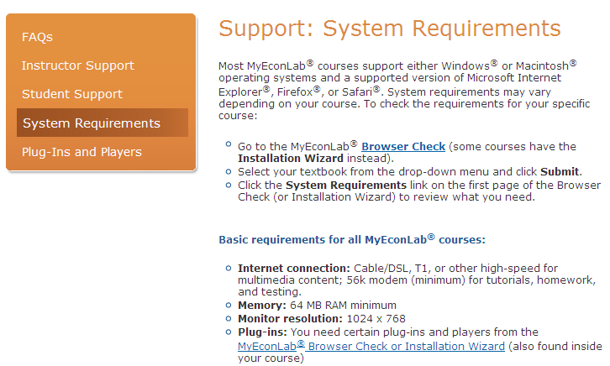

- Click Plug-Ins and Players from the side menu.
- Leave the default selection, ABCs of MyEconLab, in the pull down menu. Click Submit.
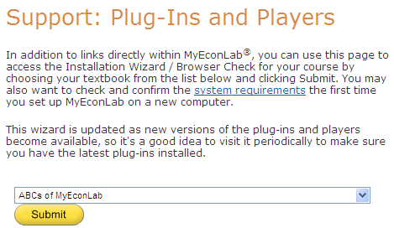
- On your personal computer, complete the Browser Check to ensure MyEconLab will work properly. Click Done.
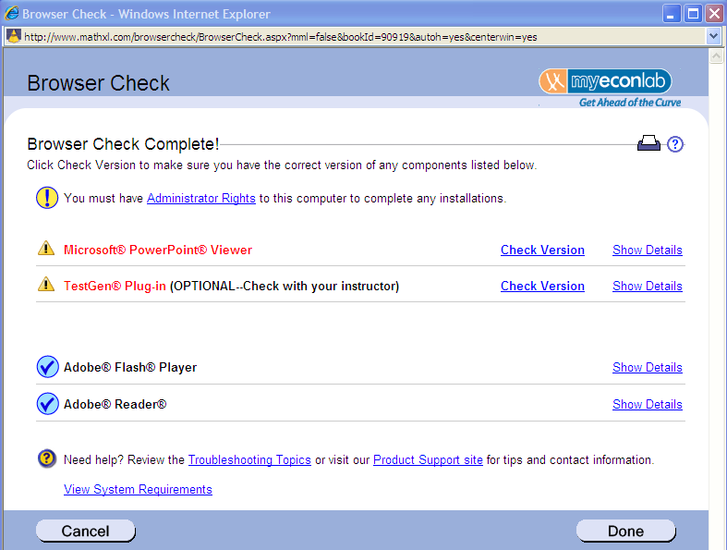
Purchase Access to MyEconLab Online
Follow these directions if you purchased a text with no access code to MyEconLab – or if you prefer to purchase an alternative form of the book (eText / Print Upgrade option).

1) To purchase access, please go to the home page and click Student to register.
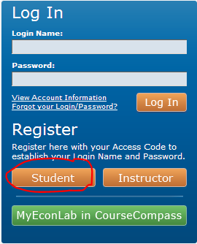

2) Enter the Course ID provided by your instructor (if prompted) and click the Next button.
Professor S. Cunningham’s Course ID for Fall 2011: XL0R-71FH-901Z-8BA2
3) Your textbook will be displayed (may not match image below).
Under Enrollment Options, select Buy Now and select to purchase access with an eBook or without.

- Read the License Agreement and Privacy Policy. Select I Accept to proceed.

- Select the appropriate answer to “Do you have a Pearson Education account?”
If you answer Yes: Enter your Login Name and Password
If you answer No: Create a Login Name and Password
If you answered Not Sure: Enter an email address to check.
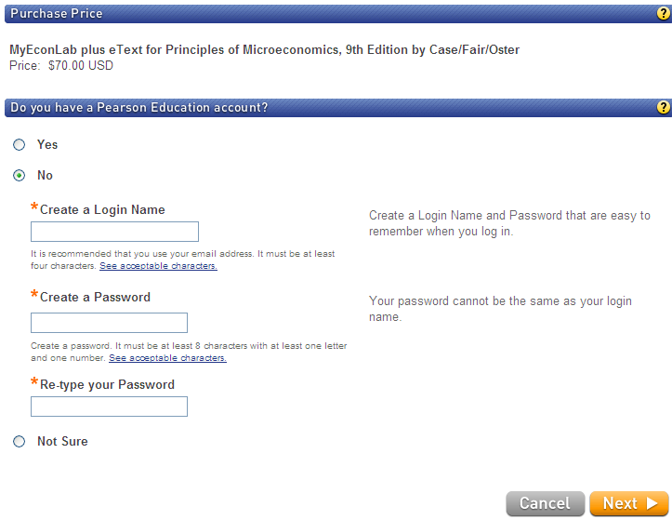
- Enter your Personal Information. Enter your School Location, ZIP code (Baylor is 76706). Click the Next button.
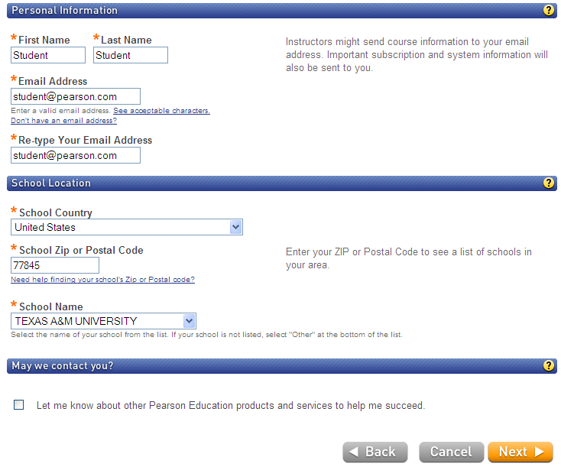

- Enter payment and billing information. Select Continue.
You will need a credit card or PayPal account and valid email address to complete the transaction.
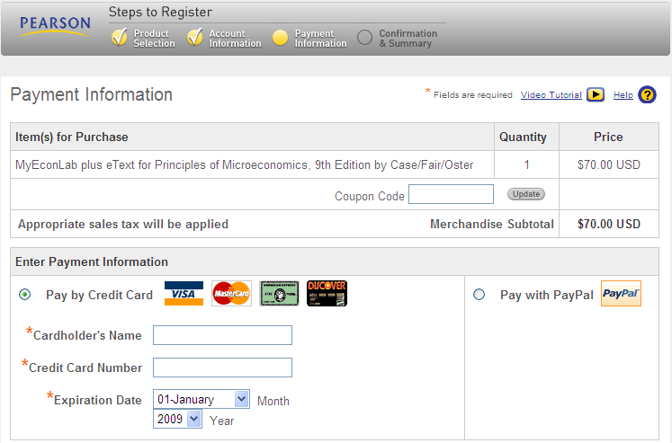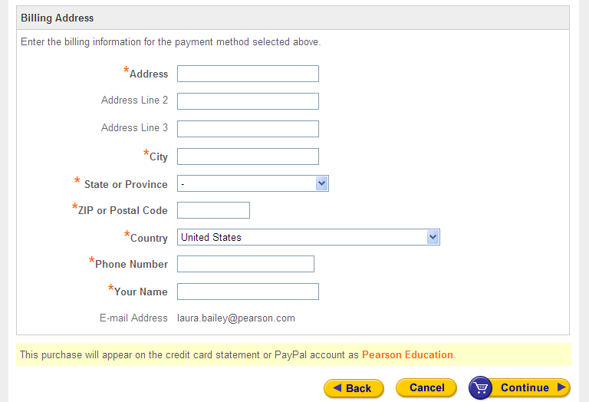

- Review your Order Summary. Click the Place Order button.
- Review your Confirmation & Summary.

Register with an Access Code and Enroll in a MyEconLab Course
Follow these instructions if you purchase a package with the textbook and myeconlab access.
1) To register for MyEconLab with an access code, please go to the home page and click Student to register.

2) Enter the following Course ID: XL0R-71FH-901Z-8BA2
Click Next.
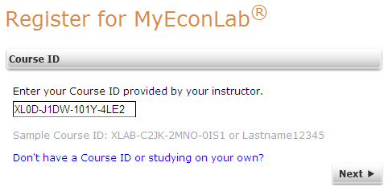

3) Under Enrollment Options, select Access Code. Click Next.
Note: The textbook in the image below may not represent the one for your course.

4) Read the License Agreement and Privacy Policy. Select I Accept to proceed.
5) Select the appropriate answer to “Do you have a Pearson Education account?”
If you answer Yes: Enter your Login Name and Password
If you answer No: Create a Login Name and Password
If you answered Not Sure: Enter an email address to check.
Enter your Access Code (found in the Value Package purchased at the Bookstore).
Click Next.
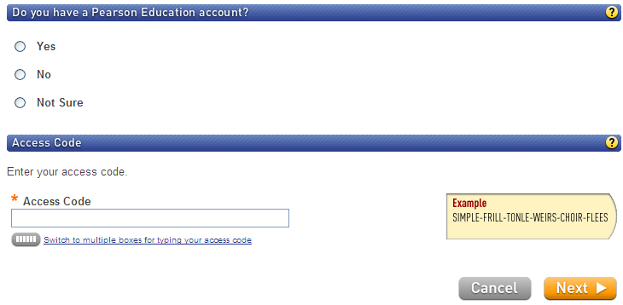

6) Enter your Personal Information. Enter your School Location, ZIP code (Baylor is 76706). Click the Next button.

7) Review your Confirmation & Summary.
8) Click on the course to enter.

Purchase Print Upgrade
Follow these directions if you prefer a print version of the text (not eText), but would like a cheaper option than the traditional bound textbook.

- Once you have logged into myeconlab.com, click Student Center from the side navigation menu.
Under Buy a Textbook or eText, click the myPearsonStore.com link.

- Click Add to Cart to purchase the Print Upgrade.
NOTE: The print upgrade is a loose-leaf version of the text. It is less expensive and there is no resale value. When you click the link in step 2, the textbook registered for your professor will automatically load in the MyPearsonStore window.

