ELITE Think Tank - White Paper #2

Putting Critical Chain
Learning Online

Paper Prepared by eLITE Think Tank

Lead Author: L. Michael Van Hoozer, Jr.
Director of Performance Development and e-Learning
BSI Consulting, Houston, Texas
mvanhoozer@bsiconsulting.com

Dr. Jim Moshinskie
Baylor University
James_Moshinskie@baylor.edu

ELITE (eLearning Incites Teaching Excellence) Think Tank Members:
Claude Balthazard, Ph.D.,  Organizational Studies, Inc.  Larry Carille, Ph.D.,  A.T. Kearney, Inc.  Chris Good,  Motorola University  Ira Kasdan,  Carlson Marketing Group  William N. Knapp,  Deloitte Consulting  Jim Moshinskie, Ph.D.,  Baylor University | Ara Ohanian,  VuePoint Corporation  Bruno Strasser,  Werner-Siemens-Schule Training Center,  Stuttgart, Germany.  Michael VanHoozer,  BSI Consulting  Michael Walsh,  SynerProject  -  Secretary: John Boyd,  VuePoint Corporation

By the year 2002, more than half of the e-Learning applications will involve what may be called supply-chain e-learning (Maise, 2000). Supply-chain e-learning provides opportunities anywhere, anytime, for customers, suppliers, regulators, manufacturers, distributors and partners to learn about a corporation's products and service. Given the broad audience, an appropriate term for supply-chain e-learning is critical chain learning (CCL), a name that encompasses its audience – all stakeholders in both the supply-chain and the demand-chain as depicted in figure 1.

As these new and broadened e-learning initiatives are developing, corporations are seeking new ways to determine whom to involve in such untraditional projects and, more importantly, what the target outcomes are. This white paper developed by the eLITE (Electronic Learning Incites Teaching Excellence) think-tank group examines critical chain e-learning, particularly the role of instructional designers in ensuring a successful implementation. The paper precisely defines critical chain learning, introduces one possible process to design and develop such training, and presents case studies from corporations that have already implemented it.

Critical Chain Learning Defined

Corporations may not readily recognize the education of partners, consumers, and customers as training; they may view it as marketing. While there is a fine line between marketing and education, the common thread between the two is information. The difference is typically the point of view or perspective that the information is presented. Traditionally, companies have used marketing as a vehicle to present their products and services from the company’s point of view.

Critical Chain Learning provides a possibility to present the information from the learner’s point of view using the same methods and techniques that are employed in constructing a training class or e-learning application. The critical success factor is presenting the information based on identifiable and measurable learning objectives. E-learning is an effective medium for conveying this education across your critical chain as illustrated in figure 2 on the next page.
Figure 1
Corporations can realize many advantages by creating critical chain e-learning applications:
Figure 1
Figure 2
- Shortened cycle time to reach targeted stakeholders

- Lowered costs to reach multiple customer groups

- Increased effectiveness collecting stakeholder feedback, message validation, learning curve, refinement, and customization opportunities, and

- Faster diffusion across adoption groups.

A belief that the change you are attempting to effect in learners is valuable to all – that the change is for their benefit – is implicit in this approach. Just as with classroom training, you need to address alternative positions: situations in which a product or service would not be appropriate. You do not want your web site to create dissatisfied customers out of unqualified prospects.

Business Case and Buy-In
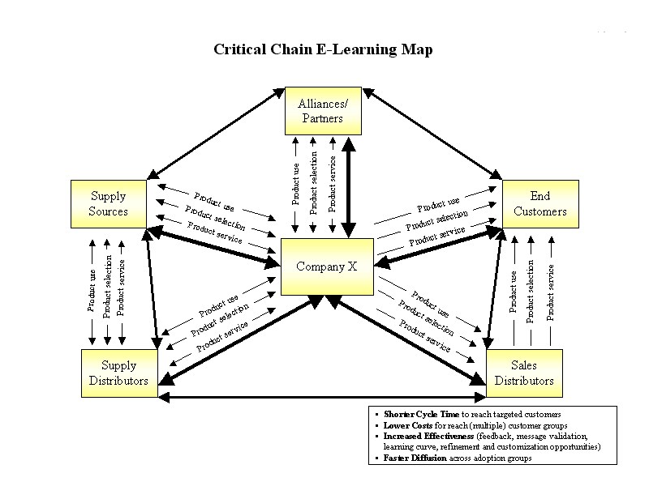

Stakeholder buy-in is important for critical chain learning (CCL) projects. The concept – developing learning-oriented opportunities for suppliers and customers – is likely to be new to an organization and to its leaders, and special attention may be required when creating the business case for a CCL project. In addition, those planning the project may not immediately consider instructional designers as contributors to e-business projects. This suggests that we must make sure to emphasize the value instructional designers bring to the table to create successful CCL projects:

- Instructional designers focus on performance outcomes for individuals. The discipline of instructional design forces one to define an observable objective than can be attained, and to pin the training design on how each element advances the learner toward the objective. For example, we were involved in the development of a critical chain learning site where the objectives were (a) that prospective clients would recognize that the company’s product would be a great thing for the client to have, and (b) that prospects would recognize that they possessed the skills to use the product, and (c) that prospects could apply for the product. With those objectives set, design of the e-learning application was a snap.

- Instructional designers are skilled at working with subject matter experts (SMEs) – SMEs from marketing, sales, or any other corporate role. Pairing an instructional designer with a marketer or sales person results in compelling, effective messages structured in a way that allows learners to achieve observable goals.

The Process of Creating Critical Chain Learning

This paper recommends a systems approach when tackling CCL projects. The suggested model involves seven stages, each incorporating a series of procedures to support that stage. We have developed these procedures based upon experience from our own CCL projects, and we offer them as a starting point for those implementing similar projects.

Stage 1: Create Your Team

The project to develop critical chain e-learning begins, as usual, with a team. The team as a whole should be skilled in instructional design and development, creative design and development, web technologies, customer relationship management, change management, e-commerce, and marketing. The team must have a corporate champion who will actively participate in the development process. The champion will lead the sponsorship and marketing campaign to implement the project within the corporation.

Stage 2: Determine the Scope
of the Project

Instructional design methodology begins with assessing the needs of the learners, determining what they know and can do versus what they need to know and do. When creating e-learning applications for a public audience and with largely unknown learners, defining appropriate and effective training is a challenge. If learners are unknown, creating objectives and developing relevant learning is difficult at best; therefore, the team will need to find a way to get to know the “unknown learner.”
The least expensive and fastest approach to identifying the unknown learner is expert opinion. Subject matter experts (SMEs) should be able to describe the target learners: what they know or do not know, the mistakes they are likely to make, what they value or disregard. While the expert opinion of SMEs should reflect the target needs of your learners, make sure that you have checks and balances in place for validating their information. As with any other SME-derived information, the team will need to validate the opinions of several SMEs, challenge their assumptions, and facilitate the SMEs through the process of producing a learner profile.

If the unknown learners represent the members of a large and diverse demographic, surveying a statistical sampling of learners allows identification of the needs and values of the target audience. A statistician can help determine the size and composition of the sample, the method of delivering the survey, and the approach to analyzing and interpreting the results.

A properly designed and administered survey will produce results, but the team may find that the impersonal nature of this approach deprives it of clues to effective objectives and the opportunity to change direction if the assumptions on which the research project are founded prove false.

Blind focus groups are a variation on statistical sampling. Participants are chosen on the basis of a demographic; they may not know who is developing the training; they may not have a true stake in the outcomes. The user of the focus group results is most often not in the room, but is watching through a camera or two-way mirror. Changes to the planned questions are passed to the facilitator, making blind focus groups more variable and interactive than surveys.

Interactive focus groups allow conversations between instructional designers and prospective learners. Ideally, the participants will be identified representatives of presumptive learners – in the case of supply-chain learning, actual customers or suppliers for whom you are building the e-learning application.

When the targeted learners are high in an organization, bringing those learners to a focus group requires understanding the benefits to the learners of the ultimate solution, clearly communicating the benefits to the targets, and calling in markers (i.e. requesting attendance based on your relationship). However you get them there, you owe participants value for their time, and the value you deliver immediately is largely intangible – being heard; learning about the issues; influencing their industry; networking with their peers.

Interactive focus groups for supply-chain learning work exactly like facilitated sessions with groups of target learners within an organization. The goal is to convert the unknown learners into real people with real needs, and discuss with learners the ways to meet their needs. You can then develop plans as a team that will be mutually beneficial to your company as well as the learners.
Conducting individual interviews of a small sampling of target users is roughly equivalent to SME opinion of the targets’ needs. Without interaction between targets (as in a focus group) you cannot readily validate opinions, and yet there is a temptation to accept all information as fact because of the source.

Stage 3: Determine the Outcomes

The audience visiting such corporate e-learning sites tends to seek one of three outcomes: (1) Learn material, (2) Learn material and apply it, and (3) Learn material, apply it, and be assessed. The following paragraphs elaborate on each of these outcomes:

- Learn – Gain information on the corporation, its products and its services, and support information. This should be in a non-sales-pitched, straight-forward approach. You can use audio, video, flash animations, and digital photographs to create an interactive experience for the learner. At this stage, an e-learning application focuses on educating and informing learners about a company’s products and services. The key to this type of e-learning is that objectives are learner-focused, in the same way that a good sales message focuses on benefits to the recipient.

- Learn and Apply – As you move up the maturity continuum, learners are able to apply their knowledge. Learners are presented information, and then interact with your site. An example would be an online stock-trading site that provides e-learning content for their potential customers and allows them to make trades on the site. Interactivity increases with scenarios, multiple-choice questions, and simulations where learners can virtually test out the products or services. In our stock trading example, material might explain stocks and options and how to transact trades. When visitors are familiar with the material, they might visit a virtual stock exchange and try their hand at buying and selling.

- Learn, Apply, and Be Assessed – The most comprehensive level of e-learning uses formal assessment to ensure that learners have comprehended and can apply the material covered in the e-learning application. For this outcome, you need to use formal assessment methods for certifying or validating that the information has been learned. An example would be creating an online certification program for channel partners who help to represent, sell, or provide services for a company. Partners’ knowledge of a company’s products and services helps ensure that the company’s brand is accurately represented to the marketplace. Suppose you are a software company selling your products through technology-consulting companies. You would want to verify that each partnering consulting company was a knowledgeable and authorized vendor for each of your products. Another example would involve sales consultants for a homebuilder who learn sales techniques, gain experience through virtual scenarios and simulations, and then take a test to achieve corporate certification.

These outcomes match the critical chain learning maturity continuum depicted in figure 3. This maturity continuum developed by BSI Consulting, a member of the eLITE think-tank group, illustrates the three distinct levels of critical chain learning applications:

- Educate and inform
- Enable skills
- Validate learning

Stage 4: Plan Implementation

Before you begin design, determine how learners will be drawn to the site.

- Will employees be sent to the site by corporate directive? If this is the case, you can assume that learners will come.
- Will customers be led to the site by sales persons? Consider what a sales person will have to do in the presence of a customer; design an elegant entry.
- Will business partners be directed to the site by text on your web site? You will need a marketing campaign that persuades business partners to go there.
- Will you conduct a marketing campaign to entice learners? Make sure that what you deliver will support a compelling marketing message.
- Will training be a requirement of some other activity? Tie e-learning access to the activity.
- Are learners motivated, coerced, or casual learners? Motivated learners and those who are driven by external forces need to be able to find the e-learning application when they want it. Casual learners need to be given a reason to be motivated or coerced – consider marketing or structural changes.

Whoever your learners are and whatever draws them, you will need a communications plan that lets all learners know what learning is available, how to get it, and why it is good for them.
Figure 3

Stage 5: Design and Develop

The design stage encompasses instructional design, visual design, and technical design. Basically, instructional design for an e-learning application uses the same methods as any other instructional design project:

- Structure
- Activities for learners
- Content that must be presented before learners can do the activities
- Content tailored to meet each objective.

If the best way to convey information is through modeling, decide how to model the event. If the best way to achieve an objective is through lecture, decide how to present the verbiage.
Figure 3

As with any web project, the visual design of the site needs expert guidance. In art school, designers learn how viewers receive visual clues. Trained designers understand how the physiology of the eye affects our perception of color. They know which areas of the screen are most active, the areas in which content will be readily noticed, and which areas of the screen can hold peripheral information without being distracting.
Many sites today feature colorful animation and synthesizer music built using such software as Macromedia Flash as attention getters. While these eye-catching openers may be quite effective the first time, visitors may find them annoying on subsequent visits; therefore, a “skip” option should be available. While these colorful and upbeat electronic displays may appeal to some generations, others may be unimpressed by such approaches. Careful usability testing will ensure a good audience match with such electronic wizardly.

After expert designers review the design in principle, the team should conduct periodic formative evaluation – again, usability testing – of the site. This kind of evaluation involves putting the design into practice with test subjects who have not yet seen the site. Usability testing requires a pool of test volunteers, qualified for demographics such as age, income, occupation, family size, and buying habits (Schroeder, 2000). One way to select your participants is to build a database of volunteers, perhaps from online questionnaires, and then select those who fit the proposed user profile.

When demographics disqualify some users from testing one specific site, their records should be retained until they match the needs of another site. As volunteers pilot-test the proposed site, collect quantitative (surveys) and qualitative (comments) data and look for trends. Record information about their experience and their thoughts as they traverse the site.

You do not need to achieve total consensus in how a problem should be fixed, but – especially if you use a small sample – you should accept any problem with the site as a signal that you can improve.

The art of usability testing lies in structuring a test, observing what actually happens in the test, assessing the causes of the problems that were observed, and prescribing changes. There are companies that will do this for you if you do not have the skills in house.

Stage 6: Implement

After the site has been developed, you are ready to deploy the application. An effective CCL marketing plan should specify activities and timing to properly launch the e-learning initiative. You should include e-mail announcements leading up to the event as well as a launch e-mail that specifies the following:

- URL location of the site

- User ID and password, if applicable

- Basic instructions for getting started with the site.

- Customer support options for the site.

- Technical specifications, e.g., desired screen size and color settings

- Any plug-ins necessary

- When and where any help is available

Stage 7: Evaluate / Maintain

Once the site is up and running, the team will need to conduct ongoing summative evaluations of site effectiveness, user comments, and needed changes. Use the power of the Internet to poll site visitors electronically and immediately for data that will help the team determine if they are on track with content.
Figure 4

Ask questions about content usefulness, navigation ease, and any new features that are needed. From this data, conduct an impact analysis to determine where future time should be devoted on the site. Based on the information you gain, you can create a site evolution strategy for your e-learning application that can help you continue to make it useful and effective for your audience.

In this era of knowledge management, there is a greater emphasis on keeping content current. Therefore, on-going procedures should be set in place to maintain the site. The design team should periodically check the content for freshness and accuracy and update accordingly (Tennyson and Foshay, 2000). Questions that should be asked include:

- Has the product or service changed or improved?
- Is it still available?

- What comments have been collected from the intended audience on the usefulness and/or usability of the site?

- Has the intended audience changed?
- Has the media used to develop the site been updated so newer capabilities can be used on the site?

Critical Chain Learning
Case Study

A large corporation acquired a company that, along with selling products, is a premier provider of a complex service - integrated supply management. Their approach is somewhat different from others in the field, and they needed to explain the service to their customers. Integrated supply management is the service of outsourcing procurement and management of the items a company buys and consumes while conducting business, like pencils and light bulbs. The well-designed company brochure was six 8.5" x 11" pages of text. The average sales cycle was over one year including extensive analysis, and only half of the customers that investigated the service were qualified for it.

The corporation's solution was to produce an e-learning module that would allow customers to educate themselves about integrated supply, the corporation's approach and offerings, and their own likelihood of realizing benefits from it. The piece is approximately ten minutes long. Visitors who are unfamiliar with the basic concepts can get an education in the most common approaches in the industry.

Those who understand integrated supply management can view case studies and run economic scenarios with their own numbers. Any visitor to the site can ask the corporation for more information.

By using instructional design methodology and the steps presented in this white paper, the project team built a critical chain e-learning application that is rich, clear, and effective. The application was built using Macromedia Flash and audio voice over. By using these technologies, the project team was able to create an effective interactive experience for the user that appeals to multiple styles of learning.

Also, the application utilizes an metaphor which draws a comparison between integrated supply management and the procurement of water for your house (Figure 4). The analogy helped to illustrate how the e-commerce solution that the company was providing could help to streamline a customer’s procurement of supplies.
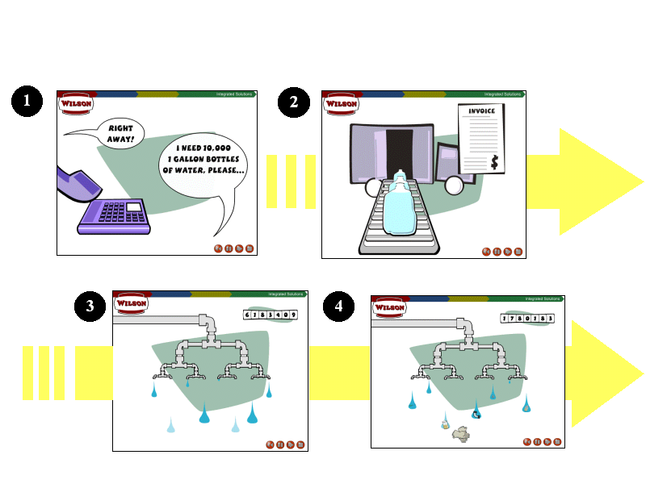

References
Figure 4

Maise, Elliott. (2000). “Customer and Supply Chain e-Learning,” a mega-session presented at the TechLearn 2000, Orlando, FL., November 14, 2000.
Schroeder, W. (2000). When It Rains It Pours: Avoiding Flash Floods in Test Scheduling. Eye for Design 7(4), pp 6-9.
Tennyson, R., and Foshay, W. (2000). “Instructional Systems Development.” In Tobias, S., and Fletcher, J., eds., Training and Retraining. New York: Macmillan Reference USA.

