Business Literacy E-Learning Portal

Scope: Conoco University’s entry is an extensive web-based training portal that presented basic “Business Literacy” skills to all of its employees worldwide over the corporate intranet. The ambitious, three-year project represents the largest enterprise-wide training initiatives ever implemented by Conoco University since it started in 1996.

Needs Analysis: The project began with a survey of 92 key international managers who identified the need for increased employee business acumen to help Conoco implement its aggressive Year 2003 goals. Both instructional and non-instructional interventions were developed, including this web-based training.

Working with 53 international subject matter experts, exact learning outcomes were developed at both the “knowledge” and “application” levels using a Context-Performance Matrix. Using constructivist learning approaches, seven highly-interactive modules were developed to teach employees how Conoco operates, how the company measures success financially, how to set up and read financial reports, and how to make financial decisions.

Two metaphors, carefully selected and crafted for a diverse international audience, are used in the opening modules. One module teaches how Conoco makes money by relating it to the fishing industry. In another module, the employees establish their own bike shop business, then correlate this to making financial decisions within their own Conoco division. To test “knowledge” objectives, an animated “Biz Quiz” provides a beat-the-clock game show. For “application” exercises, the “Dilemma Zone” presents authentic, job-related simulations.
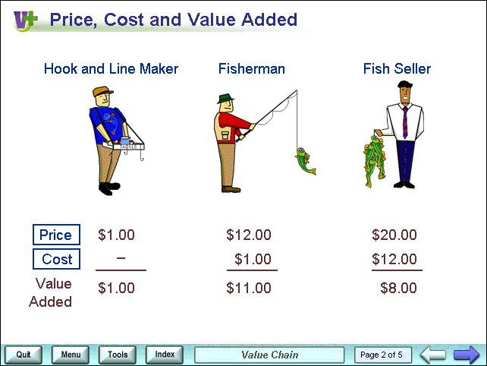

Roll Out: The project was rolled out in two phases. In Phase One, the site was implemented to selected international business units with the involvement of the human resources department and the business unit management team. Observations and evaluations gleaned from these initial rollouts allowed fine-tuning for Phase Two, which saw the site opened for all employees worldwide in July, 1999. To allow employees – and their families – to take the course on home computers, 10,000 CDs were distributed.

Incentives: In some cases, employees are hesitant to risk failure and “loose face,” thus employees are able to take the training unmonitored and at their own pace. They can re-take modules as many times as needed to pass, then receive an individualized certificate. The web-based training can be tied to the individual employee’s Targeted Development goals. Individual units also implement their own awards. For example, the Malaysia unit rewards employees who pass the training with a casual shirt and a dress-down casual day.

Results: A comparison of pre- and post-test scores shows significant knowledge improvement, and 98% of those surveyed said they would take a course delivered by WBT again. Almost 82% of the employees predict that the training will allow them to improve performance. When unit managers ranked how well employees reached the learning objectives on a scale of (poor) to 5 (excellent), and the average score was 4.2. Additionally, about 96% of the managers surveyed report noticeable improvements in employee performance after taking the course.

Lessons Learned:

The Company  - Solving problems using a well-planned systems approach works.  - Enrolling managers in every phase of a change management project increases their buy-in -- and support.  - Integrating the efforts of the various departments (the University, Information Systems, Human Resources, and Marketing) gets everyone involved and builds Company pride and  unity.  - Acknowledge everyone who helps in anyway. | The University  - You can never have enough resources -- Call on everyone you can.  - Set expectations with outside consultants and vendors.  - Document lessons learned for internal use and share them unselfishly with fellow peers at local and national ASTD meetings.  - Celebrate milestones.  - Never quit marketing the course. Keep the excitement alive.  - Build on the Company's diversity.
The Project Team  - Build on SME's enthusiasm and knowledge and make them an integral part of the project.  - Network with employees, managers, and Company officials and keep them informed of the project's progress. Always invite -- and welcome -- their honest input.  - It takes much hard work to complete such an extensive project. Devise definite plans to include editing, revising, and checking as part of all projects.  - When you make a mistake, you can fix things but it does not always feel good.  - If something goes wrong, don't waste time assessing blame. Ask how can we keep this from happening again.  Instructional Designers  - Spend the time necessary with the SME's to carefully translate their tacit knowledge into explicit knowledge that can be shared with everyone in an understandable manner.  - Following a well-researched instructional design provides consistent structure to each lesson and ensures optimal learning outcomes.  - Constantly think how each static screen of  text can be converted into interactivity that engages the learners meaningfully.  - Keep the lessons to small "bite sized" units  so the learner can clearly see his/her  progress and stay involved. | The Project Manager  - "Never send anything out unless you check over it carefully yourself and then allow others to check it again with new eyes. Excellence is no accident."  - "We ate, slept, and breathed this project for three years. Be willing to jump into any project with your head, heart, eyes and everything. This is true action learning."  - "Never quit marketing. We gave out letter openers, calendars, and newsletters to inform everyone who would listen that the course was up and running, and they could benefit from taking it."  - "I learned that our people are hungry for the knowledge to improve their performance, and are truly thankful to have a resource that teaches them in a non-threatening way."  - "You can learn something from every person you meet. Someone else always knows something you don’t know, and this synergy allows you to grow and make yourself better."  - "You do not always get a pat on the back for what you create, but the internal satisfaction is what matters the most. No one has to tell you when it is right."

Evaluation Results

Extensive qualitative and quantitative benchmarking was -- and is -- included in the process. This chart describes the relationship between expected and actual results after the September 1999 survey: (Annual surveys are conducted every September).
Item | Expected | Actual Numbers
Return rate from the employees on the Kirkpatrick Level 1 surveys. | 80% | 97%
Response rate from the supervisors on written surveys. | 80% | 60% - (Many had already commented in regional rollouts.)
Average Kirkpatrick Level 1 from employees who took the e-learning on a scale: 1 (poor) to 5 (excellent). | 4.0 or better  (Agree or better) | 4.2  (Between agree and strongly agree)
Supervisor's ranking that the training increased their employee's knowledge. | 4 or above  (Agree or better) | 4.1  (Between agree and strongly agree)
Improvement between pre- and post-test scores (Kirkpatrick Level 2). | An average of 5 questions missed on the pretest. | An average of 1 question missed on the posttest.
Employees would express positive comments about the course. | 80% of the remarks would be positive. | 98% of the remarks were positive.
Supervisors would express positive comments on the course's value. | 80% of the remarks would be positive. | 90% of the remarks were positive.
Supervisors would see an improvement in the knowledge gap of their employees. | 80% would report an improvement. | 100% reported knowledge improvement in the five key areas.
Employees would predict their probability of improving performance. | Employees would give a 80% or better chance of improving performance. | Employees gave 80% or better in three key areas; and 71% in the other two areas.

