TENET HEALTHCARE

November 24, 2003

Group 4

J.B. Sigmon
Spencer Elliott
Steven Garner
Kellie Gay
Austin Henderson
Alison Duffy
Table of Contents

- Executive Summary 3
- Introduction 4
- Recommendation #1 6
- Recommendation #2 9
- End Notes 12
- Appendix 1 13
- Appendix 2 16
- Appendix 3 19
- Appendix 4 22
- Appendix 5 22
- Appendix 6 23
- Appendix 7 32
Executive Summary

Tenet Healthcare Corporation is the nation’s second largest healthcare services company. Tenet operates hospitals in several markets across the country including California, New Orleans, Miami, St. Louis, Philadelphia, and Texas. Tenet also operates hospitals in rural communities across the South. Nearly two-thirds of Tenet’s hospitals are located in markets where Tenet holds either the number one or number two market position (appendix 1).
For the nine months ended September 30, 2003, Tenet posted a net loss of $523 million as opposed to a net profit of $848 million for the nine months ending September 30, 2002. This loss was caused by a number of industry and Tenet specific problems. Due to recent changes made by the Centers for Medicare and Medicaid Services to the final inpatient payment system rule¹, Tenet’s outlier revenue dropped from $681 million in 2002 to $50 million in 2003 (appendix 6). Tenet’s doubtful accounts expense increased from $704 million in 2002 to an incredible $1084 million in 2003. Even though admissions rose 1.6% in the 3rd quarter (2.1% for the last nine months), doubtful accounts expense rose as well (appendix 6). This increase was due primarily to “the adverse employment picture…in which increasing numbers of the unemployed lost their insurance coverage. In addition, there is a growing burden of co-payments to be made by patients rather than insurers.”¹ Another major concern for Tenet is its current legal troubles. In a conversation our group had on November 19, 2003, with Stephen Farber, CFO of Tenet Healthcare, he said, “We have everyone in the government coming after us except the department of agriculture.⁷” While this may be a slight exaggeration, Tenet is facing quite a few lawsuits stemming from patient malpractice, illegal termination of an employee, and investigations by the SEC and Congress. So far this year, Tenet has lost approximately $327 million due to adverse court judgments (appendix 6).
Over the course of the last year, Tenet has undertaken a few restructuring attempts. "Since December, the company has…announced plans to sell non-core assets and accelerate share repurchases, taken action to reduce operating expenses going forward by at least $100 million annually, announced its intention to begin expensing… the cost of stock options granted to employees, changed its calendar year…to enhance comparability with other hospital companies, adopted a new policy on Medicare outlier payments, restructured its operating divisions and regions, promoted its top hospital executives to the senior executive management team, placed a seasoned hospital executive who is also a physician in charge of its large California market, and established a groundbreaking new policy for uninsured patients that includes an offer, subject to government approval, of managed care-style pricing."² Tenet has also increased sharing of best practices across all its hospitals. Tenet is continuing to use financial counselors in its facilities to help patients identify the financial resources for which they may qualify and to identify patients who have adequate financial resources of their own.¹
We have two recommendations to combat Tenet’s troubles with its doubtful accounts. Our first suggestion is to add small well-patient care clinics in more affluent areas near current Tenet hospitals. These clinics will attract wealthier patients who need primary care services. Whenever these patients need to see a specialist for more acute secondary care, the well-patient care clinic’s doctors refer the patients to the local Tenet hospital, thus increasing the admissions of paying customers. Our second recommendation is to create a Not-for-Profit Minor Emergency Care Center within each hospital where triaged, non-emergent, uninsured patients can get less expensive primary care from a nurse practitioner or a physician’s assistant. This will decrease the actual cost to each non-emergent and uninsured patient which will in turn lower doubtful account expense when these patients’ bills prove uncollectible.
Proposal
Tenet Healthcare Corporation is one of the largest companies in the healthcare industry. Like other corporations, Tenet is highly influenced by consumer demands and new trends, insurance policies and malpractice suits, regulation, Medicare and Medicaid laws and patients who cannot pay for services,. These factors frame the environment in which Tenet must compete, and they continue to influence Tenet as it develops corporate strategies for success.
Some of the main issues that face the healthcare industry are specifically important to Tenet. First, as the Baby-boomer generation reaches retirement age, it will demand more medical care. Tenet must face these new demands and develop strategies to meet those needs. Many of the demands include well-patient care clinics for primary, acute, and elective secondary, medical care. Baby-boomer demands provide opportunities for Tenet to expand its healthcare facilities, but they also influence the corporate goals and focus of its current operations. Re-evaluation of Tenet’s core strategies and pricing policies are required to adjust to its changing environment and meet the consumers’ demands of tomorrow.
Secondly, as the demands of the elderly are met, Tenet must also address the issues of increased risk of complications associated with healthcare for the elderly. Doctors and healthcare facilities face the tradeoff of the optimal amount of testing and its associated costs versus the increased probability of malpractice lawsuits. Routine procedures are drastically complicated by geriatric treatment and health issues associated with advanced age.³ Increased risk for providing healthcare for the elderly increases the liability costs for doctors and hospitals. Malpractice insurance is one of the largest costs associated with providing healthcare for the elderly.
Third, the higher costs associated with the increased testing and procedures also add to Tenet’s large doubtful accounts expense for patients who cannot pay. Like all medical care companies, Tenet faces the ethical problem of treating patients who cannot pay and the standard practices of running a business. The healthcare industry’s doubtful accounts problem is an increasingly devastating one. The most recent announcements for the third quarter ending September 30th show Triad’s allowance for doubtful accounts raised $50 million to $134.4 million, HCA’s grew 37% to $566 million, and Tenet’s shot up by more than 200% to $522 million.¹ More specifically, Tenet’s doubtful accounts problems are more injurious than its competitors. We do realize that these doubtful accounts problems cannot be absolved; however, they can be “mitigated.”² Tenet cannot turn patients away from its facilities who require costly medical attention, even though some of these patients are unable to pay for these treatments.⁷ If the improper amount of attention and treatment is provided to a patient, regardless if the patient cannot pay, Tenet is liable to the patient and can face lawsuits, government litigation, and loss of reputation.
Fourth, many of the ethical issues Tenet faces are decided for the company by laws and regulations. The healthcare industry is one of the most highly regulated industries by both state and federal government. Tenet must comply with an assortment of regulations and endure increased investigation and litigation costs. Investigators routinely audit Tenet both on a corporate and individual facility level to ensure that Tenet is in compliance with the law. Accusations of infringements of these regulations forces Tenet to defend itself and endure a lengthy litigation procedure. The high costs of litigation must then be absorbed by the company and added to expenses.
Finally, in compliance with some of these new Medicare and Medicaid laws, Tenet must drastically change its business practices and develop new strategies. The Centers for Medicare and Medicaid Services made changes to the final inpatient payment system rule for the fiscal year beginning October 1, 2003.⁵ Among the changes, one particular section lowered the outlier payment threshold. As of January 1, 2003, Tenet accepted early adoption of these changes and incorporated them into its Medicare and Medicaid per patient pricing system. The changes drastically reduce one of Tenet’s main sources of operating revenues. As seen in appendix 5, Tenet received $830 million in outlier revenue in 2002, but according to Tenet’s CFO, Stephen Farber, Tenet expects outlier revenue of only $72 million in 2003.⁷
Because this drastic reduction is a result of the new Medicare and Medicaid payment policies, outlier revenue is not expected to return to its previous levels. Additionally, the outlier revenue is an after-cost revenue source which is added to the bottom-line profits after operating expenses for Tenet. This drastic reduction has essentially reduced Tenet’s profits by an equal amount. This policy change has created a significant problem for Tenet by almost completely eliminating one of its largest revenue sources.
The healthcare industry is wrought with problems. Tenet must make changes and incorporate new core strategies to successfully compete and survive the challenges that it faces. These opportunities and challenges are incorporated into the proposed financial actions that Tenet should make.
Recommendation 1: Buy out primary care facilities in affluent areas (Cherry-picking)
We recommend that Tenet buy out primary care facilities and employ the cherry-picking method when attracting new customers to meet baby-boomer demands, decrease the percentages of doubtful accounts to collectable receivables, and boost income from new revenue sources. Tenet will acquire primary care facilities in more affluent areas of the nation where Tenet’s secondary care hospitals already exist. We have cross referenced the nation’s wealthiest areas with Tenet’s secondary units (appendix 2 and 3). These areas will provide the most success in increasing Tenet’s revenues.
This method of acquisition is best described as cherry-picking. Cherry-picking is what the healthcare industry calls recruiting healthy, insured patients.⁶ This enables Tenet to better select its customers. The cherry-picking method will be a beneficial restructuring strategy to combat THC’s increasing doubtful accounts.
By cherry-picking, THC will see several advantages. Tenet will be able to make money from treating healthy, insured patients. The newly acquired primary care facilities in prominent neighborhoods will attract patients who are more likely to pay. The primary care facilities could provide many services: Allergy/Immunology, Cardiology, Dermatology, Family Practice, Geriatrics, Internal Medicine, Obstetrics/Gynecology, Orthopedics, Pediatrics, Radiology, and many others.
Customers coming into these well-patient care clinics will be insured and able to pay. This will increase revenues and decrease Tenet’s percentage of doubtful accounts to collectible receivables. Although doubtful accounts cannot be eliminated, adding insured and paying customers will increase Tenet’s profits.
Referrals are another main benefit to buying out primary care facilities. Tenet’s primary care patients will be referred to Tenet’s hospitals for secondary care. For example, a woman has been seeing a primary care physician for well pregnancy check ups. When it comes time for the woman to deliver her baby, she does not deliver it at the primary clinic but at the Tenet secondary hospital. Instead of sending the woman to another hospital for delivery, Tenet will be able to capture her services at the primary level and the secondary level.
One of the primary care facility’s concentrations will be geriatrics. Geriatrics is similar to the family practice section, but the care and treatment is focused on older individuals. Tenet can expect to benefit from the aging baby boomer population in these new areas where facilities have been bought out. Services will be provided at the primary care level, and then with referrals, secondary and elective care can be provided.
In recent a conversation with Stephen Farber, CFO of Tenet Healthcare, we discussed our recommendations and possible downsides. A downside of this recommendation is the “doctor element.” Currently Tenet’s doctors are at a competitive disadvantage due to the increases in liability insurance.⁷ Acquiring new primary care facilities and doctors increases the cost of liability insurance premiums.
The current high cost of liability insurance for Tenet is due to the numerous recent malpractice lawsuits and federal investigations. However, one of the first things on Tenet’s list is settling its litigation expenses from current liability lawsuits.⁷ After these have been settled, insurance premiums and litigation costs should retreat to industry standards.
This recommendation is a very practical one. Tenet currently has free cash available ($219 million) that can be used to internally fund this recommendation (appendix 6). Additionally, this recommendation is a reasonable and widely used solution in the healthcare industry.^{6,7,8}
Stephen Farber reported that Tenet is not currently using this solution. However, he explained that several of their competitors have done variations of this recommendation and have greatly benefited from it. For example, HMA is purchasing primary care facilities in selected areas.

Recommendation 2: Open not-for-profit minor care center in each of Tenet’s hospitals
Currently Tenet Healthcare does not have any not-for-profit sectors located inside its hospitals. It supports charity clinics that offer free healthcare usually a block or two away from its hospitals. Tenet tries to encourage lower income patients to use these facilities for their primary care rather than the emergency room. Tenet also employs a two track system for emergent and non-emergent patients. This method attempts to defray some of the non-critical patient costs by giving patients less costly treatment. These methods are not effective. Nonpaying customers are still using emergency rooms for common colds and minor illnesses in place of a family physician. Tenet should push these patients into nonprofit sectors of its hospitals to save on costs and reduce doubtful accounts expense.
First, Tenet should reallocate the money spent on the free clinics to its own nonprofit foundations within its hospitals. Tenet should encourage local government funding and community donations. It should elicit support from local doctors, nurses, and administrative personnel for volunteer time. Tenet should alter the current two track system so that patients triaged as non-emergent would be pushed over to its not-for-profit sectors.
These steps will lower Tenet’s expenses in several ways. The volunteer time and the minimal per patient staffing in the centers will reduce the number of paid positions required. Pushing non-emergent patients to these centers will significantly lower the number of patients in the traditional emergency rooms, thereby reducing the number of expensive emergency room physicians required. These reduced costs will further be supplemented by donations and tax revenue from the local communities.
The patients that use the emergency room as a primary care facility are generally responsible for most of Tenet’s doubtful accounts expense.⁷ They cannot afford to visit a family practitioner and so they go to Tenet’s ERs and then do not pay the bill. Because of EMTALA laws, Tenet is required to treat patients regardless of their ability to pay (appendix 7). However, Tenet is not required to treat them with the expensive medical care they are currently “handing out.”⁶
All of the steps in our recommendation are designed to reduce doubtful accounts expense by lowering the cost of treatment to patients. Tenet’s not-for-profit centers will still charge the patients a fee, but it will be reduced considerably by Tenet’s lowered expenses. The patients will be more willing and able to pay.⁶ However, when they don’t pay, Tenet will be writing off a smaller amount of receivables, thereby lowering its doubtful accounts expense.
With the recent bad press and potential litigation issues, this solution also presents the opportunities of bettering Tenet’s public image and reducing its legal liabilities. Non-emergent patients are allowed to be discharged without care after their initial triage (appendix 7).⁷ Tenet’s not-for-profit centers would accept these patients. This reduces the liability from a triage mistake, as well as it presents Tenet in a positive light.
However, the recommendation of opening not-for-profit centers has potential downsides. First, donations and volunteer time is uncertain and not guaranteed. However, the expenses from the not-for-profit centers are already part of Tenet’s operating expenses. Therefore, financing the not-for-profit centers does not rely on donations, volunteer time, or any additional funding. Any donations or volunteer time received would simply be an added benefit to reduce costs. Another potential downside is the overall complication of taxes for a not-for-profit center within a for-profit hospital. Additional work and effort will be required of Tenet’s Accounting Department.
According to Diana Takvam, Tenet’s investor relations contact, not-for-profit centers have not been established in Tenet’s hospitals. Stephen Farber, CFO of Tenet Healthcare, confirmed Ms. Takvam’s statement.
In conclusion, while Tenet Healthcare is currently in a challenging situation, our recommendations, if implemented, would serve to increase shareholder wealth.
End Notes
- Press release November 11, 2003 Tenet Reports Results for Third Quarter Ended September 30.

- Press release April 08, 2003 Tenet Announces Initiatives to Enhance Corporate Governance.
- Doescher, Franks, Banthin, and Clancy. “Supplemental insurance and mortality in elderly
Americans.” Archives of Family Medicine vol. 9 pp 251-257.

- Yu, Roger. “Bad Debt is Causing Pain for Hospital Firms.” The Dallas Morning News.
November 16, 2003.

- Press release June 30, 2003 Tenet Reports Results for Quarter Ended June 30.

- Garner, Scott. C.H.E. Interview. October – November 2003.

- Farber, Stephen. Interview. November 18, 2003.

- Gay, Ann. Interview. October – November, 2003.

- http://tenethealth.com/

- Press release October 22, 2003 Tenet Comments on Expected Third Quarter Results and Longer-Term Outlook.

- http://finance.yahoo.com/

- http://hcahealthcare.com/

Appendix 1
Overview
Tenet Healthcare Corporation is an investor-owned healthcare services company, and the nation’s second largest hospital company. Through its subsidiaries, Tenet owns or operates 105 acute care hospitals with 26,216 beds and numerous related businesses in 16 states. Tenet subsidiaries also own one general hospital and related healthcare facilities in Barcelona, Spain, and hold investments in other healthcare companies. Tenet and its subsidiaries employ approximately 109,700 people across the country.¹ Through this hospital network, Tenet seeks to prove itself as one of the best deliverers of integrated healthcare in the United States.
Reflecting that its major strength is as a network consolidator of diverse healthcare specialties, professionals and facilities, Tenet's name and logo reflect its core business philosophy: “the importance of shared values between partners in providing a full spectrum of quality, cost-efficient healthcare.¹” Tenet Healthcare Corporation (THC) is traded on the NYSE.
Facilities: Integrated delivery systems are the foundation that provides competitive advantage in Tenet’s operating strategy. Tenet operates healthcare systems in a number of major markets across the country, including Southern California, New Orleans, Miami and Greater Southern Florida, St. Louis, Philadelphia and Texas. The company is working to develop new networks in much of the South and Southeast regions (appendix 2). Tenet tailors each network to the needs of its local and regional communities, seeking to ensure that each hospital maintains its local identity and historic mission in the community, while gaining access to Tenet’s national resources and management expertise. Nearly two-thirds of Tenet’s hospitals are located in markets where Tenet holds either the number one or number two market position.⁹
Customers and Services: Tenet strives to create a strong customer service culture by providing quality medical care and patient safety through monitoring and best practices. Over 28,000 patients are treated daily in its hospitals.⁹ Each of Tenet’s major hospitals is an acute care provider, meaning that its customers are often patients who require the most highly skilled level of critical care for the most acute, or severe, illnesses and injuries. Tenet’s specialized facilities provide a full range of innovative care and unique services (appendix 4).
To assist disadvantaged customers, Tenet created its Compact with Uninsured Patients; its promise to treat uninsured patients fairly and with respect during and after treatment, regardless of ability to pay.¹⁰ This document, a major pillar of Tenet’s mission and values statement, includes a proposal to offer HMO-style pricing to self-pay patients, discounted billing to certain disadvantaged customers, and limits to the extent of legal actions Tenet will take to collect on certain unpaid accounts. Tenet provided $1.7 billion in uncompensated care in 2002.⁹
Competitive Environment: The competition Tenet faces in the $1.4 trillion healthcare services market is broad, but the two largest competitors are HCA, Inc. and Triad Hospitals, Inc.¹² These competitors’ business strategy is similar to Tenet’s in that they compete in managing a nationwide chain of subsidiary hospitals, and surgical and rehabilitation centers. Nashville-based HCA, Inc.’s main goal is commitment to “the care and improvement of human life.” HCA is currently the largest healthcare services provider in the U.S. HCA controls approximately 190 hospitals and 80 outpatient centers worldwide.¹² HCA generates almost $20 billion in annual revenues; about 2.5 times more than Tenet.¹¹
Triad, Inc. owns about 70 healthcare facilities, including four hospitals. Triad facilities are strategically located in small cities and carefully selected urban areas. Triad employs about 28,000 people, four times less than Tenet, yet it produces almost half Tenet’s revenue.¹¹
Industry Trends: Although Tenet is the second largest for-profit hospital chain, the company competes in an industry that is marked by increasing and complex challenges. While managed care appeared to be the solution for controlling healthcare cost inflation during the mid-1990s, costs have begun rising rapidly.⁷ In particular, the cost of pharmaceutical drugs is skyrocketing. Moreover, the U.S. population is aging rapidly as the “baby boomer” generation reaches retirement age. The life expectancy of seniors is extending, so they will place a significant and increasing strain on the healthcare.
These and other political and market forces are eroding the ability of healthcare firms to control underlying medical care costs. Employers have seen health coverage premiums increase dramatically. Rising costs have forced many employers to require workers to pay for a larger share of healthcare benefit programs by raising workers' co-payments and increasing participation in paying premiums. Private insurers are increasingly unwilling to pay higher hospital rates, while government programs haven’t kept pace with rising costs. With many Americans unemployed, the number of uninsured is also rising. Moreover, hospitals throughout the industry are seeing an increase in unpaid bills, even among patients initially thought to have insurance coverage or the means to pay.⁸
Despite attempts to make healthcare affordable for everyone, it is plausible that healthcare costs will rise faster than will premiums collected to cover them. Though there is still growth within all aspects of the healthcare industry, some argue that efficiency and competition have been largely overlooked. In the absence of private competition, waste has been immense. For example, in 1998, the Medicare program lost an estimated $12.6 billion to bogus billings. Unfortunately, Tenet has been implicated as a contributor to this problem.
Appendix 2

Tenet Healthcare Corp. owns or operates 105 acute care hospitals with 26,216 beds and numerous related businesses in 16 states.
 | Hospital Name | Metro Area | Address | City | State | Zip Code
1 | Brookwood Medical Center | Birmingham | 2010 Brookwood Medical Center Dr. | Birmingham | AL | 35209
2 | Central Arkansas Hospital | Greater Arkansas | 1200 South Main | Searcy | AR | 72143
3 | National Park Medical Center | Greater Arkansas | 1910 Malvern Avenue | Hot Springs | AR | 71901
4 | Regional Medical Center of NEA | Greater Arkansas | 3024 Stadium Blvd. | Jonesboro | AR | 72401
5 | Saint Mary’s Regional Medical Center | Greater Arkansas | 1808 West Main | Russellville | AR | 72801
6 | Alvarado Hospital Medical Center | San Diego | 6655 Alvarado Road | San Diego | CA | 92120
7 | Brotman Medical Center | Los Angeles | 3828 Delmas Terrace | Culver City | CA | 90231
8 | Centinela Hospital Medical Center | Los Angeles | 555 East Hardy Street | Inglewood | CA | 90301
9 | Century City Hospital | Los Angeles | 2070 Century Park East | Los Angeles | CA | 90067
10 | Chapman Medical Center | Orange County | 2601 East Chapman Avenue | Orange | CA | 92869
11 | Coastal Communities Hospital | Orange County | 2701 South Bristol Street | Santa Ana | CA | 92704
12 | Community Hospital of Hunington Park | Los Angeles | 2623 East Slauson Avenue | Hunington Park | CA | 90255
13 | Community Hospital of Los Gatos | Northern California | 815 Pollard Road | Los Gatos | CA | 95032
14 | Daniel Freeman Marina Hospital | Los Angeles | 4650 Lincoln Blvd. | Marina del Rey | CA | 90292
15 | Daniel Freeman Memorial Hospital | Los Angeles | 333 North Prairie Avenue | Inglewood | CA | 90301
16 | Desert Regional Medical Center | Palm Springs | 1150 North Indian Canyon Drive | Palm Springs | CA | 92262
17 | Doctors Hospital of Manteca | Northern California | 1205 East North Street | Manteca | CA | 95336
18 | Doctors Medical Center - San Pablo | Northern California | 2000 Vale Road | San Pablo | CA | 94806
19 | Doctors Medical Center of Modesto | Northern California | 1441 Florida Avenue | Modesto | CA | 95350
20 | Encino-Tarzana Regional Medical Center | Los Angeles | 16237 Ventura Blvd. | Encino | CA | 91436
21 | Fountain Valley Regional Hospital | Orange County | 17100 Euclid | Fountain Valley | CA | 92708
22 | Garden Grove Hospital and Medical Center | Orange County | 12601 Garden Grove Blvd. | Garden Grove | CA | 92843
23 | Garfield Medical Center | Los Angeles | 525 North Garfield Avenue | Monterey Park | CA | 91754
24 | Greater El Monte Community Hospital | Los Angeles | 1701 Santa Anita Avenue | South El Monte | CA | 91733
25 | Irvine Regional Hospital and Medical Center | Orange County | 16200 Sand Canyon Avenue | Irvine | CA | 92618
26 | John F. Kennedy Memorial Hospital | Palm Springs | 47-111 Monroe Street | Indio | CA | 92201
27 | Lakewood Regional Medical Center | Los Angeles | 3700 East South Street | Lakewood | CA | 90712
28 | Los Alamitos Medical Center | Los Angeles | 3751 Katella Avenue | Los Alamitos | CA | 90720
29 | Midway Hospital Medical Center | Los Angeles | 5925 San Vicente Blvd. | Los Angeles | CA | 90019
30 | Mission Hospital of Hunington Park | Los Angeles | 2623 East Slauson Avenue | Hunington Park | CA | 90255
31 | Monterey Park Hospital | Los Angeles | 900 South Atlantic Blvd. | Monterey Park | CA | 91754
32 | Placentia Linda Hospital | Orange County | 1301 Rose Drive | Placentia | CA | 92870
33 | Queen of Angels-Hollywood Presbyterian | Los Angeles | 1300 North Vermont Avenue | Los Angeles | CA | 90027
34 | Redding Medical Center | Northern California | 1100 Butte Street | Redding | CA | 96001
35 | San Dimas Community Hospital | Los Angeles | 1350 West Covina Blvd. | San Dimas | CA | 91773
36 | San Ramon Regional Medical Center | Northern California | 6001 Norris Canyon Road | San Ramon | CA | 94583
37 | Sierra Vista Regional Medical Center | Central California | 1010 Murray Avenue | San Luis Obispo | CA | 93405
38 | Suburban Medical Center | Los Angeles | 16453 South Colorado Avenue | Paramount | CA | 90723
39 | Twin Cities Community Hospital | Central California | 1100 Las Tablas Road | Templeton | CA | 93465
40 | USC University Hospital | Los Angeles | 1500 San Pablo Street | Los Angeles | CA | 90033
41 | Western Medical Center - Anaheim | Orange County | 1025 South Anaheim Blvd. | Anaheim | CA | 92805
42 | Western Medical Center - Santa Ana | Orange County | 1001 North Tustin Avenue | Santa Ana | CA | 92705
43 | Whittier Hospital Medical Center | Los Angeles | 9080 Colima Road | Whittier | CA | 90605
44 | Cleveland Clinic Hospital | Miami | 3100 Weston Road | Weston | FL | 33331
45 | Coral Gables Hospital | Miami | 3100 Douglas Road | Coral Gables | FL | 33134
46 | Delray Medical Center | Miami | 5352 Linton Blvd. | Delray Beach | FL | 33484
47 | Florida Medical Center | Miami | 5000 West Oakland Park Blvd. | Ft. Lauderdale | FL | 33313
48 | Good Samaritan Medical Center | Miami | 1309 No. Flagler Drive | West Palm Beach | FL | 33401
49 | Hialeah Hospital | Miami | 651 East 25th Street | Hialeah | FL | 33013
50 | Hollywood Medical Center | Miami | 3600 Washington Street | Hollywood | FL | 33021
51 | North Ridge Medical Center | Miami | 5757 N. Dixie Highway | Fort Lauderdale | FL | 33334
52 | North Shore Medical Center | Miami | 1100 N. W. 95 Street | Miami | FL | 33150
53 | Palm Beach Gardens Medical Center | Miami | 3360 Burns Road | Palm Beach Gardens | FL | 33410
54 | Palmetto General Hospital | Miami | 2001 West 68th Street | Hialeah | FL | 33016
55 | Parkway Regional Medical Center | Miami | 160 NW 170th Street | North Miami Beach | FL | 33169
56 | Pinecrest Rehab Hospital | Miami | 5360 Linton Blvd. | Delray Beach | FL | 33484
57 | St. Mary’s Medical Center | Miami | 901 45th Street | West Palm Beach | FL | 33407
58 | West Boca Raton Medical Center | Miami | 21644 State Road 7 | Boca Raton | FL | 33428
59 | Atlanta Medical Center | Atlanta | 303 Parkway Drive N.E. | Atlanta | GA | 30312
60 | North Fulton Regional Hospital | Atlanta | 3000 Hospital Blvd. | Roswell | GA | 30076
61 | South Fulton Regional Hospital | Atlanta | 1170 Cleveland Avenue | East Point | GA | 30344
62 | Spalding Regional Hospital | Atlanta | 601 South 8th Street | Griffin | GA | 30223
63 | Sylvan Grove Hospital | Atlanta | 1050 McDonough Road | Jackson | GA | 30233
64 | Doctors Hospital of Jefferson | New Orleans | 4320 Houma Blvd. | Metairie | LA | 70006
65 | Kenner Regional Medical Center | New Orleans | 180 West Esplanade Avenue | Kenner | LA | 70065
66 | Meadowcrest Hospital | New Orleans | 2500 Belle Chasse Highway | Gretna | LA | 70056
67 | Memorial Medical Center | New Orleans | 2700 Napoleon Avenue | New Orleans | LA | 70115
68 | NorthShore Psychiatric Hospital | New Orleans | 104 Medical Center Drive | Slidell | LA | 70461
69 | NorthShore Regional Medical Center | New Orleans | 100 Medical Center Drive | Slidell | LA | 70461
70 | St. Charles General Hospital | New Orleans | 3700 St Charles Avenue | New Orleans | LA | 70115
71 | MetroWest Medical Center | Boston | 115 Lincoln Street | Framingham | MA | 01701
72 | Saint Vincent Hospital | Greater Mass. | 20 Worcester Center Blvd. | Worcester | MA | 01608
73 | Des Peres Hospital | St. Louis | 2345 Dougherty Ferry Road | St. Louis | MO | 63122
74 | Forest Park Hospital | St. Louis | 6150 Oakland Avenue | St. Louis | MO | 63139
75 | Saint Louis University Hospital | St. Louis | 3635 Vista Avenue | St. Louis | MO | 63110
76 | St. Alexius Hospital-Broadway Campus | St. Louis | 3933 S. Broadway | St. Louis | MO | 63118
77 | St. Alexius Hospital-Jefferson Campus | St. Louis | 2639 Miami Street | St. Louis | MO | 63118
78 | Gulf Coast Medical Center | Biloxi | 180 DeBuys Road | Biloxi | MS | 39531
79 | Central Carolina Hospital | Greater N. Carolina | 1135 Carthage Street | Sanford | NC | 27330
80 | Frye Regional Medical Center | Greater N. Carolina | 420 North Center Street | Hickory | NC | 28601
81 | Creighton University Medical Center | Omaha | 601 North 30th Street | Omaha | NE | 68131
82 | Lake Mead Hospital Medical Center | Las Vegas | 1409 East Lake Mead Blvd. | North Las Vegas | NV | 89030
83 | Graduate Hospital | Philadelphia | 1800 Lombard Street | Philadelphia | PA | 19146
84 | Hahnemann University Hospital | Philadelphia | Broad & Vine Streets | Philadelphia | PA | 19102
85 | Medical College of Pennsylvania Hospital | Philadelphia | 3300 Henry Avenue | Philadelphia | PA | 19129
86 | Roxborough Memorial Hospital | Philadelphia | 5800 Ridge Avenue | Philadelphia | PA | 19128
87 | St. Christopher’s Hospital for Children | Philadelphia | Erie Avenue at Front Street | Philadelphia | PA | 19134
88 | Warminster Hospital | Philadelphia | 225 Newtown Road | Warminster | PA | 18974
89 | East Cooper Regional Medical Center | Greater S. Carolina | 1200 Johnnie Dodds Blvd. | Mt. Pleasant | SC | 29464
90 | Hilton Head Regional Medical Center | Greater S. Carolina | 25 Hospital Center Blvd. | Hilton Head Island | SC | 29926
91 | Piedmont Healthcare System | Greater S. Carolina | 222 South Herlong Avenue | Rock Hill | SC | 29732
92 | St. Francis Hospital | Memphis | 5959 Park Avenue | Memphis | TN | 38119
93 | Brownsville Medical Center | South Texas | 1040 West Jefferson Street | Brownsville | TX | 78520
94 | Centennial Hospital | Dallas | 12505 Lebanon Road | Frisco | TX | 75035
95 | Cypress Fairbanks Medical Center | Houston | 10655 Steepletop Drive | Houston | TX | 77065
96 | Doctors Hospital of Dallas | Dallas | 9440 Poppy Drive | Dallas | TX | 75218
97 | Houston Northwest Medical Center | Houston | 710 FM 1960 | Houston | TX | 77090
98 | Lake Pointe Medical Center | Dallas | 6800 Scenic Drive | Rowlett | TX | 75088
99 | Nacogdoches Medical Center | East Texas | 4920 Northeast Stallings Drive | Nacogdoches | TX | 75961
100 | Park Plaza Hospital | Houston | 1313 Hermann Drive | Houston | TX | 77004
101 | Plaza Specialty Hospital | Houston | 1300 Binz Street | Houston | TX | 77004
102 | RHD Memorial Medical Center | Dallas | 7 Medical Parkway | Dallas | TX | 75234
103 | Shelby Regional Medical Center | East Texas | 602 Hurst Street | Center | TX | 75935
104 | Sierra Providence Health Network | El Paso | 1625 Medical Center Drive | El Paso | TX | 79902
105 | Trinity Medical Center | Dallas | 4343 North Josey Lane | Carrollton | TX | 75010
106 | Twelve Oaks Medical Center | Houston | 4200 Portsmouth | Houston | TX | 77027

Appendix 3
EASI Top 100 Rank Analysis
Variable: | Household Income, Median ($)
Rank | Value | City Name | County Name
by Size
1 - 100
1 | 200,114 | Chevy Chase Village, MD | Montgomery, MD
2 | 200,000 | Atherton, CA | San Mateo, CA
3 | 200,000 | Hidden Hills, CA | Los Angeles, CA
4 | 200,000 | Rolling Hills, CA | Los Angeles, CA
5 | 200,000 | Kenilworth village, IL | Cook, IL
6 | 200,000 | Brookville village, NY | Nassau, NY
7 | 200,000 | Sands Point village, NY | Nassau, NY
8 | 199,167 | Laurel Hollow village, NY | Nassau, NY
9 | 197,897 | Rancho Santa Fe, CA | San Diego, CA
10 | 196,289 | Muttontown village, NY | Nassau, NY
11 | 193,125 | Plandome village, NY | Nassau, NY
12 | 192,163 | Hillsborough, CA | San Mateo, CA
13 | 191,358 | South Barrington village, IL | Cook, IL
14 | 189,189 | Cherry Hills Village, CO | Arapahoe, CO
15 | 188,931 | Scarsdale village, NY | Westchester, NY
16 | 188,318 | Bloomfield Hills, MI | Oakland, MI
17 | 184,477 | Piney Point Village, TX | Harris, TX
18 | 184,444 | Mission Hills, KS | Johnson, KS
19 | 177,262 | Hunters Creek Village, TX | Harris, TX
20 | 174,118 | Bunker Hill Village, TX | Harris, TX
21 | 173,485 | Newport Coast, CA | Orange, CA
22 | 171,615 | Wayne village, IL | Kane, IL
23 | 171,341 | Hewlett Harbor village, NY | Nassau, NY
24 | 168,297 | Winnetka village, IL | Cook, IL
25 | 167,623 | Woodside, CA | San Mateo, CA
26 | 167,301 | Glencoe village, IL | Cook, IL
27 | 167,197 | Los Altos Hills, CA | Santa Clara, CA
28 | 166,463 | Chevy Chase, MD | Montgomery, MD
29 | 163,101 | Chappaqua, NY | Westchester, NY
30 | 162,879 | River Hills village, WI | Milwaukee, WI
31 | 162,842 | Lloyd Harbor village, NY | Suffolk, NY
32 | 162,770 | New Castle, NY | Westchester, NY
33 | 161,096 | Blackhawk-Camino Tassajara, CA | Contra Costa, CA
34 | 160,776 | Roslyn Estates village, NY | Nassau, NY
35 | 156,720 | Great Falls, VA | Fairfax, VA
36 | 156,489 | Pound Ridge, NY | Westchester, NY
37 | 153,993 | Kings Point village, NY | Nassau, NY
38 | 151,879 | Travilah, MD | Montgomery, MD
39 | 151,861 | Weston, MA | Middlesex, MA
40 | 151,761 | Huntington Bay village, NY | Suffolk, NY
41 | 151,400 | Riverwoods village, IL | Lake, IL
42 | 150,300 | Highland Park, TX | Dallas, TX
43 | 149,398 | North Hills village, NY | Nassau, NY
44 | 149,144 | Essex Fells, NJ | Essex, NJ
45 | 149,124 | East Hills village, NY | Nassau, NY
46 | 148,946 | Munsey Park village, NY | Nassau, NY
47 | 148,182 | Great Neck Estates village, NY | Nassau, NY
48 | 147,396 | Fox Chapel, PA | Allegheny, PA
49 | 147,039 | Monte Sereno, CA | Santa Clara, CA
50 | 146,633 | Paradise Valley, AZ | Maricopa, AZ
51 | 146,591 | Belle Meade, TN | Davidson, TN
52 | 146,328 | Portola Valley, CA | San Mateo, CA
53 | 146,290 | Darien, CT | Fairfield, CT
54 | 146,186 | Weston, CT | Fairfield, CT
55 | 145,055 | Mountain Lakes, NJ | Morris, NJ
56 | 144,268 | Castle Pines, CO | Douglas, CO
57 | 143,750 | Old Westbury village, NY | Nassau, NY
58 | 143,561 | Wetherington, OH | Butler, OH
59 | 143,073 | North Oaks, MN | Ramsey, MN
60 | 142,982 | Bronxville village, NY | Westchester, NY
61 | 142,284 | Lincolnshire village, IL | Lake, IL
62 | 140,726 | Lattingtown village, NY | Nassau, NY
63 | 140,625 | Nissequogue village, NY | Suffolk, NY
64 | 140,229 | Wilton, CT | Fairfield, CT
65 | 140,185 | Saratoga, CA | Santa Clara, CA
66 | 140,083 | Loyola, CA | Santa Clara, CA
67 | 139,983 | Dover, Norfolk County, MA | Norfolk, MA
68 | 139,850 | New Canaan, CT | Fairfield, CT
69 | 139,615 | Kildeer village, IL | Lake, IL
70 | 139,474 | Barrington Hills village, IL | Cook, IL
71 | 138,728 | Wolf Trap, VA | Fairfax, VA
72 | 138,287 | The Village of Indian Hill, OH | Hamilton, OH
73 | 137,607 | Alamo, CA | Contra Costa, CA
74 | 136,744 | Mendham, Morris County, NJ | Morris, NJ
75 | 135,972 | Brookmont, MD | Montgomery, MD
76 | 135,806 | Tewksbury, NJ | Hunterdon, NJ
77 | 135,590 | Coto de Caza, CA | Orange, CA
78 | 135,275 | Darnestown, MD | Montgomery, MD
79 | 134,786 | Lake Forest, IL | Lake, IL
80 | 134,688 | Franklin Lakes, NJ | Bergen, NJ
81 | 134,247 | Lake Success village, NY | Nassau, NY
82 | 134,203 | Briarcliff Manor village, NY | Westchester, NY
83 | 133,824 | Medina, WA | King, WA
84 | 133,459 | Greenwood Village, CO | Arapahoe, CO
85 | 133,233 | Southlake, TX | Tarrant, TX
86 | 132,749 | Piedmont, CA | Alameda, CA
87 | 132,721 | Saddle River, NJ | Bergen, NJ
88 | 132,537 | Pepper Pike, OH | Cuyahoga, OH
89 | 132,519 | North Barrington village, IL | Lake, IL
90 | 131,731 | Oak Brook village, IL | DuPage, IL
91 | 131,649 | Gates Mills village, OH | Cuyahoga, OH
92 | 131,618 | Clyde Hill, WA | King, WA
93 | 131,563 | Georgetown, CT | Fairfield, CT
94 | 131,307 | Long Grove village, IL | Lake, IL
95 | 131,291 | Carlisle, MA | Middlesex, MA
96 | 131,027 | Hawthorn Woods village, IL | Lake, IL
97 | 131,000 | Alpine, NJ | Bergen, NJ
98 | 130,921 | Belvedere, CA | Marin, CA
99 | 130,854 | West University Place, TX | Harris, TX
100 | 130,603 | Birmingham, PA | Chester, PA
Footnotes:
Easy Analytic Software, Inc. (EASI) is the source of all updated estimates. All other data are derived from the US Census and other official government sources.
All estimates are as of 4/1/00 unless otherwise stated.
The Right Site® for the Web - Census 2000 Edition
Easy Analytic Software, Inc.
541 Benigno Boulevard Bellmawr, NJ 08031-2507 - phone 856 931 5780 fax 856 931 4115
Appendix 4

Tenet’s hospitals provide innovative care and unique services including the following:
- General acute care services including emergency room services  - Cardiology including open-heart surgery  - Gastroenterology  - Hematology  - Infectious Disease treatment  - Medical Oncology  - Neurology | - Neurosurgery  - Obstetrical services  - Orthopedics and joint-replacement surgery  - Pathology  - Psychiatry  - Pulmonary Medicine  - Radiation Oncology  - Radiology

Appendix 5

Medicare and Medicaid Outlier Revenue

Quarters | 2002 | 2003
1st Quarter | 197 M | 18 M
2nd Quarter | 223 M | 16 M
3rd Quarter | 261 M | 16 M
4th Quarter | 149 M | 22 M*
Annual Total | 830 M | 72 M*

* CFO Stephen Farber estimated Outlier Revenue
Appendix 6

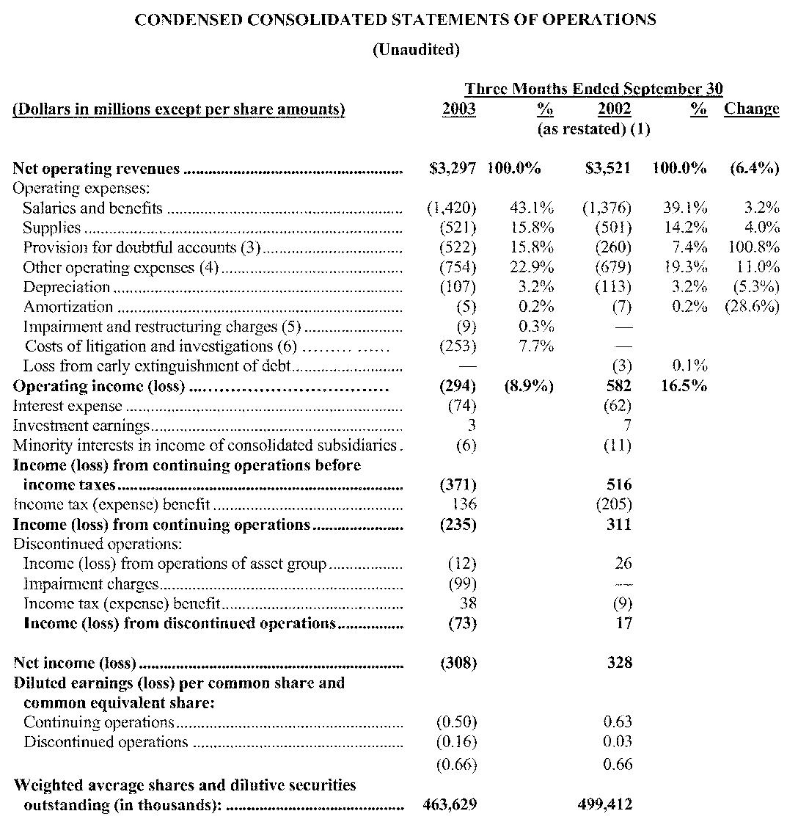
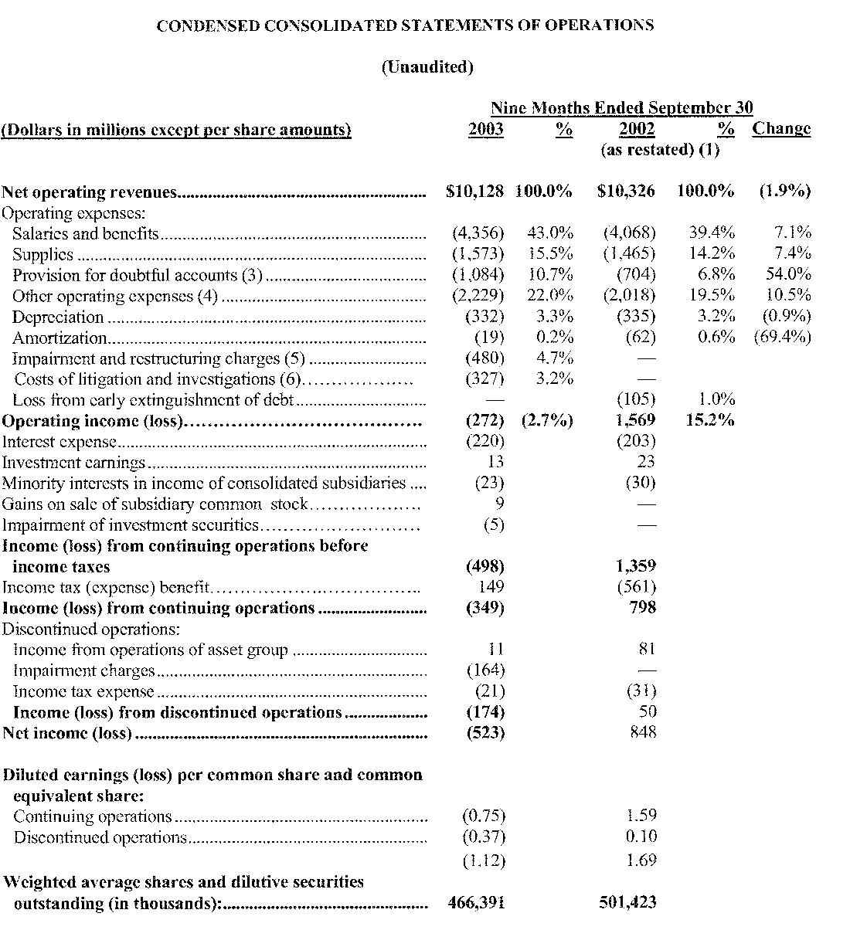
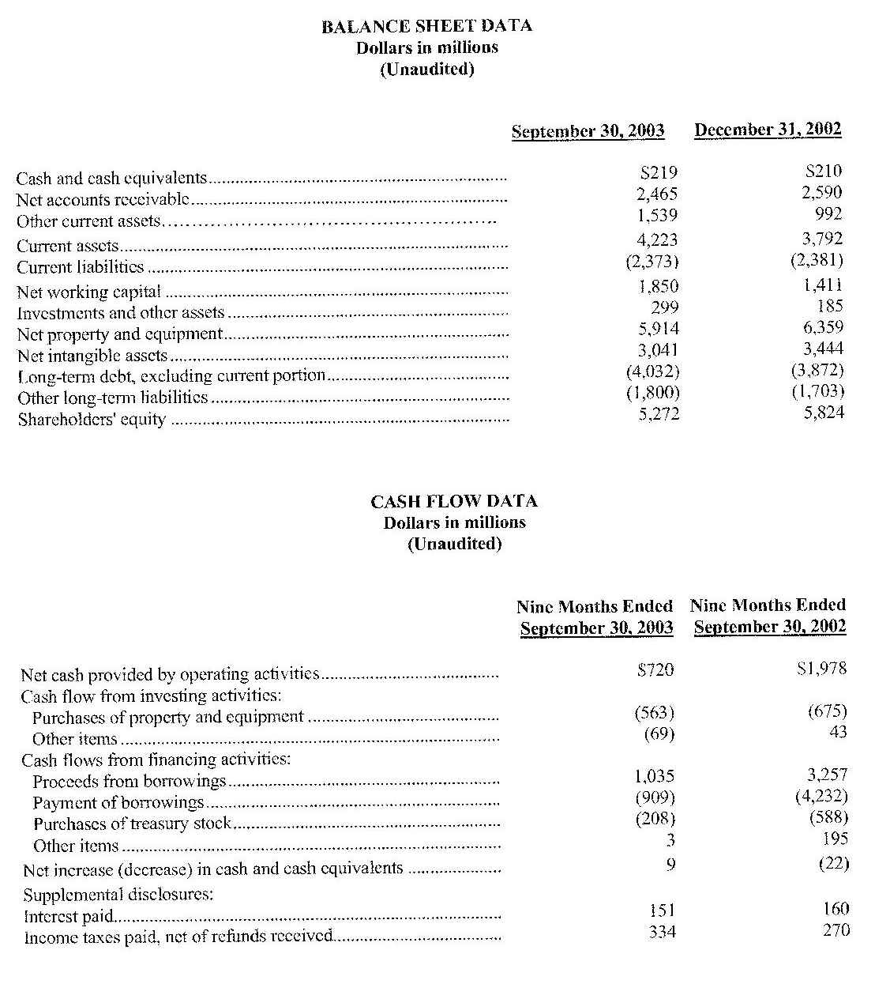
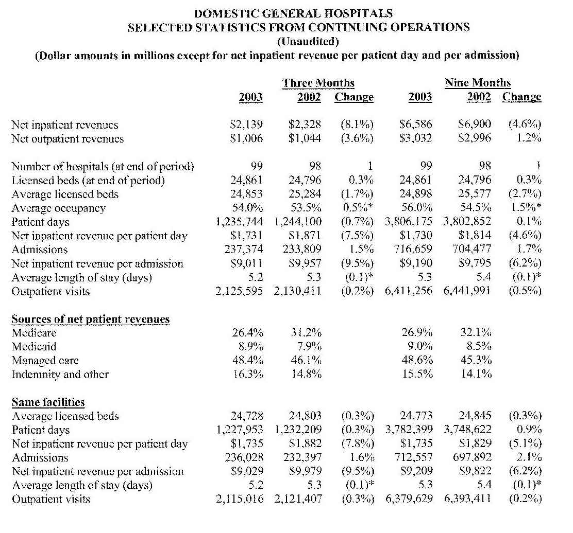
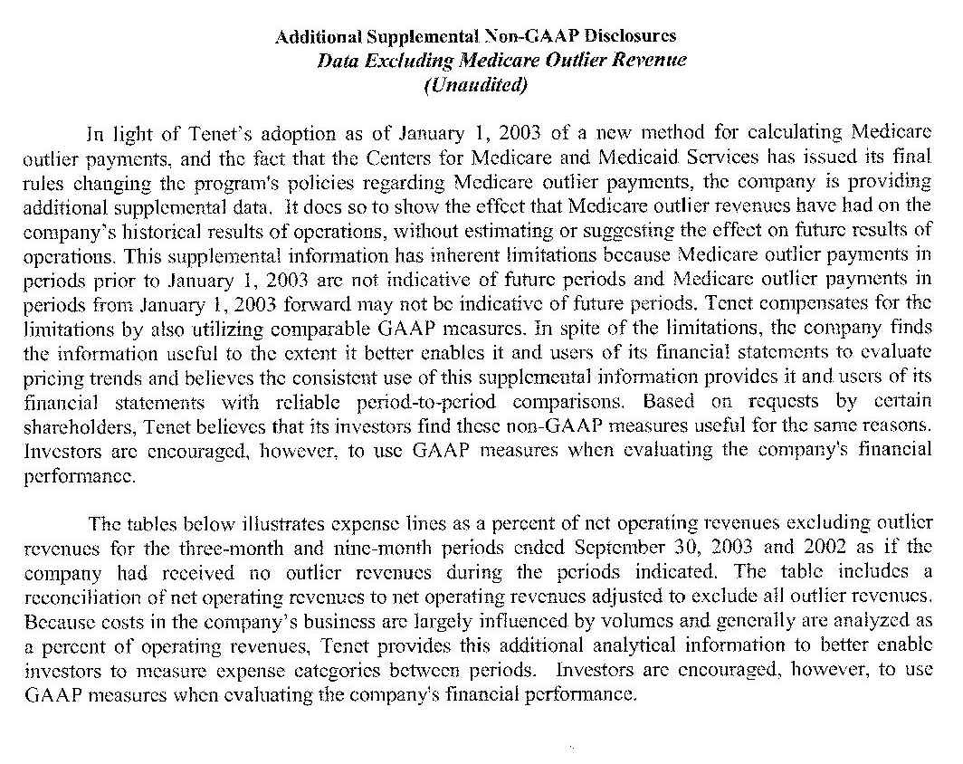
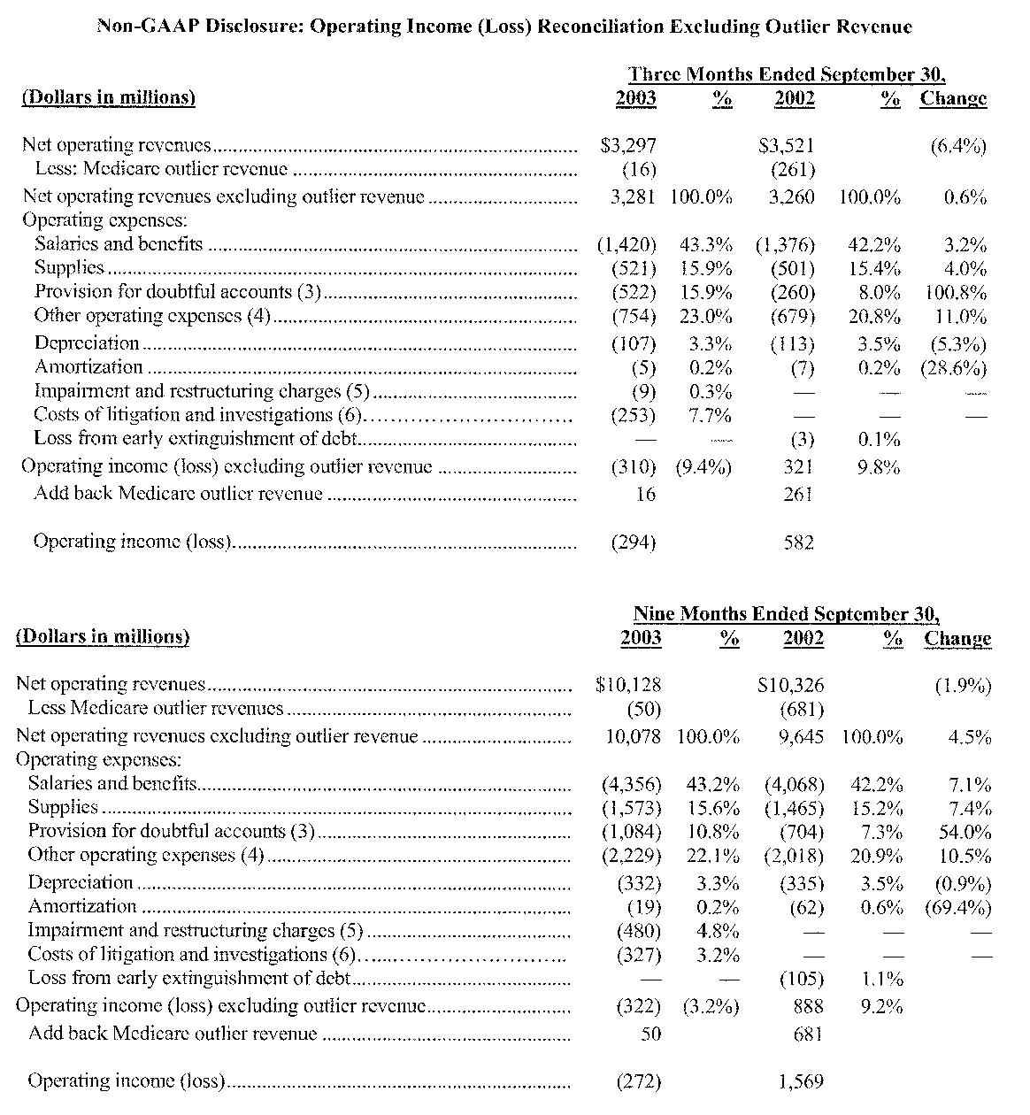
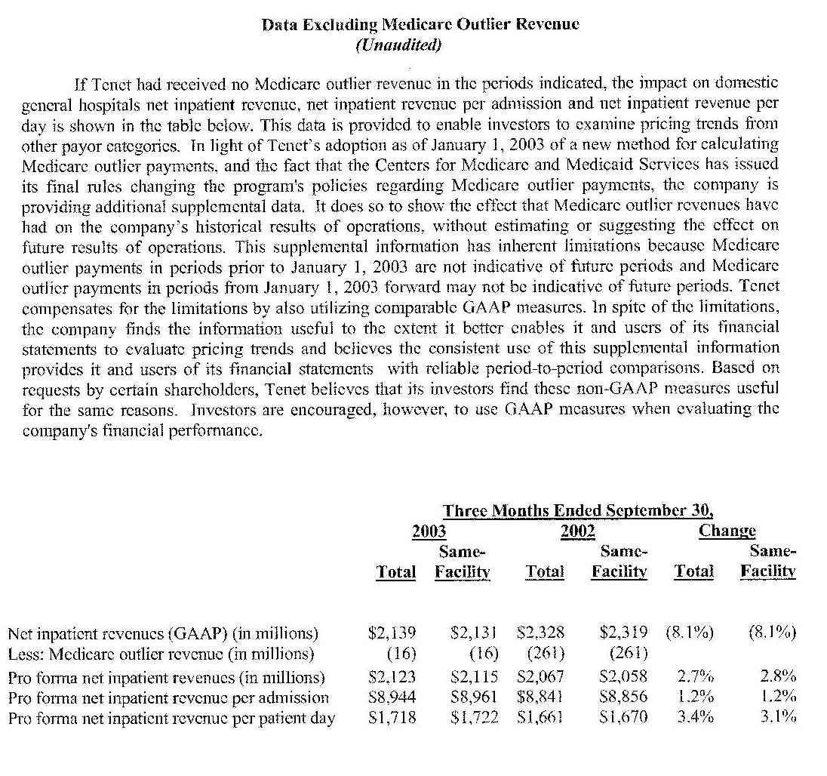
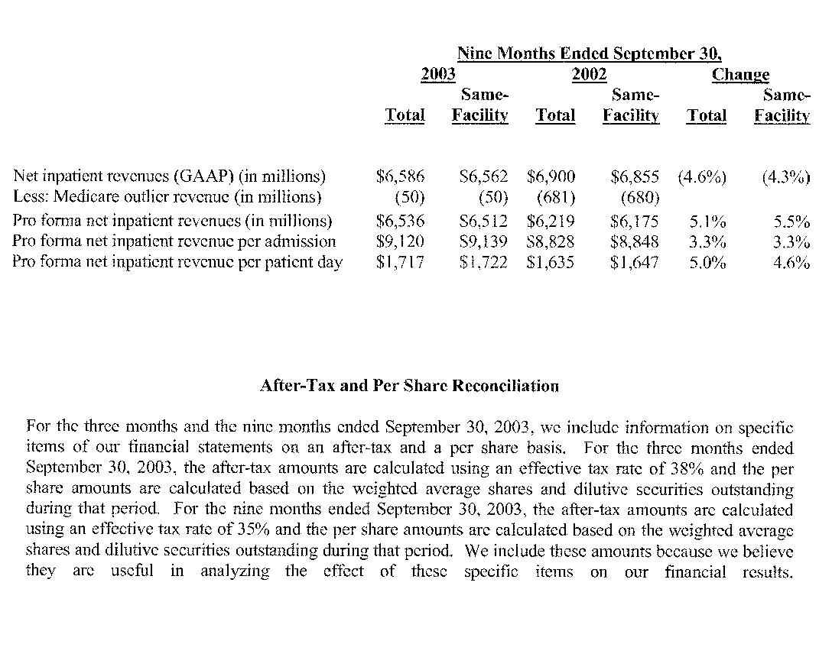
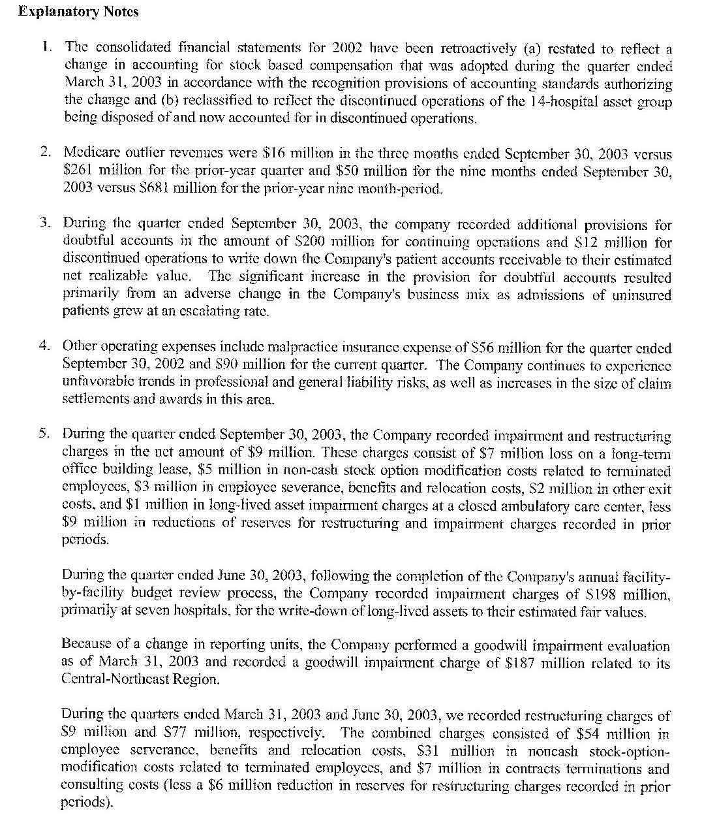
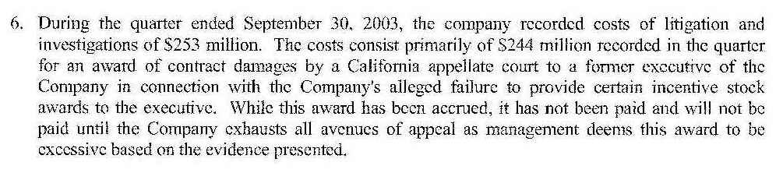

Appendix 7
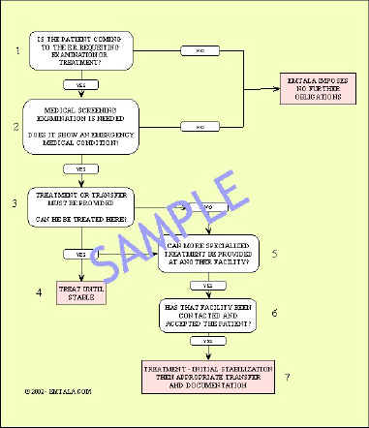
EMTALA Flow Chart

