Introductory WordPress Guide
MIS1305
G. Green

What is WordPress? 2
Login to your account 4
The Edublogs Interface 5
Admin Bar 5
Navigation Menu 6
Dashboard 6
Edit Profile 7
Settings 7
Appearance 8
Themes 8
Header 8
Background 9
Widgets 9
Content Items 10
Posts 10
Categories 11
Pages 11
Define a Static “Front Page” 12
Menus 13
Media 14
Links 17
Forms 18
Formatting Toolbar 20
Editing Modes 20
Standard Formatting Toolbar 20
Advanced Formatting Toolbar 20

What is WordPress?
WordPress is a tool that allows one to design a blog (i.e. web log) or an entire e-portfolio. Baylor University uses a WordPress-based blogging service which is hosted by Edublogs, a company that specializes in large-scale WordPress implementations for colleges and universities. This platform allows you to select themes, plug-ins, headers, and widgets to personalize your WordPress site.
A blog is a contraction of “web log”. Blogs can be started and maintained free of charge, or can by sponsored financially by the blogger, a university, a corporation, or a group. A blog allows everyone a chance to promote, research, write articles, build links (blogrolls), exchange ideas and best practices, and interact with others on personal, professional, corporate, political, and social issues and topics. The opening page is called the front page.
Blogs mainly consists of two items:
Pages | Posts
- designed for content that rarely changes  - do not have a timestamp  - Others don’t update  - Blogs/websites may have many pages  - cannot be assigned categories or tags | - designed for content that varies often  - have a timestamp; automatically arranged in reverse chronological order  - others can contribute content  - blogs have many posts but only one “post” page  - can be assigned categories or tags

blogs.baylor.edu/yourloginname
Developing your WordPress Site, go to:  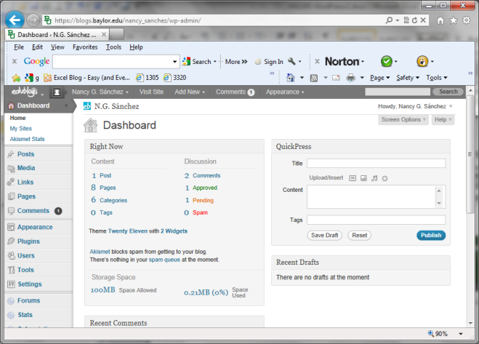  blogs.baylor.edu | Viewing your Wordpress Site, go to:  blogs.baylor.edu/yourloginname
Sample “Theme”
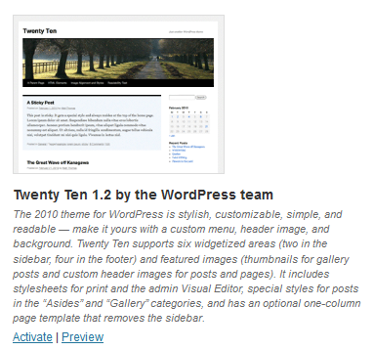
Sample “Page”
Menu
Header

Sidebar

Widgets:
- Search
- Text
- Calendar
- Categories
- Etc…
Content

Footer

Sample “Post”
Footer

Login to your account

- Steps
Note: Internet Explorer will issue the following: 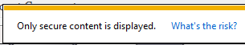

  - Open Firefox

    - go to blogs.baylor.edu

  - Select SITE LOGIN
    - Use your BearID and password

The Edublogs Interface

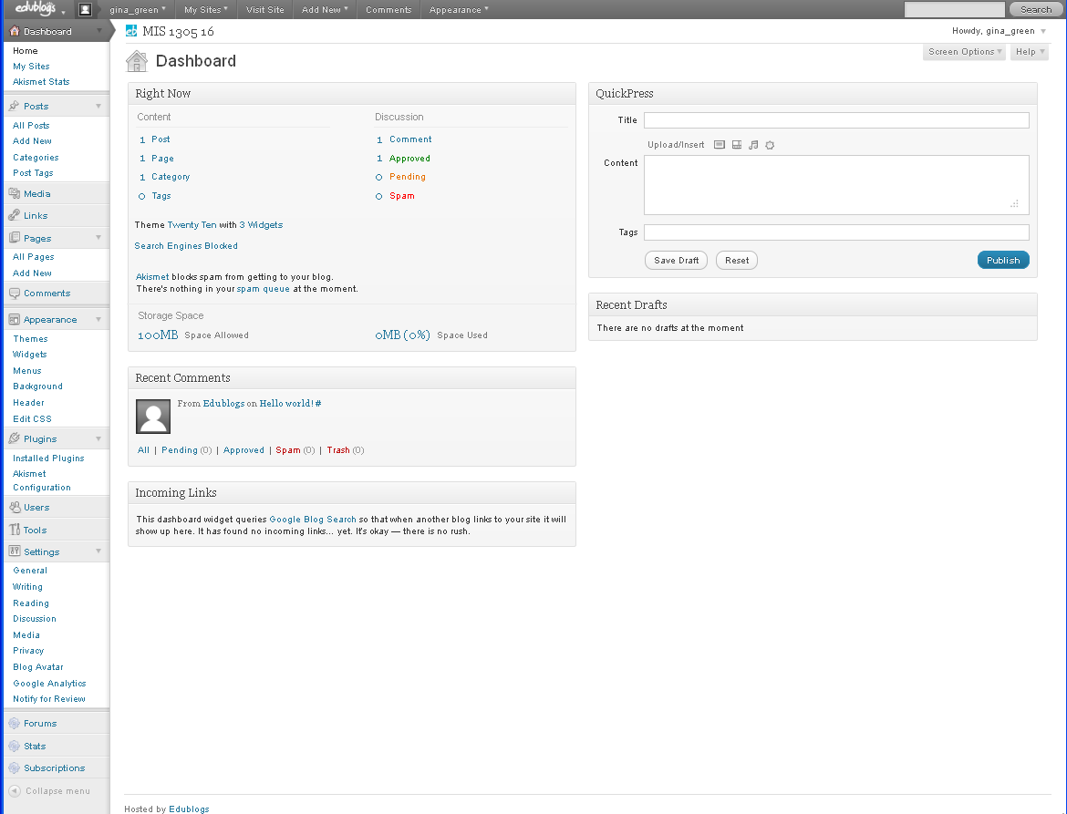

Admin Bar

- My Sites – click here to select the website you want to work with
- Current Site – click here to view the front page of your current website as it appears now
- (Comments) – view comments made to your site that require your moderation, and respond to them if you wish
- + New – use as a quick way to add a new Post, Page, Media, or Link
- Howdy, your name – used to Edit your profile, or Log out

Navigation Menu

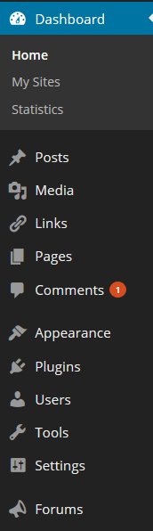 | Dashboard home  - returns you to the Dashboard  Content Items  - Posts  - Media  - Links  - Pages  - Comments  Site Management  - Appearance – themes, widgets, menus, background, header  - Plugins  - Users  - Tools  - Settings  Other features  - Forums  - Stats  - Subscriptions  - Inbox

Dashboard
A Dashboard is a behind-the-scene screen where you can adjust your Wordpress settings, view recent comments to your existing blog posts, and create new blog posts. When you log in to your blog/website, you get the Dashboard screen.
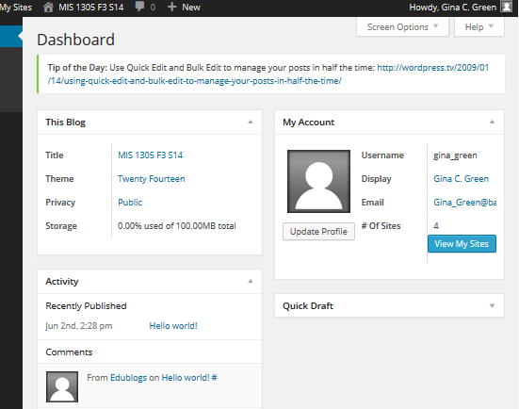
- This Blog module – overview of your website
- Activity module - most recent blog comments ; hover to respond to the comment
- My Account module – quick view of your Edublogs account/profile settings
- Customizing the Dashboard
  - Screen Options button – upper right corner; used to (de-)select Dashboard modules
  - Note: Each module can be: Moved, Collapsed/expanded

Edit Profile
Change your personal information (name, biographical info, contact info)
- Steps: Admin Bar | select your name | Edit My Profile
  - Update your information (if necessary)
    - First name & last name
    - Website - http://blogs.baylor.edu/yourusername
    - Biographical info
  - Change your password (if necessary)
  - Select “Update Profile”

Settings
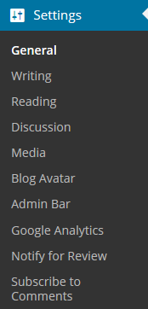
Change the blog/site’s settings
- Steps: Navigation Pane | Settings | ….

- General
- Site Title – add a descriptive title to your site
- Tagline – state the website’s purpose
- Email Address – your preferred email
- Time – time zone (Chicago is in our time zone)
- Select “Save Changes”!

- Writing - review & make your own choices
- Reading - review & make your own choices
- Discussion - review & make your own choices
- Privacy - review & make your own choices

Appearance
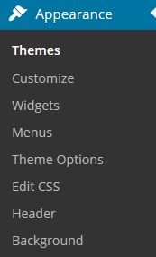
Change the appearance of the blog/site and add widgets/tools to your site for visitors
- Steps: Navigation Pane | Appearance | ….

Themes
Select a predesigned layout & appearance for your site. It’s a quick way to design a site.
- Most themes cannot be altered and are “use as is”.
- Almost all Edublogs themes include ability to make some changes:
  - Upload custom image headers
  - Add a background image
  - Display comments on pages
- Some themes have “Theme Options” that allow you to modify additional options.
- See http://theedublogger.com/2008/07/17/the-100-edublogs-themes-separated-into-categories-to-make-choosing-your-next-theme-easier/ for a categorization of Edublogs Wordpress themes.

- Steps:
  - Search Installed Themes
Our default Theme: “Twenty Fourteen”
We will change to the Theme: “Twenty Ten”

  - Preview the Theme

  - Activate the Theme

Header
A header is typically an image that is shown at the top of a site. You may use the theme’s default image (or upload a custom image). Note: If you upload your own image, pay attention to the size required by the theme. For example: for the theme “Twenty Ten“, the size of the header image is: 940 × 198 pixels. A list of header image sizes for many Wordpress themes is here: http://en.support.wordpress.com/themes/custom-header-image/.
- Steps:
- Select the header image
    - Use a single Default image (or select Random), or
    - Upload a single image or multiple images (and run Random)
      - Can design in PhotoShop or even PowerPoint (save as *.png)
    - Crop & Publish
- Save Changes!

Background
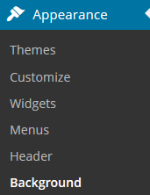
Select a background color or image. You can upload your own image and edit it as you like.
- Steps:
- Make changes by selecting either of the following options:
    - Select “Select a Color” to use the color picker, or
    - Select “Browse” to upload an image
- Save Changes!

Widgets
Customize the sidebar with visual, interactive tools that provide useful information to the reader.
Search widget | - allows your visitors to type in a keyword and then find information quickly on your blog site.
Text widget | - allows you to place any text (e.g. welcome message) on the sidebar. You may add more than one text widget on a side bar.
Calendar widget | - displays a calendar on the sidebar; you can access blog posts by date
Categories widget | - displays your posts by categories (i.e. major topics)
Tag Cloud widget | - displays your posts by tags (i.e. keywords)
Links widget | - displays URLs to the websites you choose in the Links item in your Dashboard. These can be personalized to your favorites.
- Google: blog widgets

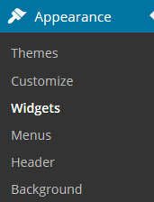
- Steps:
  - To activate a widget, drag the widget to the right side bar
  - To deactivate a widget, drag it left to either of the following areas:
    - “Available Widgets” –this area deletes the widget’s settings.
    - “Inactive widgets” – this area keeps the widget’s settings.
  - Save Changes!

Content Items

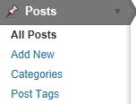
Posts
Write an entry to be published in your blog/site.
- Steps: Navigation Pane | Post | Add New
  - Enter a title
  - Type & format your content
  - Determine your Discussion settings for “Allow Comments” and “Allow trackbacks & pingbacks”
    - If these two options are not visible, click Screen Options and ensure the Discussion and Comments boxes are checked.
  - Pick your categories & tags. Note: You may add new categories in this window.
    - Categories chapters ; Tags keywords in an index
  - Preview or Publish!
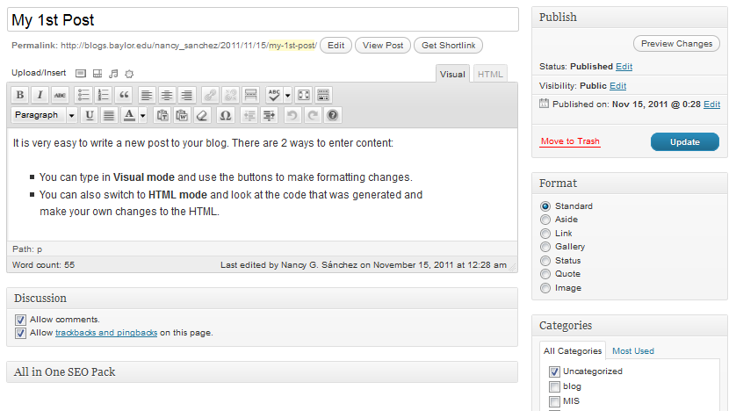
- Adding & Formatting Content
  - See the “Formatting Toolbar” section of this document

- Making Bulk Changes
  - Select more than one post
  - Change “Bulk Actions” to “Edit” (or “Move to Trash”)
  - Click “Apply” button!!
  - Make changes | Select “Update” button

Categories
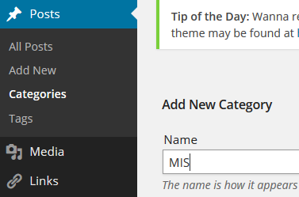
The “Category” feature is used to assign keywords to a Post.
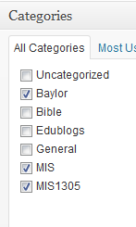
- Steps to create a new Category:
  - Navigation Pane | Posts | Categories

  - Type the category name | select “Add New Category” button

  - Now, you can open a Post and add assign it to specific categories.
  - Also, you should add the “Categories” Widget so the user can select a Category to view.
Note: Post summaries viewed through category links will always be clean and stripped of inline styles.

Pages
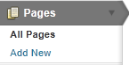
Design a page that contains content that will rarely change.
- Steps: Navigation Pane | Page | Add New
  - Enter a title
  - Type & format your content
  - Determine your Discussion setting for “Allow Comments” and “Allow trackbacks & pingbacks”
    - If these two options are not visible, click Screen Options
    - FOR THIS CLASS you should UNCHECK the Discussion and Comments boxes for all web Pages
  - Preview or Publish!

Define a Static “Front Page”
Your front page may be either a dynamic page containing a list of all of your latest posts OR a static page containing information that rarely changes (e.g. introducing your site).
- For this class, we will use a “Static Front Page”
- Steps:
  - Make sure you have created your front page, typically called “Home”

  - Make sure you have created a blank page to hold all of your posts. Sample names include “Blog” or “Posts”.

  - Define your pages:
  - Navigation Pane | Settings | Reading
  - Set the “Front page displays” settings
    - Select “A static page”
    - Set Front Page: Home (assuming this is the name of your front page)
    - Set Posts page: Blog (assuming this is the name of your blank page)
    - Save Changes!
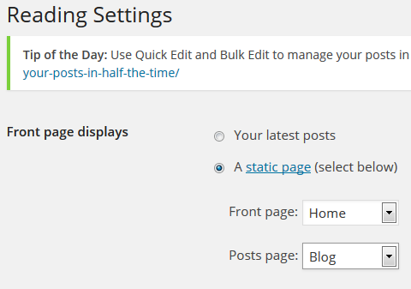

Menus
Create your own Custom Menu by adding menu items to the menu bar. It gives users quick access to your content.
Note: Ensure you previously created a few Content Items before creating a menu.
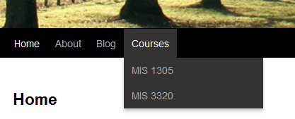
- Menu items may be:
  - Pages static pages
  - The “Posts page” a single page displaying all posts
  - Categories of posts display all posts in a category
  - Custom Links to specific websites displays any urls that you specify
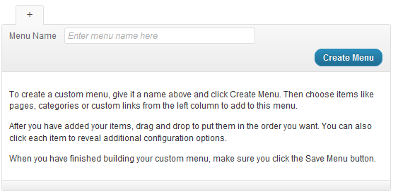

- Steps:
  - If the Menu Window is grayed out: type a new Menu Name: Main Menu | click “Create Menu”.

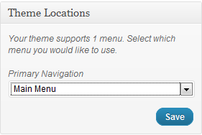
  - On the left pane, set your “Primary Navigation” to Main Menu | click “Save”

  - Add items to the Menu bar
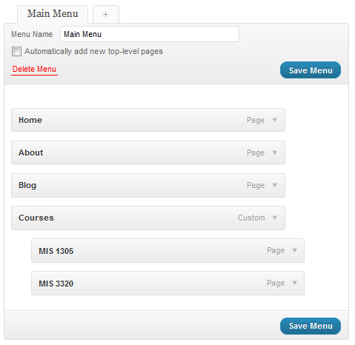
    - Select any Pages you want to include | click “Add to Menu”
    - May add any Custom Links (i.e. web addresses) to any external pages you want to include
    - May also add Categories this will create an item that displays all posts in that category.

  - To create a submenu, demote a menu item by dragging the item to the right until it is indented

  - Tip: The Course item below was created via a custom link with a real url because it will require one. However, once I added it, I then removed the url so that it wouldn’t actually do anything when it’s clicked.

Media
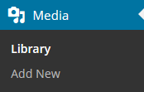
Create a media library by uploading your files (e.g. images, video, audio, documents, etc.) to edublogs.

Uploading Items to the Media Library
- Navigation Pane | Media | Add New
- “Select Files” button
- Locate media files on your computer to upload; Open
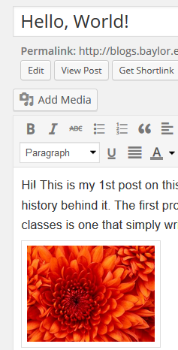

Inserting Individual Media Items on a Page or Post
Inserting media items individually allows you to control the placement of media items on the page/post.
- Open a Post or Page
- Click “Add Media” button
- Select appropriate tab--select “Media Library” tab if you previously stored your media item in the library; otherwise select “Upload Files”
- Select the media item that you want to use by clicking and ensuring the check mark appears
- Change settings on right-hand side (title, alignment, alternate text, etc)
  - If you want text wrapping, select an Alignment option
- Click “Insert into Post” (or page) button

Inserting Multiple Media Items: Gallery
Galleries are one or more media items inserted and organized into a Page or Post. There is one gallery of media items per page/post. NOTE: Creating multiple galleries requires a plug-in that is available via Wordpress but not in eduBlogs.
- Open a Post or Page
- Position cursor where you want to place multiple pictures
- Click the “Add Media” button
- Click the “Create Gallery” button
- Choose existing images from the Media Library OR go to the Upload Files tab to either drag and drop files from your computer into the box, or to click the Select Files button to locate files to upload.
- Ensure the images you want in the gallery are selected via check marks; if they are not selected, click on the images to select/check them
- When done choosing all images, click the Create a new Gallery button
- Modify any Gallery Settings as desired
- Click the “Insert gallery” button
Creating a Slide Show
- Go to Plugins, then “All” and ensure the Slideshow Gallery plugin is activated (i.e., checked)
- Go to Slideshow in the Navigation area, then Manage Slides
- Click Add New to add a picture to your slide show
- Fill in a Title (e.g., Galveston Beach) and a Description (e.g., 2013 Vacation) of the picture
- Click the Browse… button and upload the picture file
- Click Save Slide
- Repeat above steps for each picture you want to add to the slideshow.
- On the webpage that you want the slideshow to appear on, click on the Insert a Slideshow icon on the Visual tab in the position you want the slideshow to appear; choose Custom Added Slides, then click Insert (or OK).
- Save your webpage and view it.

Adding Audio or Video
NOTE: Uploading video into edublogs requires that your video be less than 10mb in size.
- Open a Post or Page
- Position cursor where you want to place the audio clip
- Click the “Add Media” button
- If you have not already uploaded the audio file to Wordpress,
  - click the Upload Files tab
  - Drag and drop files from your computer into the box, OR click the Select Files button to locate files to upload
- On the Media Library tab, click on the audio file you want to be played on your webpage and ensure the check mark appears.
- On the right-hand side, set details as appropriate. I suggest leaving the default “Embed Media Player” in the Attachment Display Settings Embed or Link box.
- Click the Insert into page button. By default, the audio must be manually started, and the audio will not loop. To change these settings, update the HTML:
  - To autoplay, add autoplay=”on” after the file name portion of the audio tag
  - To loop the audio, add loop=”on” after the file name portion of the audio tag

Adding Audio Playlist (one or more audio files in same position)
- Open a Post or Page
- Position cursor where you want to place the audio clip
- Click the “Add Media” button
- Click the Create Audio Playlist link
- If you have not already uploaded the audio file to Wordpress,
  - click the Upload Files tab
  - Drag and drop files from your computer into the box, OR click the Select Files button to locate files to upload
- On the Media Library tab, click on the audio file you want to be played on your webpage and ensure the check mark appears.
- On the right-hand side, set details as appropriate. I suggest leaving the default “Embed Media Player” in the Attachment Display Settings Embed or Link box.
- Click the “Add to audio playlist” button. By default, the audio must be manually started, and the audio will not loop. To change these settings, update the HTML:
  - To autoplay, add autoplay=”on” after the file name portion of the audio tag
  - To loop the audio, add loop=”on” after the file name portion of the audio tag

Adding YouTube Video
- Go to YouTube and locate the video you want to place on your page
  - Click the Share link
  - Click the Embed link
  - Copy the HTML code that is displayed
- Open your Wordpress Post or Page in HTML view
- Position cursor where you want to place the video clip
- Paste the HTML code that you copied from YouTube

Adding Video from your Own Web-Accessible Storage (using Box as an example)
- Go to Box and locate the video you want to place on your page
  - Click on the Share link
  - Click the Embed option
  - Copy the HTML code that is displayed
- Open your Wordpress Post or Page in HTML view
- Position cursor where you want to place the video clip
- Paste the HTML code that you copied from Box

Links
Used to add external links to your site. The links are automatically displayed in your blogroll, a list of links in your sidebar.
- Type the link name
- Enter the web address (don’t forget the http://)
- Set the Target option
  - may need to scroll down to find it
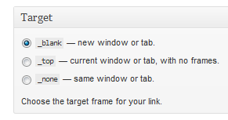

- If you do not want the link to be visible to users, be sure to check “Keep this link private”
- After creating links, you can add the “Links” Widget (aka…blogroll) so users can see and select your non-private links to view.

Order of Links
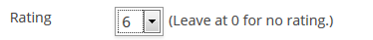
There is a 2-step process to change the order of your links.
- Edit each Link. Scroll to the bottom and change the “Rating” option. If you have 6 pages and you want your favorite link on top, make it a 6. The 2nd favorite one should be set to a 5, and so on.

- Open the Links Widget. Change the “Sort By” option from “Link Title” to “Link Rating”.
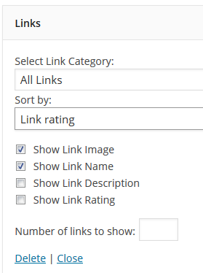

Forms
Used to receive structured user data.
- Go to Plugins | Installed Plugins | Click Activate link for the Formidable plugin
- In Navigation area go to Formidable | Forms | Add New
- Choose a Pre-Built form as a starter if desired and click Create, OR Create a Blank Form

- Edit the form as desired, then click Create
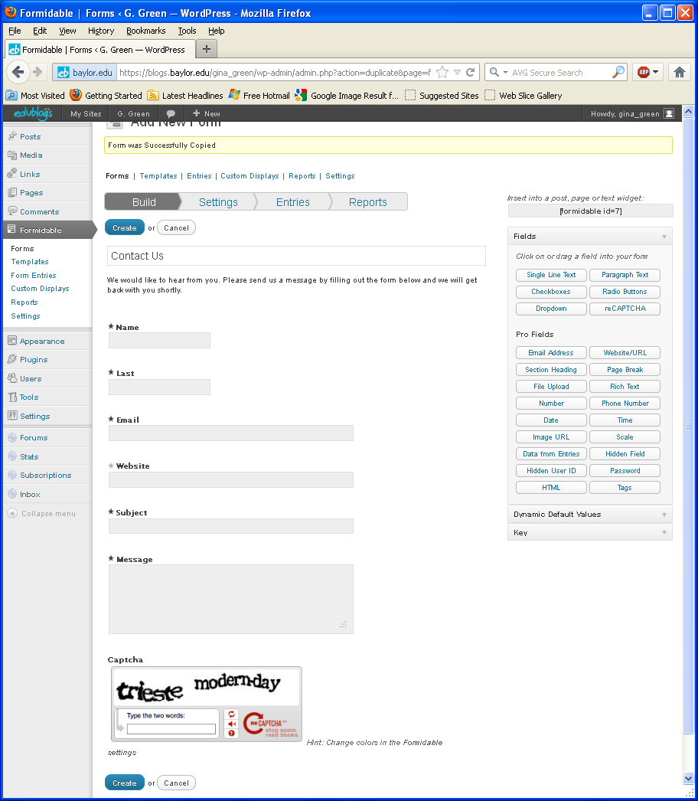

- After the form is created, Add a New Page to the website which will contain your form. Click on the Add Formidable Form icon.

- Click on the dropdown to select the form you created. You may also want to check the Display form description box. Click the Insert Form button. This will place a link to the form on the webpage.
- Before publishing the page, be sure to Uncheck the Allow Comments and Allow trackbacks and pingbacks boxes.

- Be sure to add this new page to your Menu.
To view form submissions, go to Formidable | Form Entries | Reports | Go | Entries. You should also be notified via email of submissions.

Formatting Toolbar

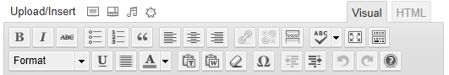

Editing Modes
- Visual Editing mode - uses WYSIWYG (What You See Is What You Get)
  - Highlight the text you want to format, then click appropriate button
- Text (i.e. HTML) mode – change the HTML code or add your own

Standard Formatting Toolbar
- Kitchen Sink button – show/hide; last button on top, right – displays the Advanced toolbar
- Bold, italics, strikethrough
- Lists – ordered & unordered
- Blockquote
- Alignment buttons
- Link or Un-link
- Toggle Full Screen Mode

Advanced Formatting Toolbar
- Format – Paragraph, H1, H2, etc.
- Underline
- Align full
- Select Text Color
  - Tip: If you apply a color change to text but it doesn’t seem to have applied the change, save your change and check out the actual page in the browser. It should have made that change.
- Paste as Plain Text
- Paste from Word
- Remove Formatting
- Insert Custom Character
- Indent, Outdent buttons
- Undo (Ctrl+Z), Redo (Ctrl+Y)
- Help

