MS Excel 2013 Outline

Basics
What is a Spreadsheet? What is Excel?

Excel Interface (label the objects)

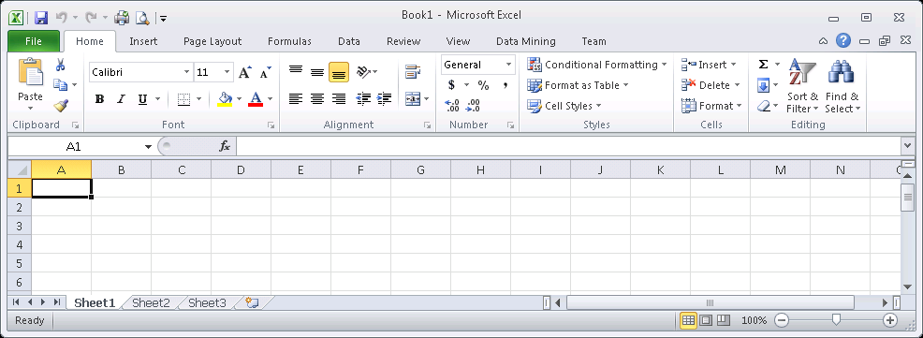

- File tab
  - Print
  - Excel Options
- Workbook
- Help
- Ribbon Tabs Groups Icons (Command Buttons)
- Name Box
- Formula Bar
- Select All Button
- Active Cell
- Worksheet (Move, rename, color tab)
- New Worksheet
- Views (Normal, page layout, page break)
- Zoom Controls
- Shortcut menu
- Contextual Tabs (not shown)

Example 1 (“Intro” worksheet)
Spreadsheet Components
- Cell
- Active Cell
- Cell Referencing
- Cell Range
  - Adjacent
  - Non-adjacent
  - Moving
- Columns/Rows
  - Adjusting
    - Manually
    - Double-Click
    - Specifically
  - Hiding
  - Adding / Deleting

Cell Contents (4 types)
- number
- text
- date
- formula (and formula view)

Other features
- Named Range
- Right-Clicking
- Cell size too small

Example 2 (“AutoFill” worksheet)

Copy & Paste options

AutoFill
- Using the Fill Handle
  - Drag/Drop
  - Copy+Double-click to fill all the way to end of column (must have info in at least one column)
- Numbers, Text, Ordinal Positions
- Dates, Months, Days of Week

Printing
- Worksheet
- Workbook

Example 3 (“Common PC Shortcuts” worksheet)
Select All

Save
Cut
Copy
Paste
Bold
Italics
Find/Search
Display Formulas
Display Print Menu

MS Excel 2013 Outline

Formatting

Example 1 (“Formatting” worksheet)
Home Tab
- Select All | Resize Columns
- Select All | Resize Rows
- Borders
- Fill Color
- Orientation – rotate
- Alignment – horizontal & vertical
- Merge & Center – each line
- Comma Style & Decimals
- Format Painter
- Conditional Formatting
- Wrap Text (or Alt-Enter)

Review Tab

Comments

View Tab (screen options)
- Freeze Panes
- Split worksheet
- Gridlines

Page Layout Tab (printout options)
- Page Setup Group| Page Setup dialog |Sheet Tab| Print | Gridlines
-OR- Sheet Options Group | Gridlines view and/or print
- Page Setup Group | Print Titles | Sheet Tab | Row & Column Headings
-OR- sheet options group | Headings view and/or print
- Page Setup Group | Print Titles | Sheet Tab | Rows to repeat at top or columns at left
-OR- Page Setup group | Print Titles | …
- Page Setup Group | Breaks | Insert Page Break
- Margins Tab

Insert Tab
- Header & Footer
MIS 1305 Excel
insert file: | insert sheet

  - Special codes: File Name, Sheet Name, Date, Time

Example 2 (“NumberFormats” worksheet)

Home tab
- Clearing a Cell editing group
- Format as Table styles group
- Currency Formats: number group
  - Accounting style
  - Currency style
- Date Formats: number group
  - Short
  - Long
  - Custom
- Data Bars styles group, conditional formatting

Example 3 (“Sorting” worksheet)

Data Tab (also on Home tab, Editing group)
- Sort Order
  - Ascending
  - Descending
- Sort Fields
  - Single-field Sort
  - Multi-field Sort

Example 4 (“You Do It_Formatting” worksheet) – optional but strongly recommended
Partial Example of desired look when printed (footer not shown):

MS Excel 2013 Outline

Formulas & Functions

- If, Lookup Functions
- Linear & Growth Trends
- Loan & Investment Functions

Example 1 (“Formulas” worksheet)

Formulas
- Basic formulas

- Complex formulas
  - Order of Precedence: ( ), ^, *, /, +, -, Left-to-right

- Formula View
  - Show Formulas
  - Shortcut

#1 Rule:

Example 2 (“Basic Functions” worksheet)

Basic Statistical Functions
- SUM
  - AutoSum
  - SUM, and Bad examples
- AVERAGE
- MEDIAN
- MIN & MAX
- ROUND
- COUNT
- COUNTA
- COUNTIF
- Nested Functions

Example 3 (“Dates” worksheet)

Basic Date Functions
- TODAY
- NOW
- YEAR
- MONTH
- DAY
- WEEKDAY
- Calculations with Dates

Example 4 (“RelativeRef”, “AbsoluteRef”, and “RunningSum” worksheets)

Types of Referencing
- Relative Reference

- Absolute Reference

- Mixed Reference

Example 5 (“IF1” and “IF2” worksheets)

Logical Functions
- IF

=IF(logical_test, [value_if_true], [value_if_false])

- Nested IF

  - =IF(logical_test, [value_if_test_true], IF(logical_test2, [value_if_test2_true], [value_if_test2_false]) )

Example 6 (“Lookup” worksheet)

Lookup Functions

- =VLOOKUP(lookup_value, table_array, column_index_number, [range_lookup])
Lookup_value

Table_array

Column_index_number

Range_lookup

- =HLOOKUP(lookup_value, table_array, row_index_number, [range_lookup])

Row_index_number

Example 7 (“Errors” worksheet)
Handling Errors

- IFERROR

  - =IFERROR( expression, value_if_expression_generates_error)

Example 8 (“PMT” and “PPMT&IPMT” worksheets)

Basic Financial Functions
- Formulas tab | Insert Function
- Amortization Schedule
- PMT
- PPMT
- IPMT

=PMT (rate, nper, pv, fv, type)

Rate

Nper

PV

FV

Type

=PPMT (rate, per, nper, pv, fv, type)

=IPMT (rate, per, nper, pv, fv, type)

Per

Example 9 (“Fill Growth Series” worksheet)

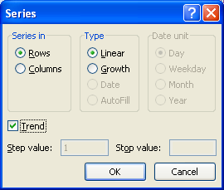
Projecting Future Values
- Linear (constant amount) and Growth (constant percentage) Trends
- Uses Autofill to fill in series of values
  - First specify (i.e., highlight) desired starting and ending values
  - Home | Editing | Fill | Series…

MS Excel 2013 Outline

Charts

Chart Terminology (label the objects)
- Chart Area, Plot Area
- Category Axis, Value Axis
- Data Marker, Data Series
- Tick Marks, Gridlines (NOT SHOWN)
- Titles: Chart, Category, Value
- Labels: Category, Value, Data
- Legend

Common Chart Types

*Column Chart
- Stacked Column Chart
- Line Chart
- * Pie Charts

*we’re doing these

Creating a Chart
- Identifying the Chart Data

- Select a Chart Type
  - Column
  - Pie

- Layout Tab
  - Legend
  - Data Labels
  - Format Selected Objects
    - Slice “Explosion”
    - Fill Color, …
  - Chart Title
  - Axis Titles
  - Change Units
    - Layout Tab | Axes group | Primary Vertical Axis | Show Axis in Hundreds
  - Gridlines
  - Walls
  - Data Table
  - Chart Rotation
  - Chart Name

- Design Tab
  - Selecting/Editing Chart Data
  - Name Chart object
  - Move Chart
  - Modify Chart Style
  - Switch Row & Column

- Format Tab
  - Shape Styles
    - Fill
- Outline
  - Chart Size

- Can copy Charts to other Office products

MS Excel 2013 Outline

Tables & Pivot Tables

Example 1 (“Subtotals” worksheet)

Subtotals
- Must first Sort the data

- Data Tab | Outline group| Subtotal icon

- Level / Detail Buttons

- Data Tab | Outline | Subtotal | Remove All

Example 2 (“Filters” worksheet)

Filter
- Filter on :
  - exact values
  - range
- Custom Filter
- Combining Filters

Example 3 (“Tables” worksheet)

Tables
- Insert Tab | Tables group | Table icon
- Can have more than 1 table on a worksheet
- Table has Name, Records, Fields
  - Rename Table (Design tab | Properties | Table Name)
- Totals Row (Table Design tab; check Totals Row box)
- Formatting Table (Table Tools Design | Table Style Options)
- Add/Delete Records
- Splitting Table
- Benefits of tables
  - Adds AutoFilter for each Field
  - Makes the Table Contextual Tab available
  - Auto formatting
  - Totals row
  - Table Analysis tools (requires add-in), etc…
- Removing Table Object (Design tab | Tools | Convert to Range)

Example 4 (“Pivot Tables” worksheet)

Pivot Tables
- Create Pivot Table
  - Insert Tab | Tables group| PivotTable icon
- Set up the Pivot Table report
  - Choose Row and Column Labels
  - Choose Values
  - Optional: Report Filter
- Select the Function
- Format Numbers
- Slicer
  - Add: Options tab | Sort & Filter | Insert Slicer
- One for each field selected
  - Remove: right-click and choose Remove “slicer_name”
- Format Pivot Table
  - Styles: Design tab | PivotTable Styles | choose Pivot Style
  - Layout: Design tab | Layout | Report Layout
- Show in Compact Form
- Show in Tabular Form
- Refresh the data as needed
  - Options | Refresh

MS Excel 2013 Outline

Multiple Worksheets & Workbooks

Linking to a Cell…
- On Another Worksheet
worksheetname!cellreference

- On Another Workbook
‘[filename]worksheet’!cellreference

