MS Access 2013 Outline

Databases

Tables
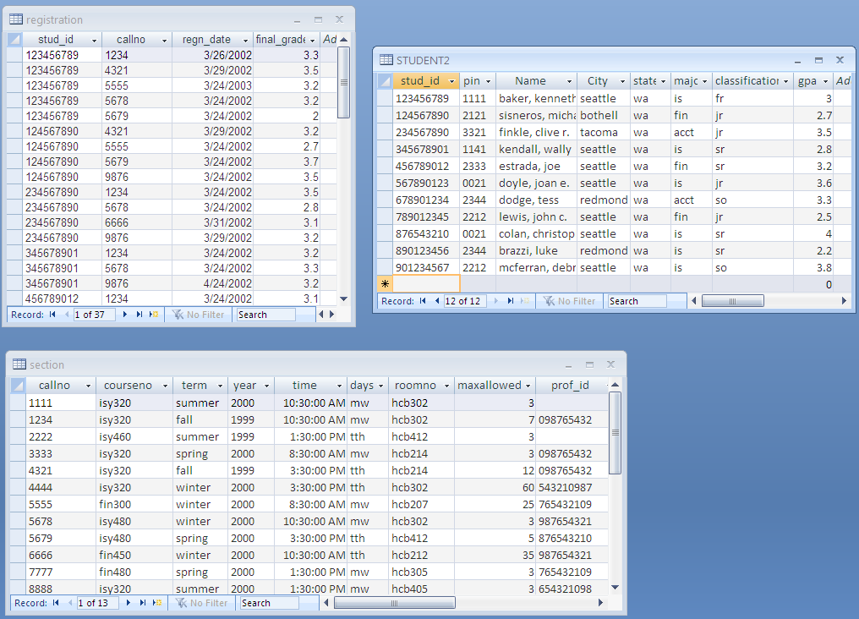
Data vs. Information
Spreadsheet vs. Database

Relational Database Management Systems (RDBMS)
- DBMS
  - Software that permits an organization to centralize data, manage it efficiently, and have shared access to stored data

- Database
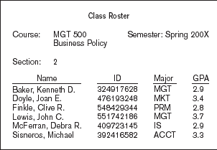
- Collection of data centrally organized in storage to serve many applications efficiently

- Relational Model
- Database is a collection of related tables
- Tables consist of related records
- Records consist of related fields; represents all information about one object/thing
- Field is a characteristic of an object that is of interest
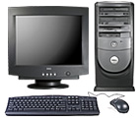
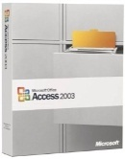
  - Primary Key field uniquely identifies each record in a table
Database
User
Employee DB
NFL DB
Orders DB, Registration DB, …
Student Registration DB
etc…
  - Atomic vs. Composite/Concatenated

- Example: NFL Database
  - What objects would we need to collect information about?
  - What data would we want to collect and/or analyze about each object?
  - Are any of the objects related?
MS Access
- Desktop RDBMS
- Graphical User Interface
- Part of Office suite
- Can “access” data in other RDBMS’s:
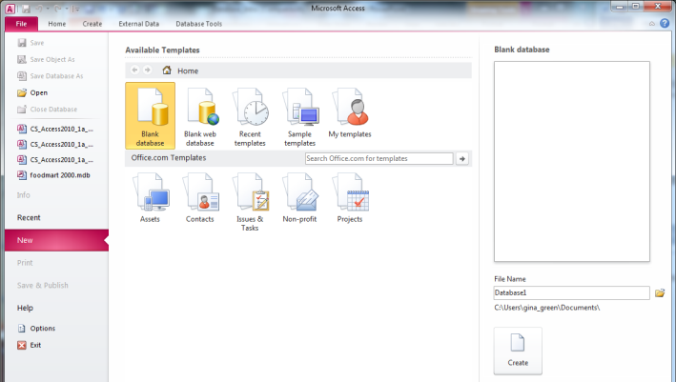
  - MS SQL Server
Click here to create the db
Previously-opened db's will be listed here
Click on folder; Save db to mis1305_
access folder
Change file name to mis1305.accdb
  - Oracle
  - MySQL …
- Objects
  - Tables
  - Forms
  - Queries
  - Reports

Creating a Database
- Accdb vs Mdb
- Compact and Repair

Creating Tables (Design View)
- Name

- Fields with Data Types, Lengths
- Text
Title | Type | Rating | Stars | MovieID | Co. | Year
The Untouchables | Action | PG13 | 3.5 | 1011 | MGM | 1991
Far and Away | Drama | PG | 3 | 1212 | PMT | 1991
Lion King | Family | G | 2.75 | 1411 | DIS | 1993
Twister | Action | PG | 3.5 | 2321 | PMT | 1995
- Memo
- Number
- Date/Time
- Currency
- AutoNumber
- Yes/No
- OLE Object
Maintaining Tables (Datasheet view)
- Enter data records
- Deleting rows of data
- Filter data
- Sort data
- Formatting table
- Adjust column widths
  - Drag
  - Specify Field Width

Relating Tables (Table Tools Design or Tables tab)
- Shows that objects have something in common
- Allows us to examine data spread across multiple tables
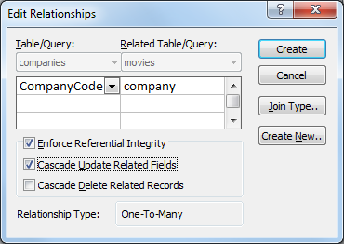
- Requires a Primary Key (PK) and Foreign Key (FK)
- Example: Movies and Companies
  - Ensure related tables closed
  - Create new table: Companies
    - Create tab | Tables group | Table button
  - Fields: CompanyCode; Name; DateStarted; CEO
  - Enter data for DIS, MGM, and PMT
  - Relate Movies table to Companies table
    - Close tables first
    - Database Tools | Relationships group | Relationships button
    - Drag common column from one table to the related table
    - Set PK and FK appropriately
      - CompanyCode = PK in the Table/Query
      - Company = FK in the Related Table/Query
Printing Tables
- Two options
  - Open table in datasheet view; File tab | Print | Print (preview)

  - Open table in datasheet view; Select All button | Copy | Paste into Word

Importing Tables
- Can use data that resides outside of Access from within Access
- Import
- Link
- External Data tab | Import & Link group | click appropriate button corresponding to format of source data

MS Access 2013 Outline

Queries
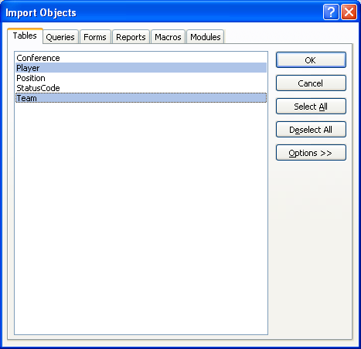
Import an existing table into our database
- Open your existing MIS1305 database

- Click External data tab | Import & Link group | Access icon

- Browse to the nfl(2009).accdb database you saved to the desktop; ensure Import tables… is selected; click OK

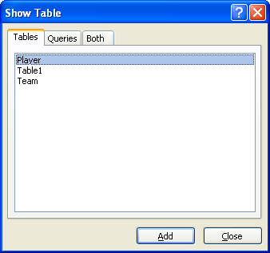
- Select the “Player” and “Team” tables (click 1st table then hold the Ctrl key to highlight 2nd table); OK; Close

Create a new Query
- Start in Design View
- Query Design Grid
- Steps
- Select the Tables involved
- Select the Fields
- Specify which Records you want
- Specify Sort options, if any
- Hide fields that you don’t want to see in the result
- Run (execute) the Query; puts you in Datasheet View
- Save the query

Operators
- Typical Mathematical Operators: = > < >= <= <>
- IN
- LIKE
- BETWEEN
- AND
- OR
- IS NULL
- NOT

Customize Queries
- Parameter queries
- Rename query columns
- Calculated Fields, Expressions
- Top Values query
- Unique Values query (NOTE: SAM will require setting Unique Values property)

Sorting Query Results

Text in Queries
- Use single OR double quotes (NOTE: SAM will require double quotes)
- e.g., =’mnv’ (or =”mnv”)

Dates in Queries
- Format is #mm/dd/yyyy#

Editing the Query
- Move fields
- Delete fields
- Rename the query

Totals Button (Σ)
- Total line:
  - Aggregate Functions
    - SUM, AVG, MIN, MAX, COUNT works the same as in excel
  - Group By
Crosstab (like Pivot Table)
- Row heading (can have multiple)
- Column heading (can only have one)
- Value (can only have one)

Multi-Table Queries
- Data for query spread across two or more tables
- Tables typically related
- Ensure related tables “connected” on common fields
- Can set “join properties” to modify records that are displayed
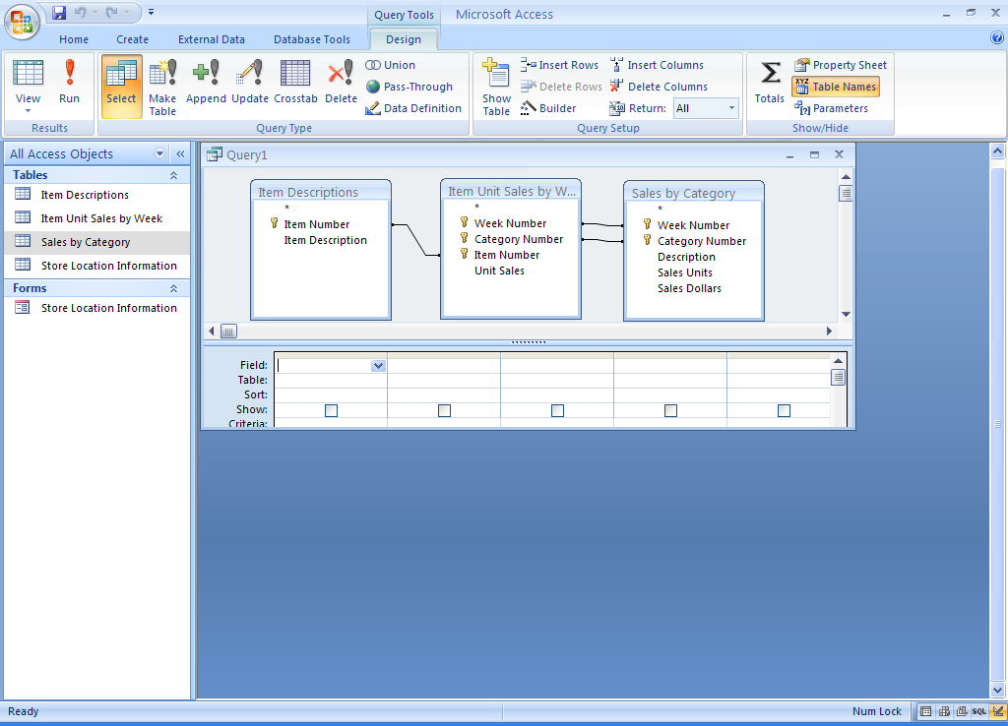

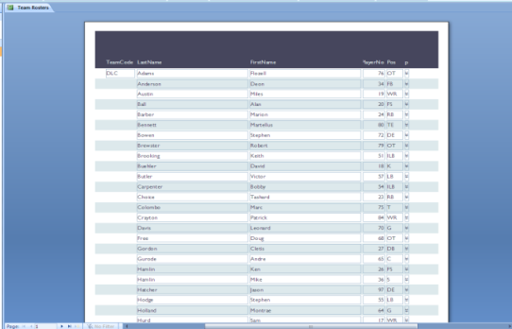
MS Access 2013 Outline

Reports

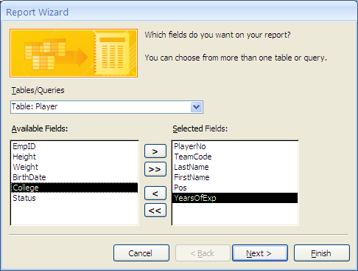
Create a Report
- Create Tab | Report Wizard and select the following:
  - Table Name or Query
  - Fields
  - Grouping
  - Sorting
  - Layout style
  - Orientation
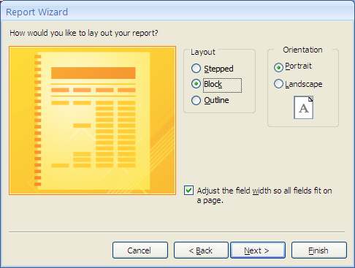
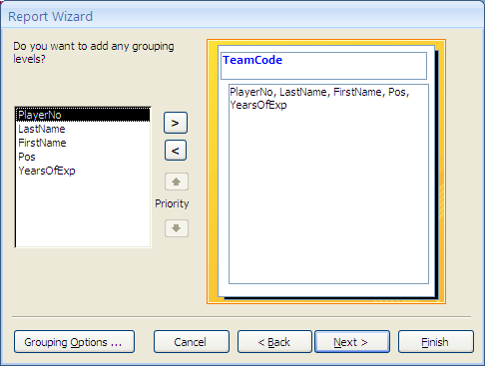
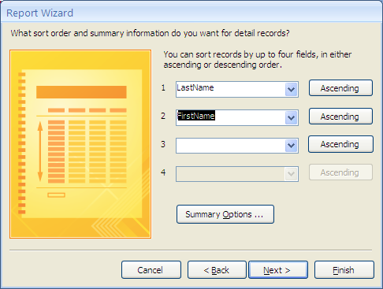
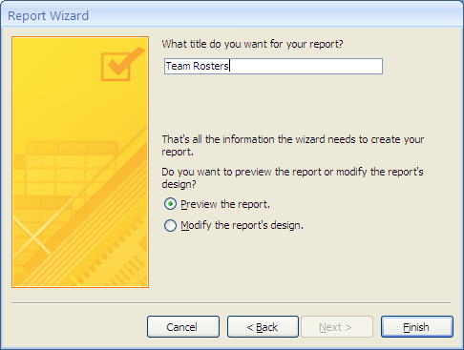

Views
- Layout View

- Design View

- Report View

MS Access 2013 Outline

Forms

Forms
- Graphical representation of table(s)
- Maintain data in table

Create a new Form (Form button)
- Ensure desired table is highlighted
  - Eg, Team
- Create tab | Forms group | Form button
- Creates Stacked Design of fixed textbox widths with all fields in table; controls “glued” together
- If table has a linked/related “child” table, it is shown by default
  - Delete the child table by clicking on the child table, then hitting the Delete key
- Can use form as-is, OR change the layout and/or design

Create a new Form (Form Wizard)
- Ensure desired table is highlighted
  - Eg, Team
- Create tab | Forms group | Form Wizard button
- Creates Stacked Design of varying textbox widths with all fields in table; controls NOT “glued” together
- Linked/related “child” tables not shown
- Can create form from table(s) or query(s)
- Can use form as-is, OR change the layout and/or design

Form Layout View
- Change the arrangement and appearance of labels and fields
- Form Layout Tools contextual tabs | Format tab
Controls
- Format tab
- Controls = Fields
- Can change controls together by selecting desired controls
  - Example: bold and center all labels

- Resizing/Moving Fields
  - Example: Resize Stadium, Logo fields
  - Example: Move ConfCd, Div, Wins, Losses fields
  - Example: Remove Logo label; move logo field

- Changing Colors, Fonts
  - Select the entire form; change Fill/Back Color
  - Select the Form’s title; change Font Style; change title to NFL Teams
  - Select all Labels; change Font Color to dark red

Form Design View
- Format tab | View icon | Design view
- Can remove control layout
- Can change what gets displayed/entered on a form
- Can add controls (e.g., additional fields, buttons, …) to a form
- Property Sheet: Can further describe, validate fields. For example, can limit values entered into fields
(NOTE: IN operator is not supported)
  - Example: Add a new, calculated control labeled “Years in Existence”
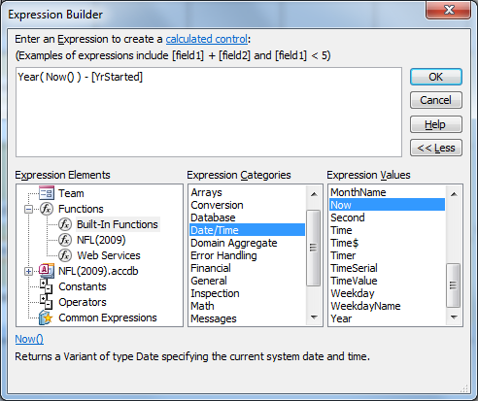
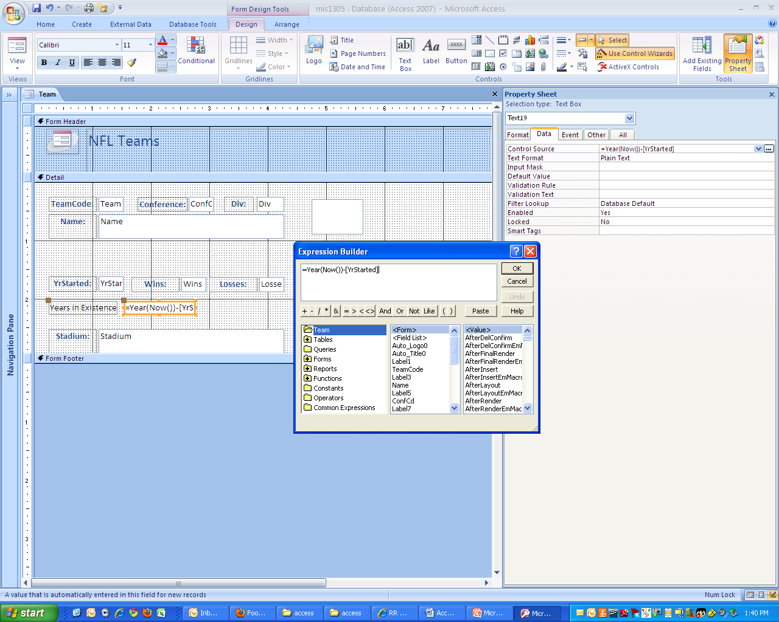
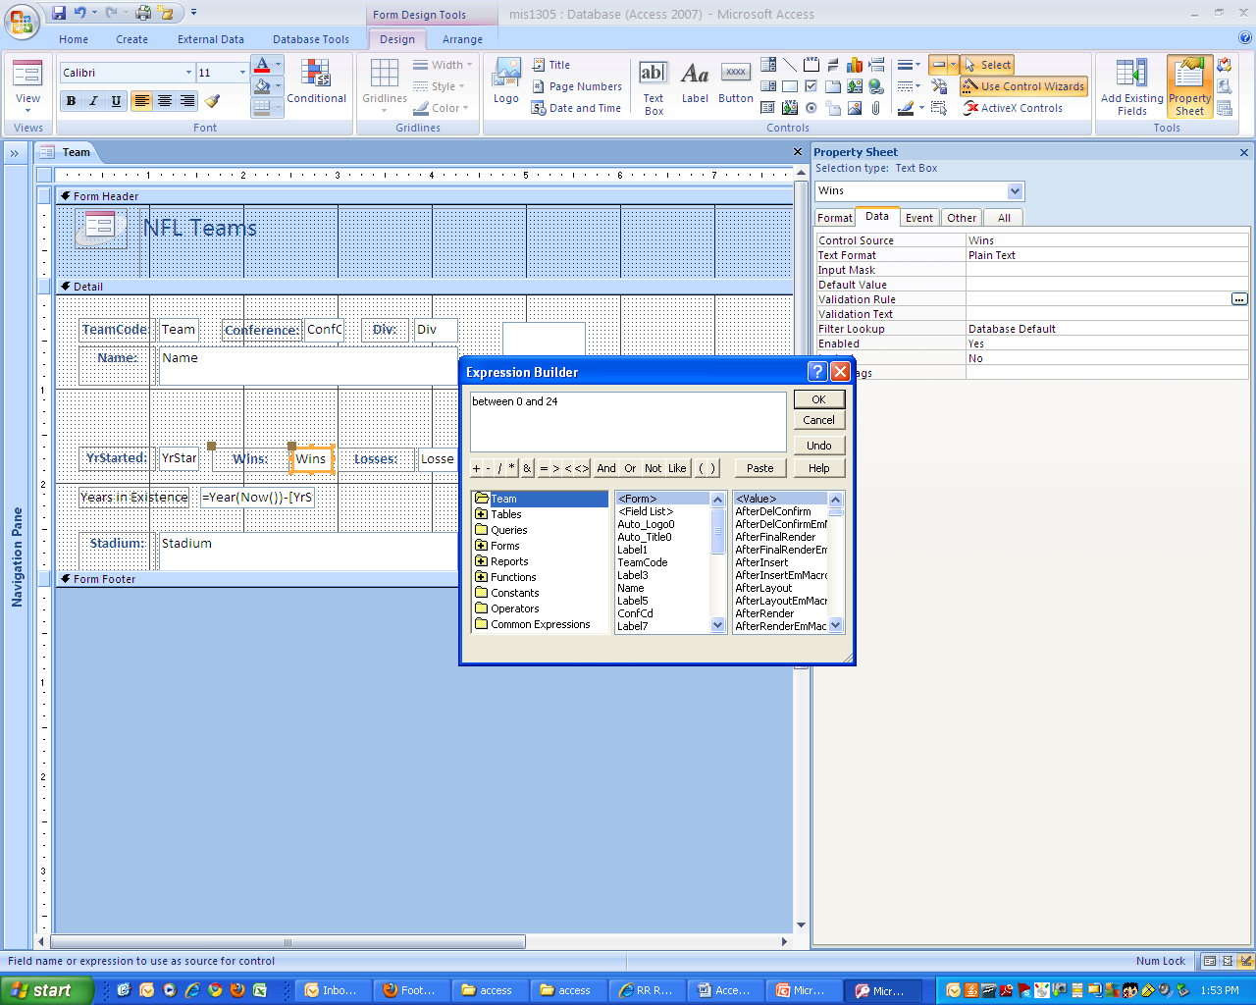
  - Example: limit values in Wins field to values between 0 and 24.
  - Example: Set width of Stadium text box to 2 inches.
Form View
- User’s view
- Add, Change, Delete records
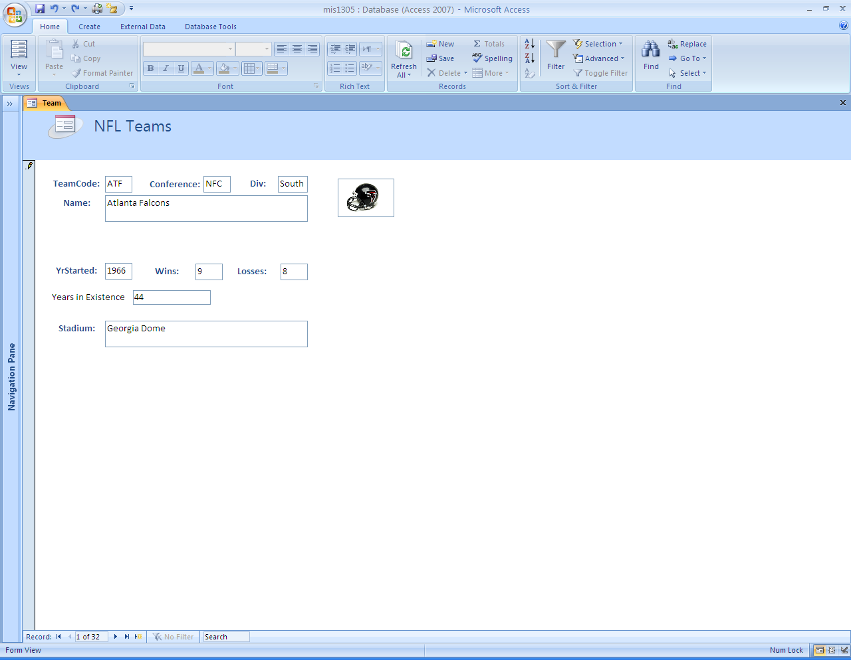
- Example: add a new record, change some fields, then remove (ie, delete) the record

