Introduction
- What is a blog? _______________________________________________________
- What is Wordpress? ___________________________________________________
  - Posts _________________________________________________________
  - Pages _________________________________________________________

Getting Started—Log In and Setup
- Open Firefox
- Review my blog: blogs.baylor.edu/gina_green
- Log-In to your account: blogs.baylor.edu | Site Log-in
  - Enter your BearID and password
- Review Environment -- Admin Bar, Dashboard, and Navigation Menu

- Edit My User Profile
    - First name & last name
    - Website - http://blogs.baylor.edu/yourusername
    - Biographical info
    - New Password DON’T DO THIS!!!
    - “Save Changes”!

- Change Site Settings
- General
    - Site Title – descriptive title for site. E.g., your name
    - Tagline – what site is about. E.g., a sample WordPress Site
    - Email Address – your preferred email
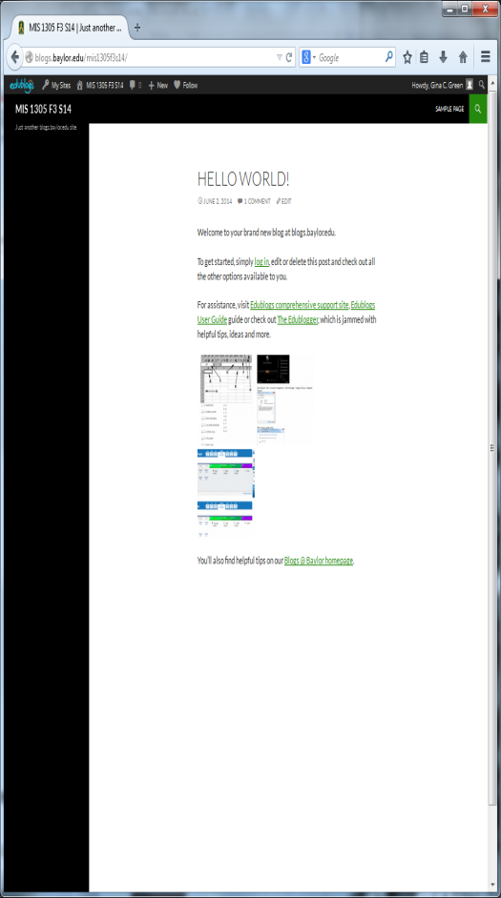
    - Time – time zone (Chicago is ours)
    - “Save Changes”!
  - Reading
    - Visibility settings

- Visit your Current Site
  - Home = example of Post
  - Sample Page = example of Page

Appearance
- Theme Twenty Ten | Activate
  - Can search for theme
- Customize Header Image
  - eg, download http://business.baylor.edu/gina_green/game-day.jpg
- Customize Color (Background Color)
  - Eg, Green

- Widgets (visual, interactive tools, can give structure to site & help with navigation)
  - Primary Widget Area (be sure to SAVE changes)
    - Search
    - Text Widget – e.g. enter your favorite verse, quote, …
    - Calendar
    - Categories

Add Content Items
- Posts
  - Modify default post: “Thoughts on Wordpress”
  - Add New Post:
    - Title e.g., “Share Your Thoughts”
    - Content …content of your post… (include any formatting)
    - Discussion Allow Comments
    - Trackback, Pingback
      - T: notify a website if you reference it
      - P: notify other sites of your entry
  - Add New Categories: “About Wordpress”
    - Categories are like topics or subjects
- Pages
  - Modify default page: “MIS1305 Class Website”
  - Add New Page: “MIS1305 Class Resources”
  - Add New Page: “MIS1305 Blog” (do not put any content on this page)

Define Static Front Page
- Settings | Reading | Front page displays | Static page
  - Select Front page: e.g., “MIS1305 Class Website”
  - Select Post page: “MIS1305 Blog”

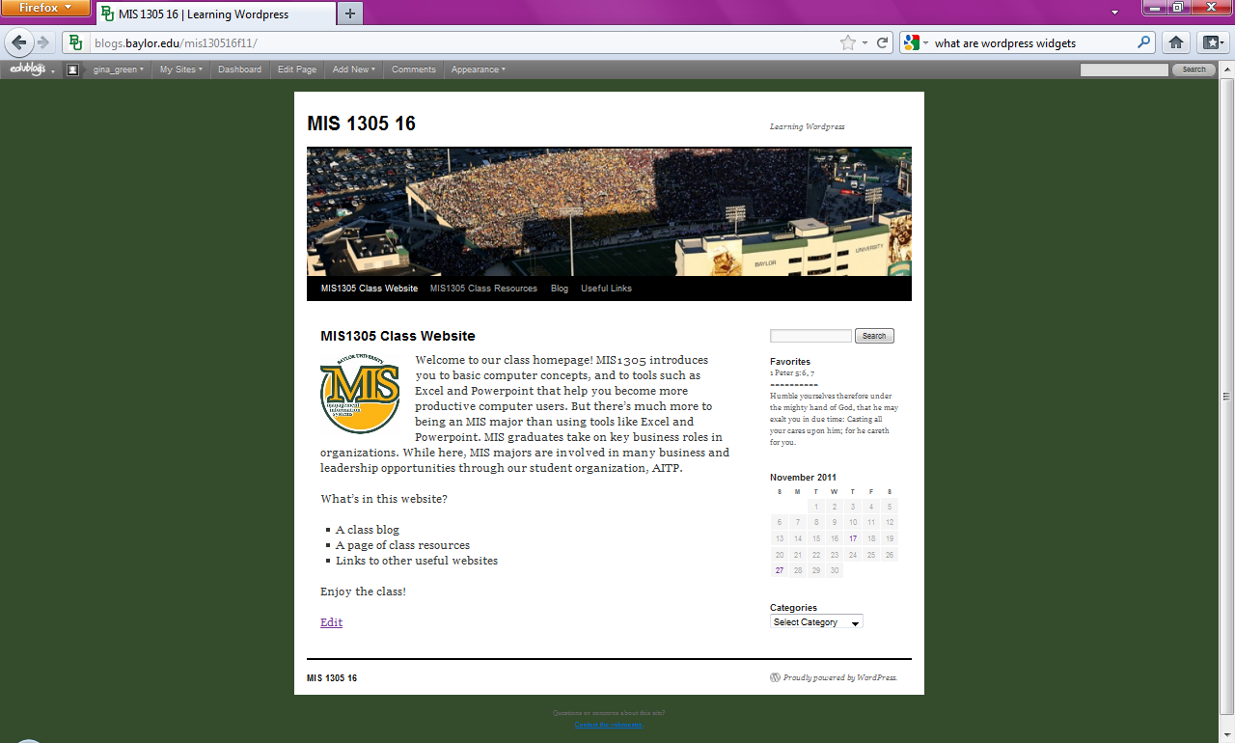
Create Menu
- Add pages, blog to the Menu
  - Don’t forget to specify the primary menu
- Custom Menu Items
  - e.g., external links as menu items

More Things
- Media
  - Add individual pictures to a page
  - Create/View the Media Library
  - Add Gallery to a page
  - Add Slideshow to a page (requires Plug-In)
  - Add audio and video to a page
- Links
  - Add Link widget
  - Add a few pertinent external links
- Forms
  - For getting structured user data (e.g., surveys, polls, requests for services, etc…)
  - Can use surveys developed in other applications (e.g., Qualtrics, etc…)
  - Requires Plug-In
- Plug-Ins
  - Can access additional widgets, functionality
Contact Me

