/* Single-Table queries */
1. Show the first name and last name of all players who play the quarterback (QB) position.

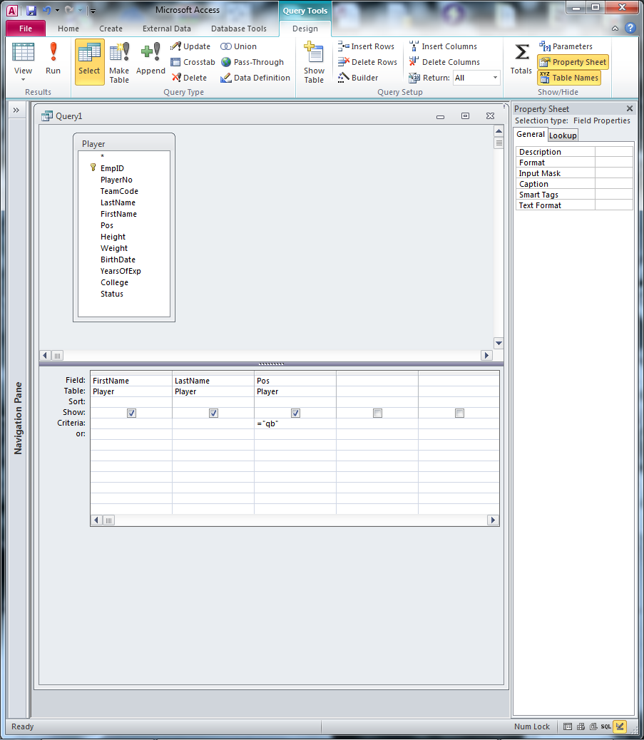

*** NOTE: SAM requires double-quotes for text criteria ***
2. Show the first name and last name of all players who play in the position indicated by the user.

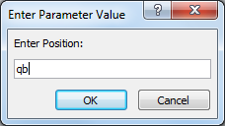

3. Show the first name, last name, and college of all players who weigh over 300 pounds and have an active (ACT) status.

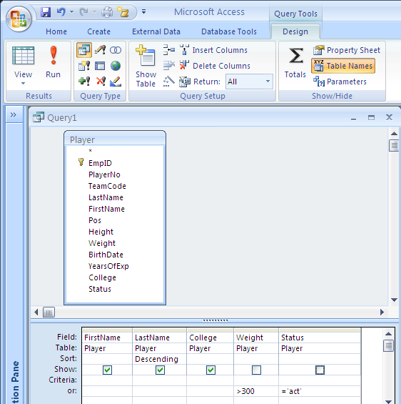

4. Show the first name, last name, player number, and team code of all players who are either quarterbacks (QB) or who weigh over 300 pounds.

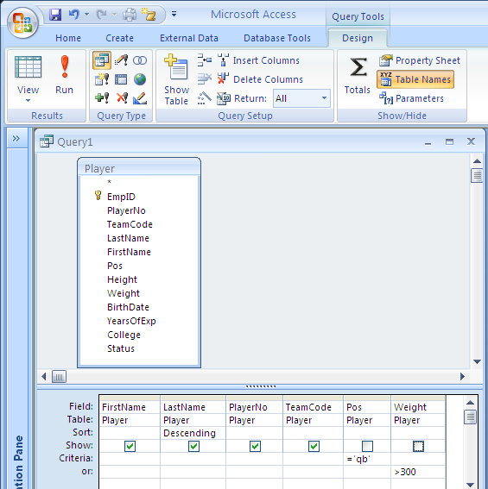

5. Show all the teams whose stadiums were built with public funds.
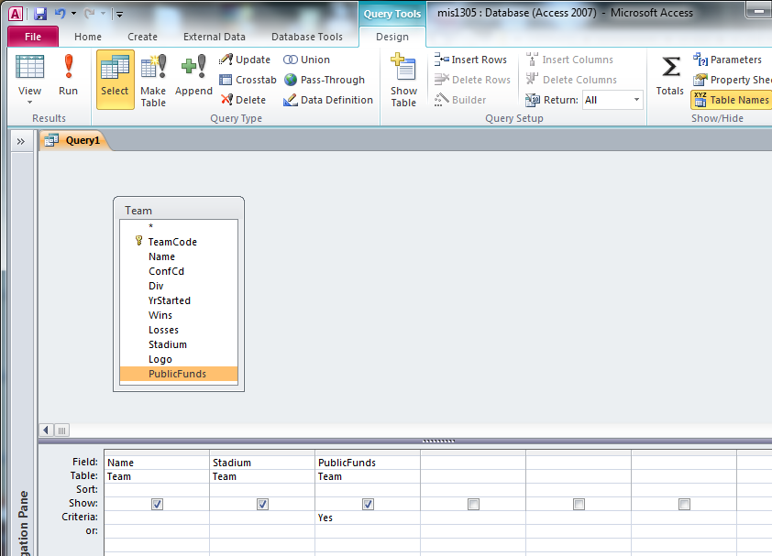
6. Show the first name and last name of all players who went to either Baylor or Texas Christian, sorted by last name, descending.

7. Show the 5 heaviest players in the NFL.
8. Find all players who play for either the New Orleans Saints (NOS), Indianapolis Colts (INC), or the New York Jets (NYJ). Show the player’s empID, name, team code, and position, sorted by team code and last name.

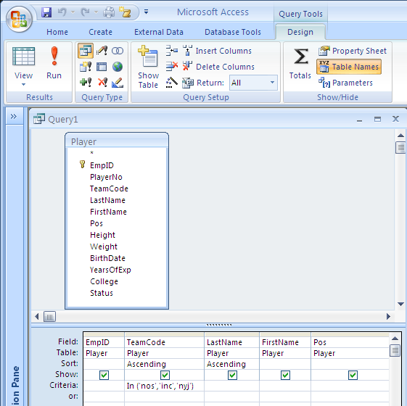

9. Find players who went to colleges with either “Texas” or “Michigan” in their college names. Show the players’ names, college, and years of experience. Sort answers by college.

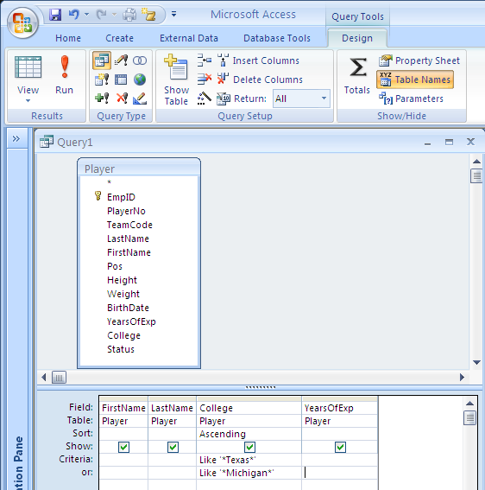

10. Find players born between 1/1/1965 and 12/31/1972. Show the player’s names, birthdate, position, and team code.

11. Find players born between 1/1/1965 and 12/31/1972 who play in positions that don’t end with a “B”.

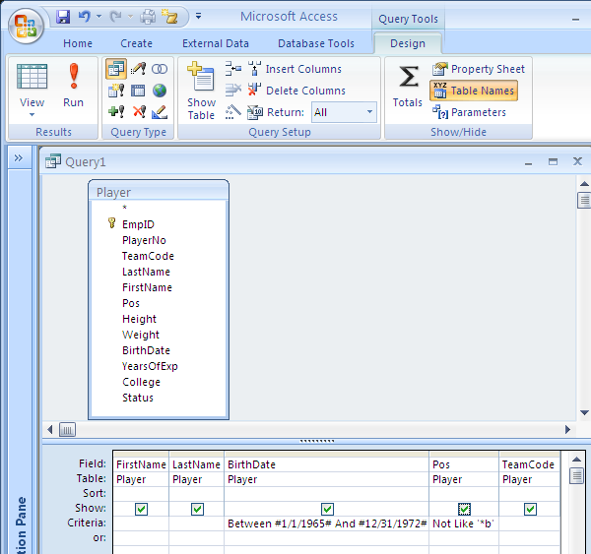

12. Find players whose weight we do not know. Show the player’s first and last name, and team code.

/* Functions */

13. What’s the shortest height of any player? Show just the height.

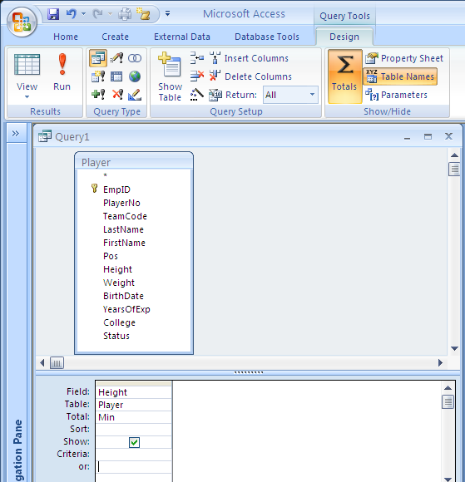

14. What’s the most number of years of experience that a player has? Show the number of years.

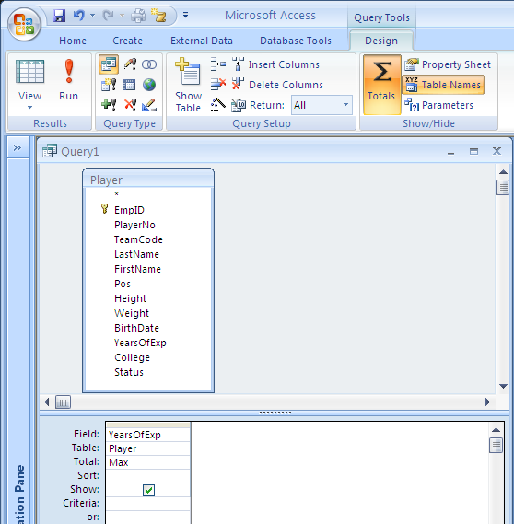

15. Show the largest weight and the average weight of all players. Name these values “Largest Weight” and “Average Weight”.

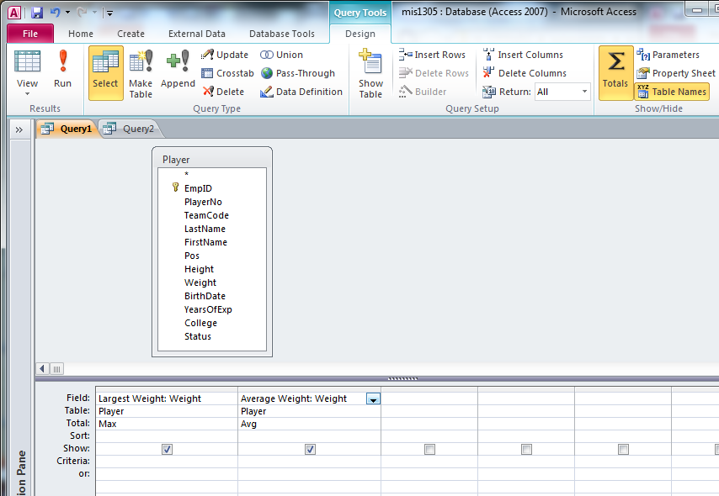

16. Show the names and ages of players.

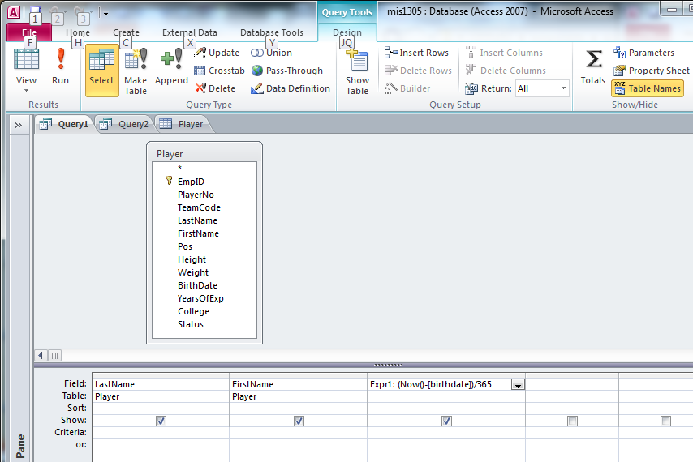

17. Show the largest weight, the average weight, and the total weight of all players.

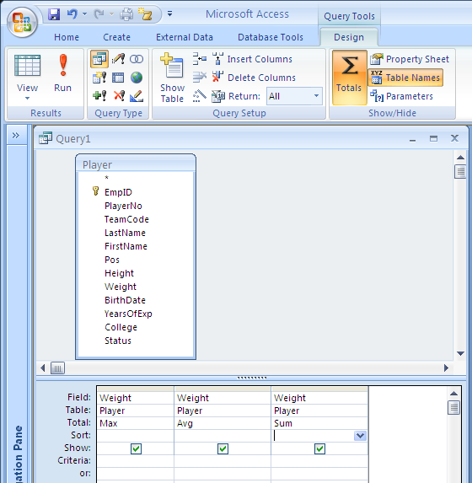

18. How many players are in the Player table?

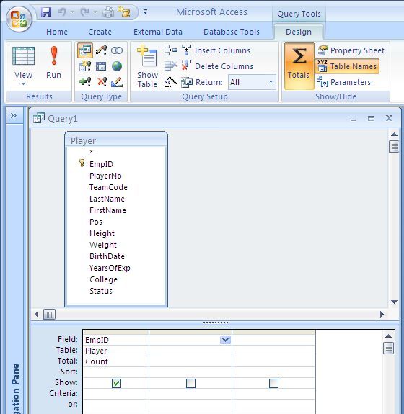

19. How many teams do we have in the Player table?

19b. How many players are on each team? Show how many and show the team codes.

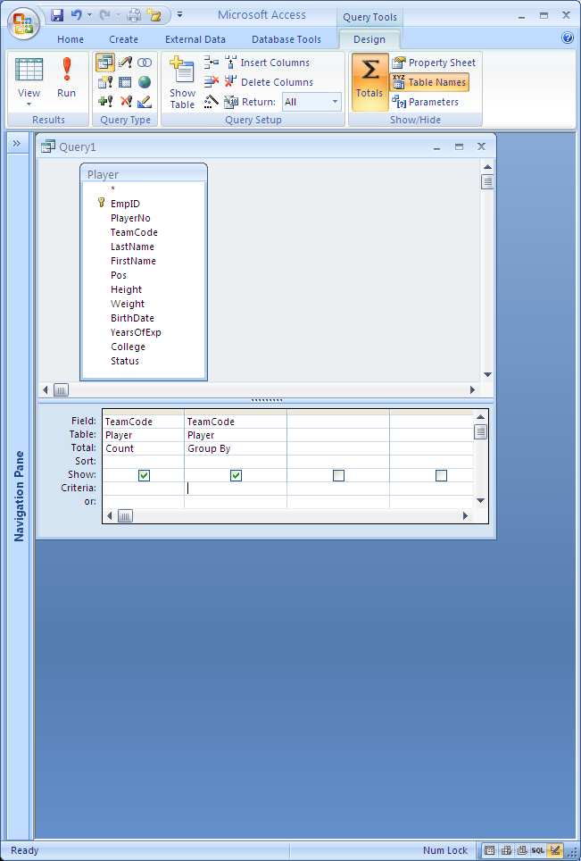

20. Show each different college that players came from. 3 methods shown.
***SAM requires the 1st method ***

SQL View

21. Show how many players attended each college in our database.

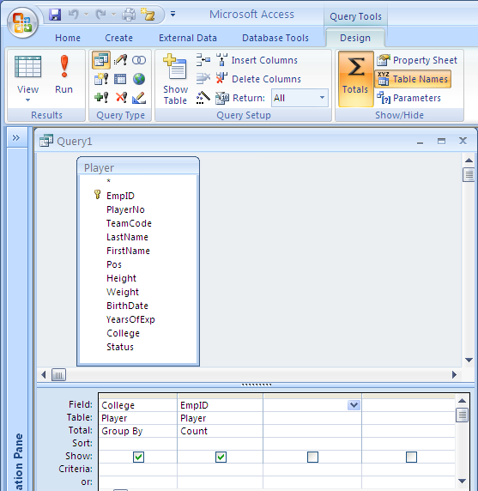

22. For each team, show how many players there are and the average weight of the players.

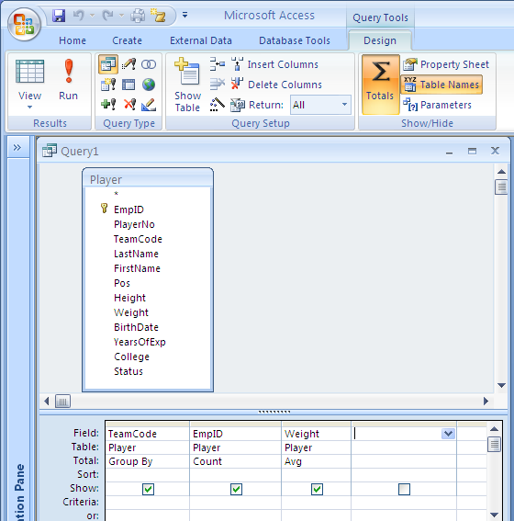

23. Show the total years of experience for the Minnesota Vikings (MNV) team.

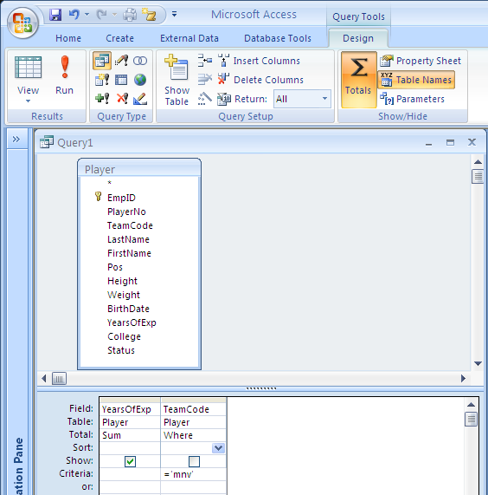

24. For each position and status, show the average height and average weight of the players.

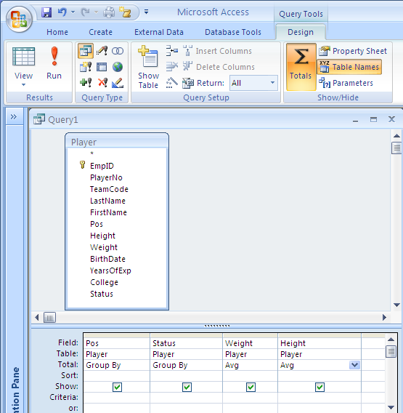

/* CrossTab Queries */

25. For each position and status, show the average height of the players.

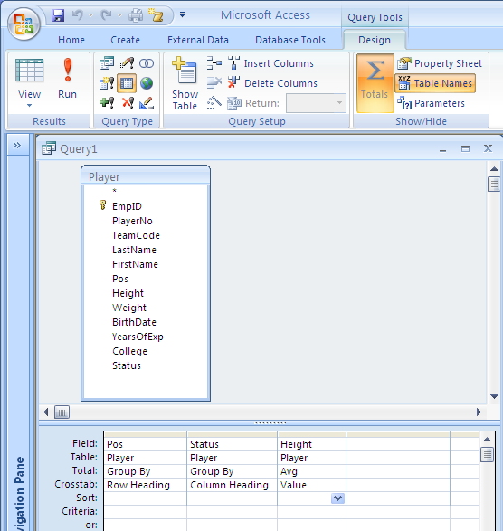

26. For each position and status, show the total years of experience and average height of the players.

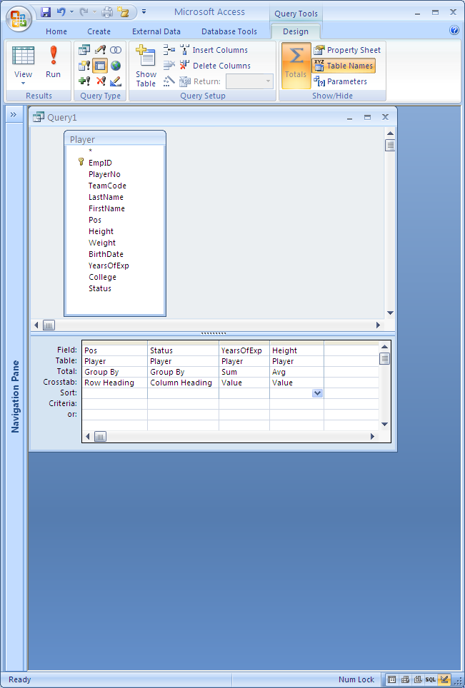
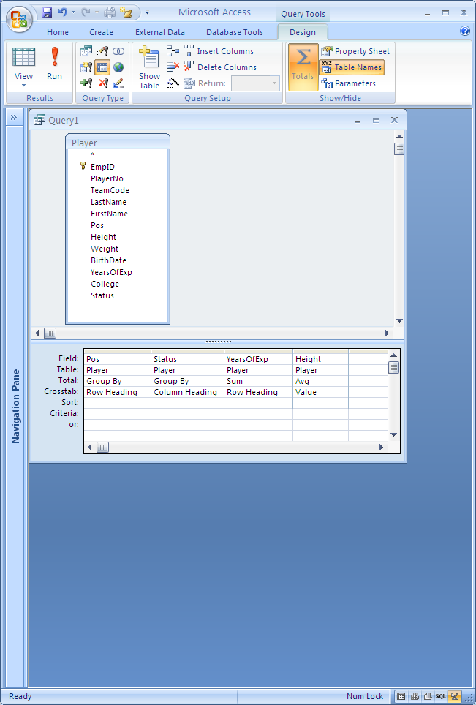
/* Multi-Table Queries */

27. Show the Employee ID, player number, player first and last name, team code, and team name of all players.

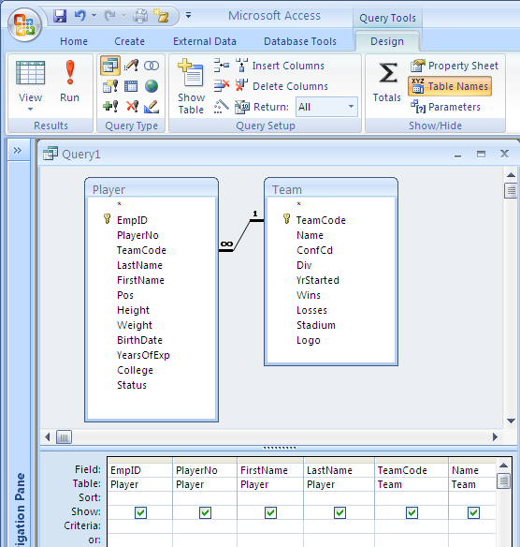

28. Show player number and team name of all players whose teams have at least 10 wins and whose team started after the year 1966.

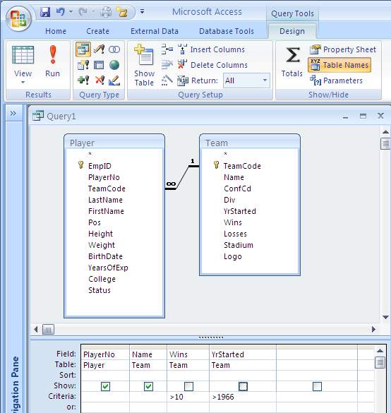

29. Show the employee ID, last name, first name, team name, and division (DIV) of players from colleges with either “Texas” or “Michigan” in their names, and whose teams are in the South division.

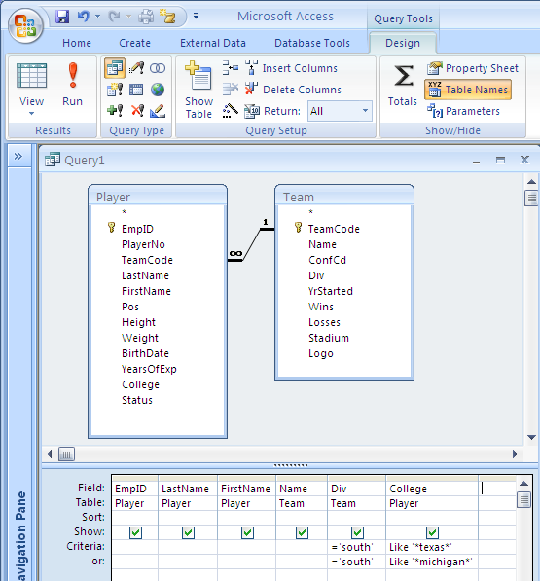

30. Show all the teams along with the colleges represented on those teams.

