Warren Buffett’s investing tip for LeBron James: Stick with an index fund
(MarketWatch) Published: Mar 2, 2015 10:12 a.m. ET 2 3

4

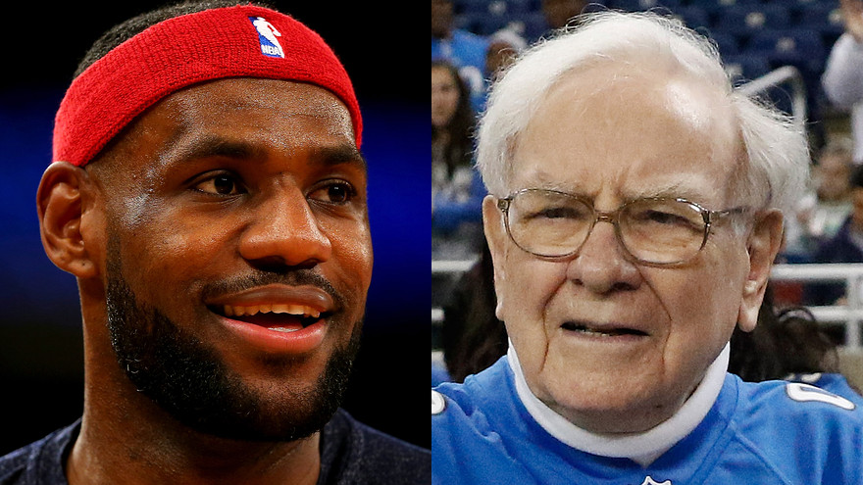Getty Images
By

VICTOR REKLAITIS
NEW YORK— Warren Buffett isn’t recommending stock picking, real estate or anything complicated to LeBron James.
The billionaire investor essentially advised the multi-millionaire basketball star to keep it simple when James asked him for investing advice on Monday.
“Everybody’s got an idea for him, and usually the simplest is the best,” Buffett said on CNBC during a segment that featured James asking a couple of questions.

The Oracle of Omaha said athletes are often approached with investing ideas tied to restaurants or real estate, but James should buy a low-cost index fund, while also keeping a significant cash reserve — “whatever makes him comfortable.”
“Just making monthly investments in a low-cost index fund makes a lot of sense,” Buffett said.
He added: “Owning a piece of America, a diversified piece, bought over time, held for 30 or 40 years, it’s bound to do well. The income will go up over the years, and there’s really nothing to worry about.”
The Berkshire Hathaway BRK.A, -0.15% BRK.B, -0.15% CEO has given this advice before. He once told index-investing pioneer Jack Bogle: “A low-cost index fund is the most sensible equity investment for the great majority of investors.”

And last year, Buffett’s annual letter to shareholders mentioned that he’s suggested his trustee use a low-cost S&P 500 index fund. He said at that time: “My advice to the trustee couldn’t be more simple: Put 10% of the cash in short-term government bonds and 90% in a very low-cost S&P 500 index fund. (I suggest Vanguard’s.)”

