Money Buys Happiness and You Can Never Have Too Much, New Research Says
By Derek Thompson | The Atlantic – Mon, Apr 29, 2013 11:41 AM EDT

Reuters
Americans have a peculiar conviction that the one thing money can't give us is satisfaction. You can't buy happiness, we've all been told. "Mo Money Mo Problems", Biggie concurred. And while we can all agree that desperate poverty is hideous, there is a broadly held view that after a certain level of income (around $75,000, say), more money doesn't buy more well-being.
But it's just not so. Economists Betsey Stevenson and Justin Wolfers have been arguing for years that, yes, richer families tend to be happier, and no, there is not an automatic cut-off point. In other words: Mo money, fewer problems.
Their elegant and straightforward new paper can be nicely summed up in the two graphs below. The first graph looks at income groups within countries. In all nations surveyed, richer households reported more life satisfaction. (Statistical note: This graph is logarithmic. That means doubling your income from $1,000 to $2,000 raises satisfaction by the same amount as doubling your income from $10,000 to $20,000. You can imagine why this might make a good theoretical case for income redistribution.)
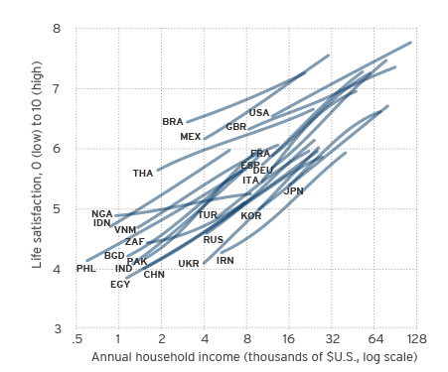
The next graph compares different countries, rather than different households within countries. Here, each circle represents a nation, with the richest ones clustered on the right. If extra income didn't matter for well-being, you'd expect the line to flatten. Instead, it steepens. More money doesn't just mean happier families. It means happier countries.
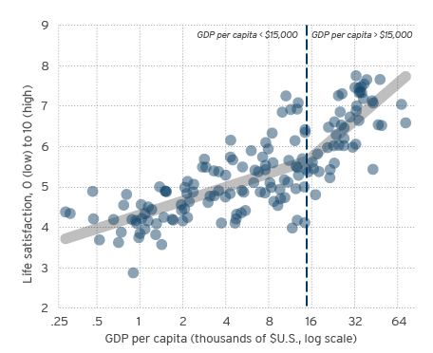

But Biggie was onto something. Even though the United States seems to score the highest in life satisfaction in the first graph, other studies have suggested an overall flat-lining of happiness here. Economist Daniel Kahneman found that people earning above $75,000 "do not appear to enjoy either more positive affect nor less negative affect than those earning just below that," Stevenson and Wolfers report. In a past paper, the duo found that, although the U.S economy had doubled in size since the early 1970s, overall well-being has declined.
Stevenson and Wolfers' two-part explanation could be summed up as, well, mo money, mo problems. Those problems would be social turmoil (such as the rise of single-parent households) and income inequality, which they suggested could act as a tax on self-reported satisfaction, counteracting the effects of rising total income.
That's not a reason to stop reaching for policies that grow the pie. But it might be a reason to consider better policies to divide it so that more reaches the poorest families.

