Waco MSA Economic Outlook for 2012

by
Tom Kelly, Director
Baylor Center for Business and Economic Research

Although the U.S. officially escaped from the grasps of the “Great Recession” in June 2009, individuals and economic sectors alike still feel the effects of the worst economic crises since the Great Depression. Officially beginning in December 2007 the U.S. recession had a profound effect on spending by American households with positive quarterly changes in real personal consumption returning only in the second quarter of 2009. Although officially over, consumer and investor confidence continues to be rattled by many of the post-recession challenges that remain—the risk that Europe’s economy could falter under a debt crisis and the growing burden of public debt on the U.S. economy, as well as anxieties over the Middle East. The August negative price “correction” in the stock market added to the risk of a “double dip” recession on the heels of less than one percent real GDP growth during the first half of 2011.
The U.S. economy continues to perform well below its potential with about 9 percent of the labor force officially unemployed. Gridlock among public policymakers has added to uncertainty among potential investors and reduced confidence among potential consumers, but history tells us that the U.S. economy will survive and prosper at some time in the future. The big question is “when?” Clearly economic recovery will depend on the creation of jobs that will emerge almost exclusively in the private sector.
Job growth, higher sales tax collections—both from business and consumer purchases—signal that most of the metro areas in Texas, including Waco, have emerged from the recent recession. The Texas and Waco MSA unemployment rates have been below the national rate for 57 consecutive months, although they continue to be well above prerecession levels, partly in response to growth in the labor force fueled by population shifts from other regions of the country. Home sales continue to suffer and are projected to continue on a slow path to recovery despite low mortgage rates. Manufacturing output has experienced a rebound over the past two years, but it is still below pre-recession levels. The good news is that investment in equipment and software continues to expand and businesses are leaner and more efficient with much larger cash holdings than prior to the recession. This puts private employers in a position to expand output and employment in response to positive change in projected future revenues as they occur.
Between September 2010 and September 2011 Texas gained 248,000 nonfarm jobs while the Waco MSA gained 1,600 nonfarm jobs. Employment data in table 1 show that only Abilene, Wichita Falls, and Killeen-Temple-Ft. Hood among Texas MSAs experienced job losses compared with a year ago.

Table 1: Texas Metro Areas Nonfarm Employment, September 2010 and 2011

MSA | Sep '10 | Sep '11 | % Change
Abilene | 64,700 | 61,900 | -4.33
Amarillo | 109,800 | 111,800 | 1.82
Austin-Round Rock-San Marcos | 768,700 | 785,800 | 2.22
Beaumont-Port Arthur | 158,300 | 160,400 | 1.33
Brownsville-Harlingen | 125,600 | 126,600 | 0.80
College Station-Bryan | 97,900 | 100,900 | 3.06
Corpus Christi | 177,000 | 183,700 | 3.79
Dallas-Fort Worth-Arlington | 2,870,300 | 2,942,500 | 2.52
El Paso | 278,500 | 281,800 | 1.18
Houston-Sugar Land-Baytown | 2,539,500 | 2,605,800 | 2.61
Killeen-Temple-Fort Hood | 127,900 | 127,200 | -0.55
Laredo | 87,700 | 90,900 | 3.65
Longview | 96,100 | 97,400 | 1.35
Lubbock | 129,000 | 132,000 | 2.33
McAllen-Edinburg-Mission | 218,200 | 223,100 | 2.25
Midland | 69,100 | 70,800 | 2.46
Odessa | 61,500 | 63,600 | 3.41
San Angelo | 44,800 | 44,800 | 0.00
San Antonio-New Braunfels | 841,100 | 852,200 | 1.32
Sherman-Denison | 42,300 | 43,000 | 1.65
Texarkana | 56,300 | 57,100 | 1.42
Tyler | 92,600 | 94,300 | 1.84
Victoria | 49,000 | 51,600 | 5.31
Waco | 105,600 | 107,200 | 1.52
Wichita Falls | 58,200 | 57,600 | -1.03
Source: Texas Workforce Commission

Waco MSA Employment

The Waco unemployment rate remains stubbornly high, so that while the layoff rate of firms has stabilized, the job finding rate continues to be slower than during past postwar business cycle recoveries. This “jobless” recovery is similar to the period following the 2001 recession but of greater magnitude. Fortunately, the Texas and Waco metro area economies have been able to outperform the nation over the past several years and presently face very little risk of a “double-dip” recession.
The Bureau of Labor Statistics reports two measures of employment performance within geographic areas based on separate monthly surveys—one from households and the other from establishments. The household survey is used to determine the area’s labor force, employment, and unemployment rate, which is the percentage of the labor force that is not employed. It does not capture the impact of underemployment due to part time workers nor those who are working in jobs that are below their historical qualifications, but it does capture self-employed persons that are not on establishment payrolls. The monthly BLS establishment survey gathers data on nonfarm employment among industry sectors in a geographic area. In additional to these monthly surveys the Texas Workforce Commission also reports quarterly “covered” employment and average weekly wages compiled from employers subject to the Texas Unemployment Compensation Act. It includes all wages and salaries, including bonuses, commissions, and cash values of remuneration received other than cash. It excludes employment covered by the Railroad Retirement Act, self-employed persons, and unpaid family members. Reported covered employment data is more accurate but less timely than monthly estimates because of the lag in compiling and reporting the data. Each of these data series may be used to compare Waco and Texas employment growth. The household survey is used to measure unemployment rates, while the establishment surveys show trend changes in employment among industry sectors.

Waco and Texas Household Employment Survey

Employment measured by the household survey perhaps receives the most public attention because it is used to measure an area’s unemployment rate. Yet the measure is probably the least accurate measure of economic performance because it can be affected by change in both employment and the labor force consisting of existing non-institutionalized persons over age 16 that are actively seeking employment. Since the labor force includes geographic movements by transitory workers, smaller areas are characterized by a more volatile labor force than the State or larger region in which they exist.
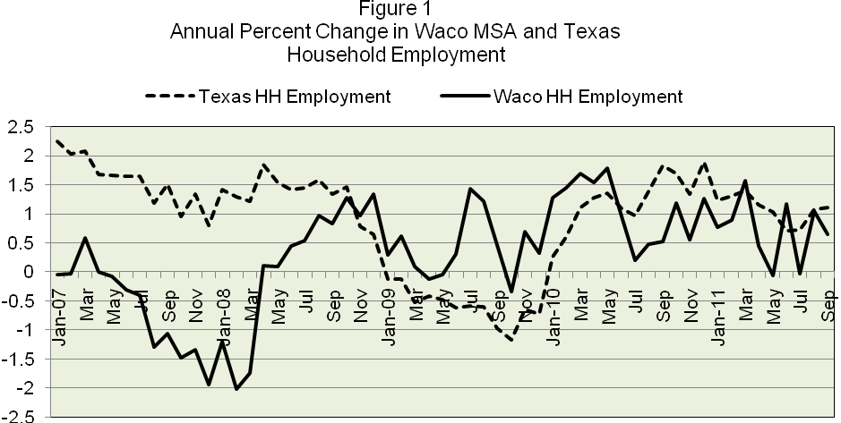 Source: U.S. Bureau of Labor Statistics

Figure 1 shows the percent change in monthly employment from the same month in the previous year reported by the household survey from January 2007 through September 2011 for the Waco MSA, the State of Texas, and the nation. Beginning in May 2007 households in Waco reported negative growth in employment compared with the same month of the previous year that lasted until April 2008, even though employment reported by households increased throughout Texas. This shift in employment is partly explained by rising energy prices that stimulated employment opportunities in energy intensive areas of Texas that benefitted from rising energy prices through mid-year 2008. The Waco MSA is an energy importer while the State of Texas is an exporter, as shown by a location quotient for energy extraction in Waco of 0.09, measured by the percent of Waco total employment in energy extraction divided by the percent of Texas employment in energy extraction. Rising gasoline and other energy prices reduced discretionary income of Waco consumers and profits of Waco businesses, while they were adding to output and employment elsewhere throughout the State.
Waco’s employment growth from the same month of the previous year did not resume until May 2008. As state employment began to slow in the fourth quarter of 2008 with the decline in energy prices, Waco’s job growth exceeded the state average until July 2010. Following the 2009 recession-hit job losses, Waco and Texas households have reported positive employment growth during nearly every month compared to the previous year since January 2010.

Waco MSA and Texas Unemployment Rates
Figure 2 shows unemployment rates for the Waco MSA compared with the State of Texas and the nation. In 2007 the shift in employment from the Waco MSA to other parts of the State resulted in very little change in relative unemployment rates locally compared with statewide averages. Both unemployment rates remained relatively stable at slightly above 4 percent of the labor force, so that while the Waco MSA lost jobs it also experienced a decrease in the labor force at about the same rate. In late 2008, when Texas’ employment growth slowed while Waco employment improved, the Waco MSA unemployment rate fell compared with the state average. Since the beginning of 2010 the unemployment rate in Waco has been more volatile and reached the State average several months. The Texas unemployment rate has been below the U.S. rate for 57 consecutive months while the Waco unemployment rate has outperformed the national average since March 2008.
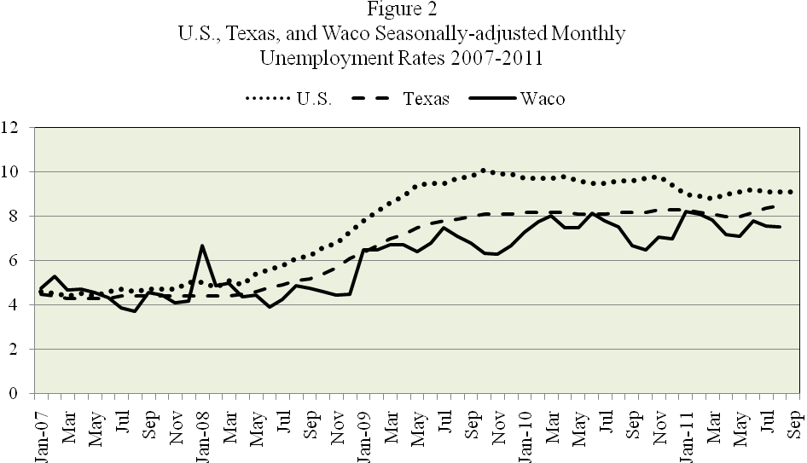
Source: U.S. Bureau of Labor Statistics

In 2012 the unemployment rate in Texas and the Waco metro area is expected to average about one percent lower than the national average despite a higher pace of growth in the labor force due to demographic shifts in employment opportunities that attract workers from geographic regions outside of Texas. However, the projected growth in the unemployment rate will decrease slowly in 2012 because of not only relatively slow employment growth but also faster growth in the labor force as more persons seek employment as they become more encouraged about finding a job.
Waco MSA, Texas, and U.S. Nonfarm Employment by Establishments

Nonfarm payroll employment gathered by the BLS’s establishment survey since January 2007 is used in figure 3 to show the growth rate, , in the number of monthly nonfarm payroll workers employed by Waco MSA, Texas, and U.S. establishments compared with the same month of the previous year.
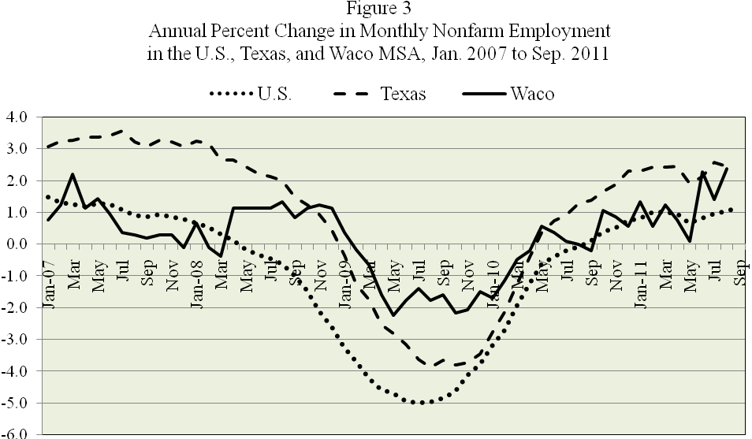
Source: U.S. Bureau of Labor Statistics

In general, the change in employment growth rates by nonfarm establishments in the Waco Metro Area is less than the Texas average, including greater stability during 2009 when the recession had its greatest impact on employment. Both Waco and Texas entered the recession in about a year after the national recession and experienced fewer recession-hit job losses. Although Waco MSA employment by establishments fell less than the statewide average in 2009, employment growth during the recovery phase in 2010 has not been as strong in Waco as statewide totals. However, Waco continued to exhibit its comparative stability over the business cycle due to the diversification of its industries and employment strength in the healthcare and education service industries that are relatively stable over the business cycle.

Waco Quarterly Covered Employment and Income

While monthly surveys report estimates of nonfarm employment, the Texas Quarterly Census of Employment & Wages also reports local wage and salary income for covered workers. The effect of rising labor productivity among Waco MSA establishments has enabled employers to increase output without adding to employment and to raise wages without increasing labor costs. Employment and wages reported quarterly for covered workers are shown in figures 4 and 5, respectively, for the Waco MSA from 1st quarter 2005 through 1st quarter 2011 (the most recent data available when preparing this report).

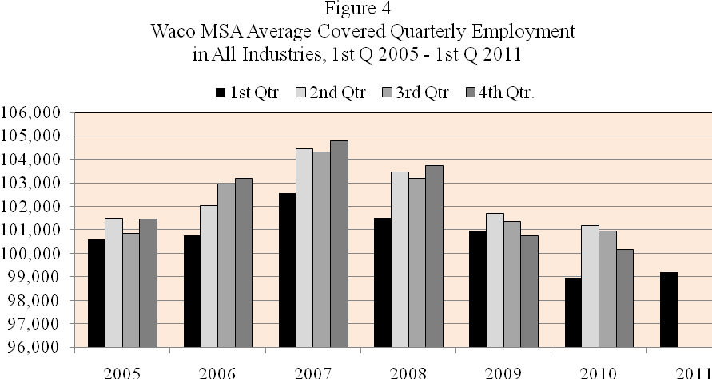
Source: Texas Workforce Commission, Texas Quarterly Census of Employment & Wages

Figure 4 shows that beginning in the first quarter of 2008 through the fourth quarter of 2010 Waco MSA establishments averaged fewer covered employees than during the same quarter of the previous year. However, in the first quarter of 2011 positive gains occurred in average employment compared with the first quarter of 2010, even though the number of jobs remained below pre-recession levels. Although employment fell each quarter compared with the same quarter of the previous year from 2008 through 2010, output fell by less than the number of lost jobs resulting in labor productivity gains that enabled firms to pay existing workers higher wage and salary income without raising labor costs. Hence, wage income was more stable than employment over the period.
Figure 5 shows that average wage income received by Waco MSA covered workers compared with the previous year fell in the first three quarters of 2009, but during the last three quarters of 2010 higher wages and more hours worked resulted in rising wage income despite fewer jobs compared with the same quarter in the previous year. The increase in 1st quarter 2011 wage income reflected both continued rising wage income per worker and an increase in the number of workers compared with 1st quarter 2010.
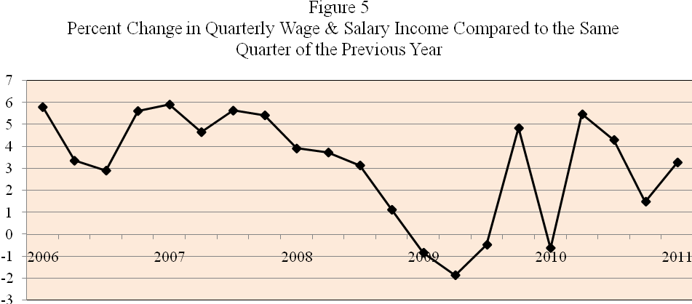
Source: Texas Workforce Commission, Quarterly Census of Employment & Wages

Although average wage and salary income increased during first quarter of the year slower growth in U.S. growth in GDP has raised concerns over whether job growth early in the year is sustainable. However, private nonfarm employment continued to increase during the second quarter of 2011, reaching the highest monthly growth rate in June 2011 of 2.6 percent before slowing slightly in July.
The increase in employment in June was also accompanied by a rise in the average workweek that reached 37.5 hours in May 2011 compared with only 35.5 hours in May 2010. For the year, the workweek has averaged 36 hours. However, after exhibiting greater stability in 2010 it has been more volatile in 2011, declining in June and July but still remaining above the yearly average. The rise in the workweek generally precedes growth in employment during the cycle recovery period, setting the stage for additional employment as the economy moves closer to its potential output. There is reason to expect an increase of about 6.5 percent in private nonfarm employment in 2012, largely as a result of C3’s new call center operations. In June 2011 average hourly earnings of Waco private nonfarm workers was $16.95 per hour. Although C3 workers will start at $9.50 per hour plus benefits, its operation will initially raise total area wage income by 3.6 percent. Projected wage gains and growth of other private nonfarm jobs of at least 1.5 percent will increase local wage income by more than 5 percent next year which is only 1 percent below pre-recession gains in 2007.

The Rate of Inflation and Real Worker Income

To determine the impact on purchasing power of Waco covered workers the change in nominal wage and salary income must be adjusted for changes the rate of inflation, shown in figure 6. During 1st quarter 2009 when the annual rate of change in Waco MSA nominal income turned negative the annual rate of inflation also decreased and even turned negative in mid 2009 as energy prices fell from their July 2008 peak. In May 2011 when nominal wage income increased 5.7 percent compared with May 2010 average prices in Central Texas had increased 3.6 percent. The continued rise in gasoline and food prices in early summer increase the annual inflation rate to 4.2 percent in July 2011 at a time when average weekly wage income of private nonfarm workers fell an estimated 5.6 percent from the same month in 2010. The September consumer price index increased slightly below 4 percent, while the core inflation rate that excludes food and energy remained near 2 percent.

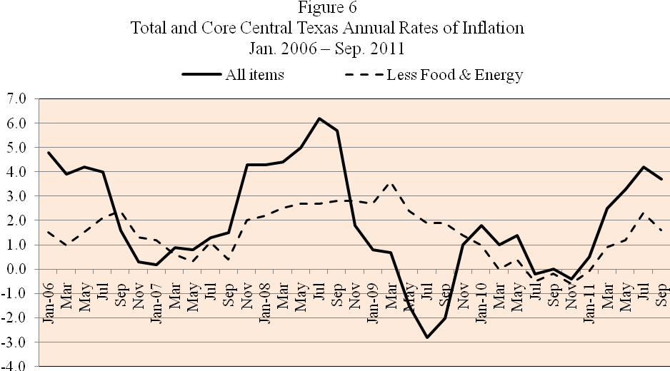
Source: Baylor Center for Business and Economic Research

Since inflation represents rising prices, not “high” prices, the September central Texas inflation rate of 3.9 percent is likely to decline in the near future as energy prices continued their decline since August. Slower global growth is relieving pressure on commodity prices so that the inflation rate is likely to decrease over the remainder of this year with the average inflation rate in 2012 is expected to converge closer to the core rate of about 2 percent until global economic growth expands. Lower inflation will help households, but the pace of growth in the average weekly earnings per worker is expected to remain slow, resulting in greater dependence on growth in employment to create gains in worker income next year.

Waco MSA Employment Performance among Sectors

Total Waco Metro Area nonfarm employment generally reflected business cycle influences that emerged nationally that slowed employment and output growth. However, an analysis of changes in nonfarm employment among sectors provides a clearer understanding of the impact of the recession on the Waco economy and the potential for expansion in the future. Table 1 shows 2008 and 2010 employment in basic industry sectors and the 2008-10 percent change in the Waco MSA. These two years surround 2009 when the national recession had it largest impact on Waco. (The BLS also reports data labeled ‘unclassified’ that is not included, so that column totals may not add to the sum of the 11 sectors reported.) Sectors are presented according to their relative employment size. Firms in healthcare and education services employ the largest average number of local workers, amounting to 27,000 or 27.3% of total employment in 2010.
Data in table 2 show that employment performance varied significantly among Waco industries, allowing some industries to add to employment despite the negative impact of the recession. Net recession-hit job losses over the two-year period amounted to 2.6 percent of the 2008 total or 2,633 workers. Trade, transportation, utilities and manufacturing job losses totaled 2,596 while the service sector, consisting of public administration, professional and business services, financial services, and information lost an additional 1,722 net jobs. On the positive side, employment in healthcare and educational services, leisure and hospitality, and construction continued to expand during the recession and provided stability to the local economy. However, as we will see from a shift-in-share analysis, even among those industries that were negatively affected by recession the reduction in local employment was only one-half the amount predicted by nationwide industry performance, resulting in an increase in the competitive share of nationwide industry jobs held by local firms.

Table 2: Employment Changes in Waco MSA, 2008 to 2010
Sector | Employment | Employment | Employment Change | Percent Change
Sector | 2008 | 2010 | Employment Change | 2008 - 2010
Education and Health Services | 25,410 | 27,000 | 1,590 | 6.3
Trade, Transportation, and Utilities | 19,910 | 18,484 | -1,426 | -7.2
Manufacturing | 15,386 | 14,216 | -1,170 | -7.6
Leisure and Hospitality | 9,759 | 9,830 | 71 | 0.7
Professional and Business Services | 8,995 | 8,558 | -437 | -4.9
Financial Activities | 6,602 | 6,212 | -390 | -5.9
Construction | 6,072 | 6,140 | 68 | 1.1
Public Administration | 4,357 | 3,772 | -585 | -13.4
Other Services | 2,997 | 2,998 | 1 | 0
Information | 1,722 | 1,412 | -310 | -18
Natural Resources and Mining | 350 | 305 | -45 | -12.9
Total | 101,560 | 98,927 | -2,633 | -2.6

Source: U.S. Bureau of Labor Statistics

Shift in Share Analysis

Shift-in-share analysis decomposes the change in area employment into three possible causes called (1) the national growth component, (2) the industry mix component, and (3) the competitive share component. The first source of change is due to the growth or contraction in the national economy, primarily due to the business cycle. The second source of change, called the industrial mix component, measures how well an industry has performed, net of the effects of the business cycle. A region with a higher percentage of jobs in less cyclically sensitive industries is less vulnerable to the business cycle. The final component of shift-in-share analysis, called the competitive share, is the area employment change that occurred over the period after accounting for the national recession and industrial mix effects.
Table 3 presents the results of a shift-in-share analysis of local industry employment compared with nationwide performance from 2008 through 2010, enabling us to compare the effects of the recession on the local economy compared with the national average. The question answered by shift-in-share analysis is “how does this loss of jobs match up with the potential loss of jobs if the Waco economy had experienced the same impacts due to the recession as the national average?” The results of the analysis show that Waco performed much better than predicted by nationwide performance in all but three industry sectors.

Table 3: Shift-In-Share Analysis of Waco versus Nationwide Employment

Sector | National Growth | National Growth | Industry Mix | Industry Mix | Competitive | Competitive
 |  |  |  |  | Share | Share
Sector | Percent | Jobs | Percent | Jobs | Percent | Jobs
Construction | -5.2 | -315 | -17.3 | -1,048 | 23.6 | 1,431
Manufacturing | -5.2 | -799 | -8.9 | -1,371 | 6.5 | 1,000
Education and Health Services | -5.2 | -1,320 | 7.6 | 1,924 | 3.9 | 985
Leisure and Hospitality | -5.2 | -507 | 2.4 | 233 | 3.5 | 345
Other Services | -5.2 | -156 | 2.2 | 67 | 3 | 90
Financial Activities | -5.2 | -343 | -1.8 | -118 | 1.1 | 71
Professional and Business Services | -5.2 | -467 | -0.4 | -32 | 0.7 | 62
Natural Resources and Mining | -5.2 | -18 | 0.7 | 2 | -8.4 | -29
Information | -5.2 | -89 | -4.1 | -70 | -8.8 | -151
Trade, Transportation, and Utilities | -5.2 | -1,034 | -1.2 | -229 | -0.8 | -163
Public Administration | -5.2 | -226 | 6.7 | 293 | -15 | -652
Totals |  | -5,274 |  | -349 |  | 2,989
- The National Growth Component: During the time period 2008 to 2010, the nation's net total employment fell by -5.2 percent, representing the percentage decrease from 134.8 million in 2008 to 127.8 million in 2010 due to the business cycle. If Waco MSA employment had fallen by the national average of -5.2%, rather than -2.6% we would have lost 5,274 jobs rather than 2,633 jobs (shown in table 2), indicating that the recession had one-half the negative impact on the Waco Metro Area employment as the national average.
- The Industrial Mix Component: This component is found by calculating the percent growth rate for an economic sector at the national level and subtracting from it the national growth component. A loss of jobs below -5.2 percent means that employment in the industry was more stable than the average for all industries over the recession, contributing to a favorable industry mix. An unfavorable industry mix occurs in industries that have a negative growth rate that is greater than -5.2 percent. Table 3 lists the industry mix component for each sector based on nationwide performance. The most favorable industrial mix component was 7.6 percent in the Education and Health Services sector that was responsible for 1,924 jobs (7.6 percent times this sector's base employment of 25,410 jobs). Construction and manufacturing were the most unfavorable sectors with negative growth rates nationwide of 17.3 percent and 8.9 percent respectively. For all eleven sectors the industrial mix component was responsible for decreasing Waco MSA employment by 349 jobs. The majority of these jobs losses due to the area’s industry mix are attributed to job losses in manufacturing because of the sector’s relative importance in the Waco economy.
- The Competitive Share: The competitive share in each industry is derived by comparing the change in local employment with the change that would be expected based on national averages. If an industry’s local competitive share is positive, then it created more jobs than predicted by nationwide performance, implying that local establishments in that industry have an advantage in promoting employment growth relative to the national economy. For example, from table 3 if Waco MSA employment in the Education and Health Services sector employment matched national trends it would have fallen -5.2 percent due to the business cycle and gained 7.6 percent due to its favorable industry mix, for a net gain of 2.4 percent. However, local employment increased by 6.3 percent from 2008 to 2010 resulting in job growth of 3.9 percent or 985 more jobs than predicted by the national average that are attributed to favorable local conditions in the sector.
Table 3 shows that in Waco the construction sector had the largest gain in the competitive share of jobs over the period with job growth in a number of nonresidential projects more than offsetting fewer residential construction jobs. Over the period local construction employment increased by 68 jobs (see table 2) while Waco MSA construction jobs would have fallen by 1,363 jobs if the local economy had matched the nation’s rate of job layoffs, for a net competitive shift-in-share of 1,431 jobs. Similar analysis shows that if local manufacturing firms had reduced employment at the same rate as the national average over the years 2008-10, then local manufacturing employment would have fallen by 2,170 jobs rather than 1,170 jobs, representing a competitive shift-in-share gain of 1,000 manufacturing jobs over the period. Other sectors with a positive competitive share were leisure and hospitality, financial activities, and professional and business services.
The public administration sector lost more jobs than predicted by national trends resulting in a loss of competitive share of 652 jobs. Retail trade employment also decreased more than the number predicted by nationwide cyclical and industry mix averages as local consumers purchased more items from larger, less labor intensive retailers. Across all sectors, the Waco MSA had a total competitive share component of 2,989 jobs that helped to reduce the number of jobs the area would have lost had it performed at the national average.

Recent Annual Percent Change in Industry Employment

Employment performance among industries following the 2008-10 period are shown in the following series of charts showing the annual percent change in monthly employment compared with the same month of the previous year for industries presented in Table 2.

Figure 7
Waco MSA Annual Percent Change in
Manufacturing Employment from Same Month in Previous Year

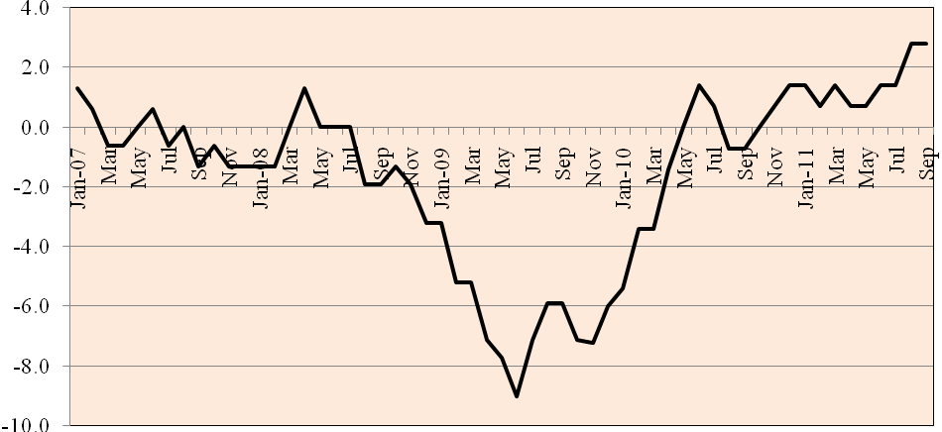
Source: Bureau of Labor Statistics

As shown in figure 7, the reduced demand for producer goods in 2007 leading up to the recession moderately lowered manufacturing employment in the Waco Metro Area before recession-hit jobs fell significantly beginning in the fourth quarter of 2008, reaching a maximum negative growth rate of 8% in June 2009 that coincided with the official trough date of the national recession. However, Waco employment in manufacturing has been stable or increasing each month since January 2010. Gains in manufacturing employment are projected to be positive in 2012, but the pace of growth is dependent on the pace of the national and global economic recovery.

Figure 8
Waco MSA Annual Percent Change in
Construction Employment from Same Month in Previous Year

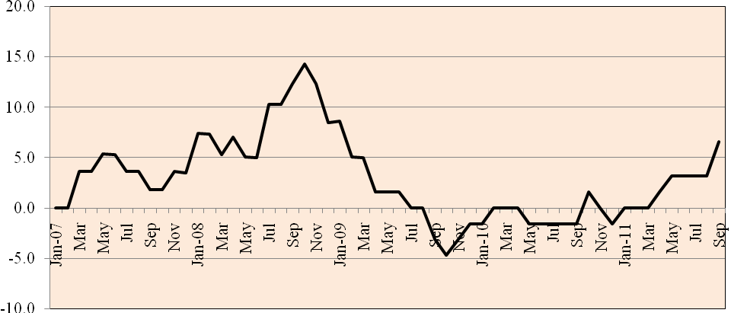
Source: Bureau of Labor Statistics

Construction employment, shown in figure 8, experienced strong growth in 2008 despite a reduction in home building. Additions to school systems and public facilities, expansion in healthcare facilities, commercial development in Downtown Waco and other nonresidential projects helped to reduce the impact on Waco of the national recession. The completion of construction projects slowed the pace of employment and eventually led to net layoffs by the middle of 2009 compared with the previous year. However, since April 2011 construction employment has increased with additional spending in sight for 2012, including $100 million by Baylor University that will have an economic impact of about $180 million over the next 18 months. Several housing developments are also on line to increase construction jobs in 2012. (Housing demand is examined more fully in a later section of this report.)
The slump in consumer spending following the reduction in consumer confidence initiated by the stock market “crash” in late 2008 is shown in figure 9. However, positive gains have emerged over the past several months, reaching prerecession growth rates, but trade employment gains will have to continue for over a year to reach prerecession levels.

Figure 9
Waco MSA Annual Percent Change in Retail Trade
Employment from Same Month in Previous Year

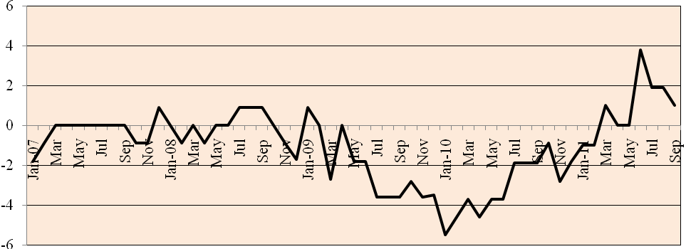
Source: Bureau of Labor Statistics

The impact of slower demand for credit due to the recession is shown in figure 10 as employment in financial activities in the Waco MSA fell substantially beginning in 2008. However, 2011 employment growth in the financial sector has increased since last April and is expected to grow moderately in 2012.

Figure 10: Waco MSA Annual Percent Change in Financial Activities
Employment from Same Month in Previous Year

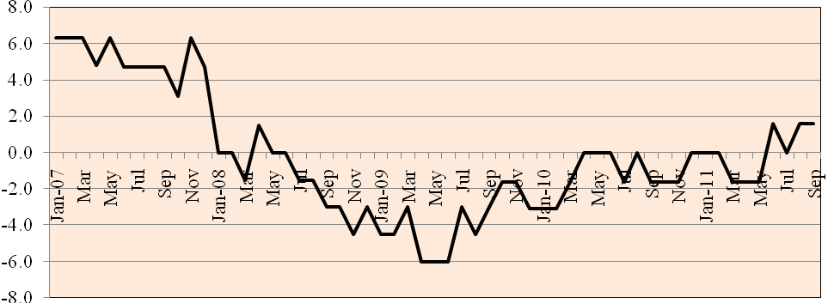
Source: Bureau of Labor Statistics
Employment growth by establishments in Waco’s professional and business services that had been growing rapidly was brought to a halt in 2009 by the recession, even though employment fell at a slower rate than the national average. In 2011 the 12-month rate of growth in professional and business employment growth has increased with the recovery rate of the economy. It must be noted that establishment data may not accurately reflect this sector’s total employment, since professionals may offer services as single proprietors working out of their households.

Figure 11: Waco MSA Annual Percent Change in Professional and Business
Activities Employment from Same Month in Previous Year

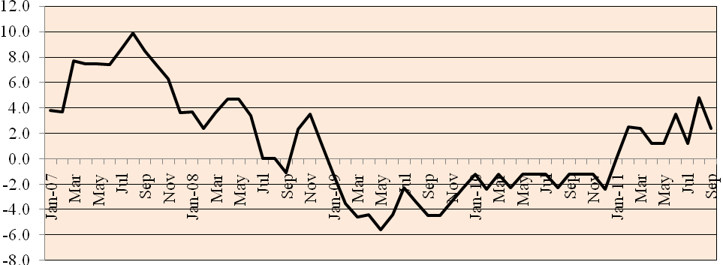
Source: Bureau of Labor Statistics

Employment in Waco education and healthcare establishments, shown in figure 12, has continued to increase since the middle of 2008 in spite of the recession.

Figure 12: Waco MSA Annual Percent Change in Education and Health
Services Employment from Same Month in Previous Year

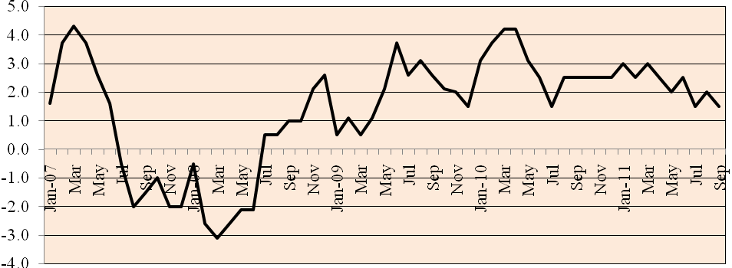
Source: Bureau of Labor Statistics
Waco’s leisure and hospitality employment, shown in figure 13, hotel and motel tax receipts reflect additional visitor spending over the past year that is projected to continue to rise in 2012.

Figure 13: Waco MSA Annual Percent Change in Leisure and Hospitality
Employment from Same Month in Previous Year

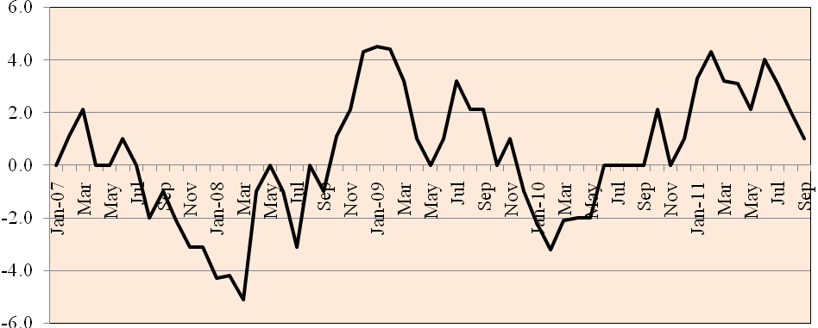
Source: Bureau of Labor Statistics

Employment in the public sector, shown in figure 14, was counter cyclical during the recession and helped to stabilize the Waco MSA economy. However, recent fiscal austerity has reduced employment growth in the public sector with only modest expansion projected in 2012

Figure 14: Waco MSA Annual Percent Change in Government
Employment from Same Month in Previous Year

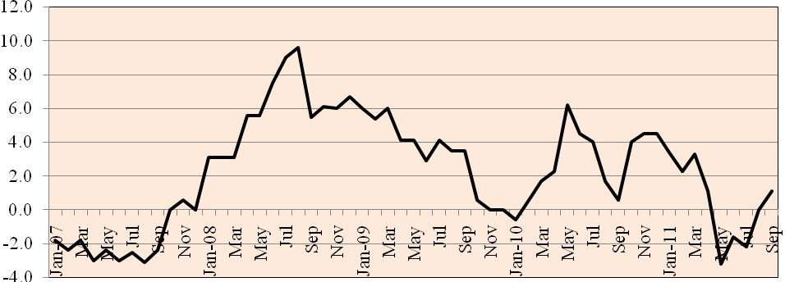
Source: Bureau of Labor Statistics

In recent months in 2011 the Waco economy has experienced positive job growth in every component of the private sector with only public sector negative growth during the summer months compared with a year ago. The greatest uncertainty for the Waco economy exists with regard to spending by households on retail sales and spending on residential construction, two sectors that warrant additional inspection when projecting job and income growth in 2012.

Waco MSA Retail Sales

Before the recession began, many Americans were naïve concerning the growth patterns exhibited by major sectors of the economy, believing that asset values would continue to rise into the unforeseeable future. Consequently, consumers spent money more than was financially reasonable or realistic. When the housing and stock markets plunged nationwide consumer confidence plummeted and personal consumption fell by levels not seen since the Great Depression. Figure 15 shows the dollar value of quarterly sales and seasonally-adjusted sales by Waco retailers from 2007 through 2010. Seasonally-adjusted retail sales in the Waco MSA peaked in the second quarter of 2008 and remained relatively stable until the fourth quarter of 2008 when retail sales began to fall in response to the change in consumer confidence and wealth.
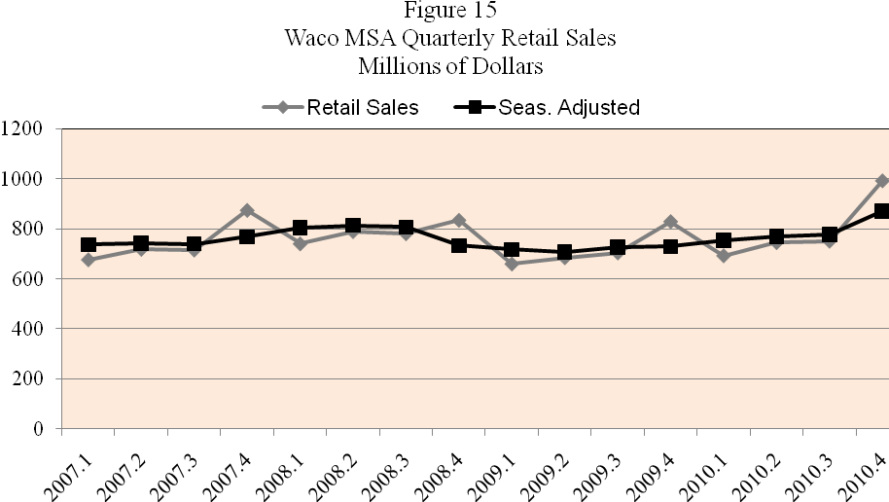
Source: Texas Comptroller of Public Accounts
The unit decrease in Waco MSA retail sales in 2009 from 2008 is less than the change in dollar sales due to the drop in the rate of inflation during the cyclical downturn, especially due to the change in gasoline prices that rose above $4 per gallon in July 2008 before falling by the end of the year to reach an average price of $2.60 per gallon June 2009. Table 4 shows that by 2nd quarter 2009 dollar retail sales had fallen 13 percent from the previous year’s peak reached in 2nd quarter 2008.
Table 4: Percent Change in Waco MSA Quarterly Retail Sales & Gasoline Store Sales from Same Period in Previous Year

Period | % Change  Total MSA Retail Sales | % Change Gasoline  Store Sales
2008.1 | 9.41 | 29.26
2008.2 | 9.87 | 19.73
2008.3 | 9.14 | 19.37
2008.4 | -4.56 | -23.49
2009.1 | -10.88 | -38.39
2009.2 | -13.31 | -40.64
2009.3 | -9.86 | -43.79
2009.4 | -0.62 | -7.86
2010.1 | 4.99 | 15.80
2010.2 | 8.88 | 11.39
2010.3 | 6.69 | 9.67
2010.4 | 19.69 | 16.49
Source: Texas Comptroller of Public Accounts
Regression analysis shows that during the three-year period from 2008 - 2010 eighty-six percent of the change in dollar sales in Waco can be explained by the change in gasoline sales, not including its effect on consumer confidence. On average, the 40 percent reduction in gasoline sales in second quarter 2009 would result in a 14 percent decrease in total retail sales, other things equal. Since retail sales fell only 13.3 percent, one could argue that dollar sales might have actually increased slightly in second quarter 2009 if gas prices had not fallen.
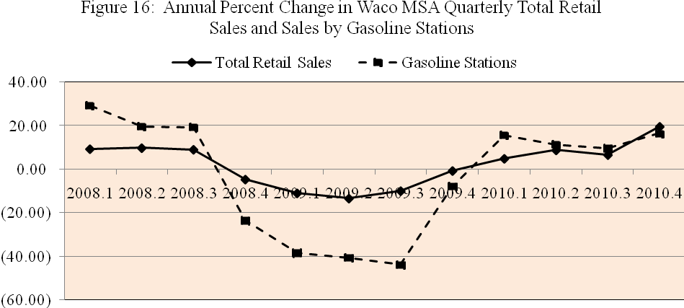
Source: Texas Comptroller of Public Accounts
Table 5 shows that the nearly all of the improvement was due to the increase in 4th quarter 2010 sales by automobile dealer and parts stores that increased 102.5 percent compared with the 4th quarter of the previous year. This quarterly increase auto sales was not just a local change, but it was a nationwide increase that caught industry analysts by surprise since it did not reflect an increase in employment or income, but rather an easing of credit conditions affecting automobile finance at a time when pent-up demand and consumer optimism came together at the beginning of the new model year.

Table 5: Waco MSA 4th Quarter Retail Sales and Annual Percent Change
from Same Period of Previous Year, 2009 and 2010

Product | Retail Sales | Retail Sales | Percent | Change
Product | 2010 4th Qtr | 2009 4th Qtr | 2009-10 | 2008-09
Motor Vehicles | $295,447,357 | $145,900,397 | 102.5% | -17.2%
Home Furnishings | $19,044,800 | $16,661,501 | 14.30% | -6.7%
Electronics/Appliance | $28,641,736 | $34,557,013 | -17.12% | 5.5%
Building Materials | $73,933,509 | $73,592,157 | 0.46% | -9.8%
Food and Beverage | $128,390,231 | $128,279,493 | 0.09% | 11.0%
Health and Personal | $36,795,871 | $35,153,780 | 4.69% | 0.0%
Gasoline Stations | $127,240,473 | $116,300,178 | 9.41% | -4.0%
Clothing Stores | $33,631,759 | $32,314,858 | 4.08% | -1.7%
Sport/Hobby/Books | $30,033,858 | $29,775,855 | 0.87% | 6.4%
General Merchandise | $155,363,358 | $153,614,580 | 1.14% | -1.7%
Miscellaneous Stores | $51,424,442 | $52,047,425 | -1.20% | -4.6%
Nonstore, Other | $13,774,932 | $12,053,770 | 14.28% | -11.1%
TOTAL | $993,722,326 | $830,251,007 | 19.69% | -3.8%
Source: Texas Comptroller of Public Accounts

Waco MSA motor vehicle sales amounted to 29.7 percent of total retail sales in the fourth quarter of 2010. If automobile dealer and parts sales had remained unchanged, total retail sales would have increased only 1.7 percent in 4th quarter 2010 compared with the same quarter in 2009. While this reflects a reversal from the decrease that occurred in 2009 when automobile sales fell 17.2 percent, this unusually high rate of increase in motor vehicle sales and parts has slowed and is unlikely to reoccur over the next year. In addition to automobile sales pent up demand for home furnishings was also satisfied when their sales increased 14.4 percent during the 4th quarter compared with 4th quarter 2009 after having fallen by 6.7 percent from the same quarter in 2008.
Growth in consumer demand has historically been predicated on rising employment and income and consumer confidence in addition to existing consumer debt loads and asset values. Certainly the current economic climate for households is better than in 2008 when the Lehman collapse caused the financial system to totally seize up and stock values to collapse. Hence, any plausible recession scenario that begins with consumer spending would predict a much shallower slump in 2011-12 than in 2008-09. Fortunately, in the Waco economy there is reason to expect an increase in net employment due to hiring by the C-3 call center of eventually 550 persons in the information industry while average wage income of currently employed workers is expected to keep pace with the cost of living. Employers are leaner and more efficient than in 2008 and layoffs have stabilized even though job findings continue to be difficult. Waco is adding to its population and buying power even though households continue to be cautious in adding new debt while paying off existing credit obligations. Employment growth in the private sector increased during the first three quarters of the year although rising inflation since the second quarter eroded some of the increase in buying power.
A number of unfavorable influences including the debt crisis and stock market “correction” resulted in the Conference Board’s consumer confidence index for U.S. households plummeting from 59.2 in July to 44.5 in August, the lowest level since April 2009. The decrease in consumer confidence was not surprising in the wake of a rancorous debate over the debt ceiling and the S&P downgrade of U.S. debt, but the magnitude of the decrease was much worse than expected. The danger of this decrease is that it could turn out to be a self-fulfilling prophecy as it affects consumer buying intentions. The bright spot of the report was an increase in reported plans by consumers to buy automobiles. Also the manufacturing sector appears to be off on a good start with early third quarter U.S. orders for durable goods rising 4.1 percent led by a 9.8 percent increase in factory orders for motor vehicles and parts, the fastest pace in eight years. Also, household real income is expected to be supported by lower headline inflation as energy and other commodity prices are lowering worldwide. The immediate projection is that dollar and unit retail sales will grow moderately in the fourth quarter among most sectors, although sales of automobiles and home furnishings will level off compared with the increase they experienced a year ago. Trade employment will increase seasonally during the fourth quarter and will continue to increase at a slow pace next year.

Sales Tax Rebates

Sales tax rebates received by political jurisdictions in McLennan County are not exclusively dependent on the dollar value of retail sales, since some items are not taxed and some taxed items are not sold by retail stores. However, the change in unit sales tax receipts is a measure of the change in economic activity. Table 6 present year-to-date sales tax rebates reported in August for the largest local jurisdictions and for the total county based on sales through the first two quarters of the year. It also presents the percentage change in tax rebates for the first two quarters of 2011 compared with the same period in 2010. For the first two quarters of 2011 tax rebates for all jurisdictions in the county increased 3 percent compared with the same period in 2010. Tax rebates for the City of Waco have been slightly lower than for the entire county.

Table 6: Year-to-date Tax Rebates for Selected Cities and MSA Totals
from Taxable Sales in First Two Quarters in 2010 and 2011

City | Current | 2011 Payments | 2010 Payments | 2010-11  % Change
City | Rate | To August | To August | 2010-11  % Change
Bellmead | * 1.50% | 2,144,974.18 | 2,075,354.50 | 3.35%
Beverly Hills | 1.50% | 401,174.14 | 396,642.91 | 1.14%
Hewitt | 1.50% | 815,402.73 | 758,710.48 | 7.47%
Lacy Lakeview | 1.50% | 591,117.70 | 479,343.96 | 23.31%
Lorena | 1.50% | 188,647.12 | 180,897.66 | 4.28%
Mart | 1.25% | 74,509.46 | 76,441.31 | -2.52%
McGregor | 1.50% | 411,675.47 | 393,450.30 | 4.63%
Riesel | 1.25% | 141,637.25 | 211,062.42 | -32.89%
Robinson | 1.50% | 631,016.86 | 609,519.42 | 3.52%
Waco | 1.50% | 19,016,465.53 | 18,515,328.13 | 2.70%
West | 1.50% | 260,413.54 | 254,983.01 | 2.12%
Woodway | 1.50% | 1,190,971.09 | 1,154,393.91 | 3.16%
County Total |  | 26,002,059.96 | 25,234,183.31 | 3.04%
Source: Texas Comptroller of Public Accounts

Tax rebates do not reflect the change in gasoline prices, but when adjusted for the core inflation rate of 1.5 percent they reflect only modest growth of 1.5 percent over the first two quarters of the year for the entire Waco metro area. Higher local employment levels and wage income next year are projected to increase sales per capita by about 4 percent in addition to another 1 percent growth due to growth in local population and the number of visitors. Taxable sales are projected to rise next year by at least 3 percent and could improve toward the end of the year.

Waco MSA Housing Market

The slowdown in housing starts in Waco and Texas in 2006 reflected a more accurate appraisal of the area housing market by local households and lenders than the nationwide market. Unlike parts of the country that experienced a housing bubble the price of new and existing housing in the Waco market has been relatively stable following the recession despite the loss of employment, reduced housing demand, and rising foreclosures.

Waco Housing Prices

As shown in figure 17, the downward pressure on housing prices have occurred among houses valued below $120 thousand while prices have increased among houses valued between $120 thousand and $300 thousand. As expected, construction of new housing in the Waco MSA has responded to demand in the upper priced segment of the market, so that the average price of the 442 single family units built in 2010 amounted to $172.2 thousand compared with an average price of $159.3 thousand for the 424 units built in 2009.

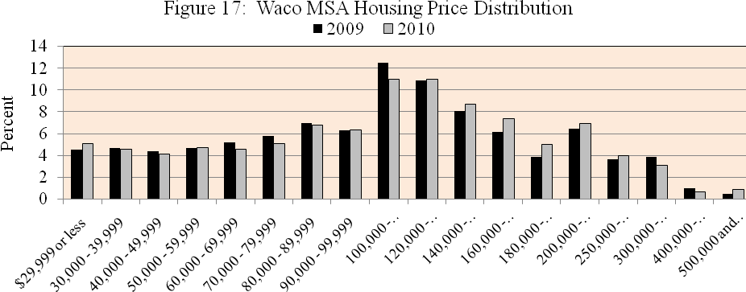
Source: Texas A&M Real Estate Research Center

The average selling price of single family residences sold each month through July 2011 compared with the same month a year ago is shown in figure 18. Average selling prices were either unchanged or increased during the most recent six months ending in July, which is not surprising since the average price exceeded the $120 thousand threshold for which market prices have been rising.

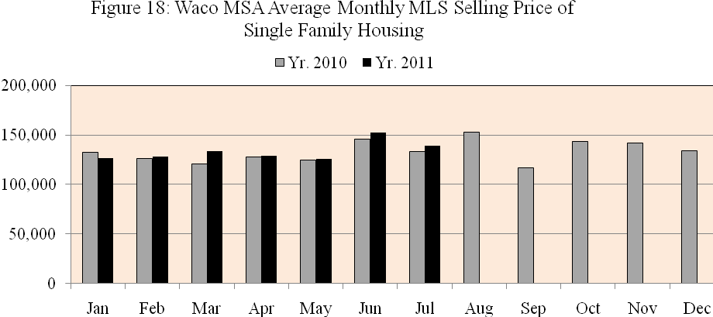
Source: Texas A&M Real Estate Research Center

The increase in the average selling price of existing housing compared with the previous year does not necessarily mean an appreciation of individual housing values but, rather, it may reflect higher market activity among higher priced structures. A shift of market sales toward higher priced housing indicates stronger demand growth for existing housing than predicted by total units sold.
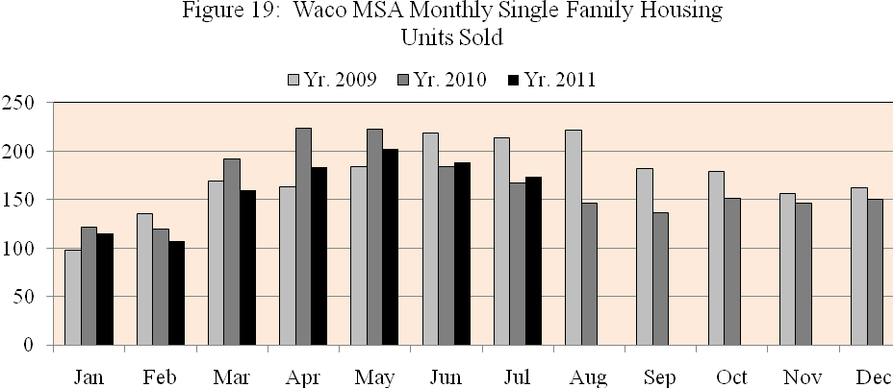
Source: Texas A&M Real Estate Research Center
Figure 19 shows that not only did the price of houses sold increase but also the number of unit sold improved in June and July compared with the same month a year ago. It may be too early to predict a significant change in the Waco housing market, there has been renewed interest among developers of new subdivisions in the area.

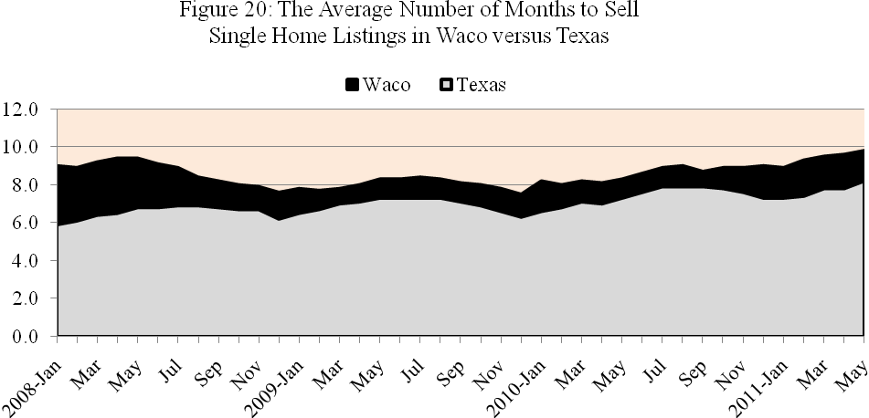
Source: Texas A&M Real Estate Research Center

Figure 20 shows that the rate of sales relative to the number of homes listed increased the average number of months it takes to sell a home to 10 months in mid-year 2011, which is well above the statewide average. The higher rate of sales in June and July compared with a year ago was matched by an increase in the number of listings with little effect on the inventory turnover rate. It appears that more existing home owners are anxious may be interested in trading up to higher priced existing housing or in purchasing a new home. (It appears that success in lowering the turnover rate of existing housing is faces a similar effect as success in lowering the unemployment rate when an increase in the rate of employment encourages more persons to enter the labor force.)

Waco MSA Building Permits

Figure 21 shows the annual growth rate in single family housing in Waco and Texas from 2003 through 2010. The annual growth rate in Waco MSA single family building permits reached 27 percent in 2004 and 2005 before experiencing slight negative growth from the previous year in 2006. Negative growth continued from 2007 through 2009 before improving slightly in 2010. The Texas homebuilding industry experienced a similar pattern in reduced housing starts over the same period.
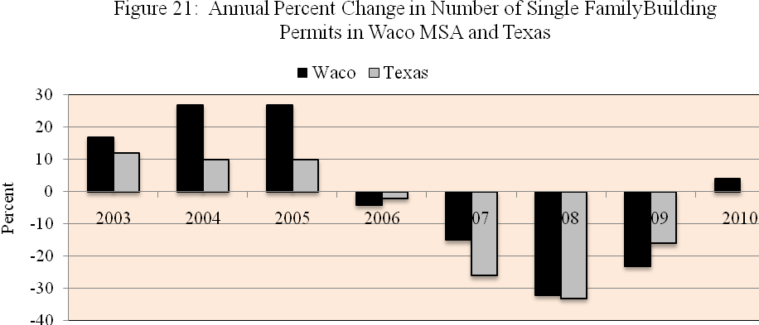
Source: Texas A&M Real Estate Research Center

A first thought is that housing demand could have fallen in response to an increase in mortgage interest rates. Among other local factors in addition to mortgage rates that could determine the demand for new housing are inventories of existing housing, the area’s housing affordability index, average new housing prices, annual income, change in area population, the unemployment rate, and the Texas consumer confidence index.

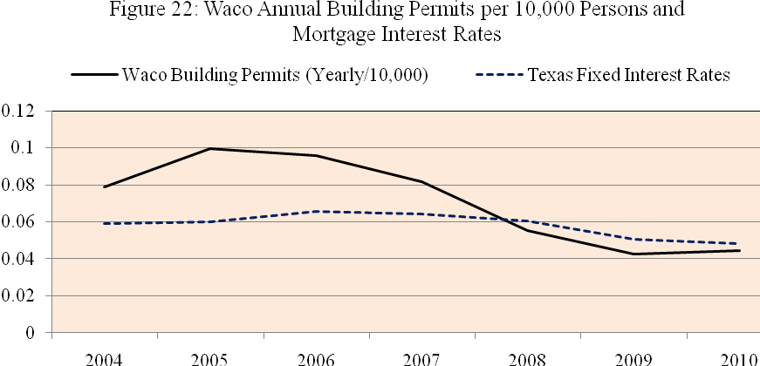
Source: Texas A&M Real Estate Research Center and Texas Ahead
A stepwise regression that included potential factors that could affect building permits led to the following forecasting equation that included four statistically significant predictor variables. These variables that explained 86 percent of the variation in annual building permits led to the following results:

Y = -1259.6 + 29,940.4 X₁ – 486.9 X₂ – 0.00000014 X₃ + 0.0175 X₄
where
X₁ is the Texas fixed interest rate on mortgages
X₂ is the percent change in the Waco population
X₃ is the total annual Waco income
X₄ is the average value of dwelling units

The positive effect of mortgage rates suggests that potential buyers may be more sensitive to expected future rates than to existing rates. Falling mortgage rates may cause people to delay the purchase of a new home on the expectation that rates will fall further in the future. The positive relation between average value of housing units and building permits reflects the impact on housing demand of a change in its overall asset value compared with alternative assets purchases. Growth in population and annual income affected housing demand as expected. Based on these variables a conditional point forecast of single family housing building permits in 2012 amounts to 455 units based on projected fixed mortgage rates of 5.1 percent, change in population of 1.1 percent, total area income of $15,065 million, and average housing value of $164.2 thousand. The standard error of the forecasting model was 128 units or about +/- 28 percent of the point estimate. The relatively wide range in the prediction interval illustrates the difficulty in forecasting housing starts based on traditional causal variables. It also means that favorable gains in household confidence that is not easily measurable could result in significantly more housing starts next year than predicted by our point forecast.

Housing Affordability

Table 7 shows the housing affordability rate (measured by the ratio of median family income to the level of income needed to qualify for an 80 percent, fixed-rate mortgage to purchase the median priced home) for all area homebuyers and first time homebuyers in Waco compared with the Texas average. Historically, even though Waco median household income has been below the state average, Waco has enjoyed a significantly lower cost of living led by more stable and affordable housing than in many other parts of Texas and the country. However, just as Waco median home prices did not increase as much as other regions prior to the recession they have not fallen sharply during and following the recession, so that Waco’s affordability advantage has narrowed relative to the Texas and the U.S. averages, except in the lower price range attractive to first time homebuyers. While the affordability rate for existing homeowners in Waco did increase in 4th quarter 2010, it grew at a slower pace than in other parts of state and the nation. The narrowing of the affordability rate may be one reason why the turnover rate of existing single family housing in Waco decreased relative to the state average.

Table 7: Housing Affordability Index¹ in U.S., Texas, and Waco MLS Area

¹The Housing Affordability Index is the ratio of median family income to the income required to qualify for an 80 percent, fixed-rate mortgage to purchase the median priced home.
MLS Area |  |  | 4th Qtr  2010 |  |  | 3rd Qtr  2010 |  | 4th Qtr  2009 |  |  | 2009 |  |  | 2008
First-Time Homebuyers
Waco |  | 1.98 |  |  | 1.69 |  | 1.98 |  |  | 1.98 |  |  | 1.44
Texas | 1.41 |  |  | 1.42 |  |  |  | 1.41 | 1.41 |  |  | 1.12
USA Total | 1.01 |  |  | 0.99 |  |  |  | 1.01 | 1.01 |  |  | 0.75
All Area Homebuyers
Waco |  |  | 2.47 |  |  | 2.20 |  | 2.27 |  |  | 2.21 |  |  | 1.84
Texas |  |  | 2.42 |  |  | 1.93 |  | 1.92 |  |  | 1.88 |  |  | 1.59
USA Total |  |  | 2.29 |  |  | 1.78 |  | 1.79 |  |  | 1.77 |  |  | 1.33
Source: Texas A&M Real Estate Research Center

Historically, even though Waco median household income has been below the state average, Waco has enjoyed a significantly lower cost of living led by more stable and affordable housing than in many other parts of Texas and the country. However, just as Waco median home prices did not increase as much as other regions prior to the recession they have not fallen sharply during and following the recession, so that Waco’s affordability advantage has narrowed relative to the Texas and the U.S. averages, except in the lower price range attractive to first time homebuyers.
Builders are understandably cautious, but some developers are becoming more optimistic based on recent sales in the intermediate price range between $140,000 and $200,000. In October the Waco MSA was one of 23 individual housing markets nationwide to receive recognition as “improving” by the National Association of Home Builder’s First American Improving Markets Index (IMI). To achieve this recognition a metro area must see growth in industry employment from the BLS, house price appreciation from Freddie Mac, and housing permit growth from the U.S. Census Bureau for at least six months following their respective troughs.
We are well into 2011 and Waco metro area population is increasing at about a one percent annual rate adding about one thousand households per year, but new single family housing starts are increasing at an annual rate of about 450 units. Demand for additional rental and owner occupied housing is beginning to push up prices and set the stage for additional housing investment in 2012. Already new housing developments have been announced that will add 120 new building lots to the area. Residential construction will not lead the job market recovery like it did following the 2001 recession, but if other components of Waco economy base continue to improve as expected, then the increase in employment and income will provide a positive stimulus to spending on residential construction in 2012.

Summary and Conclusions

In preparing this 2012 forecast of the Waco economy in early 3rd quarter 2011 I probably could not have found a worse time. Like all of us, I was dismayed over the plunge in the stock market in response the worsening of the European debt crisis, U.S. politicians’ fight to the final hours over terms needed to raise the debt ceiling, Standard & Poor’s downgrade of the nation’s long-term bond credit rating, and a growing steam of analysts predicting a double-dip recession. The Dow-Jones Industrial Average fell 16 percent from July 21 to August 10 and like many of you I fretted over what this meant about any future retirement plans. The BEA had issued its revision of the 2nd quarter real GDP growth downward to only 1 percent growth, resulting in a cumulative average growth rate of 0.7 percent over the first half of the year. I took some hope in my experience that even if the nation slumped back into recession the Waco economy has been historically more stable than the nation. This evidence was reinforced by a shift-in-share analysis that showed the during the 2008-2010 period Waco lost one-half the number of jobs it could have lost had the recession affected local employers in each industry by the same rate as the national average. I have also regained some personal hope as the Dow regained about half of its early August loss by the first of September.
I was also encouraged by the fact that output by manufacturers in the U.S. managed to expand in August for the 25th straight month with a significant shift in share to local manufacturing establishments. American consumers also kept shopping in August despite the July drop in the Conference’s Board consumer confidence index. Fewer people also applied for unemployment insurance in August, giving some hope to the job market even though gains were not enough to lower the nation’s unemployment rate from 9.1 percent. While more recent evidence is that the economy is unlike to experience a double-dip recession, there is still concern over whether the expansion is strong enough to lower the unemployment rate, raise wages, and drive the housing market out of its doldrums.
The big question moving forward, even for the local economy, revolves around sources of growth in output and jobs in the global economy, especially in factory output. Waco manufactures employ 14.3 percent are employment and account for 21.6 percent of its total sales output. U.S. manufacturers barely expanded operations in August as they adapted to a slowdown in demand around the world, not just in the U.S. and Europe but around the world. Growth in China and other emerging countries has been driving up the demand for commodities and agricultural products, as well as machinery and technology needed for rapid industrialization. Texas has led all states in job creation since the end of the recession, benefitting energy intensive areas of the State and manufacturing centers that are strong exporters, like Waco. For now, the picture in manufacturing is mixed, but China is taking steps to slow it breakneck pace of growth threatened by overheating. Other developing countries that purchase our manufactured goods are being dragged down by slower growth in Europe and the U.S. economies. Slowdowns in different parts of the world are feeding off each other.
Across the U.S., including Texas and Waco, the slowdown in public spending threatens to weaken the economy in coming months unless employment gains occur in the private sector. At this point business firms don’t appear to have stepped up layoffs. In fact, companies are willing to fill critical positions that become vacant, but this is not adding significantly to the number of new positions. In preparing this forecast I have come to appreciate the immense uncertainty in the marketplace weighing on firms investment and hiring decisions. Some of this is due to uncertainty over public policy not just in this country but around the world. By the first of September Brazil’s central bank, which had raised interest rates five times this year, cut them amid concern over how the global slowdown will affect the Latin America’s largest economy. In Asia, many central banks are raising rates to fight inflation. In Europe the ECB recently acted to lower interest rates after keeping them relatively high to meet their inflation target. In the U.S. the Federal Reserve promises to keep the federal funds rate near zero, and there is increased speculation that they may again pursue bond purchases to lower long term rates. The White House has even down shifted its forecast of economic growth and employment for the rest of 2011 and for 2012, even in the face of an election year.
In the face of all of this uncertainty I am tempted to excuse myself from making any forecasts; and I must honestly confess that I am hesitant to place a number on any measure. However, because I like to look back on my successes and my failures (which I try to forget) I will throw out a few numbers. Waco price inflation will average 2.5 percent in 2012 as food and energy prices slow their current pace of increase due to slower global commodity demand. Nonfarm employment will increase by 2.5 percent in 2012 with all net gains taking place in the private sector led by job growth in the information and business and professional service sectors and stable growth in the healthcare & education and leisure & hospitality industries. The Waco unemployment rate will decrease to 8 percent in July 2012 compared with 8.4 percent in July 2011. Waco real output will start slow but average 3 percent in 2012, reaching 3.5 percent by the end of the year. The prime interest rate will be slightly above 3.25 percent throughout the year. The thirty-year conventional mortgage rate will average 4.75 percent.

