Waco MSA Economic Forecast for 2011
by
Tom Kelly, Director
Baylor Center for Business and Economic Research

The U.S. economy officially entered into recession in February 2007 reached bottom in June 2009 during which the nation’s economy shrank by 4.15 percent. The large aggregate shock had equivalent shocks on the labor market, resulting in a loss of 8.3 million jobs and an increase in the U.S. unemployment rate from 4.7 percent to 10.1 percent in late 2009. In September of 2010 more than 14.5 million people were officially unemployed and many more are underemployed. More striking is the length of time that people remain unemployed. The average length of time that current unemployed workers stay out of work is 34 weeks, about 50 percent longer than at cyclical peaks.
The unemployment rate is the primary indicator used to measure the health of the labor market, but it does not give information about the underlying causes. In any given month some employed workers lose their jobs, measured by the separation rate, and some workers find jobs, measured by the job finding rate. The recent recession is following the typical cyclical pattern of job separation versus job finding. Specifically, the job separation rate increases rapidly at the onset of the recession, then levels off before the unemployment rate peaks and decreases during the latter part of the downturn. After the separation rate levels off, most of the subsequent increase and duration of the cyclical component of the unemployment rate is caused by the low job finding rate. Low job finding rates explain the existing persistence of long-run unemployment.
The headline jobless figure of 9.5% nationwide is bad enough, but unemployment rate does not begin to convey the problem as it fails to measure those who have become discouraged and quit looking for work. Over the second quarter of 2010 alone more than a million U.S. jobseekers fell out of the labor force reaching a total of 5.9 million in the ranks of persons who are finding their jobless status becoming a permanent state of hopelessness. Not only are private employers reluctant to add workers, but government cuts are sweeping through cities and states, threatening tens of thousands of jobs and slicing away at services once thought vital, including schools, street lighting, libraries, refuse collection, and public transport networks.
By August 2010 it became evident that the early year inventory-cycle boost was over and the government stimulus boost was fading. The strength in the private sector from exports and business equipment spending was also weakening. Businesses which had earlier generated higher than expected net earnings through job cuts and rising labor productivity have stripped their workforce down to the “bare bones” and face falling labor productivity in producing more output. Still, they remain reluctant to add workers when threatened by slower growth in sales revenue and uncertainty regarding changes in public policy. As a result, analysts are downsizing forecasts of growth in output for the remainder of the year that, while sufficient to keep the economy out of recession, will not be enough to significantly lower the unemployment rate.

The Waco MSA Unemployment Rate

The U.S. Bureau of Labor Statistics surveys households each month to determine estimates of unemployment rates among selected geographic areas. The unemployment rate is measured by the percent of the labor force that is unemployed. The labor force is the number of persons 16 years of older that are not in institutions who are currently working or actively seeking employment. Economists allude to the impact of “search costs” that increase for jobseekers during recession as a reason for “disguised” unemployment that is not reflected by the BLS survey. In addition to the duration of employment the unemployment rate also fails to measure the extent of full time versus part time employment or under employment by workers in lower paying jobs compared with previous occupations. Nevertheless, the household survey does benefit from the fact that jobs may be performed by sole proprietorships that are not included in the BLS establishment survey.
Figure 1 shows the Waco MSA seasonally-adjusted monthly unemployment rate and the annual rate of change in the labor force and employment from the same month in the previous year from January 2007 through mid 2010. (Reported BLS monthly unemployment data has not been seasonally adjusted.)
Figure 1: Waco MSA Annual Percent Change in the Labor Force and Employment
and Seasonally-adjusted Monthly Unemployment Rate

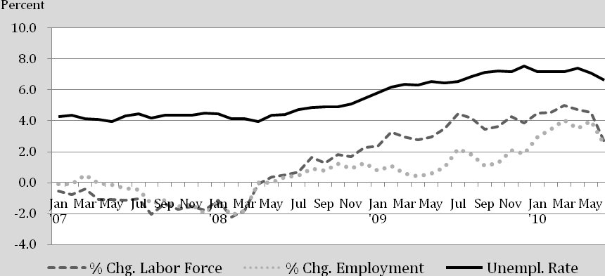
Source: U.S. Bureau of Labor Statistics

Throughout 2007 the Waco MSA was able to sustain an unemployment rate of slightly above 4 percent despite a slight reduction in the number of household workers. The reason for the stable unemployment rate can be attributed to a reduction in the labor force at about the same rate as the reduction in employment. Since May 2008 the Waco MSA household survey has reported continuous growth in employment that exceeded the level reached during the same month of the previous year. However, over the same period the Waco MSA labor force increased faster than employment, resulting in an increase in the seasonally-adjusted unemployment rate to a peak of 7.6 percent in December 2009. (The reported non seasonally-adjusted rate for December 2009 is 6.9 percent, but fewer seasonal jobs occurred than normal during last year’s peak holiday period.)
A part of this increase in the labor force is from existing residents, but among geographic areas the unemployment rate also changes in response to relative employment opportunities that affect migration of workers among regions. In 2007, local transitory workers were flocking to other parts of Texas, especially to larger metropolitan areas and regions ‘fueled’ by higher energy prices. But beginning in May 2008 the Waco MSA labor force began to increase rapidly causing an increase in the local unemployment rate despite rising employment. Beginning in early 2008 local commercial and public construction projects increased significantly, several in response to public bond elections, attracting transitory construction workers. Gains in early 2010 also reflected Census workers that temporarily increased the labor force and employment. By March 2010 the annual rate of change in local employment reached 4 percent, but growth in the labor force reached almost 5 percent, so that the local unemployment rate increased. In July 2010, the reported unemployment rate reached 7.5% compared with 7.2% a year ago, but total employment increased by 940 jobs compared with July 2009.

Table 1
Level and Annual Rate of Change in the Labor Force, Employment, and
Unemployment Rate in Selected Texas MSA’s in July 2010

Selected Texas Metro Area | July 2010 |  |  | Annual Percent Change
 | LF | EMPL | Un Rate | LF | EMP | Un Rate
Abilene | 85,005 | 79,205 | 6.8 | 1.56 | 1.23 | 0.3
Amarillo | 134,887 | 127,051 | 5.8 | 0.7 | 0.79 | -0.1
Austin-Rd Rock-San Marcos | 917,551 | 850,427 | 7.3 | 3.03 | 3.22 | -0.2
College Station-Bryan | 114,018 | 106,337 | 6.7 | 3.44 | 3.17 | 0.2
Dallas-Fort Worth-Arlington | 3,254,047 | 2,977,029 | 8.5 | 1.77 | 1.69 | 0.1
Houston-Sugar Ld-Baytown | 2,902,632 | 2,647,352 | 8.8 | 0.43 | 0.15 | 0.5
Killeen-Temple-Fort Hood | 168,327 | 155,079 | 7.9 | 3.35 | 2.79 | 0.5
Lubbock | 148,804 | 138,817 | 6.7 | 1.86 | 1.29 | 0.5
Midland | 74,954 | 70,685 | 5.7 | 0.62 | 0.42 | -1.0
Odessa | 70,524 | 64,668 | 8.3 | -1.2 | 0.59 | -1.6
San Antonio-New Braunfels | 985,210 | 908,909 | 7.7 | 0.66 | 0.13 | 0.4
Tyler | 101,599 | 93,455 | 8.0 | 0.07 | 0.25 | -0.2
Waco | 118,612 | 109,690 | 7.5 | 1.22 | 0.86 | 0.3
Wichita Falls | 73,635 | 67,619 | 8.2 | 0.12 | 0.21 | 0.1
Source: Texas Workforce Commission

Data in Table 1 show that Waco is not the only Texas Metro Area that has experienced a higher unemployment rate at the same time that total employment is rising. Abilene, Bryan-College Station, Killeen-Temple, and Lubbock are other intermediate sized areas with rising unemployment rates due to higher growth in the labor force than employment. It also shows that relatively low unemployment rates can exist in slower growth areas, such as Amarillo and Midland. Only the Austin-Round Rock-San Marcos MSA experienced strong employment growth with a slightly lower unemployment rate.

Texas and Waco MSA Nonfarm Employment

Establishment data gathered by the U.S. Bureau of Labor Statistics illustrated in figure 2 show that the State of Texas and the Waco MSA economies have outperformed the national average over the past several business cycles, although they are not immune to adverse business cycle influences. The three most recent national recessions officially began in March 1991, March 2001, and December 2007.

Figure 2: Annual Percent Change in Mid-year
Nonfarm Employment in Waco MSA versus State of Texas

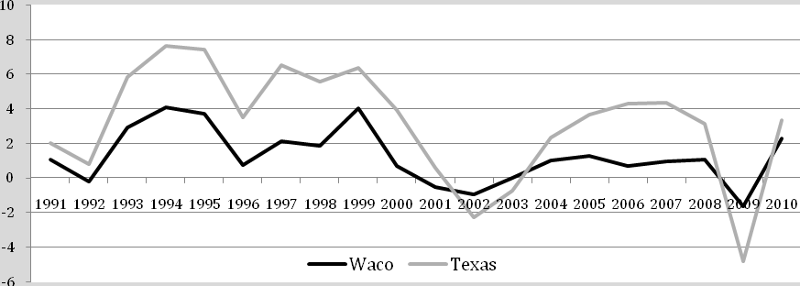
Source: U.S. Bureau of Labor Statistics

The annual rate of change in mid-year nonfarm employments confirms Waco’s reputation for greater cyclical stability than the State average both during the expansion and contraction phases of the business cycle. During the most recent 2001 recession Waco job losses mirrored nationwide performance and led statewide losses, but the loss of high tech jobs impacted metro areas such as Austin more severely than the local economy. During the 2007 recession the loss of jobs statewide and in the Waco MSA lagged the loss of jobs nationwide and again was less severe in Waco than the state average. In 2008, Texas added 252,000 jobs, ranking first among the states, while over the same period the U.S. economy lost 279,000 jobs. In 2008, the Waco MSA (McLennan County) added 900 jobs, an increase of 0.8 percent but less than half of the statewide rate of growth.
Both the Texas and the Waco economies have benefitted from greater stability in housing markets compared with the national average, but Texas also benefitted from rising energy prices until late 2008. Much of the higher relative success of the state performance compared with Waco in 2008 can be attributed to the favorable economic impact of rising early year oil prices on energy producing regions of the state. Waco does not have a significant energy producing sector, so that higher energy prices had no direct benefit locally but, rather, had an adverse impact on local spending due to higher gasoline prices that reduced household discretionary income. By late 2008, as energy prices fell in response to slower global demand, Waco’s economy emerged as more stable that the statewide average.
Despite early resistance to the national cyclical downturn both the Texas and the Waco MSA economies could not escape the plunge in consumer spending that occurred in late 2008. By early 2009, a year after the beginning of the national recession, Texas and the Waco MSA joined the rest of the country in losing jobs as many employers throughout the country reduced their workforce when faced with declining revenues. In 2009, Texas lost 296,000 nonfarm jobs, a decrease of 2.8 percent, while the Waco MSA experienced a loss of 1,350 jobs, a decrease of 1.3 percent.
While figure 2 shows Waco MSA annual mid-year performance, a more detailed monthly view of seasonally-adjusted nonfarm employment over the past decade is shown in figure 3. The impact of the 2001 recession and “jobless recovery” resulted in the loss of 2.1 thousand jobs in the Waco MSA before it returned to pre-recession levels in late 2003 about 32 months after the beginning of the recession. However, over the 5-year period from mid 2003 through late 2008 Waco MSA nonfarm establishments added 6.1 thousand additional jobs, averaging 1.1 percent job growth per year.
Figure 3: Waco MSA Seasonally-adjusted
Monthly Nonfarm Employment, 2000-2010

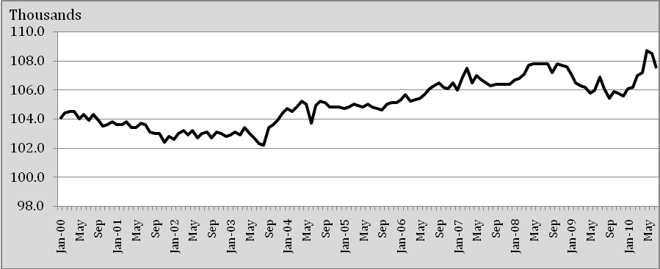
Source: U.S. Bureau of Labor Statistics

In May 2008, Waco’s seasonally-adjusted nonfarm employment reached a peak of 107.8 thousand workers and lost only 200 jobs by the end of the year. However, by September 2009 Waco’s seasonally-adjusted nonfarm employment had decreased another 2,200 jobs, representing a peak to trough decline of 2.2 percent. This rate of local job cuts in 2009 was significantly faster than during the 2001 recession, but it rebounded in January 2010. By May 2010, Waco MSA seasonally-adjusted nonfarm employment had reached 108.7 thousand jobs that amounted to 900 more jobs than the 2008 peak prior to the downturn. However, before celebrating this apparent rapid business cycle recovery in early 2010 it must be recognized that much of the gain was due to inventory restocking, temporary government stimulus programs, and hiring of temporary government census workers.
Figure 4 shows nonfarm seasonally-adjusted employment by private sector employers in the Waco MSA over the past 10 years. Private seasonally-adjusted nonfarm jobs reached at peak in June 2008 of 90.3 thousand workers before falling to a low of 86.7 thousand in September 2009. Although seasonally-adjusted private nonfarm establishment employment in July 2010 improved by 1.8 thousand jobs from the September 2009 trough, private establishment jobs remained 1.6 thousand workers below the June 2008 peak. Clearly public sector jobs have temporarily helped to soften the blow of the recession, but it is increasingly clear that improved future economic performance locally and nationwide will increasingly rely on growth in the private sector.

Figure 4: Waco MSA Seasonally-adjusted
Private Sector Nonfarm Employment

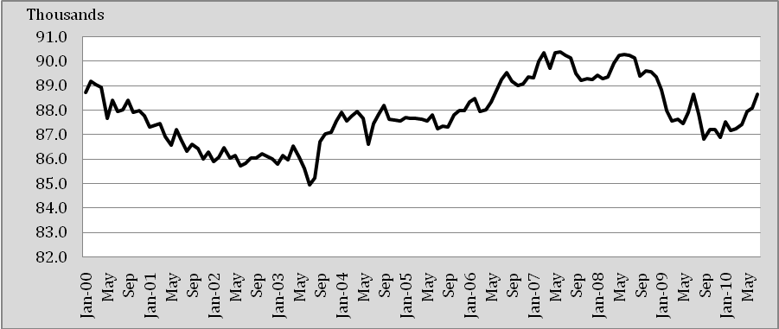
Source: U.S. Bureau of Labor Statistics

The Central Texas Inflation Rate

Figure 5 shows the annual percent change in the central Texas bi-monthly consumer price index (CPI) and the “core” inflation rate equal to the percent change in the CPI less food and energy.

Figure 5: Central Texas Bi-monthly Consumer Price Index

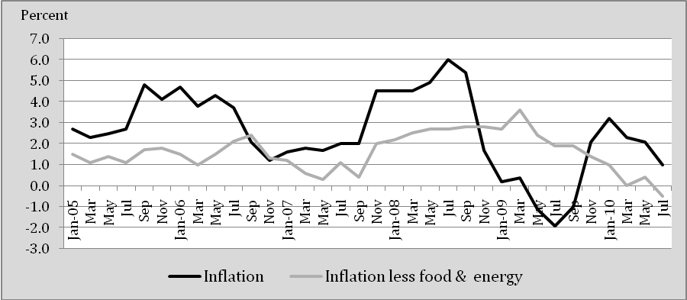
Source: Baylor Center for Business and Economic Research
The central Texas inflation rate, as in other parts of the country, has been particularly sensitive to energy prices over the past three years, beginning in late 2007. In July 2008, higher gasoline prices peaked at over four dollars per gallon providing the principal reason for consumer prices in central Texas averaging 6 percent higher than in July 2007. Over the same period the core inflation rate was less than 3 percent. In the fourth quarter of 2008, the actual inflation rate fell below the core rate reflecting the effect of collapsing energy prices that continued until late 2009. In July 2010, the Central Texas core inflation rate was negative as the economic slowdown substantially reduced the demand for goods and services putting downward pressure on prices.
Concern over possible deflation has postponed the willingness of the Federal Reserve to reduce the money supply or engage in any policy that would raise interest rates. Nevertheless, there are some pundits that cite the large volume of excess reserves as a source of potential growth in the money supply that could create inflation in the future. At this time, however, there is little reason to expect either deflation or accelerated inflation in the near future. The “spread” between the actual and the inflation-indexed 10-year Treasury bond rate in mid October was 1.8 percent indicating that expected inflation by bond investors will average less than the Fed’s unofficial target rate of about 2 percent. I would expect that inflation will remain between one and two percent in 2011.

Components of Private Employment in Waco MSA

If growth in employment by private establishments is the key to job growth in the local economy, then in what industries are they likely to occur? Tables 2 and 3 summarize the industry location of private employment in 2009 in Waco compared with the nation and the State of Texas. Also presented are Waco MSA location quotients for 2008 and 2009 that divide the percentage of average employment in an industry locally by the percentage of average employment in the same industry in the United States and in Texas, respectively. Location quotients above 1 generally signal an industry produces more than can be locally consumed and, thus, adds to an area’s economic base by exporting to outlying regions.
Table 2
U.S. and Waco MSA Private Employment by Industry in 2009 and
Waco Location Quotients in 2008 and 2009¹

Industry | U.S. Total 2009 | Waco 2009 | Waco LQ 2008 | Waco LQ 2009
Total, all industries | 106,946,360 | 83,480 | 1.00 | 1.00
Agriculture, forestry, fishing and hunting | 1,142,142 | 157 | 0.19 | 0.18
Mining, quarrying, oil and gas extraction | 641,487 | 159 | 0.34 | 0.32
Utilities | 560,707 | 516 | 1.76 | 1.18
Construction | 5,949,527 | 6,115 | 1.10 | 1.32
Manufacturing | 11,810,333 | 14,379 | 1.52 | 1.56
Wholesale trade | 5,562,388 | 3,886 | 0.93 | 0.90
Retail trade | 14,545,184 | 10,749 | 0.95 | 0.95
Transportation and warehousing | 3,985,169 | 2,268 | 0.77 | 0.73
Information | 2,807,216 | 1,514 | 0.73 | 0.69
Educational services | 2,420,297 | 3,598 | 1.87 | 1.90
Health care and social assistance | 15,892,995 | 12,748 | 1.07 | 1.03
Arts, entertainment, and recreation | 1,921,819 | 740 | 0.49 | 0.49
Finance and insurance | 5,616,544 | 4,660 | 1.12 | 1.06
Real estate and rental and leasing | 1,971,694 | 1,538 | 1.01 | 1.00
Professional and technical services | 7,479,927 | 2,443 | 0.39 | 0.42
Management of companies | 1,855,648 | 682 | 0.27 | 0.47
Administrative and waste services | 7,153,640 | 5,374 | 0.99 | 0.96
Accommodation and food services | 11,078,396 | 8,990 | 1.02 | 1.04
Other services, except public admin. | 4,369,634 | 2,944 | 0.88 | 0.86
Unclassified | 181,612 | 20 | 0.15 | 0.14
¹Location Quotients are equal to the percentage of total employment in each industry locally divided by the percentage of total employment in the same industry nationally. Source: U.S. Bureau of Labor Statistics
Table 3
Texas and Waco Private Employment by Industry in 2009 and
Waco Location Quotients in 2008 and 2009¹

Industry | Texas -- 2009 | Waco 2009 | 2008 LQ | 2009 LQ
Total, all industries | 8,366,570 | 83,480 | 1.00 | 1.00
Agriculture, forestry, fishing and hunting | 58,069 | 157 | 0.28 | 0.27
Mining, quarrying, and oil & gas extraction | 202,996 | 159 | 0.08 | 0.08
Utilities | 48,002 | 516 | 1.59 | 1.08
Construction | 597,538 | 6,115 | 0.90 | 1.03
Manufacturing | 837,134 | 14,379 | 1.69 | 1.72
Wholesale trade | 498,916 | 3,886 | 0.81 | 0.78
Retail trade | 1,141,651 | 10,749 | 0.95 | 0.94
Transportation and warehousing | 354,487 | 2,268 | 0.67 | 0.64
Information | 205,130 | 1,514 | 0.78 | 0.74
Educational services | 114,935 | 3,598 | 3.11 | 3.14
Health care and social assistance | 1,135,815 | 12,748 | 1.18 | 1.12
Arts, entertainment, and recreation | 109,595 | 740 | 0.68 | 0.68
Finance and insurance | 445,773 | 4,660 | 1.11 | 1.05
Real estate and rental and leasing | 175,247 | 1,538 | 0.88 | 0.88
Professional and technical services | 561,414 | 2,443 | 0.40 | 0.44
Management of companies | 76,534 | 682 | 0.53 | 0.89
Administrative and waste services | 612,823 | 5,374 | 0.91 | 0.88
Accommodation and food services | 895,278 | 8,990 | 1.00 | 1.01
Other services, except public admin. | 290,918 | 2,944 | 1.03 | 1.01
Unclassified | 4,315 | 20 | 0.48 | 0.46
¹Location Quotients are equal to the percentage of total employment in each industry locally divided by the percentage of total employment in the same industry statewide.
Source: U.S. Bureau of Labor Statistics
A comparison in Table 2 between Waco MSA and U.S. average private establishment employment among industries in 2009 results in location quotients significantly above 1 for utilities, construction, manufacturing, and educational services. The change in an industry location quotient between 2008 and 2009 represents a shift in the share of jobs nationally or statewide that occur in local establishments that may have been impacted by the economic downturn. Location quotients in each of the above industries increased in 2009 compared with 2008, indicating that these industry components of the Waco MSA economic base were more resistant to the cyclical downturn than the national average.
When compared with the statewide totals in 2009 the Waco MSA averaged 72 percent more manufacturing jobs, 214 percent more educational service jobs, and 12 percent more jobs in health care and social assistance, not counting public jobs at the VA hospital. From 2008 to 2009 Waco annual average employment in manufacturing and in educational services increased relative to the state average but fell slightly in healthcare and social assistance in the private sector. In 2009, Waco also had 6percent more jobs in finance and insurance than the state average, but its share fell from 11 percent above the state average in 2008.
The largest deficiencies in local employment compared with statewide averages in 2009 occurred in professional and technical services, 56 percent (L.Q. = 0.44); transportation and warehousing, 36 percent; art, entertainment, and recreation, 32 percent; and information, 26 percent. Wholesale and retail trade jobs are also 22 percent and 6 percent less, respectively, than expected based on statewide averages, and their shares fell slightly in 2009 compared with 2008.
Differences in a region’s relative employment size and growth is dependent of such factors as the population size and density, geographic location, and historical location decision of employers such as Baylor University. Many of the factors are self-reinforcing, such as the presence of an international airport that attracts employers of professionals, and sports franchises that attract other entertainment and hotel accommodation facilities. Agglomeration economies also attract clusters of higher technology firms that, in turn, support a larger and more varied retail sector. Also, because of its geographic proximity to Dallas and Austin the retail trade leakage from Waco to nearby larger metropolitan areas is higher than areas like Lubbock that are of similar size and income but are more geographically isolated from larger, more diverse competitors.
Largely as a result of Waco’s current industry structure, location, and recent performance the general consensus among regional economists is that the Heart of Texas region that includes Waco will grow slower than the Texas state average over the next decade unless there is some significant breakthrough affecting new industry growth. A promising long-run influence is the development of new industries associated with new product innovations fueled by the linkage between local education facilities and recently created Central Texas Research and Technology Park that is a collaborative of Baylor, TSTC, and state, county and city leaders. The Baylor Research and Innovation Collaborative (BRIC), housed in the former General Tire’s main building donated by Clifton Robinson, is an initial project that promises to be the catalyst for both high profile and startup companies researching new ideas. Ray Perryman forecasts that the park will have a $1.5 to $4.2 billion economic impact and create between 8,000 and 22,000 jobs in the first 15 years. When coupled with additional infrastructure and development of land in East Waco along the corridor between the BRIC location and downtown Waco and the further development of TSTC as an industrial airport linking with Waco with rising global demand, the ingredients and plans are place to significantly exceed current long-run growth expectations for the Waco economy.
In determining both the short run rate of recovery three industries sectors stand out as the key to near term economic recovery; namely, housing, retail trade, and manufacturing. These three sectors are most sensitive to changes in the production of inventories in response to initial changes in demand conditions. While the service sector is inherently more stable than the goods sector because it is not as dependent on inventory investment, it is not void of cyclical influences. In the discussion to follow I will review the specific outlooks for housing, retail trade, and manufacturing in the goods sector, and I will also examine recent and projected performance in visitor and travel related services, professional and business services, financial services, and healthcare and education services in order to project their expected performance in the near future.

The Outlook for Housing

The national recession that began in December 2007 was the worst since the Great Depression. By the end of 2008 it was clear that the damage to the housing sector was unusually severe, but this was not unexpected. After all, the financial crises that led to the recession began in the market for mortgage securities that originated in the housing sector. It is also apparent that the extent of damage in housing varied considerably among geographic areas in the country. Specifically, those areas that did not experience a significant housing price bubble were able to withstand a slower market without a free fall in housing prices. Lower housing prices not only increase foreclosures, but they also cause potential homebuyers to forestall home purchases under the expectation that lower prices will occur in the future.

Figure 6: Annual Percent Change in Quarterly Waco Housing Price Index
From Same Quarter of Previous Year

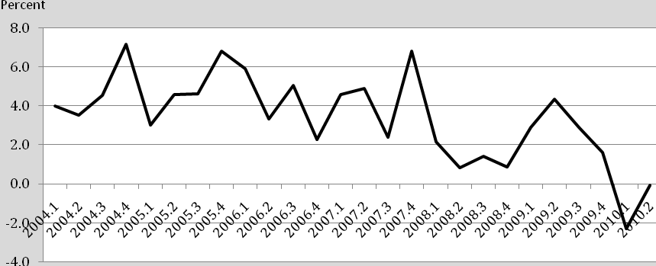
Source: Economagic: Waco, TX: House Price Index, Estimated using Sales Prices and Appraisal Data. 1995Q1=100

Figure 6 shows the annual percent change in Waco housing prices based on sales prices and appraisal data reported by Economagic. From 2004 through 2007 Waco housing prices increased an average of 4.5 percent from the previous year, faster than the average rate of change in the Central Texas consumer price index of 2.7 percent. However, the higher rate of increase in Waco area home prices cannot be described as a housing bubble led by speculative demand that drove housing prices ‘through the roof’ as in many parts of the country. In 2008 the rate of increase in average Waco MSA housing prices fell to 1.3 percent, well below the average rate of inflation of 4.3 percent that had increased because of rising energy and food prices. In 2009, average home prices increased by 2.5 percent, but over the first two quarters in 2010, as foreclosures continued to put downward pressure on the market, average home prices decreased an average of 1.6 percent marking the first time since the beginning of the Economagic price index series in first quarter 2005 that Waco MSA housing prices decreased.

Figure 7: Percent Change in Waco MLS Single Family Housing Unit Sales
From Same Month of Previous Year

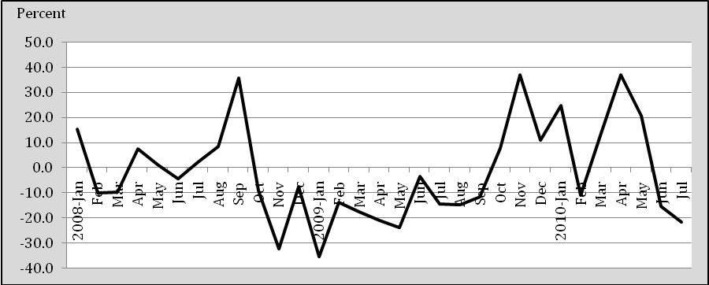
Source: Texas A&M Real Estate Research Center

Figure 7 shows the percent change in Waco MuliList unit sales of single family housing sales compared with the same month of the previous year since January 2008. MLS housing sales slowed over the period until late 2009 when sales improved with the help of government tax credits and falling mortgage rates. When tax credits expired it was hoped that lower mortgage rates would sustain housing demand, but June and July unit housing sales fell with July unit MLS sales falling 21.6 percent compared with July a year ago.
The Texas A&M Real Estate Research Center reports that in 2009 the Waco MSA affordability index, equal to the ratio of median family income to the income required to qualify for an 80 percent fixed-rate mortgage to purchase the median-priced home, increased to 2.21 from 1.84 in 2008, well above its previous high of 2.1 reached in 2004. Lower housing prices and record low mortgage rates have undoubtedly increased the affordability index even further in 2010.
To date, much of the benefit from low mortgage rates has been to existing households who have been able to refinance their mortgage loans and reduce their payments. Potential buyers may be waiting for another government tax credit or additional Federal Reserve purchase of securities to further reduce mortgage rates. But, the fundamental reason for lower housing demand is uncertainty about future income and job security that could limit the ability to make mortgage loan payments. The impact of job losses is a principal reason for the increase to 144 housing foreclosures in McLennan County offered for sale in September 2010 compared with 96 in September a year ago.

Figure 8: Average Number of Months to Sell MLS Single Home Listings at
Current Rate of Monthly Sales

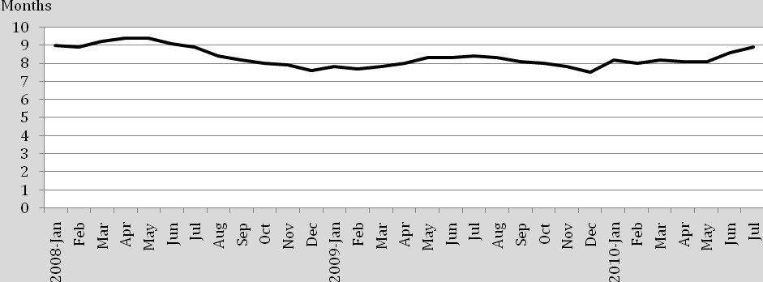
Source: Texas A&M Real Estate Research Center

Figure 8 shows the average number of months that it would take to sell the existing inventory of MLS single family houses based on the current monthly rate of sales. A 6 month selling period is often viewed as the break between a ‘buyers’ versus a ‘sellers’ market. The last year that the rate of MLS monthly single family sales averaged less than 6 months of existing inventories was in 2005. From 2006 through early 2008 monthly inventories increased faster than sales so that the inventory-to-sales ratio reached 9.4 months in April and May 2008, definitely a buyers’ market that put downward pressure on prices. Slower monthly sales add to the inventory of existing listings along with new listings, so that in July 2010 the 21.6 percent reduction in current sales following the expiration of the federal tax credit resulted in a 9 percent increase in listings compared with July 2009.

Figure 9: Annual Percent Change Waco MSA Building Permits
From the Previous Year

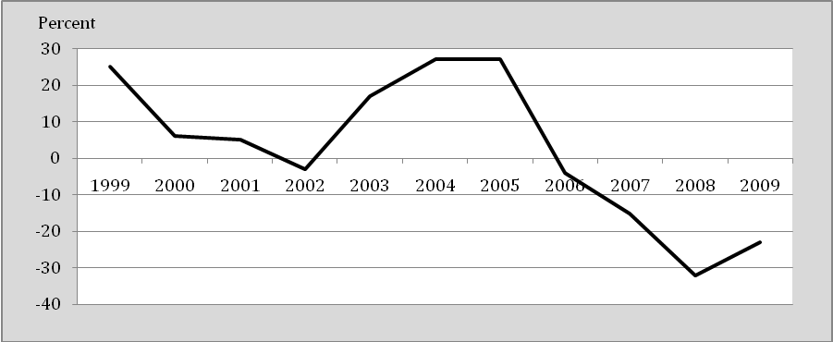
Source: Texas A&M Real Estate Research Center

The increase in inventories of existing housing provides an unfavorable setting for construction of new housing. Figure 9 shows the annual percent change in single family building permits issued each year in the Waco MSA over the 10-year period from 1999 through 2009. The decrease in building permits in 2001 and 2002 reflects a relatively modest negative impact during the 2001 recession on steady growth in new housing units that averaged 9.6% annually over the previous 10 years. Following the “jobless recovery” that ended in 2003 pent-up housing demand and stronger employment growth led to an increase in single family housing permits that reached a peak 997 units in 2005. Even though the annual rate of growth in housing permits fell in 2006 and 2007 the number of permits issued amounted to 958 and 816 units, respectively, which are the second and third strongest years on record in the Waco MSA. However, by 2008 the slower growth in sales of existing housing and the decrease in annual single family permits to only 551 units provided strong evidence that forces affection the national housing slump were impacting Waco’s housing market. In 2009 single family housing permits fell further to only 424 units and builders increasing turned to ‘contract’ rather than ‘speculative’ construction. In addition to slower demand by existing residents, the demand by retirees moving to Waco decreased as they also faced difficulty in selling existing housing throughout the country.

Figure 10: Waco MSA Single Family Building Permits over the
12-month Period Ending in January 2007 through July 2010

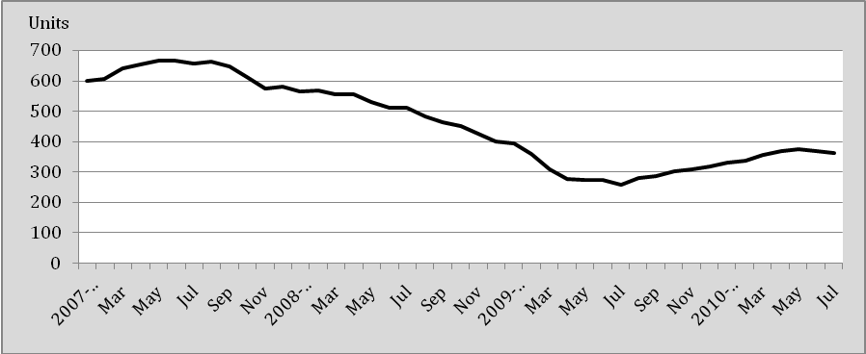
Source: Texas A&M Real Estate Research Center

Figure 10 shows that the number of new single family building permits over the previous 12-month period reached bottom in July 2009 and improved gradually in June and July of 2010. There has been talk of a “double dip” in the housing cycle that reflects the possibility of slower household spending in general. This is consistent with nationwide evidence that the housing market will not lead recovery in the economy but will reinforce the recovery when employment and income improves. Even a brief slump in housing demand by itself would not be enough to cause a “double dip” recession locally or nationwide. In the meantime, builders remain cautious and will continue to focus on individual contract construction in 2011 until job growth increases and it becomes clearer to households that the future promises higher prices and mortgage rates if they continue to delay their decision to purchase a new home.

The Outlook for Retail Trade

One of the biggest reasons for the slow recovery from the national recession has been the lack of growth in personal consumption spending. While the annual rate of increase in U.S. real GDP was 3.7 percent in the first quarter 2010 the contribution from personal consumption was only 1.33 percent. In the second quarter, personal consumption contributed only 1.38 percent to growth in U.S. real GDP that increased at an annual rate of 1.7 percent. Unless consumers step up domestic consumption the U.S. economy is projected to continue to experience relatively slow growth for the remainder of 2010 and 2011. The good news is that households have been increasing their savings rates out of current income by reducing their debts. The increase in current savings has been at the expense of current consumption. In the future households will be a better position to step up consumption from higher personal income and still retain their higher savings rates necessary to support their retirement years and reduce the need for U.S. borrowers to rely so heavily on savings from countries around the world.

Figure 11: Percent Change in Dollar Value and Inflation-adjusted Retail Sales in
Waco MSA from Same Quarter of Previous Year

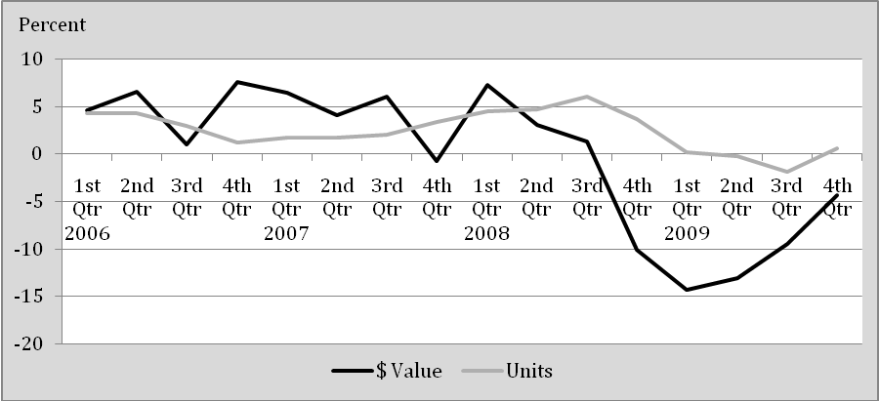
Source: Texas Comptroller of Public Accounts

Figure 11 shows the percent change in total retail sales in the Waco MSA for each quarter since 2006. The rate of growth in retail sales was relatively stable until the fourth quarter of 2008 following the collapse of the stock market that sent cold shivers among households who suddenly stopped spending not just in Waco but throughout the country. Negative growth in retail sales continued throughout 2009, although the rate of decrease from the same quarter of the previous year slowly improved. Since the values are in terms of current prices the fact that the rate of inflation in Central Texas slowed to virtually zero in 2009 from 4.3 percent in 2008 means that the decrease in unit sales was less than dollar sales, although most of the impact was in sectors affected by energy prices. After adjusting for the average rate of inflation unit sales fell in 2009 but not by nearly the rate indicated by dollar sales, so that during the fourth quarter of last year unit sales were virtually unchanged from the fourth quarter of 2008.

Table 4
Industry Gross Retail Sales in Waco MSA in Fourth Quarter 2009 and
Percent Change from Fourth Quarter 2008

Products
Products | Outlets 4th Qtr. 2009 | Outlets 4th Qtr. 2008 | Gross Sales  4th Qtr 2009 | 2008-09 Percent Change
Motor Vehicles | 256 | 296 | $143,073,731 | -17.20%
Home Furnishings | 115 | 126 | $16,661,501 | -6.70%
Electronics/Appliance | 90 | 98 | $34,557,013 | 5.50%
Building Materials | 100 | 102 | $45,162,627 | -9.80%
Food and Beverage | 130 | 131 | $128,354,096 | 11.00%
Health and Personal | 101 | 107 | $35,479,967 | 0.00%
Gasoline Stations | 177 | 180 | $116,353,486 | -4.00%
Clothing Stores | 368 | 365 | $32,256,537 | -1.70%
Sport/Hobby/Books | 197 | 188 | $29,771,041 | 6.40%
General Merchandise | 104 | 113 | $153,614,580 | -1.70%
Miscellaneous Stores | 1,364 | 1,464 | $39,172,086 | -4.60%
Nonstore, Other | 301 | 318 | $13,220,508 | -11.10%
Totals | 3,303 | 3,488 | $787,677,173 | -3.79%
Source: Comptroller of Public Accounts
Retail sales during the fourth quarter are the “make or break” period for many retailers. Table 4 shows that during the fourth quarter of last year sales of automobiles, home furnishings, and building materials were particularly hard hit by slumping demand. Clothing sales also fell as households shifted to lower priced items and purchased items for immediate needs. The reduction in the gross sales of gasoline stations was partly due to lower fuel prices that failed to increase unit sales, reflecting price inelastic demand. The strongest gains occurred in sales of food and beverages, especially by grocery stores. The increase in sales by electronics outlets was driven by a shift among many households to greater home entertainment with less spending on travel and entertainment. The pattern of demand in 4th quarter 2009 is typical of households during an economic recession as households postpone the purchase of durable goods and economize on purchases of food and household services.
As we enter into the fourth quarter of 2010 consumers continue to be cautious about the future to increase their savings rates which recently increased to over 6 percent as a percentage of disposable income compared to, at times, negative rates prior to the recession. Retailers are expected to continue to respond to slower spending with price incentives while they maintain conservative inventory levels. One favorable influence is that gasoline prices will remain relatively low helping to add to discretionary income.
Figure 12 shows the annual rate of change in quarterly sales tax receipts received by the City of Waco since the first quarter of 2005. The lower inflation rate during the second half of 2009 partially contributed to reduced sales tax receipts that are based on dollar rather than unit sales, but sales taxes fell faster than the rate of inflation. September 2010 year-to-date sales tax receipts for the city of Waco amounted to 73.2 percent of the total for all Waco jurisdictions. These receipts are based on sales for the previous two months and, hence, cover cumulated sales from November of 2009. The total for all jurisdictions in the county decreased 0.61 percent over the period while year-to-date sales tax receipts for the City of Waco fell 0.95 percent, indicating a slight shift in sales to outlying cities. Sales tax receipts are projected to increase during 4th quarter 2011 and gather some momentum in 2011.

Figure 12: Annual Percent Change in Quarterly
City of Waco Sales Tax Receipts

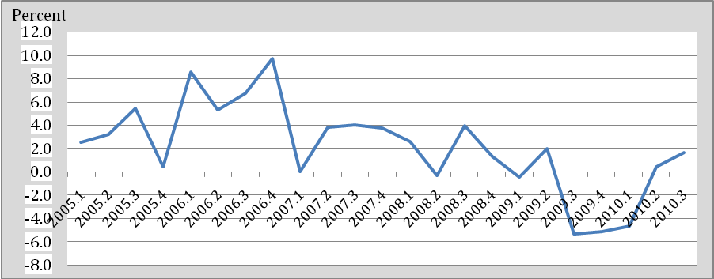
Source: Texas Comptroller of Public Accounts

Figure 13 shows that the decrease in retail sales has led to fewer retail trade employees. Since levels are compared with the same month of the previous year they do not reflect seasonal change but rather an attempt by area retailers to maintain profits by reducing labor costs as well as a shift in sales to less labor intensive big store retailers.

Figure 13: Annual Percent Change Monthly Retail Trade Employment in
Waco MSA from Same Month of Previous Year

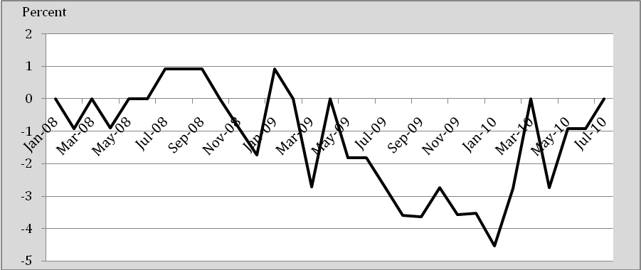
Source: U.S. Bureau of Labor Statistics

Many employers have cut personnel as much as possible, so that employment appears to be stabilizing, but retail trade employment growth is not projected to increase significantly except for seasonal purposes until households increase their rate of spending. Seasonal trade employment will increase in the fourth quarter due to seasonal demand that historically has increased Waco trade employment by 2.3 percent in November and 3.8 percent in December compared with the monthly average, temporarily adding about 400 jobs to the area.

The Outlook for Manufacturing

The Waco economy is manufacturing intensive compared with national and statewide averages, as represented by 2009 location quotients for manufacturing, (shown earlier in tables 2 and 3) that averaged 1.56 and 1.72, respectively. Waco’s diversified manufacturing base has historically been more stable during business cycle downturns than both national and state averages. The increase in Waco MSA location quotients from 2008 to 2009 compared to both the nation and the state average (also shown in tables 2 and 3) indicates that employment in manufacturing continued to be more stable than national and state averages despite the rise in company layoffs. Manufacturers are poised to increase inventories and employment as the economy improves. The prospects for rising export demand are also increasing. The ISM Purchasing Managers Index for Manufacturing released in September that reports the percentage of favorable measures of manufacturing output that are increasing is 56.3 compared with 55.5 the previous month and 52.9 a year ago, suggesting an increase in future manufacturing activity.
Figure 14 shows that some of the impact of manufacturing job losses experienced since the middle of 2007 have been offset by an increase in average weekly wages received by the fewer remaining workers, reflecting a rise in average labor productivity. The most rapid rate of decrease in local manufacturing employment since that time occurred during the third quarter of 2009 with slight improvement through the first quarter of 2010.

Figure 14: Annual Percentage Change in Quarterly Waco MSA Manufacturing
Employment & Average Wage Income from the Same Quarter of the Previous Year

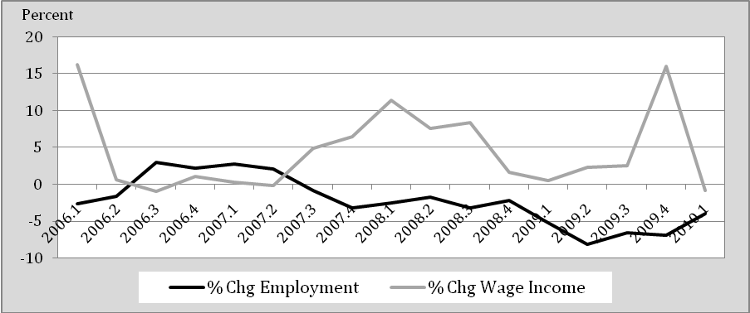
Source: Texas Workforce Commission

Figure 15 shows that layoffs by area manufacturers were in response to slower sales growth in 2007 compared with 2006 that was not fully offset in early 2008 before declining again in the fourth quarter. First quarter 2009 improvement in sales revenue coupled with continued layoffs to reduce labor costs enabled firms to maintain higher than expected net revenues early in the year before slumping later in the year.

Figure 15: Annual Percent Change in Quarterly Manufacturing Sales in
Waco MSA from Same Quarter of Previous Year

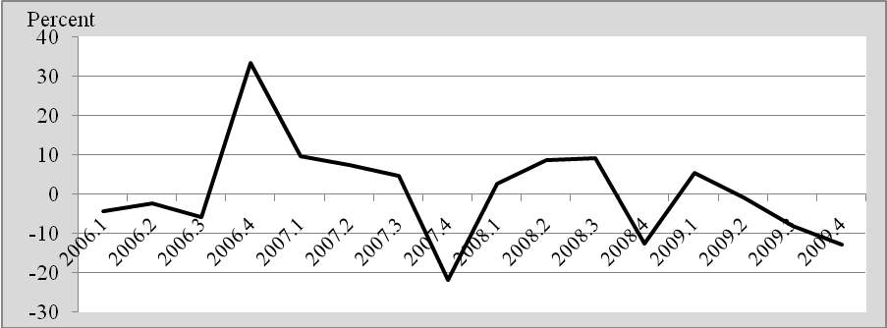
Source: Texas Comptroller of Public Accounts

Waco MSA quarterly manufacturing employment covered by the Texas Unemployment Compensation Act averaged 4 percent lower in 1st quarter 2010 compared with 1st quarter 2009, while average weekly wages fell by $10 per worker over the same period. Although covered employment and wage income reported by Waco establishments is available only through the first quarter of 2010, the annual percent change in BLS monthly estimates of manufacturing employment in the Waco MSA are shown in figure 16.

Figure 16: Annual Percent Change 2010 Monthly Waco MSA Manufacturing
Employment from Same Month in 2009

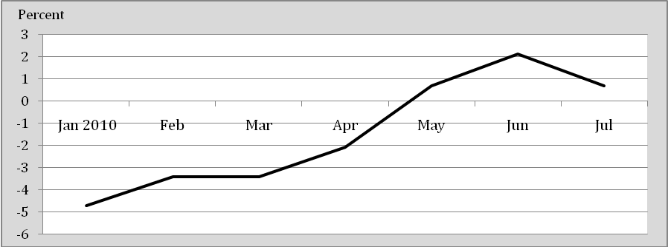
Source: U.S. Bureau of labor Statistics

These recent monthly estimates by the U.S. Bureau of Labor for the Waco MSA are encouraging in that manufacturing firms increased employment over the months of May through July compared with the same month a year ago, also reflected in preliminary August estimates. This seems to indicate that local layoffs by Waco manufacturers are over and local firms are stepping up production. Producers are realizing that you can only stretch workers so far and they will need to add workers to increase output in the future, even if they are contract jobs rather than full time employees with benefits.
Historically manufacturing output has lagged aggregate output and added strength to the economic recovery after it occurs. In this case, especially for firms exporting abroad, the manufacturing sector may be more responsive in creating jobs and initiating the recovery by adding to wage income and consumer optimism. However, one problem in predicting growth in manufacturing is the difficulty in separating cyclical change from trend forces. The number of manufacturing jobs throughout the country continues to exhibit a downward trend, partly hiding some of the cyclical improvement that is emerging. In the local economy employment in manufacturing should be higher a year from now helping to replace local wage income and buying power.

The Services Outlook

In mid-year 2010 the goods sector employed 20.1 thousand of the 107.3 thousand nonagricultural workers in the Waco MSA. Of the remaining 87.2 thousand workers in the service sector, 68 thousand were in private service industries. Public employees included government as well as public school employees. The cyclical performance of the service sector is more stable than the goods sector, but it also has been influenced by the recent recession.
Figure 17 shows the annual percent change since January 2001 in monthly employment in the goods sector and the private service sector compared with the same month of the previous year. In the aftermath of the 2001 recession private service employment decreased in response to the downturn in goods production. In 2008-09 while goods production decreased, private service employment actually showed gains from negative growth over the previous five years.

Figure 17: Annual Percent Change in Monthly Employment in
Goods versus Private Services Sectors

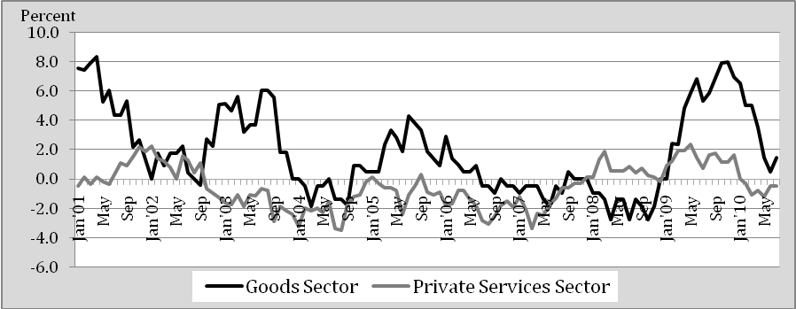
Source: US Bureau of Labor Statistics
Clearly, private employment by Waco service establishments changes in response to changes in output; however, the change in employment has been driven by two factors that are not directly measured by private service establishment data. One factor is the increase in labor productivity in the service sector in which one worker with improved information technology is able to perform the tasks of several previous employees. The second factor is the increase in services provided by sole proprietors under contract that are not recorded as permanent wage and salary employees. Among services that are most affected by cyclical forces are travel and related services, professional and technical services, and financial services. Other important, but more stable, industries are healthcare, and educational services.

Travel and Related Services

Figure 18 shows trends in direct visitor spending (not including a multiplier effect) in the Waco MSA from 1994 through 2009.

Figure 18: Waco MSA Annual Visitor Spending from 1994 through 2009

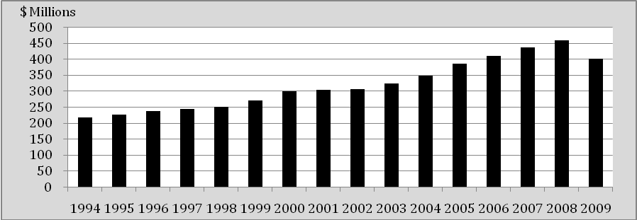
Source: Dean Runyan Associates

Following little change in response to the 2001 recession Waco MSA direct visitor spending increased substantially from 2003 to 2008, reaching a peak of $463.5 million in 2008 before falling by 12.3 percent to $406.4 million in 2009. Interestingly, while total direct spending decreased in 2009, industry employment generated by travel spending increased by 1.7 percent primarily due to a 5.1 percent increase in arts, entertainment, and recreation employment. This suggests that much of the reduction in dollar spending is due to price changes rather than unit spending. Table 6 shows that most of the impact of price changes is reflected in the single most important component of visitor spending; namely, local transportation and gasoline.

Table 6
Total Dollar Amounts and Percent Change in Commodities
Purchased by Visitors to Waco MSA

Commodities Purchased | 2007 | 2008 | 2009 | % Chg '07-'08 | % Chg '08-'09
Accommodations | 53.6 | 55.8 | 53.0 | 4.1 | -5.0
Food Service | 81.7 | 83.5 | 85.0 | 2.2 | 1.8
Food Stores | 24.1 | 24.9 | 24.9 | 3.3 | 0.0
Local Transportation and Gas | 134.6 | 156.1 | 102.0 | 16.0 | -34.7
Arts, Entertainment and Recreation | 42 | 41.6 | 41.4 | -1.0 | -0.5
Retail Sales | 97 | 93.0 | 92.8 | -4.1 | -0.2
Visitor Air Transportation | 2.1 | 2.0 | 1.7 | -4.8 | -15.0
Totals | 435.1 | 456.9 | 400.8 | 5.0 | -12.3
Source: Dean Runyan Associates

To gain further insight into the cause of lower visitor spending Table 6 examines all the sources of annual visitor spending by commodities purchased in 2007 -09. In 2009, Waco MSA visitor spending decreased by $56.1 million compared with 2008. However, of this decrease 96.4 percent was due to a $54.1 million decrease in the dollar value of gasoline purchases. When 2008 is compared with 2007 the increase in gasoline spending by visitors amounted to $21.5 million of the $21.8 million increase. Hence, if gas prices had remained stable in 2008 rather than skyrocket early in the year to over $4 per gallon, direct visitor spending in Waco in 2008 would have increased by only 1.4 percent compared with 2007.
Figure 19 illustrates the impact of gasoline spending on the dollar impact of visitor spending in the Waco MSA by plotting the percentage change in visitor’s spending on all commodities and on gasoline since 1995. In 2006-07, total spending by visitors was virtually unchanged as gasoline spending fell indicating that other components of visitor spending were rising. In 2007-08, total spending fell slightly while gasoline spending increased, indicating that other components of visitor spending were falling. Further analysis found that the decrease was due to a reduction in spending by visitors in Waco retail trade establishments. Rising gasoline prices in early 2008 that reached over $4 per gallon in July not only “taxed” local consumers, but it also reduced visitor’s spending in Waco retail establishments. In 2009, lower gasoline prices contributed to a 34.7 percent annual decrease in visitor spending on gasoline percent which accounted for all but a small amount of the reduction in total visitor spending.

Figure 19: Annual Percent Change in Visitor’s Total and
Gasoline Spending in Waco MSA

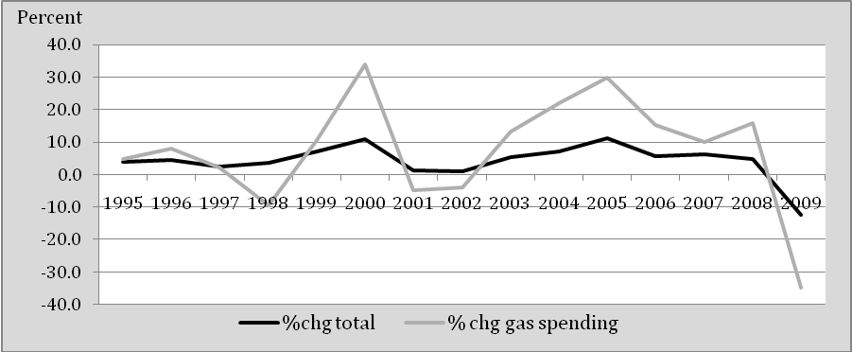
Source: Dean Runyan Associates

Statistical regression analysis shows that 85 percent of the variation in total visitor spending in the Waco MSA over the past fifteen years has been explained by the percentage of spending on gasoline. It also shows that if the percentage spending on gasoline had remained constant, total visitor spending in the Waco MSA would have increased annually by an average of $10.6 million dollars each year. The combined influences of trend forces plus the percentage spent on gasoline explains 99.4 percent of total visitor spending from 1994 through 2009. In 2008, the model predicts that total visitor spending would have been $456.8 million based on trend forces and the percent spending on gasoline, almost exactly what actually occurred. In 2009, the model predicts visitor spending of $414.4 million, so that cyclical forces other than reduced spending on gasoline reduced visitor spending by only $13.6 million, or 3.3 percent below its predicted value.
The Texas Travel Research report for 2009 shows that visitor spending for accommodations in the Waco MSA decreased 5 percent after a 4.1 percent gain the previous year. Table 8 shows average nights sold, room revenue, and occupancy rates for Waco hotels over the first two quarters of 2010 compared with the first two quarters of 2009.

Table 8
Waco Hotel Performance in 2010
Compared with Same Period in 2009

Measure | 2nd Qtr 2009 | 2nd Qtr 2010 | 2009-10
 | Year-to-date | Year-to-date | % Change
Number of Hotels | 43 | 45 | 4.65
Number of Rooms (000) | 3.5 | 3.8 | 8.57
Number of Nights sold (000) | 343 | 357 | 4.08
Room Revenue (000) | $23,212 | $23,589 | 1.62
Average Room Rate | $67.64 | $66.16 | -2.19
Occupancy Rate (%) | 53.8 | 52.5 | -2.42
Source: Texas Travel Research Center

Over the year ending in second quarter 2010, two new hotels and 500 additional hotel rooms were added to the Waco MSA, and year-to-date nights sold increased 4.08 percent compared with the same period a year ago. However, the increase in nights sold did not keep pace with the increase in total area hotel rooms, so that the average hotel occupancy rate fell from 53.8 percent to 52.5 percent. In spite of more room nights sold, the increase in room capacity put downward pressure on the average year-to-date 2010 room rates, resulting in a decreased of 2.4 percent compared with the first two quarter in 2009. Still, despite the lower average room rate the additional number of room nights sold resulted in an increase in hotel room revenue 1.62% in the first two quarters of 2010 compared with the same period a year ago. Total room revenue is projected to continue to increase over the next year as visitor spending increases.
Employment in leisure and hospitality in the Waco MSA is up 3 percent in August compared with a year ago and is projected to increase above average over the remainder of 2010 and 2011. Baylor enrollment has reached record figures with record attendance by out-of-county parents and friends expected during the 2010-11 school year. Waco continues to develop and market new attractions for visitors, such as the Mammoth Site and renovated Cameron Park that are too many to list.

Business and Professional Services

Figure 20 shows that in 2006 and 2007 jobs in professional and business services in Waco increased at a record pace, adding 1.4 thousand jobs from December 2005 to December 2008 reaching a total employment of 9 thousand workers before dropping by 700 workers, or 7.8 percent, in 2009.

Figure 20: Annual Percent Change in Waco MSA Employment in
Business and Professional Services

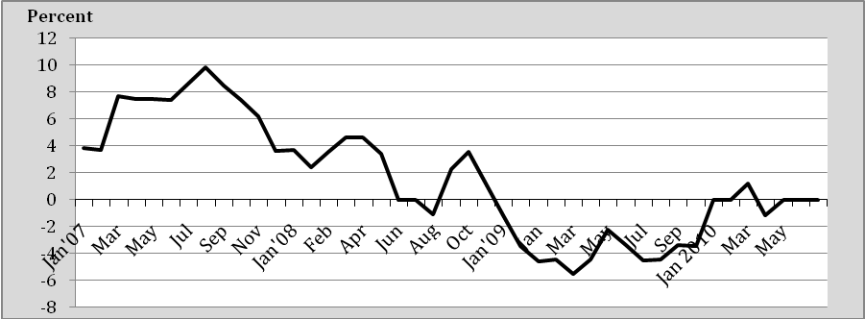
Source: Texas Workforce Commission

In July 2007, the annual rate of growth in business and professional service employment peaked at 10 percent and continued to be positive each month the summer months of 2008. After a brief rally at the end of 2008 negative growth in professional and service employment prevailed throughout 2009 in response to the downturn in business activity in all sectors of the economy. Although employment fell during 2009, Waco’s share of statewide business and professional employment increased over the period, raising the industry location quotient based on statewide totals from 0.40 in 2008 to 0.44 in 2009. Over the first half of 2010 professional and business service employment stopped falling and stabilized. August 2010 employment is up 1.2 percent from the same month a year ago. The projected growth in professional and business service employment is among the strongest sectors over the next ten years for the Waco MSA.

Financial Services

The Waco economy has a competitive financial services sector that, as shown in Figure 21, was quick to respond to forces affecting loan demand, including rapid employment growth reaching over 6% in 2007 followed by negative growth beginning in 2008 that reached the bottom in April/May 2009. Beginning late last year financial services employment began to improve and seems to have stabilized in 2010 in much the same way as professional and business services employment.

Figure 21: Annual Percent Change in Waco MSA
Financial Services Employment

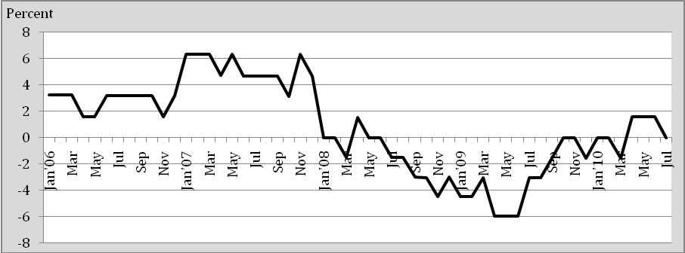
Source: U.S. Bureau of Labor Statistics

Education and Healthcare Services

The Waco MSA location quotient based on statewide totals for educational services averaged 3.14 in 2009 reflecting the importance of Baylor University and other higher education services on the local economy. The location quotient in 2009 for healthcare and social services based on private employees averaged 1.12 indicating 12 percent more employees locally than the statewide average. However, the location quotient would have been significantly higher if government employment had been included because of the presence of the VA hospital.

Figure 22: Annual Percent Change in Waco MSA
Healthcare and Educational Services Employment

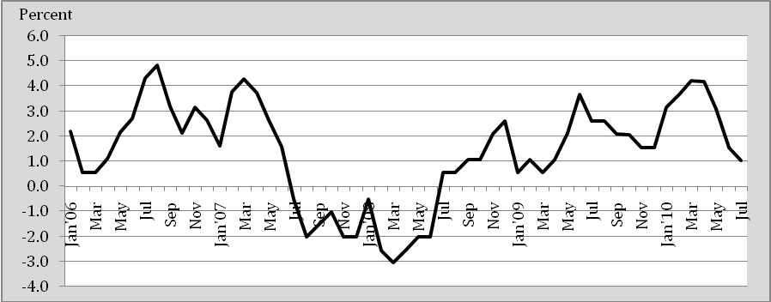
Source: Texas Workforce Commission

Figure 22 shows that that despite a failure in late 2007 and early 2008 to keep pace with the substantial growth of the previous period, employment in educational and healthcare services have grown since late 2008 helping to offset the influence of the business cycle downturn that impacted on Waco beginning in late 2008. The two sectors combine to create 20.1 thousand private sector jobs as well as employment in public schools, including MCC and TSTC, and healthcare at veterans facilities that have with an enormous economic impact that provide the foundation for Waco’s relative cyclical stability over the past two years.

Summary

The national recession officially began in December 2007. Historically, local business cycle performance has lagged national recessions by about six months and has been relatively stable compared with the national average. The local response to the recent “Great Recession” that officially ended in June 2009 was no exception. Although the national recession officially began in December 2007, net job losses began 3 months earlier. Waco’s seasonally-adjusted nonfarm employment continued to rise until it reached a peak of 107.8 thousand jobs in May 2008 before losing only 200 jobs by the end of the year.
A widely used but sometimes poor indicator of the strength of an economy is its unemployment rate. In 2007, the Waco MSA seasonally-adjusted unemployment rate averaged slightly above 4 percent, but total employment reported by households fell about 2 percent for the year. In 2007 through 1st quarter 2008 Waco’s labor force fell at the same rate as the number of jobs as many transient workers flocked to larger, faster growing areas of the state. Beginning in May 2008 the Waco MSA unemployment rate began to increase at the same time that total employment began to grow, but at a slower growth rate than the labor force. Beginning in early 2008 local commercial and public construction projects increased significantly, more than offsetting the slower growth in residential housing building permits. Transitory construction workers expanded the labor force continuously with the annual rate of growth in the labor force growth reaching over 4 percent by July 2009, compared with 2.2 percent annual growth in employment, causing the unemployment rate to increase to 7.2 percent compared 5.2 percent in July 2008. By July 2010 completion of many earlier projects slowed both the annual rate of job growth to 0.9 percent and the annual rate of growth in the labor force to 1.2 percent, so that the unemployment rate began to stabilize at 7.5 percent.
One of the benefits of the economic recession is that it has significantly reduced the inflation rate. The inflation rate based on the Central Texas Consumer price index reached a peak in July 2008 of 6 percent that that was 3.2 percent above the core inflation rate that omits food and energy price changes. By year-end 2009 the plunge in energy prices lowered the inflation rate to near zero although the core inflation rate was 2 percent. The core rate of inflation has continued to fall since early 2009 and has even dipped below zero while averaging almost no change over the past few months.
Nationwide, the core PCE was 1.4 percent in August, which is below the Fed’s target of 1.7-2.0 percent for the fourth consecutive month, giving the Fed more room to focus on employment growth without immediate concern over inflation. The general source of concern over longer run inflation is based on the amount of liquidity in the economy that is setting on the sidelines and could be activated unless the Federal Reserve exercises some sort of “exit” strategy in their holdings of government and mortgage securities. At this time, however, there is little reason to expect either deflation or accelerated inflation in the near future although there may be some change around a core rate of about 2% due to change in energy prices.
The key to improvement in the Central Texas economy is similar to forces that will drive recovery in the national economy. Housing starts, consumer spending, business investment, and export demand originating in the private sector will have to take the place of public programs, such as government’s cash for clunkers and tax credits for housing, that provided temporary stimulus but at the same time added to business and consumer uncertainty regarding future public debt and tax liabilities.
Over the three months from March through May 2010 single family housing sales in the Waco MSA increased 23.4 percent compared with the same three months a year ago. But, over the three months from June through August in 2010 single family housing sales fell 31.2 percent compared with the same three months in 2009. Total single family housing sales over the six month period from March through August were down by less than 3 percent, so that the primary impact of the tax credit program was to artificially stimulate housing sales only to be followed by what appeared to be a collapse in the housing market. In fact, the uncertainty of future changes in government policy may be having the effect of reducing current housing sales despite record low mortgage rates.
Housing demand continues to be pressed by population growth that is estimated to have increased by 1.2 percent in 2008 and 0.8 percent in 2009. The Waco MSA affordability index, equal to the ratio of median family income to the income required to qualify for an 80 percent fixed-rate mortgage to purchase the median-priced home, increased from 1.84 in 2008 to 2.21 in 2009, well above its previous high of 2.1 that was reached in 2004. The ingredients are in place for a significant increase in existing housing sales next year after the “smoke clears” in the minds of households regarding future taxes and income stability.
Coupled with higher rates of sales of existing housing next year will be improvement in the rate of construction of new single family housing. After reaching a peak rate of growth in 2005, the annual rate of Waco MSA single family housing permits have fallen by 57.5 percent over the three year period from 2006 through 2009. However, the highest annual rate of decrease occurred in 2008 at 32 percent followed by a 23 percent decrease in 2009. August 2010 year-to-date single family building permits are 15.8 percent higher than year-to-date single family building permits through August 2009. The local housing market has reached bottom and is projected to show continued improvement in 2011.
The rate of consumer spending likewise seems to have turned the corner from the slowdown that began in 4th quarter 2008. U.S. consumer spending exceeded forecast levels in August 2010 which bodes well for retailers moving forward into the holiday shopping season. Waco MSA retail sales compared with 4th quarter of the previous year fell 6.47 percent in 4th quarter 2008 and another 3.79 percent in 4th quarter 2009. Consumers are not expected to splurge, but neither are they expected to retrench. This sets us up for a better holiday-shopping season than the past two years, but the rate of increase will be modest as shoppers continue to seek bargains and are reluctant to build up credit card debt. Stable gains are expected in sales of apparel, home entertainment, food and beverage, and miscellaneous items, and some improvement is expected in sales of trucks and automobiles and building materials that suffered significantly during the economic downturn. Although the unemployment rate is slow to improve, there has been an increase in area employment (matched by larger labor force) and personal income that is supporting growth in local consumer demand. Many of the factors that have limited consumer spending have improved recently—less concern over loss of home equity, repayment of credit card debt (adds to savings rate), and improvement in 2nd quarter corporate profits that bolstered the stock market—are more favorable than this time a year ago.
The Texas factory outlook survey reveals that manufacturing in September edged up from relatively flat performance in August. As a relatively manufacturing intensive metropolitan area, the Waco MSA has historically gathered momentum in the manufacturing sector as the economy has improved. The six month forecast for production activity by survey respondents in September reported 48.7 percent projecting an increase compared with 41.2 percent projecting an increase in August. Manufacturing employment in September still lags growth in output, but it also turned slightly positive after showing a decrease in the previous month. Based on the current stage of the recovery manufacturing output is expected to improve in 2011 initially supported by more contract or temporary workers until firms are convinced there will be steady gains in economic activity.
In the service sector employment gains will be driven by the rate of recovery in the total employment and income. Business and professional service employment is projected to be a leading source of employment gains in 2011 and beyond. Leisure and hospitality output and employment also will improve next year helped by rising incomes and more visitor attractions. The largest service sectors of the local economy will be in education and healthcare services that have been important contributors to job growth and stability during the recession period and will maintain their relative importance in 2011.

Appendix
This appendix presents Table 1A that present Waco industry performance for all industries from 1st Qtr. 2004 through 1st Qtr. 2010 based on quarterly data from the Texas Quarterly Census of Employment and Wages. The data includes only covered employment which is the number of workers employed that are subject to the Texas Unemployment Compensation Act during the pay period which includes the 12th day of the month. Private and government employment, including Federal, is included, but excluded from coverage are employment covered by the Railroad Retirement Act, self-employed workers, and unpaid family members.
The payroll data (total wages) includes all wages and salaries paid to covered employees by their employer, including bonuses, commissions, and cash values or remuneration received in any medium other than cash. The average weekly wage is the numeric calculation of total wages divided by the number of employees, divided by the number 13 (weeks per quarter.)
The quarterly data is not available since the first quarter of this year. Hence, monthly estimates by the Bureau of Labor Statistics Texas MSAs are also reported from March through August 2010 to show more recent changes in employment performance in the Waco MSA and other Texas Metro Areas.
Table 1A Results

Employment: From 4th Qtr 2007 through 1st Qtr 2010 total Waco MSA employment in all industries decreased by 5,588 jobs which amounted to 5.5% from the previous peak. The downturn beginning in 1st Qtr. 2008 came on the heels of growth in employment that averaged 4.3% per year for the previous 4years. The loss of jobs during 2008 amounted to only 1%, but the rate of job loss increased to 2.9% during 2009. Employment in the 1st quarter of 2010 was down by 1,770 jobs from 4th quarter 2009, but all but 771 of these job losses can be explained by normal seasonal influences.

Wage and Salary Income: Wage income decreased in four of the last five quarters from 1st Qtr. 2009 through 1st Qtr. 2010, but by a significantly lower rate than employment. In fact, the average weekly wage during 4th Qtr. 2009 increased substantially from the previous year as employers hired fewer seasonal workers than normal and temporarily increased overtime pay.

Table 1A:
Table 1A: Waco MSA Quarterly Covered Wage and Salary Employment for
All Industries and Percent Change from Same Quarter of Previous Year

 | Employment | Avg. Wkly | Avg. Weekly | Annual | % Change
Period | All Industries | Wage | Income | Employment | Wage Income
2004.1 | 97,480 | $572 | $55,758,560 | 0.84 | 3.00
2004.2 | 99,065 | $571 | $56,566,115 | 1.34 | 3.52
2004.3 | 99,286 | $588 | $58,380,168 | 2.25 | 5.11
2004.4 | 98,678 | $633 | $62,463,174 | 1.19 | 5.87
2005.1 | 100,608 | $605 | $60,867,840 | 3.21 | 9.16
2005.2 | 101,503 | $606 | $61,510,818 | 2.46 | 8.74
2005.3 | 100,859 | $626 | $63,137,734 | 1.58 | 8.15
2005.4 | 101,458 | $652 | $66,150,616 | 2.82 | 5.90
2006.1 | 100,774 | $639 | $64,394,586 | 0.16 | 5.79
2006.2 | 102,044 | $623 | $63,573,412 | 0.53 | 3.35
2006.3 | 102,966 | $631 | $64,971,546 | 2.09 | 2.90
2006.4 | 103,199 | $677 | $69,865,723 | 1.72 | 5.62
2007.1 | 102,556 | $665 | $68,199,740 | 1.77 | 5.91
2007.2 | 104,448 | $637 | $66,533,376 | 2.36 | 4.66
2007.3 | 104,304 | $658 | $68,632,032 | 1.30 | 5.63
2007.4 | 104,770 | $703 | $73,653,310 | 1.52 | 5.42
2008.1 | 101,527 | $698 | $70,865,846 | -1.00 | 3.91
2008.2 | 103,469 | $667 | $69,013,823 | -0.94 | 3.73
2008.3 | 103,187 | $686 | $70,786,282 | -1.07 | 3.14
2008.4 | 103,731 | $718 | $74,478,858 | -0.99 | 1.12
2009.1 | 100,971 | $696 | $70,275,816 | -0.55 | -0.83
2009.2 | 101,698 | $666 | $67,730,868 | -1.71 | -1.86
2009.3 | 101,370 | $695 | $70,452,150 | -1.76 | -0.47
2009.4 | 100,752 | $775 | $78,082,800 | -2.87 | 4.84
2010.1 | 98,982 | $706 | $69,881,292 | -1.97 | -0.56

Waco MSA at a Glance
Data Series
 | Back  Data |  | Mar  2010 |  | Apr  2010 |  | May  2010 |  | June  2010 |  | July  2010 |  | Aug  2010
Labor Force Data
Civilian Labor Force (1) |  | 117.4 |  | 118.1 |  | 118.5 |  | 119.0 |  | 119.4 |  | 119.3
Employment (1) |  | 109.1 |  | 109.9 |  | 110.5 |  | 110.1 |  | 110.5 |  | 110.4
Unemployment (1) |  | 8.3 |  | 8.2 |  | 8.0 |  | 8.9 |  | 8.9 |  | 8.9
Unemployment Rate (2) |  | 7.1 |  | 6.9 |  | 6.8 |  | 7.5 |  | 7.5 |  | 7.4
Nonfarm Wage and Salary Employment
Total Nonfarm (3) |  | 106.7 |  | 107.1 |  | 108.8 |  | 108.8 |  | 108.2 |  | 108.1
12-month % change |  | 0.9 |  | 0.9 |  | 2.5 |  | 2.0 |  | 1.3 |  | 1.5
Mining, Logging, and Construction (3) |  | 5.8 |  | 5.8 |  | 5.9 |  | 6.0 |  | 6.1 |  | 6.1
12-month % change |  | -7.9 |  | -6.5 |  | -6.3 |  | -6.3 |  | -4.7 |  | 0.0
Manufacturing (3) |  | 14.2 |  | 14.2 |  | 14.3 |  | 14.4 |  | 14.4 |  | 14.4
12-month % change |  | -3.4 |  | -2.1 |  | 0.7 |  | 2.1 |  | 0.7 |  | 0.0
Trade, Transportation, and Utilities (3) |  | 17.4 |  | 17.3 |  | 17.4 |  | 17.4 |  | 17.4 |  | 17.4
12-month % change |  | -0.6 |  | -2.3 |  | -1.1 |  | -1.1 |  | -0.6 |  | -0.6
Information (3) |  | 1.4 |  | 1.4 |  | 1.4 |  | 1.4 |  | 1.4 |  | 1.4
12-month % change |  | -12.5 |  | -12.5 |  | -6.7 |  | -12.5 |  | -12.5 |  | 0.0
Financial Activities (3) |  | 6.3 |  | 6.4 |  | 6.4 |  | 6.4 |  | 6.4 |  | 6.4
12-month % change |  | -1.6 |  | 1.6 |  | 1.6 |  | 1.6 |  | 0.0 |  | 0.0
Professional and Business Services (3) |  | 8.4 |  | 8.5 |  | 8.5 |  | 8.6 |  | 8.6 |  | 8.7
12-month % change |  | 1.2 |  | -1.2 |  | 0.0 |  | 0.0 |  | 0.0 |  | 1.2
Education and Health Services (3) |  | 19.9 |  | 20.0 |  | 20.1 |  | 20.1 |  | 20.1 |  | 20.2
12-month % change |  | 4.2 |  | 4.2 |  | 3.1 |  | 1.5 |  | 1.0 |  | 2.0
Leisure and Hospitality (3) |  | 9.9 |  | 10.0 |  | 10.2 |  | 10.2 |  | 10.2 |  | 10.2
12-month % change |  | 2.1 |  | 2.0 |  | 3.0 |  | 3.0 |  | 4.1 |  | 3.0
Other Services (3) |  | 3.8 |  | 3.9 |  | 3.9 |  | 3.9 |  | 3.9 |  | 3.9
12-month % change |  | 0.0 |  | 2.6 |  | 2.6 |  | 0.0 |  | 0.0 |  | 0.0
Government (3) |  | 19.6 |  | 19.6 |  | 20.7 |  | 20.4 |  | 19.7 |  | 19.4
12-month % change |  | 7.1 |  | 6.5 |  | 11.9 |  | 10.3 |  | 7.1 |  | 4.9
Footnotes
(1) Number of persons, in thousands, not seasonally adjusted.
(2) In percent, not seasonally adjusted.
(3) Number of jobs, in thousands, not seasonally adjusted.
Abilene MSA
Data Series
 | Back  Data | Mar  2010 | Apr  2010 | May  2010 | June  2010 | July  2010 | Aug  2010
Labor Force Data
Civilian Labor Force (1) |  | 84.3 | 84.9 | 84.4 | 84.7 | 85.0 | 84.7
Employment (1) |  | 78.9 | 79.6 | 79.0 | 78.9 | 79.2 | 79.0
Unemployment (1) |  | 5.4 | 5.3 | 5.3 | 5.8 | 5.8 | 5.7
Unemployment Rate (2) |  | 6.3 | 6.3 | 6.3 | 6.9 | 6.8 | 6.7
Nonfarm Wage and Salary Employment
Total Nonfarm (3) |  | 65.1 | 65.3 | 65.5 | 65.6 | 65.3 | 65.2
12-month % change |  | -1.4 | -1.5 | -0.3 | -0.5 | 0.6 | 0.5
Mining, Logging, and Construction (3) |  | 4.5 | 4.5 | 4.5 | 4.6 | 4.7 | 4.7
12-month % change |  | -13.5 | -8.2 | -6.3 | -2.1 | 0.0 | 2.2
Manufacturing (3) |  | 2.9 | 2.9 | 2.9 | 3.0 | 3.0 | 3.0
12-month % change |  | 0.0 | -3.3 | 0.0 | 0.0 | 3.4 | 0.0
Trade, Transportation, and Utilities (3) |  | 11.8 | 11.8 | 11.8 | 11.8 | 11.9 | 11.8
12-month % change |  | -3.3 | -2.5 | -0.8 | -1.7 | -0.8 | -1.7
Information (3) |  | 1.1 | 1.1 | 1.1 | 1.1 | 1.1 | 1.1
12-month % change |  | 0.0 | -8.3 | -8.3 | -8.3 | -8.3 | -8.3
Financial Activities (3) |  | 3.6 | 3.6 | 3.6 | 3.6 | 3.6 | 3.6
12-month % change |  | -2.7 | -2.7 | -2.7 | -2.7 | 0.0 | 0.0
Professional and Business Services (3) |  | 4.6 | 4.6 | 4.6 | 4.6 | 4.7 | 4.7
12-month % change |  | -2.1 | -4.2 | -2.1 | -2.1 | -2.1 | 0.0
Education and Health Services (3) |  | 13.8 | 13.8 | 13.8 | 13.8 | 13.8 | 13.9
12-month % change |  | 3.0 | 2.2 | 2.2 | 1.5 | 2.2 | 3.0
Leisure and Hospitality (3) |  | 7.1 | 7.2 | 7.3 | 7.3 | 7.3 | 7.3
12-month % change |  | 0.0 | 0.0 | 1.4 | 1.4 | 2.8 | 1.4
Other Services (3) |  | 2.6 | 2.7 | 2.7 | 2.7 | 2.7 | 2.7
12-month % change |  | 0.0 | 3.8 | 3.8 | 0.0 | 3.8 | 3.8
Government (3) |  | 13.1 | 13.1 | 13.2 | 13.1 | 12.5 | 12.4
12-month % change |  | 0.0 | -1.5 | 0.0 | 0.0 | 0.0 | -0.8
Footnotes
(1) Number of persons, in thousands, not seasonally adjusted.
(2) In percent, not seasonally adjusted.
(3) Number of jobs, in thousands, not seasonally adjusted.
Amarillo MSA
Data Series
 | Back  Data | Mar  2010 | Apr  2010 | May  2010 | June  2010 | July  2010 | Aug  2010
Labor Force Data
Civilian Labor Force (1) |  | 133.2 | 134.6 | 133.5 | 133.1 | 134.0 | 133.5
Employment (1) |  | 125.8 | 127.0 | 126.3 | 125.1 | 126.2 | 125.8
Unemployment (1) |  | 7.4 | 7.5 | 7.2 | 7.9 | 7.8 | 7.6
Unemployment Rate (2) |  | 5.6 | 5.6 | 5.4 | 6.0 | 5.8 | 5.7
Nonfarm Wage and Salary Employment
Total Nonfarm (3) |  | 109.9 | 110.5 | 111.1 | 110.4 | 109.9 | 110.2
12-month % change |  | -0.4 | -1.2 | -0.4 | -0.2 | -1.0 | 0.6
Mining, Logging, and Construction (3) |  | 6.0 | 6.1 | 6.1 | 6.3 | 6.3 | 6.4
12-month % change |  | -9.1 | -7.6 | -7.6 | -3.1 | -3.1 | 1.6
Manufacturing (3) |  | 12.5 | 12.5 | 12.6 | 12.6 | 12.7 | 12.7
12-month % change |  | -2.3 | -1.6 | -0.8 | 0.0 | 2.4 | 1.6
Trade, Transportation, and Utilities (3) |  | 22.6 | 22.5 | 22.6 | 22.6 | 22.6 | 22.6
12-month % change |  | 0.0 | -2.6 | -0.9 | -0.9 | -1.7 | -0.4
Information (3) |  | 1.5 | 1.5 | 1.5 | 1.5 | 1.5 | 1.5
12-month % change |  | -6.3 | -6.3 | -6.3 | -6.3 | -6.3 | -6.3
Financial Activities (3) |  | 6.8 | 6.8 | 6.9 | 7.0 | 7.0 | 6.9
12-month % change |  | -1.4 | -1.4 | -1.4 | 1.4 | 0.0 | 0.0
Professional and Business Services (3) |  | 8.0 | 8.1 | 8.1 | 8.2 | 8.2 | 8.3
12-month % change |  | -2.4 | -1.2 | 0.0 | 1.2 | 0.0 | 2.5
Education and Health Services (3) |  | 16.0 | 16.1 | 16.1 | 16.0 | 16.1 | 16.3
12-month % change |  | 1.3 | 0.0 | 0.6 | 0.6 | 0.6 | 2.5
Leisure and Hospitality (3) |  | 11.3 | 11.5 | 11.7 | 11.8 | 11.8 | 11.7
12-month % change |  | 0.0 | -3.4 | -2.5 | -1.7 | -4.1 | -2.5
Other Services (3) |  | 4.4 | 4.5 | 4.5 | 4.5 | 4.5 | 4.5
12-month % change |  | -2.2 | -2.2 | 0.0 | 0.0 | -2.2 | 0.0
Government (3) |  | 20.8 | 20.9 | 21.0 | 19.9 | 19.2 | 19.3
12-month % change |  | 4.0 | 4.0 | 4.0 | 1.0 | -1.0 | 1.6
Footnotes
(1) Number of persons, in thousands, not seasonally adjusted.
(2) In percent, not seasonally adjusted.
(3) Number of jobs, in thousands, not seasonally adjusted.
Austin-Round Rock-San Marcos MSA
Data Series
 | Back  Data | Mar  2010 | Apr  2010 | May  2010 | June  2010 | July  2010 | Aug  2010
Labor Force Data
Civilian Labor Force (1) |  | 908.5 | 917.6 | 910.9 | 913.6 | 917.4 | 917.4
Employment (1) |  | 843.9 | 853.2 | 847.7 | 846.0 | 850.3 | 851.4
Unemployment (1) |  | 64.6 | 64.4 | 63.2 | 67.6 | 67.2 | 66.0
Unemployment Rate (2) |  | 7.1 | 7.0 | 6.9 | 7.4 | 7.3 | 7.2
Nonfarm Wage and Salary Employment
Total Nonfarm (3) |  | 760.4 | 765.7 | 768.6 | 771.5 | 765.4 | 769.2
12-month % change |  | -0.1 | 0.4 | 0.6 | 1.4 | 2.4 | 2.5
Mining, Logging, and Construction (3) |  | 38.7 | 39.0 | 39.0 | 39.7 | 39.6 | 40.3
12-month % change |  | -6.5 | -4.4 | -4.4 | -4.1 | -3.9 | -0.7
Manufacturing (3) |  | 46.7 | 46.4 | 46.7 | 47.1 | 47.3 | 47.6
12-month % change |  | -3.1 | -6.5 | -4.7 | -2.9 | -1.5 | -0.4
Trade, Transportation, and Utilities (3) |  | 129.9 | 130.6 | 130.8 | 130.7 | 130.4 | 130.7
12-month % change |  | -2.3 | -0.4 | -0.5 | -0.5 | -0.8 | -1.4
Information (3) |  | 19.2 | 19.0 | 18.9 | 19.0 | 18.8 | 18.9
12-month % change |  | -5.0 | -4.5 | -5.0 | -3.1 | -4.1 | -3.6
Financial Activities (3) |  | 43.7 | 43.9 | 44.1 | 44.3 | 43.9 | 44.0
12-month % change |  | 0.0 | 0.2 | 0.7 | 0.7 | 0.0 | 0.7
Professional and Business Services (3) |  | 104.2 | 106.1 | 106.2 | 108.2 | 107.7 | 109.0
12-month % change |  | -3.2 | -1.1 | -1.2 | 0.5 | 1.6 | 2.7
Education and Health Services (3) |  | 85.2 | 85.8 | 86.1 | 85.5 | 85.3 | 86.2
12-month % change |  | 3.3 | 2.8 | 2.6 | 2.9 | 2.6 | 3.0
Leisure and Hospitality (3) |  | 86.7 | 89.0 | 91.4 | 92.6 | 92.6 | 92.6
12-month % change |  | 5.9 | 7.1 | 8.7 | 10.0 | 10.1 | 10.0
Other Services (3) |  | 33.5 | 33.8 | 34.0 | 34.3 | 34.6 | 34.6
12-month % change |  | 0.3 | 2.4 | 2.1 | 1.8 | 3.6 | 3.9
Government (3) |  | 172.6 | 172.1 | 171.4 | 170.1 | 165.2 | 165.3
12-month % change |  | 2.3 | 1.1 | 0.8 | 1.4 | 5.6 | 4.0
Footnotes
(1) Number of persons, in thousands, not seasonally adjusted.
(2) In percent, not seasonally adjusted.
(3) Number of jobs, in thousands, not seasonally adjusted.
College Station-Bryan MSA
Data Series
 | Back  Data | Mar  2010 | Apr  2010 | May  2010 | June  2010 | July  2010 | Aug  2010
Labor Force Data
Civilian Labor Force (1) |  | 117.6 | 119.0 | 118.4 | 114.1 | 113.4 | 112.6
Employment (1) |  | 110.7 | 112.0 | 111.6 | 106.2 | 105.8 | 104.9
Unemployment (1) |  | 6.9 | 7.0 | 6.8 | 7.9 | 7.7 | 7.7
Unemployment Rate (2) |  | 5.9 | 5.9 | 5.8 | 6.9 | 6.8 | 6.8
Nonfarm Wage and Salary Employment
Total Nonfarm (3) |  | 99.1 | 99.9 | 100.5 | 95.8 | 94.5 | 93.5
12-month % change |  | 1.3 | 2.3 | 3.4 | 3.6 | 2.5 | 2.0
Mining, Logging, and Construction (3) |  | 6.5 | 6.5 | 6.6 | 6.6 | 6.6 | 6.4
12-month % change |  | -5.8 | -3.0 | -1.5 | -2.9 | 0.0 | -3.0
Manufacturing (3) |  | 5.2 | 5.3 | 5.3 | 5.3 | 5.4 | 5.4
12-month % change |  | -1.9 | 0.0 | 0.0 | 0.0 | 1.9 | 3.8
Trade, Transportation, and Utilities (3) |  | 13.2 | 13.2 | 13.3 | 13.3 | 13.3 | 13.3
12-month % change |  | 0.8 | 1.5 | 3.1 | 3.9 | 3.1 | 2.3
Information (3) |  | 1.1 | 1.1 | 1.1 | 1.1 | 1.1 | 1.1
12-month % change |  | -8.3 | -8.3 | -8.3 | -8.3 | -8.3 | -8.3
Financial Activities (3) |  | 3.3 | 3.3 | 3.3 | 3.3 | 3.4 | 3.4
12-month % change |  | -5.7 | -2.9 | -5.7 | -2.9 | 0.0 | 0.0
Professional and Business Services (3) |  | 5.8 | 5.8 | 5.9 | 5.9 | 5.9 | 5.9
12-month % change |  | -6.5 | -3.3 | -1.7 | 0.0 | 0.0 | -1.7
Education and Health Services (3) |  | 10.8 | 10.9 | 10.9 | 10.9 | 10.8 | 10.9
12-month % change |  | 6.9 | 6.9 | 4.8 | 4.8 | 3.8 | 3.8
Leisure and Hospitality (3) |  | 10.6 | 10.7 | 10.8 | 10.8 | 10.8 | 10.8
12-month % change |  | 1.9 | 1.9 | 2.9 | 4.9 | 3.8 | 3.8
Other Services (3) |  | 3.2 | 3.2 | 3.2 | 3.2 | 3.2 | 3.2
12-month % change |  | 0.0 | 6.7 | 6.7 | 6.7 | 10.3 | 10.3
Government (3) |  | 39.4 | 39.9 | 40.1 | 35.4 | 34.0 | 33.1
12-month % change |  | 4.0 | 3.9 | 6.4 | 6.0 | 2.4 | 1.8
Footnotes
(1) Number of persons, in thousands, not seasonally adjusted.
(2) In percent, not seasonally adjusted.
(3) Number of jobs, in thousands, not seasonally adjusted.
Dallas-Plano-Irving MSA
Data Series | Back  Data | Mar  2010 | Apr  2010 | May  2010 | June  2010 | July  2010 | Aug  2010
Labor Force Data
Civilian Labor Force (1) |  | 2,143.5 | 2,163.8 | 2,156.3 | 2,163.1 | 2,175.6 | 2,165.1
Employment (1) |  | 1,964.9 | 1,985.7 | 1,981.2 | 1,978.3 | 1,990.4 | 1,983.0
Unemployment (1) |  | 178.6 | 178.0 | 175.2 | 184.8 | 185.2 | 182.1
Unemployment Rate (2) |  | 8.3 | 8.2 | 8.1 | 8.5 | 8.5 | ) 8.4
Nonfarm Wage and Salary Employment
Total Nonfarm (3) |  | 1,997.8 | 2,011.7 | 2,027.5 | 2,037.4 | 2,023.9 | 2,021.9
12-month % change |  | -1.3 | -0.4 | 0.4 | 1.2 | 1.3 | 1.2
Mining, Logging, and Construction (3) |  | 98.2 | 99.9 | 100.0 | 103.1 | 104.3 | 104.1
12-month % change |  | -14.9 | -12.0 | -11.4 | -9.0 | -6.5 | -6.0
Manufacturing (3) |  | 170.6 | 171.9 | 175.5 | 178.5 | 177.6 | 176.4
12-month % change |  | -4.0 | -2.3 | 0.7 | 3.0 | 3.4 | 3.3
Trade, Transportation, and Utilities (3) |  | 388.1 | 384.8 | 386.1 | 387.9 | 387.8 | 390.5
12-month % change |  | -2.5 | -2.4 | -2.1 | -1.4 | -1.4 | -1.0
Information (3) |  | 63.2 | 61.8 | 61.6 | 62.1 | 61.6 | 61.6
12-month % change |  | -7.5 | -8.8 | -9.0 | -8.1 | -8.1 | -7.4
Financial Activities (3) |  | 174.1 | 174.5 | 174.2 | 174.8 | 175.0 | 174.8
12-month % change |  | -1.4 | -0.9 | -1.4 | -1.2 | -0.9 | -1.0
Professional and Business Services (3) |  | 324.9 | 329.5 | 331.3 | 334.6 | 339.7 | 340.1
12-month % change |  | 0.5 | 2.6 | 3.3 | 3.8 | 5.8 | 5.7
Education and Health Services (3) |  | 249.5 | 252.1 | 252.3 | 255.3 | 252.9 | 253.7
12-month % change |  | 6.4 | 6.8 | 6.4 | 7.5 | 5.8 | 5.8
Leisure and Hospitality (3) |  | 186.1 | 190.5 | 193.0 | 192.8 | 190.8 | 189.7
12-month % change |  | -1.5 | -1.3 | -0.9 | -1.1 | -1.3 | -1.5
Other Services (3) |  | 67.1 | 69.5 | 70.0 | 70.0 | 70.1 | 68.6
12-month % change |  | -4.6 | -3.1 | -2.2 | -2.9 | -1.4 | -2.8
Government (3) |  | 276.0 | 277.2 | 283.5 | 278.3 | 264.1 | 262.4
12-month % change |  | 2.0 | 2.8 | 5.4 | 6.1 | 4.3 | 3.4
Footnotes
(1) Number of persons, in thousands, not seasonally adjusted.
(2) In percent, not seasonally adjusted.
(3) Number of jobs, in thousands, not seasonally adjusted.
Fort Worth-Arlington MSA
Data Series | Back  Data | Mar  2010 | Apr  2010 | May  2010 | June  2010 | July  2010 | Aug  2010
Labor Force Data
Civilian Labor Force (1) |  | 1,071.6 | 1,079.0 | 1,077.1 | 1,075.1 | 1,077.5 | 1,078.3
Employment (1) |  | 982.8 | 990.9 | 990.3 | 983.3 | 985.7 | 988.4
Unemployment (1) |  | 88.8 | 88.0 | 86.9 | 91.8 | 91.7 | 90.0
Unemployment Rate (2) |  | 8.3 | 8.2 | 8.1 | 8.5 | 8.5 | 8.3
Nonfarm Wage and Salary Employment
Total Nonfarm (3) |  | 844.0 | 846.8 | 853.8 | 852.7 | 844.8 | 847.0
12-month % change |  | -1.5 | -0.8 | -0.2 | 0.1 | 0.6 | 0.5
Mining, Logging, and Construction (3) |  | 53.4 | 53.7 | 53.9 | 54.2 | 54.3 | 54.2
12-month % change |  | -11.1 | -8.7 | -7.2 | -6.2 | -5.2 | -3.6
Manufacturing (3) |  | 86.1 | 86.3 | 86.6 | 87.0 | 87.5 | 87.6
12-month % change |  | -4.9 | -3.4 | -2.4 | 1.0 | 4.7 | 0.3
Trade, Transportation, and Utilities (3) |  | 196.2 | 195.6 | 196.1 | 196.2 | 195.8 | 196.3
12-month % change |  | -2.8 | -2.3 | -2.0 | -1.6 | -1.5 | -1.3
Information (3) |  | 14.7 | 14.6 | 14.5 | 14.5 | 14.4 | 14.3
12-month % change |  | -7.0 | -7.0 | -7.6 | -7.1 | -6.5 | -6.5
Financial Activities (3) |  | 48.9 | 48.8 | 48.9 | 49.0 | 48.9 | 48.9
12-month % change |  | -2.4 | -1.8 | -2.0 | -2.0 | -2.2 | -2.6
Professional and Business Services (3) |  | 89.7 | 90.1 | 90.4 | 91.0 | 91.4 | 91.8
12-month % change |  | -3.4 | -1.5 | -1.1 | -0.7 | -0.4 | 0.2
Education and Health Services (3) |  | 106.4 | 106.6 | 107.0 | 106.2 | 106.1 | 107.0
12-month % change |  | 4.1 | 4.1 | 3.7 | 3.8 | 3.2 | 3.2
Leisure and Hospitality (3) |  | 91.1 | 92.6 | 94.3 | 95.3 | 94.3 | 94.2
12-month % change |  | 3.4 | 3.6 | 3.2 | 1.0 | 2.1 | 2.1
Other Services (3) |  | 31.8 | 32.0 | 32.2 | 32.5 | 32.3 | 32.3
12-month % change |  | 1.3 | 1.3 | 1.6 | 1.6 | 1.3 | 0.9
Government (3) |  | 125.7 | 126.5 | 129.9 | 126.8 | 119.8 | 120.4
12-month % change |  | 1.5 | 1.0 | 3.7 | 3.3 | 3.3 | 4.5
Footnotes
(1) Number of persons, in thousands, not seasonally adjusted.
(2) In percent, not seasonally adjusted.
(3) Number of jobs, in thousands, not seasonally adjusted.
Killeen-Temple-Fort Hood MSA
Data Series
 | Back  Data | Mar  2010 | Apr  2010 | May  2010 | June  2010 | July  2010 | Aug  2010
Labor Force Data
Civilian Labor Force (1) |  | 166.8 | 168.2 | 167.4 | 168.0 | 168.4 | 168.0
Employment (1) |  | 154.7 | 155.9 | 155.2 | 154.6 | 155.1 | 154.8
Unemployment (1) |  | 12.1 | 12.3 | 12.2 | 13.4 | 13.3 | 13.2
Unemployment Rate (2) |  | 7.3 | 7.3 | 7.3 | 8.0 | 7.9 | 7.9
Nonfarm Wage and Salary Employment
Total Nonfarm (3) |  | 126.5 | 126.8 | 127.6 | 127.7 | 126.4 | 126.7
12-month % change |  | 1.3 | 1.2 | 1.8 | 2.0 | 1.9 | 2.0
Mining, Logging, and Construction (3) |  | 5.5 | 5.5 | 5.6 | 5.7 | 5.7 | 5.7
12-month % change |  | -5.2 | -6.8 | -6.7 | -5.0 | -5.0 | -3.4
Manufacturing (3) |  | 7.3 | 7.4 | 7.4 | 7.5 | 7.5 | 7.6
12-month % change |  | -7.6 | -3.9 | -3.9 | -2.6 | -2.6 | 0.0
Trade, Transportation, and Utilities (3) |  | 23.0 | 23.0 | 23.1 | 23.0 | 23.0 | 23.1
12-month % change |  | -0.4 | 0.0 | 0.4 | 0.0 | 0.0 | -0.4
Information (3) |  | 2.4 | 2.4 | 2.4 | 2.4 | 2.3 | 2.3
12-month % change |  | 0.0 | 0.0 | 0.0 | -4.0 | -8.0 | -4.2
Financial Activities (3) |  | 5.4 | 5.4 | 5.5 | 5.5 | 5.5 | 5.5
12-month % change |  | 0.0 | 0.0 | 1.9 | 1.9 | -1.8 | 0.0
Professional and Business Services (3) |  | 9.8 | 9.8 | 9.8 | 9.9 | 9.9 | 9.9
12-month % change |  | -3.9 | -5.8 | -2.0 | 0.0 | 0.0 | 0.0
Education and Health Services (3) |  | 18.8 | 18.9 | 18.9 | 18.9 | 18.8 | 19.0
12-month % change |  | 5.6 | 5.0 | 4.4 | 5.0 | 3.9 | 3.8
Leisure and Hospitality (3) |  | 11.8 | 11.9 | 12.1 | 12.2 | 12.2 | 12.1
12-month % change |  | 0.0 | 0.0 | 0.8 | 0.0 | 2.5 | 0.8
Other Services (3) |  | 4.9 | 5.0 | 5.0 | 5.1 | 5.1 | 5.0
12-month % change |  | -2.0 | 0.0 | 0.0 | 0.0 | 2.0 | 2.0
Government (3) |  | 37.6 | 37.5 | 37.8 | 37.5 | 36.4 | 36.5
12-month % change |  | 5.9 | 5.3 | 5.9 | 5.9 | 5.8 | 5.8
Footnotes
(1) Number of persons, in thousands, not seasonally adjusted.
(2) In percent, not seasonally adjusted.
(3) Number of jobs, in thousands, not seasonally adjusted.
Longview MSA
Data Series
 | Back  Data | Mar  2010 | Apr  2010 | May  2010 | June  2010 | July  2010 | Aug  2010
Labor Force Data
Civilian Labor Force (1) |  | 110.6 | 111.6 | 111.3 | 111.4 | 111.3 | 111.1
Employment (1) |  | 102.3 | 103.2 | 103.1 | 102.7 | 102.6 | 102.7
Unemployment (1) |  | 8.4 | 8.4 | 8.2 | 8.7 | 8.7 | 8.4
Unemployment Rate (2) |  | 7.6 | 7.5 | 7.4 | 7.8 | 7.8 | 7.6
Nonfarm Wage and Salary Employment
Total Nonfarm (3) |  | 93.8 | 94.0 | 94.9 | 95.0 | 93.8 | 93.9
12-month % change |  | -1.9 | -1.6 | 0.0 | 0.4 | 0.4 | 0.6
Mining, Logging, and Construction (3) |  | 11.8 | 11.9 | 12.0 | 12.1 | 12.2 | 12.3
12-month % change |  | -10.6 | -9.8 | -7.0 | -2.4 | 0.8 | 0.8
Manufacturing (3) |  | 10.8 | 10.8 | 10.9 | 11.0 | 11.0 | 11.1
12-month % change |  | -8.5 | -5.3 | -4.4 | -2.7 | -0.9 | 1.8
Trade, Transportation, and Utilities (3) |  | 18.9 | 18.8 | 18.9 | 18.9 | 18.9 | 18.9
12-month % change |  | -1.0 | -1.6 | -1.0 | -0.5 | 0.0 | 0.0
Information (3) |  | 1.5 | 1.5 | 1.5 | 1.5 | 1.5 | 1.5
12-month % change |  | -6.3 | -6.3 | -6.3 | -6.3 | -6.3 | -6.3
Financial Activities (3) |  | 3.9 | 3.9 | 3.9 | 3.9 | 3.9 | 3.9
12-month % change |  | 0.0 | 0.0 | 0.0 | 0.0 | 0.0 | 0.0
Professional and Business Services (3) |  | 8.0 | 8.0 | 8.0 | 8.1 | 8.2 | 8.2
12-month % change |  | -2.4 | 0.0 | 2.6 | 2.5 | 3.8 | 2.5
Education and Health Services (3) |  | 14.9 | 14.9 | 14.9 | 14.9 | 14.8 | 15.0
12-month % change |  | 2.8 | 2.8 | 3.5 | 2.8 | 2.8 | 3.4
Leisure and Hospitality (3) |  | 8.0 | 8.1 | 8.3 | 8.4 | 8.3 | 8.3
12-month % change |  | 1.3 | 0.0 | 2.5 | 1.2 | 0.0 | 2.5
Other Services (3) |  | 3.3 | 3.3 | 3.3 | 3.3 | 3.3 | 3.3
12-month % change |  | 3.1 | 0.0 | 0.0 | 0.0 | 0.0 | 0.0
Government (3) |  | 12.7 | 12.8 | 13.2 | 12.9 | 11.7 | 11.4
12-month % change |  | 4.1 | 3.2 | 6.5 | 4.0 | -1.7 | -4.2
Footnotes
(1) Number of persons, in thousands, not seasonally adjusted.
(2) In percent, not seasonally adjusted.
(3) Number of jobs, in thousands, not seasonally adjusted.
Lubbock MSA
Data Series
 | Back  Data | Mar  2010 | Apr  2010 | May  2010 | June  2010 | July  2010 | Aug  2010
Labor Force Data
Civilian Labor Force (1) |  | 147.7 | 149.0 | 148.0 | 147.3 | 148.9 | 148.2
Employment (1) |  | 139.0 | 140.3 | 139.5 | 137.4 | 138.9 | 138.7
Unemployment (1) |  | 8.7 | 8.8 | 8.5 | 9.9 | 10.0 | 9.4
Unemployment Rate (2) |  | 5.9 | 5.9 | 5.7 | 6.7 | 6.7 | 6.4
Nonfarm Wage and Salary Employment
Total Nonfarm (3) |  | 129.2 | 129.5 | 130.2 | 128.6 | 128.7 | 128.9
12-month % change |  | -0.6 | -0.4 | 0.2 | 0.6 | 0.8 | 0.9
Mining, Logging, and Construction (3) |  | 5.9 | 5.9 | 6.0 | 6.1 | 6.2 | 6.2
12-month % change |  | -4.8 | -4.8 | -1.6 | -1.6 | 0.0 | 1.6
Manufacturing (3) |  | 4.8 | 4.8 | 4.8 | 4.9 | 4.9 | 4.9
12-month % change |  | -4.0 | -4.0 | -2.0 | 0.0 | 2.1 | 2.1
Trade, Transportation, and Utilities (3) |  | 25.1 | 25.0 | 25.0 | 25.2 | 25.1 | 25.2
12-month % change |  | -1.2 | -0.8 | -0.4 | 0.0 | 0.0 | 0.8
Information (3) |  | 4.3 | 4.3 | 4.2 | 4.2 | 4.2 | 4.2
12-month % change |  | -8.5 | -6.5 | -8.7 | -6.7 | -6.7 | -6.7
Financial Activities (3) |  | 7.0 | 7.0 | 7.0 | 7.0 | 7.1 | 7.1
12-month % change |  | -2.8 | -1.4 | -1.4 | -1.4 | 0.0 | 0.0
Professional and Business Services (3) |  | 9.3 | 9.3 | 9.4 | 9.4 | 9.5 | 9.5
12-month % change |  | -4.1 | -2.1 | -2.1 | 0.0 | 1.1 | 1.1
Education and Health Services (3) |  | 20.8 | 20.9 | 21.0 | 20.9 | 20.9 | 21.1
12-month % change |  | 3.5 | 4.0 | 4.5 | 3.5 | 3.0 | 2.9
Leisure and Hospitality (3) |  | 16.4 | 16.6 | 16.7 | 16.7 | 16.7 | 16.6
12-month % change |  | 1.9 | 0.6 | 1.8 | 2.5 | 3.1 | 3.1
Other Services (3) |  | 5.2 | 5.2 | 5.2 | 5.2 | 5.2 | 5.2
12-month % change |  | 2.0 | 2.0 | 0.0 | 0.0 | 0.0 | 0.0
Government (3) |  | 30.4 | 30.5 | 30.9 | 29.0 | 28.9 | 28.9
12-month % change |  | -0.3 | -0.7 | 0.3 | 0.7 | 0.0 | -0.7
Footnotes
(1) Number of persons, in thousands, not seasonally adjusted.
(2) In percent, not seasonally adjusted.
(3) Number of jobs, in thousands, not seasonally adjusted.
Tyler MSA
Data Series
 | Back  Data | Mar  2010 | Apr  2010 | May  2010 | June  2010 | July  2010 | Aug  2010
Labor Force Data
Civilian Labor Force (1) |  | 102.2 | 102.9 | 102.3 | 102.9 | 103.1 | 103.2
Employment (1) |  | 94.3 | 95.1 | 94.6 | 94.7 | 95.0 | 95.2
Unemployment (1) |  | 7.9 | 7.8 | 7.7 | 8.2 | 8.1 | 8.0
Unemployment Rate (2) |  | 7.8 | 7.6 | 7.6 | 8.0 | 7.9 | 7.8
Nonfarm Wage and Salary Employment
Total Nonfarm (3) |  | 92.7 | 93.2 | 93.3 | 93.9 | 93.4 | 93.4
12-month % change |  | -0.2 | 0.2 | 0.3 | 1.0 | 2.0 | 2.2
Mining, Logging, and Construction (3) |  | 5.4 | 5.5 | 5.5 | 5.6 | 5.7 | 5.7
12-month % change |  | -8.5 | -3.5 | -3.5 | -3.4 | -1.7 | 0.0
Manufacturing (3) |  | 6.3 | 6.3 | 6.4 | 6.4 | 6.4 | 6.5
12-month % change |  | -11.3 | -7.4 | -1.5 | 0.0 | -5.9 | 0.0
Trade, Transportation, and Utilities (3) |  | 18.3 | 18.3 | 18.3 | 18.3 | 18.3 | 18.4
12-month % change |  | -2.7 | -1.6 | -1.6 | -1.6 | -1.6 | -0.5
Information (3) |  | 2.1 | 2.1 | 2.1 | 2.1 | 2.1 | 2.1
12-month % change |  | -4.5 | -4.5 | -8.7 | -4.5 | -4.5 | -4.5
Financial Activities (3) |  | 4.1 | 4.1 | 4.1 | 4.1 | 4.1 | 4.1
12-month % change |  | 0.0 | 0.0 | 0.0 | 0.0 | 0.0 | 0.0
Professional and Business Services (3) |  | 8.3 | 8.4 | 8.4 | 8.5 | 8.5 | 8.5
12-month % change |  | -1.2 | 0.0 | 0.0 | 1.2 | 0.0 | 1.2
Education and Health Services (3) |  | 20.6 | 20.7 | 20.8 | 20.8 | 20.8 | 20.9
12-month % change |  | 3.0 | 2.5 | 2.5 | 3.0 | 1.5 | 2.0
Leisure and Hospitality (3) |  | 10.1 | 10.2 | 10.4 | 10.5 | 10.5 | 10.5
12-month % change |  | 7.4 | 5.2 | 5.1 | 4.0 | 5.0 | 1.0
Other Services (3) |  | 3.9 | 3.9 | 3.9 | 4.3 | 4.4 | 4.3
12-month % change |  | 2.6 | 2.6 | 2.6 | 0.0 | -2.2 | 0.0
Government (3) |  | 13.6 | 13.7 | 13.4 | 13.3 | 12.6 | 12.4
12-month % change |  | 3.0 | 1.5 | 0.0 | 3.1 | 18.9 | 14.8
Footnotes
(1) Number of persons, in thousands, not seasonally adjusted.
(2) In percent, not seasonally adjusted.
(3) Number of jobs, in thousands, not seasonally adjusted.
Wichita Falls, TX
Data Series
 | Back  Data | Mar  2010 | Apr  2010 | May  2010 | June  2010 | July  2010 | Aug  2010
Labor Force Data
Civilian Labor Force (1) |  | 73.3 | 73.9 | 73.3 | 73.5 | 73.9 | 73.4
Employment (1) |  | 67.5 | 68.1 | 67.7 | 67.4 | 67.8 | 67.5
Unemployment (1) |  | 5.8 | 5.8 | 5.6 | 6.1 | 6.0 | 5.9
Unemployment Rate (2) |  | 7.9 | 7.8 | 7.6 | 8.3 | 8.1 | 8.0
Nonfarm Wage and Salary Employment
Total Nonfarm (3) |  | 57.7 | 57.7 | 58.2 | 58.0 | 58.0 | 57.7
12-month % change |  | -3.4 | -3.0 | -1.7 | -1.2 | -0.3 | -0.3
Mining, Logging, and Construction (3) |  | 3.6 | 3.6 | 3.7 | 3.7 | 3.8 | 3.8
12-month % change |  | -7.7 | -7.7 | -5.1 | -5.1 | 0.0 | 0.0
Manufacturing (3) |  | 5.8 | 5.7 | 5.8 | 5.8 | 5.9 | 5.9
12-month % change |  | -12.1 | -12.3 | -7.9 | -4.9 | -3.3 | ( 1.7
Trade, Transportation, and Utilities (3) |  | 10.8 | 10.7 | 10.8 | 10.9 | 10.9 | 10.9
12-month % change |  | -3.6 | -2.7 | -1.8 | 0.0 | -1.8 | -0.9
Information (3) |  | 1.1 | 1.1 | 1.1 | 1.1 | 1.1 | 1.1
12-month % change |  | -15.4 | -8.3 | -8.3 | -8.3 | -8.3 | -8.3
Financial Activities (3) |  | 2.7 | 2.7 | 2.7 | 2.7 | 2.7 | 2.7
12-month % change |  | -3.6 | -3.6 | -3.6 | -3.6 | 0.0 | 0.0
Professional and Business Services (3) |  | 2.9 | 2.9 | 2.9 | 2.9 | 3.0 | 3.0
12-month % change |  | -12.1 | -12.1 | -6.5 | 0.0 | 0.0 | 3.4
Education and Health Services (3) |  | 9.3 | 9.4 | 9.4 | 9.3 | 9.3 | 9.4
12-month % change |  | 2.2 | 2.2 | 2.2 | 1.1 | 1.1 | 2.2
Leisure and Hospitality (3) |  | 6.0 | 6.0 | 6.1 | 6.2 | 6.2 | 6.1
12-month % change |  | 1.7 | 0.0 | 0.0 | 1.6 | 3.3 | 0.0
Other Services (3) |  | 2.6 | 2.6 | 2.6 | 2.7 | 2.7 | 2.6
12-month % change |  | 4.0 | 0.0 | 0.0 | 0.0 | 3.8 | 0.0
Government (3) |  | 12.9 | 13.0 | 13.1 | 12.7 | 12.4 | 12.2
12-month % change |  | -1.5 | 0.0 | 0.8 | -1.6 | -0.8 | -3.2
Footnotes
(1) Number of persons, in thousands, not seasonally adjusted.
(2) In percent, not seasonally adjusted.
(3) Number of jobs, in thousands, not seasonally adjusted.

