WACO MSA 2010 ECONOMIC FORECAST
by
Tom Kelly, Director
Baylor Center for Business and Economic Research
Annual Forecast Conference, October 2009

___________________________________________________________________
INTRODUCTION

Before last year’s Forecast Conference it was difficult to find any positive news regarding the outlook for the U.S. economy. The collapse of the housing price bubble initially fueled by excessive subprime mortgage lending was only the beginning of the financial crisis. Public awareness increased substantially on September 15, 2008 when Lehman Brothers, one of the largest investment banks in the world, failed. Over the following several months, the US stock market plummeted, liquidity dried up, companies reduced employees by the thousands, and there was no longer any doubt that recession was upon the American people. Through the second quarter of this year the recession had lasted a period of 19 months, longer than the 16-month downturns of the 1974-5 and 1982-3 recessions.
The third quarter collapse in the stock market coupled with continued decline in homeowner equities was the tipping point that significantly slowed consumer spending, falling 3.5% and 3.1%, respectively, over the final two quarters of last year. Slower consumer demand accelerated the decline in fixed investment, falling 24.2% in fourth quarter 2008 followed by negative growth of 50.5% in first quarter 2009. As a result real GDP fell by 5.4% in the fourth quarter of last year and 6.4% during the first quarter of this year, the largest quarterly decline in the U.S. economy since the second quarter of 1982, almost 27 years ago.
Although the rate of change in U.S. output during the second quarter of this year was only a negative 0.7%, the improvement was largely in response to growth in Federal government spending and tax rebates and a slower decline in net exports and nonresidential investment. The slower rate of reduction in output in the second quarter was coupled with even greater reduction in payroll employment, so that labor productivity increased 6.6% while unit labor costs fell 5.9%.
The adverse feedback loop in which banks and other lenders tightened credit availability, which in turn lowered spending by households and businesses, has faded during the third quarter. However, while investors’ appetite for risk seems to be improving, uncertainty continues with respect to business profits that only exceeded extremely low expectations during the second quarter due to layoffs and other cost savings strategies.

There is room for guarded optimism regarding improved consumer spending in the near future. The September 2009 survey by Reuters University of Michigan reported their Index of Consumer Sentiment to be 73.5, up from 65.7 in August, and reaching the highest level since the start of 2008. The Index of Consumer Expectations, a closely watched component of the Index of Leading Economic Indicators, was up from 65.0 in August to 73.5 in September, reaching the highest level recorded since the September 2007. Despite greater optimism about the future, the Michigan survey revealed that nearly all consumers expressed desire to decrease their debt and increase their savings. Although favorable response to the government’s “cash for clunkers” indicates that consumers are sensitive to price incentives, the question remains as to whether or not the higher spending on automobiles in August is at the expense of less spending in future months. The Michigan survey reported that motor vehicle buying plans fell to a six month low in September following the August gains.
Improved economic conditions increasingly point to the end of the U.S. recession, but few consumers anticipate quick fixes to dismal state of their own finances. They also have a realistic view of expected job growth that is unlikely to materialize until the middle of next year. As a result all evidence points to households continuing to be conservative, leaning toward continued high savings rates with little likelihood of returning to savings rates that were low and periodically negative during the period leading up to the recession. A reasonable projection of U.S. consumer spending in 2010 is for less than 2% growth, which is unusually low for the first year of economic recovery. Despite slower cyclical growth, a healthier pattern of consumer spending in the long run will make us less dependent on foreign borrowing to support higher investment spending. Higher investment will eventually lead to higher productivity and income that will support both higher consumption and savings in the future.
Fed Chairman Ben Bernanke expressed optimism in late August that the economy has turned the corner. U.S. output growth in the third quarter is projected to be near 3%, but almost two-thirds of this growth is projected to be from higher inventory investment. The federal government stimulus program will continue to have a positive impact through additional infrastructure investment, while Federal Reserve policy will continue to keep interest rate low until the economy gains more traction. In order to sustain higher growth next year spending by households on consumption and housing will have to improve. Since this is unlikely to occur immediately, economic performance will demonstrate an “L-shaped” recovery over the next year.

___________________________________________________________________
TEXAS AND WACO MSA PERFORMANCE

Late last year, prior to the release of 1st quarter 2009 statistics on employment and income, I observed the relative stability exhibited by the local economy and questioned whether Waco would experience negative growth in output that characterizes a recession.
Figure 1 shows the annual percent change in nonfarm industry employment for the Waco metro area compared with the state average. While Texas employment grew rapidly in 2007-08, fueled by rising energy and export demands, nonfarm employment in the Waco MSA remained virtually unchanged, actually improving during the second half of 2008 compared with the same month of the previous year, adding support to the argument for Waco’s cyclical stability.
By the end of 2008 falling energy prices and other global recessionary forces finally more than offset favorable growth influences in Texas and the local economy. Statewide monthly employment in February 2009 fell from the same month in 2008. Following a slight lag, Waco’s annual rate of employment began to decline in the March 2009, although the rate of decline was less than the state’s.
Table 1 shows that when Texas finally succumbed to national recessionary forces in early 2009, nominal industry sales fell for every metro area in the State except Texarkana that experienced slightly positive growth. Waco was the second most stable metro area in the state with a negative rate of change in gross sales of 2.6% compared with an average 16% decrease for all statewide metro areas.

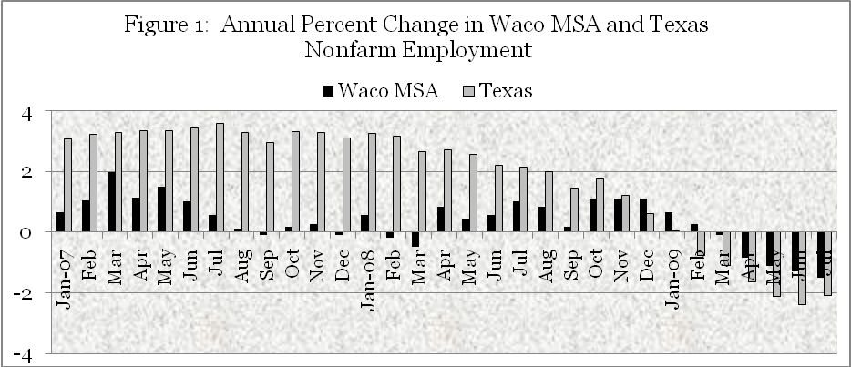
Source: Texas Workforce Commission

Table 1
1st Quarter Gross Sales by All Industries in Texas Metro Areas

Metropolitan Statistical Area | Sales 1st Qtr 2009 | Sales 1st Qtr 2008 | 2008-09  % Chg.
Abilene | $1,277,838,985 | $1,347,294,318 | -5.20%
Amarillo | $2,070,199,663 | $2,243,396,996 | -7.70%
Austin-Round Rock | $14,178,762,548 | $16,063,935,969 | -11.70%
Beaumont-Port Arthur | $7,845,508,530 | $8,423,025,215 | -6.90%
Brownsville-Harlingen | $1,369,203,167 | $1,491,366,852 | -8.20%
College Station-Bryan | $1,288,376,473 | $1,349,481,325 | -4.50%
Corpus Christi | $5,156,569,218 | $7,908,287,988 | -34.80%
Dallas-Plano-Irving MD | $53,768,417,121 | $63,157,126,458 | -14.90%
El Paso | $4,316,650,797 | $5,630,888,561 | -23.30%
Fort Worth-Arlington MD | $18,917,551,412 | $20,008,426,955 | -5.50%
Houston-Sugar Land-Baytown | $81,649,878,614 | $96,469,388,527 | -15.40%
Killeen-Temple-Fort Hood | $2,909,847,834 | $3,213,679,314 | -9.50%
Laredo | $1,109,577,306 | $1,298,201,893 | -14.50%
Longview | $2,557,186,310 | $2,913,390,881 | -12.20%
Lubbock | $2,387,106,995 | $2,651,616,661 | -10.00%
McAllen-Edinburg-Mission | $3,014,072,011 | $3,471,940,953 | -13.20%
Midland | $1,658,238,172 | $1,770,271,045 | -6.30%
Odessa | $1,589,615,317 | $1,874,065,612 | -15.20%
San Angelo | $864,388,254 | $916,621,876 | -5.70%
San Antonio | $20,706,803,954 | $30,236,599,923 | -31.50%
Sherman-Denison | $645,955,465 | $714,042,522 | -9.50%
Texarkana | $636,751,136 | $633,585,842 | 0.50%
Tyler | $1,413,821,902 | $1,536,179,663 | -8.00%
Victoria | $1,928,771,014 | $2,721,209,574 | -29.10%
Waco | $2,076,722,702 | $2,132,923,712 | -2.60%
Wichita Falls | $842,602,847 | $909,877,369 | -7.40%
MSA TOTAL | $236,180,417,747 | $281,086,826,004 | -16.00%
Texas Non-MSA Areas | $20,450,775,795 | $24,778,404,588 | -17.50%
TEXAS TOTAL | $256,631,193,542 | $305,865,230,592 | -16.10%
Source: Texas Comptroller of Public Accounts

Texas employers responded to slower sales at the beginning of 2009 by cutting payrolls at about the same rate as U.S. employers as a whole. The negative rate of growth in employment increased the unemployment rate throughout the state, but in some areas more than others. In mid-year 2009 the Waco metro area ranked seventh among the twenty-six metro areas in terms of the severity of unemployment measured by the unemployment rate.
As shown in figure 2, the Waco MSA unemployment rate increased at a slower pace than the state average, further testimony to its relative stability. The Waco MSA annual average unemployment rate in 2008 was 4.6%, only 0.3% above the 2007 annual average. Monthly rates in the latter months of 2008 crept up, although employment increased at a slower pace than the increase in the labor force.
The stability and growth of employment and income for an area is largely dependent upon its industry structure. The Bureau of Labor Statistics (BLS) has added a powerful new tool for labor market analysis to its website services: the Location Quotient Calculator. The new calculator generates location quotients, a measure that is familiar to regional economists as a way to readily compare the industrial activity levels among different areas of the country. Location quotients are ratios used to compare the concentration of a resource or activity, such as employment, in a defined area to that of a larger area or base, such as the nation. If resource consumption is homogeneous and proportional to labor inputs, then a location quotient of greater than one suggests net exports from the local area to the larger region, while a location quotient less than one suggest net imports from the larger region to the local area.

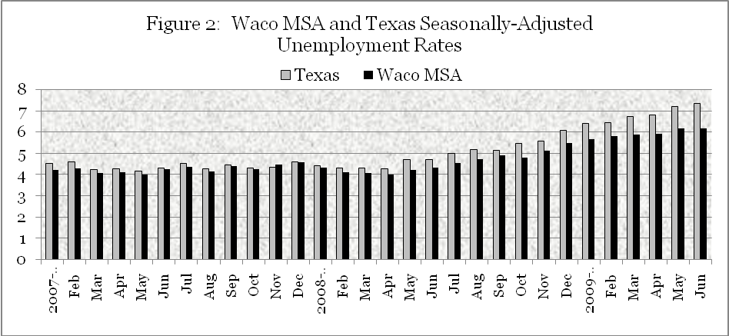
Source: BLS Monthly Household Survey

Table 2 shows the percentage of total employment among basic industries in the U.S., the State of Texas, and the Waco metro area in 2008. Location quotients for the state and Waco MSA are derived by dividing their percentage of employment in each industry by the percentage of employment nationwide.
Texas’ location quotient of 2.0 in natural resources and mining indicates that energy products were largely responsible for early statewide 2008 growth. In contrast, Waco has a location of on 0.25 in natural resources, reflecting the fact that Waco is an importer of energy products. Waco’s location quotient of 1.52 in manufacturing generally indicates greater exposure to the impact of recession on industrial production. The relatively high location quotients in both Texas and Waco in construction reflects stronger growth in commercial construction and a lower rate of decline in residential construction compared with other parts of the country.
In the nondurable goods sector Waco’s location quotient in education and health services is 18% higher than the national average and 36% higher than the statewide average, two have been largely recession proof sectors that go a long way in helping to explain the cyclical stability of Waco.

Table 2
Shares of Employment and Location Quotients for Texas and Waco MSA
Industry | U.S. | Texas¹ | Waco MSA¹ | Texas L.Q.² | Waco L.Q.²
Total, all industries | 100 % | 100 % | 100 % | 1.00 | 1.00
Natural Resources | 1.66% | 3.33% | 0.41% | 2.00 | 0.25
Construction | 6.29% | 7.72% | 6.92% | 1.23 | 1.10
Manufacturing | 11.82% | 10.60% | 17.95% | 0.90 | 1.52
Trade, Trans., and Util. | 23.05% | 24.44% | 21.53% | 1.06 | 0.93
Information | 2.64% | 2.49% | 1.94% | 0.94 | 0.73
Financial Activities | 7.04% | 7.34% | 7.70% | 1.04 | 1.09
Prof. and Bus. Services | 15.64% | 15.34% | 10.18% | 0.98 | 0.65
Education &Health Services | 15.86% | 13.76% | 18.71% | 0.87 | 1.18
Leisure and Hospitality | 11.83% | 11.54% | 11.13% | 0.98 | 0.94
Other Services | 3.96% | 3.38% | 3.50% | 0.85 | 0.88
Unclassified | 0.19% | 0.07% | 0.03% | 0.34 | 0.16
¹Percentage of area employment. ²Location quotient based on U.S. industries in 2008. Source: Bureau of Labor Statistics
___________________________________________________________________
INDUSTRY WAGE INCOME AND EMPLOYMENT

Quarterly establishment data on wage rates and employment available through the 1st quarter 2009 shows the impact of the U.S. recession on growth in Waco MSA wage income. Table 3 shows that while total wage income for nonfarm workers fell only 0.89% in 1st quarter 2008 compared with the same quarter a year ago the recession affected local industries differently. The annual percentage decline in employment, wages, and wage income was especially felt by workers in manufacturing, retail trade, finance and insurance, and real estate. First quarter construction employment and income was higher in 2009 compared with a year ago, driven by strong demand for nonresidential investment. Education employment and average wages also increased. Real estate employment experienced the largest reduction in employment, but remaining workers experienced significant gains in average wages that were still not strong enough to prevent a loss in total wage income in the industry.
Although wage data is not available since the first quarter 2009, table 5 shows industry estimates of the annual rate of change in monthly employment since the beginning of the second quarter. Since wage rates are unlikely to have increased since the first quarter, negative employment growth means continue losses in wage income.

Table 3
Annual Percent Change in Waco MSA Employment, Wages, and Wage Income
Among Selected Industries, 1st Quarter 2009 from 1st Quarter 2008

 | Percent change in 1st Qtr. 2008-09 Employment | Percent change in 1st Qtr. 2008-09 Avg. Wages | Percent change in 1st Qtr. 2008-09 Wage Income
Total, all industries | -0.31% | -0.58% | -0.89%
Construction | 5.52% | 0.15% | 5.67%
Manufacturing | -5.32% | 0.63% | -4.65%
Retail Trade | -0.56% | -3.20% | -3.74%
Financial and  Insurance | -5.34% | 0.89% | -4.40%
Education | 0.84% | 3.29% | 4.18%
Real Estate | -7.22% | 3.83% | -3.11%
Source: Texas Workforce Commission

Table 4
Annual Percent Change in Monthly Employment in Waco MSA

 | Mar | Apr | May | June | July | Aug
Industry | 2009 | 2009 | 2009 | 2009 | 2009 | 2009
Nonfarm total | -0.1 | -0.8 | -1.1 | -1.3 | -1.4 | -1.6
Construction | -1.7 | -3.3 | -4.9 | -7.9 | -6.5 | -9.5
Manufacturing | -5.2 | -5.8 | -6.5 | -6.5 | -6.5 | -5.9
Trade, trans., utilities | 0 | -0.5 | -1.1 | -2.7 | -2.2 | -3.2
Information | -5.9 | -5.9 | -5.9 | -5.9 | -5.9 | -5.9
Financial Activities | 0 | -1.5 | -1.5 | -1.5 | -1.5 | -1.5
Professional and Bus. | -2.3 | -6.7 | -6.7 | -5.6 | -4.5 | -4.5
Education and Health | 3.2 | 3.2 | 3.1 | 3.1 | 2.6 | 3.1
Leisure and Hospitality | 1.1 | 0 | -1 | 0 | 2.1 | 0
Other Services | -2.6 | -5 | -2.5 | -2.4 | -2.5 | -2.6
Government | 2.9 | 4.1 | 4 | 4.6 | 1.7 | 2.9
Source: U.S. Bureau of Labor Statistics
___________________________________________________________________
INFLATION PERFORMANCE

As shown by figure 3, the central Texas consumer price index fell 1.9% in July 2009 compared with July 2008. This amounts to the largest drop in 59 years mainly due the drop in energy prices. In July 2008 gasoline prices exceeded $4 per gallon and food prices were increasing due to rising delivery costs as well as the cost of fertilizer and other farm input prices. In September 2009 central Texas prices increased 0.57% compared with two months earlier, but still averaged 1% lower than September 2008.
The closely watched core inflation rate equal to the change in the price index for all items less food and energy increased 1.9% in Central Texas and 1.6% nationwide, staying below the Federal Reserve Bank’s targeted range. Gasoline prices have risen slightly in response to the falling dollar that has led to higher oil prices. However, their impact is not expected to increase the overall inflation rate significantly in the near future. September 2009 food prices have fallen slightly over the last six months and are 1% lower than they were in September 2008.
U.S. manufacturing capacity utilization rates are low and should put downward pressure on both inputs and final goods prices in the next several quarters, although commodity prices will respond positively as economic recovery accelerates. Slack in the labor market will temper growth in wages and salaries, which dropped off sharply during the course of the recession. In the short-run the rate of inflation in the economy is expected to remain low but will creep upward with higher commodity prices as the economic recovery progresses.
Recently announced growth in the U.S. fiscal deficit has increased media worries about longer term inflation risk. Historically, however, there is no empirical correlation between fiscal deficits and inflation. Clearly, the inflation rate is a monetary phenomenon that depends upon actions taken by the Federal Reserve to manage the money supply. The economy is currently awash with liquidity but much of this money is being held. As it is shifted into real assets, the Federal Reserve must reduce the money supply which will increase future interest rates. If the Fed does not take steps to control the money supply, then rising inflation will add to inflationary expectations that will raise nominal interest rates in the future and disrupt the stability of transactions based on the future value of the dollar.
The Fed has recently purchased mortgage based assets to encourage the recovery in the housing sector. But, if it is forced to sell these assets to reduce the money supply to control inflation, the direct increase in mortgage interest rates will slow recovery in the housing sector. The timing of these sales is a dilemma facing future Fed policy. While it is difficult to forecast future monetary policy, Fed chairman Ben Bernanke has written extensively on the need for “anchored” price expectations as a key ingredient for long run growth as well as stability.

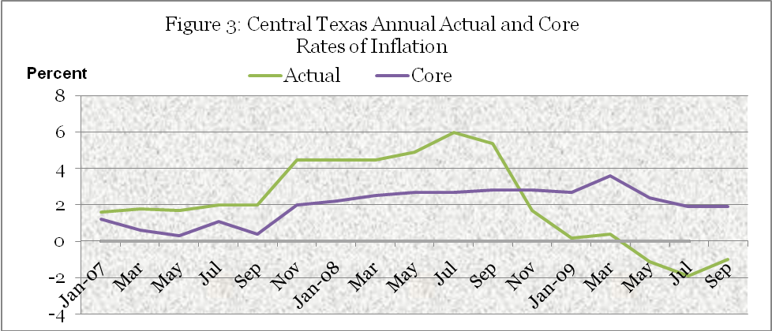
Source: U.S. Bureau of Labor Statistics and Baylor Center for Business and Economic Research

__________________________________________________________________
RETAIL SALES PERFORMANCE

The rate of recovery from recessionary forces in 2010 will to a large extent be dependent on household spending that, in turn, will depend on rising wage income and greater job certainty. Figure 4 shows that the annual percent change in 1st quarter 2009 wage income in the Waco MSA fell at annual rate of 0.8% following only a 1 percent rise during 4th quarter 2008. The change in nominal wage per worker reflects to some degree the inflation rate that reached a peak in July of 2008 before falling to zero by the January 2009. The loss of wage income is partly responsible for a drop in consumer confidence that had already been virtually destroyed by the collapse in stock market prices that shattered household wealth.
Figure 5 based on data published after several quarters by the State comptroller reveals that 4th quarter 2008 Waco MSA retail sales fell 6.5% from the relatively slow pace of 4.2% growth during 4th quarter 2007. Retail sales in 1st quarter 2009 fell to 14.3% from 1st quarter sales in 2008, due primarily to a 38.5% reduction in automotive sales.
The reduction in retail trade in 4th quarter 2008 was the first negative quarterly growth rate experienced in the Waco MSA during the past six years. The decline in 4th quarter 2008 nominal sales was partially due to a 14.5% reduction in gasoline sales that reflected lower gas prices, but even if gas prices had not changed retail sales would have fallen by 5.4 percent.

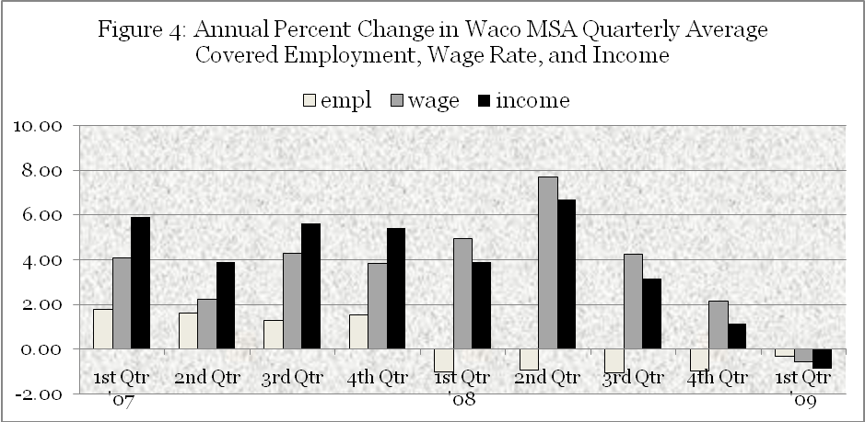
Source: Texas Workforce Commission

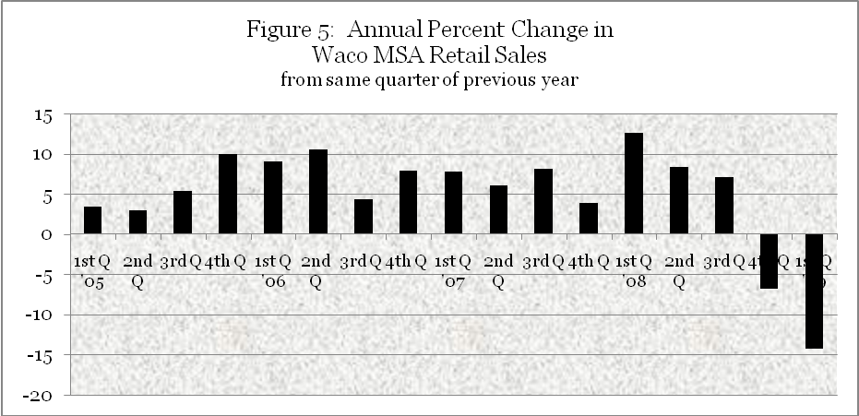
Source Texas Comptroller of Public Accounts

When people are less wealthy—even on paper—they tend to spend less. American households are finally building up their savings and paying off their debts after years of spending more than they earned. Figure 6 shows that 2008 consumers responded to the loss of household wealth with a sudden desire to reduce both credit card revolving and specific debt financed items. Consumer confidence has taken an enormous hit in recent months. As a result, households are reluctant to take on debt-financed items, reflected primarily by reduced retail sales of automobile and other “big ticket” items.

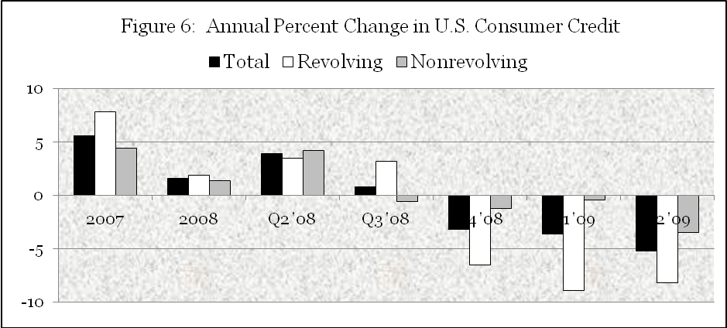
Source: U.S. Federal Reserve System

Table 5
Gross Retail Sales in Fourth Quarter 2008 and First Quarter 2009 and
Percent Change From Same Quarter of the Previous Year

Retail Trade Items | Gross Sales | Gross Sales | Percent | Change
Retail Trade Items | 2008 4th Qtr | 2009 1st Qtr | 4th Q '08 | 1st Qtr '09
Motor Vehicles | $170,185,836 | $96,336,443 | -18.00% | -38.50%
Home Furnishings | $17,835,572 | $17,153,733 | -13.80% | -12.40%
Electronics/Appliance | $32,307,145 | $22,137,161 | -0.50% | -4.60%
Building Materials | $50,058,651 | $46,312,129 | 1.10% | -5.80%
Food and Beverage | $115,164,210 | $111,716,321 | 2.80% | -0.40%
Health and Personal | $35,002,546 | $31,013,333 | -10.70% | 1.90%
Gasoline Stations | $121,548,938 | $92,781,238 | -14.50% | -35.30%
Clothing Stores | $33,124,244 | $26,391,018 | -2.60% | 1.50%
Sport/Hobby/Books | $27,961,947 | $20,207,621 | -0.20% | 3.60%
General Merchandise | $156,264,963 | $127,395,893 | 2.90% | 0.10%
Miscellaneous Stores | $44,693,779 | $34,120,712 | -4.50% | -13.90%
Non-store, Other | $14,548,240 | $25,348,506 | 6.50% | 99.20%
Total Retail Trade | $818,696,071 | $650,914,108 | -6.80% | -14.30%
Source: Texas Comptroller of Public Accounts

Table 5 shows that spending on automobiles was the most significant debt financed item that consumers stopped purchasing in 4th quarter 2008 with sales declining even more in 1st quarter 2009. Home appliances and furnishing were also hampered by the reduction in new housing starts compared with the previous year. Other discretionary purchases that decreased were personal spending, apparel, and electronics. Food and beverage spending for home consumption increased. Building materials retailers benefitted in late 2008 from remodeling and other do-it-yourself projects by home owners lost sales in early 2009 and are unlikely to gain traction until new housing starts increase late in the year.
Table 6 shows that slower retail sales and spending on other taxable items continued in 2009, reflected by the 1.04% reduction in year-to-date sales taxes receipts through September received by local jurisdictions based on taxable sales through July.

Table 6
September 2009 Unit Sales Tax Receipts and Year-to-Date Payments and
Percent Change from Same Period a Year Ago

McLennan County Jurisdiction | Payment Sept. 2009¹ | % Change 2008-09 | Payment Year to Date | % Change 2008-09
Bellmead | 245,699 | -0.09% | 2,304,386 | 1.91%
Beverly Hills | 50,722 | -10.89% | 407,340 | -12.22%
Bruceville Eddy | 5,230 | 33.78% | 51,559 | -3.00%
Crawford | 4,085 | 20.50% | 32,893 | -2.83%
Gholson | 1,851 | 11.44% | 19,569 | 15.68%
Hallsburg | 303 | -49.68% | 3,503 | 20.73%
Hewitt | 86,779 | -34.42% | 866,127 | -13.19%
Lacy Lakeview | 52,497 | 8.34% | 478,285 | 1.81%
Leroy | 158 | -35.44% | 2,216 | 25.52%
Lorena | 16,659 | -15.89% | 216,566 | 14.94%
Mart | 8,095 | 0.08% | 81,985 | 2.44%
McGregor | 39,270 | -5.47% | 437,248 | 3.13%
Moody | 2,274 | 178.51% | 25,992 | 11.19%
Riesel | 37,897 | -26.32% | 325,717 | 77.90%
Robinson | 64,180 | -10.46% | 664,080 | 2.33%
Ross | 277 | -5.48% | 2,579 | -5.35%
Waco | 2,010,055 | -8.53% | 20,738,960 | -1.28%
West | 29,025 | -2.32% | 289,875 | 4.93%
Woodway | 132,689 | -8.75% | 1,276,175 | -7.77%
County Total | 2,787,747 | -8.89% | 28,225,056 | -1.04%
¹Based on July taxable sales
Source: Texas Comptroller of Public Accounts

Monthly tax rebates for August and September compared with the same month a year ago are down 4.18% and 8.89%, respectively, signaling a significant decline in sales during June and July compared with the same month a year ago. While additional auto sales due to the cash for clunkers government subsidy will improve tax rebates received in October (based on August sales), receipts are reduced by the back-to-school tax holiday. However, the positive sales responses to the back-to-school tax holiday and the cash for clunkers program indicate that consumers do have pent-up demand that could be unleashed this holiday season if retailers offer price incentives. Of course, while unit sales may increase in response to price incentives, retailers face narrowing profit margins. Even as employment starts to improve in 2010 consumers will remain cautious, so that spending is likely to lag behind real after-tax income for the next several quarters. The economy will really begin to reflect higher household expectations when new residential construction shows more positive signs that will add to spending on furniture, appliances, and other home furnishings.

MANUFACTURING PERFORMANCE

In 2008 employment by manufacturing firms made up almost 18 percent of Waco metro area private nonfarm employment in contrast to an average of only 10.6 percent statewide. In general, manufacturers facing slumping revenue respond by cutting inventory costs, reducing payroll through layoffs, and seeking other costs savings. While this generally makes Waco more vulnerable to recession than the state average, some manufacturing industries are more sensitive to recession than others.
As the global recession lengthened U.S. manufacturing jobs which had declined only 3% from July 2007 through July 2008 decreased 12.1% from July 2008 through July 2009. Figure 7 shows that Texas and Waco MSA manufacturers experienced a similar pattern of job layoffs beginning in late 2008 and accelerating in 2009 before stabilizing recently at lower levels of employment.

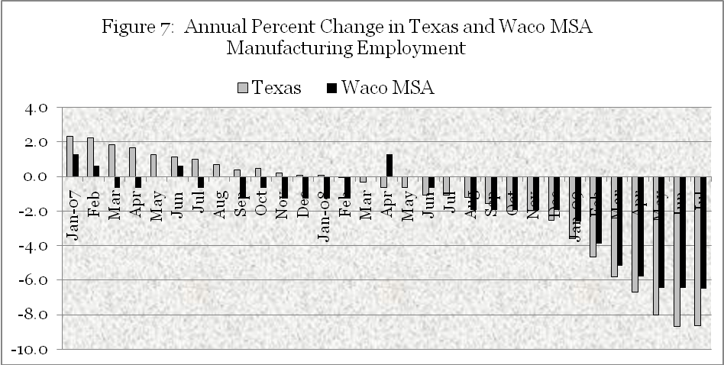
Source: Texas Workforce Commission

Table 7
Percent of Manufacturing Employment in U.S. and Waco MSA and
Annual Percent Change from July 2008-09 and July 2007-08

 |  |  |  | Annual % Change
 | %  U.S. | % Waco | Waco L.Q. | July '08-09 | Jul' 07-08
Total, all manufacturing | 11.82% | 17.95% | 1.52 | -12.1 | -3.0
Wood products | 0.40% | 1.16% | 2.89 | -20.5 | -11.4
Paper products | 0.39% | 0.81% | 2.07 | -8.9 | -2.0
Printing and related support activities | 0.52% | 0.67% | 1.28 | -12.5 | -4.8
Food products | 1.30% | 2.81% | 2.16 | -0.7 | -1.2
Textile product mills | 0.13% | 0.26% | 2.01 | -14.4 | -7.0
Computer and electronic products | 1.10% | ND | ND | -9.1 | -1.8
Transportation equipment | 1.42% | 2.53% | 1.78 | -17.8 | -4.7
Petroleum and coal products manufacturing | 0.10% | 0.03% | 0.32 | -3.3 | 4.3
Chemical products | 0.75% | 0.78% | 1.04 | -4.9 | -1.2
Plastics and rubber products manufacturing | 0.64% | 0.77% | 1.20 | -15.1 | -1.9
Nonmetallic mineral products | 0.41% | 1.23% | 3.00 | -13.0 | -7.0
Fabricated metal products | 1.36% | 1.34% | 0.99 | -15.3 | -2.3
Machinery | 1.04% | 1.24% | 1.18 | -16.5 | 0.3
Source: Texas Workforce Commission

Table 7 shows that the reason for higher state manufacturing performance compared with Waco during the earlier of the two 12-month periods period was job growth in the energy industry that benefitted Texas but not Waco. The Waco MSA location quotient for petroleum and coal products is 0.32, which indicates that Waco is a net consumer of petroleum and coal products not an exporter. The energy industry was the only manufacturing industry that experienced any significant positive nationwide employment growth from July 2007 until July 2008. In every manufacturing industry, including energy, jobs have declined at a faster pace over the following four quarters thorough 2nd quarter 2009. Among Waco MSA manufacturing industries that are prominent exporters (as shown by their high location quotients) only employment in food products remained relatively stable over past year, while employment in other important categories, including wood products, fabricated metals, machinery, and transportation equipment have fallen significantly in response to the recession.
The reduction in manufacturing employment does not imply that manufacturing output fell proportionally. Payroll costs are saved by producing output from fewer workers, resulting in higher labor productivity and lower labor costs. Table 3 in the appendix shows separates quarterly manufacturing sales into its trend, seasonal, and cyclical-irregular components. Since 2003 the average trend rate of growth Waco manufacturing sales is 5.34% per year. After correcting for seasonal changes Waco manufacturing sales fell 12% below trend levels in 4th quarter 2008. However, manufacturing sales in 1st quarter 2009 fell less than the amount caused by normal seasonal forces. In fact, first quarter manufacturing sales were 15.7% higher than first quarter sales a year ago even though manufacturing employment had decreased.
Manufacturing employment in Waco seems to have stabilized over the past couple of months, although it remains more than 6.2% lower than a year ago. Inventories for most producers are relatively low, so that projected increases in sales are expected to increase production next year. But, excess capacity will reduce expected growth in new fixed capital investment, including new plant locations, next year.

___________________________________________________________________

CONSTRUCTION AND HOUSING PERFORMANCE

The current U.S. recession began with the financial crisis that was the result of the collapse in a price bubble in the U.S. housing market driven by easy monetary policy. The sale of collateralized mortgage obligations derived from subprime mortgage financing spread losses from the mortgage market to other financial markets that eventually led to reduced spending in other sectors of the economy. Although the Waco housing market did not experience excessive price inflation, the financial crisis and subsequent reduction in employment and income have significantly reduced the demand for housing and new single family housing starts.
Although residential construction has decreased, 2008 growth in Waco construction employment exceeded statewide totals, generated by $434 million in public bond issues and additional commercial construction in health care, financial services, hotel accommodations and other ventures that more than offset fewer residential construction jobs. Construction employment decreased in 2nd quarter 2009 compared with the same month a year ago due to the completion of several major commercial projects. This decrease is not surprising since in the 1st quarter 2009 Waco’s seasonally-adjusted construction sales were 35% above the predicted trend level since 2003. (See appendix table 2.)
With several public projects still forthcoming and with the market for residential construction near its bottom, employment and output in the construction industry is expected to continue above its trend rate of growth throughout 2010. Figure 8 shows that the annual growth rate in monthly construction employment in the Waco MSA compared with state totals. Unlike statewide performance Waco MSA average monthly construction employment increased throughout 2008 compared with the same month of the previous year. Recently in 2009 construction employment has decreased from the same month in 2008 as several major projects have been completed. Nevertheless construction employment is projected to continue above trend growth as new projects begin and residential housing starts begin to improve.

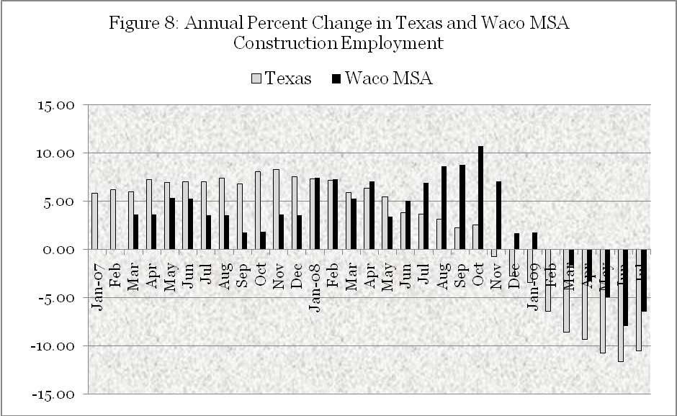
Source: Texas Workforce Commission

Table 8
Annual Rate of Change in Single Family Housing Permits, Texas and Waco

Date | Texas 12 Month |  | Waco MSA 12 Month
Date | Total Units | Percent | Total Units | Percent
Date | Total Units | Change | Total Units | Change
2007-Jan | 152,650 | -6 | 598 | 3
Feb | 150,056 | -8 | 605 | 4
Mar | 145,860 | -12 | 642 | 13
Apr | 143,319 | -13 | 652 | 15
May | 138,890 | -17 | 665 | 13
Jun | 132,781 | -21 | 666 | 13
Jul | 129,770 | -23 | 658 | 11
Aug | 125,087 | -25 | 664 | 13
Sep | 121,521 | -26 | 647 | 8
Oct | 118,396 | -27 | 611 | -3
Nov | 115,430 | -28 | 574 | -13
Dec | 112,378 | -28 | 580 | -10
2008-Jan | 109,341 | -28 | 566 | -5
Feb | 106,187 | -29 | 568 | -6
Mar | 101,315 | -31 | 555 | -14
Apr | 98,720 | -31 | 555 | -15
May | 94,766 | -32 | 529 | -20
Jun | 92,125 | -31 | 510 | -23
Jul | 89,485 | -31 | 510 | -22
Aug | 86,158 | -31 | 483 | -27
Sep | 83,442 | -31 | 462 | -29
Oct | 80,520 | -32 | 450 | -26
Nov | 77,287 | -33 | 426 | -26
Dec | 74,846 | -33 | 401 | -31
2009-Jan | 72,204 | -34 | 393 | -31
Feb | 69,261 | -35 | 357 | -37
Mar | 66,864 | -34 | 307 | -45
Apr | 63,751 | -35 | 276 | -50
May | 61,674 | -35 | 273 | -48
Jun | 60,725 | -34 | 274 | -46
Jul | 60,293 | -33 | 257 | -50
Source: Real Estate Center at Texas A&M University

Table 8 shows the annual rate of new single-family residential housing permits over the prior 12-months for the Waco MSA compared with the state of Texas. The Texas 12-month-to-date total for single family building permits turned negative in December 2006. New housing construction in Waco, on the other hand, continued to expand in the first three quarters of 2007 before the annual rate of new permits turned negative. The annual rate of decrease in new housing permits in Waco was also lower than the state average throughout 2008, only falling to the state average in February 2009.
Since February the annual rate of decrease in local single family building permits in the Waco MSA has been higher than annual rate of decrease for Texas. The higher current rate of decrease in Waco housing starts compared with the state average reflects the lag in Waco’s home building cycle. Over the 12-months ending in July 2009 Waco totaled 257 single-family housing permits, amounting to only 38 percent of the total number of permits issued during the 12-month period ending in July 2007. In the state of Texas, total single-family housing permits for the 12-month period ending in July 2009 were forty-five percent of the 12-month total reached in July 2007. If it takes about the same length of time to work down housing inventories, then the construction cycle for new residential housing is not expected to reach bottom until the first of next year, several months later than the state average.
Recent surveys of potential home buyers view home buying conditions very favorably, but home selling conditions remained quite negative, scuttling home buying plans among those who already own a home. Potential first-time homebuyers are faced with down payment and other credit requirements for loan qualification. As a result Waco housing sales and single family building permits are lower than a year ago, although the annual rate of decrease in MLS sales is decreasing. Housing starts will continue to lag sales but should begin to improve as inventories of existing housing are reduced and jobs and income improve.
The demand for housing is ultimately dependent on growth in the number of households in an area. The largest component of housing demand in an area is from existing households who become homeowners, rather than renters, or those who move from one house to another. Net new housing demand occurs when new households enter the area or existing housing is retired. Net household formation generally occurs with growth in total population. Total population growth includes the natural rate of change (births less deaths) plus net migration (persons entering minus persons exiting the area). Waco, like the state of Texas, has experienced net positive domestic and international migration over the past two years partly due to its relatively strong economy in comparison to other parts of the globe. The rate of population growth in Waco increased 0.9 percent in 2008 which is equal to the average annual rate over the past 10 years. Waco’s stable growth in population occurred continues to be below the state’s population growth rate that remained constant at 2.0%. The increase in Waco’s population amounted to an increase of approximately 800 additional households in 2008, which is significantly greater than the 401 new housing permits registered during the period. Based on population trends the Waco housing market is not overbuilt but, rather, is building up “pent-up” demand that will be unleashed in the future.
The increase in demand for existing housing will reduce inventories and encourage developers to build new housing. One influence that could accelerate housing purchases in the near term is the American Recovery and Reinvestment Act of 2009 that authorizes a tax credit of up to $8,000 for qualified first-time home buyers purchasing a principal residence prior to December 1 of this year. Expectation of higher future mortgage rates could also accelerate housing demand by qualified borrowers. Figure 9 shows the percentage change in the rate of sales of single-family housing units sold during the previous 12-month period in the Waco MSA compared to the state of Texas from January 2007 through July 2009. Beginning in September 2008 single-family MLS sales turned down for both the local and state economies, but the rate of decrease improved the second half of 2008 in Waco while continuing to deteriorate statewide.
Since May 2008 the number of MLS listings in Waco have decreased at a faster rate than the decline in MLS sales, so that despite slower sales the average months needed to sell current inventories at the present rate of sales in July 2009 has fallen from 9.4 months to 8.4 months over the period. In general, when inventories exceed 6 to 6.5 months the residential housing market is viewed as a buyer’s market rather than a seller’s market. The Waco market is a buyer’s market with excess inventories continuing to put downward pressure prices while discouraging builders increasing their rates of new construction.

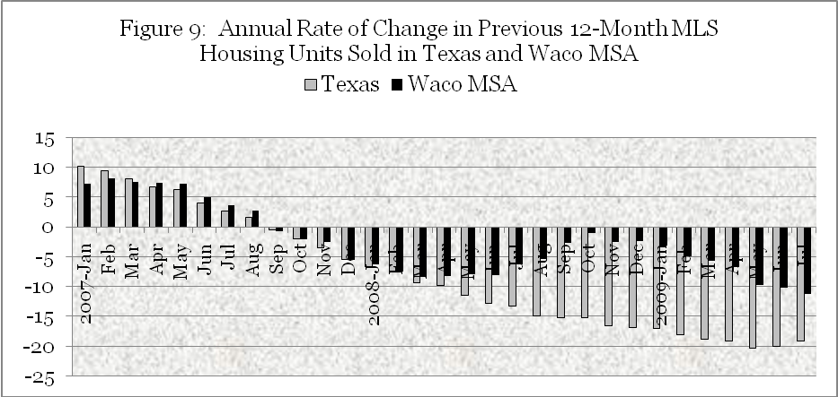
Source: Real Estate Center at Texas A&M

Figure 10 shows the annual rate of change in the average MLS single family housing selling price for units sold during the previous 12-months. The 12-month average selling price of Waco MLS housing grew at a faster rate than the state of Texas average from August 2007 through July 2008. In October of last year the annual average MLS single family selling turned negative, decreasing by an average of 6 percent during the first quarter of the year. While MLS single family selling prices still average less this year than during the same period a year ago, the rate of decrease is falling, suggesting that the market for housing is on the road to recovery from its low point earlier in the year.
A significant factor that is reducing seller prices is the number of area housing foreclosures. The number of McLennan County properties posted for foreclosure in September stands at 96, up from the 89 posted for the same month last year. For the year 2009 through September, a total of 1,016 properties have been posted for foreclosure. That’s 25 percent more than the 813 posted through September 2008.
A higher foreclosure rate puts downward pressure on prices, but it also discourages potential sellers from listing their homes on the market. This reduction in supply mitigates some of the downward pressure on price and helps to explains why the reduction in overall housing prices have been less during in the last few months compared with earlier in the year. As sales of existing housing improve the number of listings will also increase, so that the length of time to sell existing inventories will continue to be above 8 months.

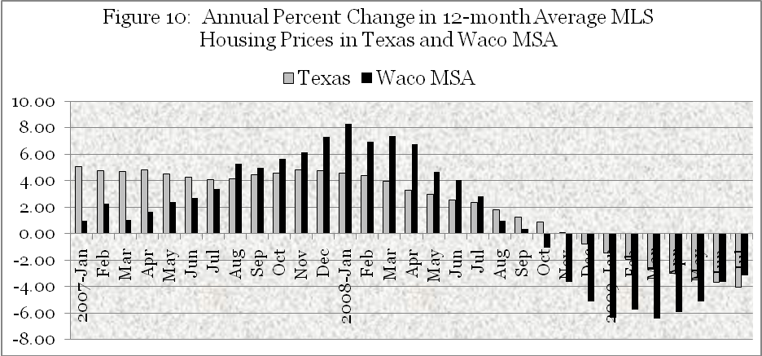
Source: Based on MLS data from Real Estate Center at Texas A&M
Table 9
Housing Affordability Index¹ in U.S. , Texas, and Waco MLS Area

MLS Area² | 2nd Qtr | 1st Qtr | 2nd Qtr | 2008 |  | 2007
MLS Area² | 2009 | 2009 | 2008
First-Time Homebuyers
Waco | 1.98 | 1.98 | 1.33 | 1.44 |  | 1.30
Texas | 1.41 | 1.41 | 1.08 | 1.12 |  | 1.00
USA Total | 1.01 | 1.01 | 0.71 | 0.75 |  | 0.63
All Area Homebuyers
Waco | 2.13 | 2.52 | 1.83 | 1.84 |  | 1.78
Texas | 1.85 | 1.95 | 1.55 | 1.59 |  | 1.45
USA Total | 1.57 | 1.55 | 1.27 | 1.33 |  | 1.11
¹The Housing Affordability Index is the ratio of median family income to the income required to qualify for an 80 percent, fixed-rate mortgage to purchase the median priced home.
²The MLS Area is the reporting Realtors® association's geographic area.
Source: Real Estate Center at Texas A&M University

Table 9 shows that lower housing prices have increased housing affordability significantly in Waco as well as in Texas and the U.S. In 2009 the Waco area’s 2nd quarter housing affordability index increased in the second quarter as median housing prices fell relative to median income for all area households. However, the 2nd quarter affordability index for first time homebuyers did not decline because households in this lower income category experienced a decline in income at the same pace as the decline in the median priced home.
Waco is projected to increase home purchases to qualifying first time buyers during the last part of this year in response to the $8 thousand first-time homeowner incentive that expires at the end of November, relatively low mortgage rates, and relatively high affordability rates driven by lower housing price. The most significant barrier to rising home sales is continued uncertainty over the tenure and stability of future employment. Unfortunately, employment growth is projected to lag the recovery and is not expected to improve appreciably over the next several quarters.

__________________________________________________________
HOSPITALITY AND LEISURE INDUSTRY OUTLOOK

Employment in the leisure and hospitality industry in Texas has exhibited the same pattern of change as total nonfarm employment (see figure 1). Figure 11 shows that Waco MSA employment in leisure and hospitality industries declined in 4th quarter 2007 through 4th quarter 2008 before partially recovering in 4th quarter 2008 and 1st quarter 2009.
The time series on sales by arts, entertainment, and recreation establishments in the appendix table 12 shows that since 2003 sales increased at an average annual rate of 7.19%. However, 1st quarter 2009 sales fell 1.2% compared with the first quarter in 2008, reversing a 22% increase that had occurred between 1st quarter 2008 and 1st quarter 2007. This turnaround illustrates the impact on household discretionary spending due to the economic downturn.
Although sales by arts, entertainment, and recreation establishments declined, the leisure and hospitality industry for both Texas and Waco experienced net gains in employment during 2009. Probably because of Waco’s central location along I-35, its relatively stable economic performance over the past two years, it’s recognized development of tourist attractions and projected convention facilities, and, possibly, the greater exposure to outside investors while pursuing the Bush Presidential Library, investors continue to project rising demand for visitor accommodations that is reflected by the expansion of local hotel capacity.

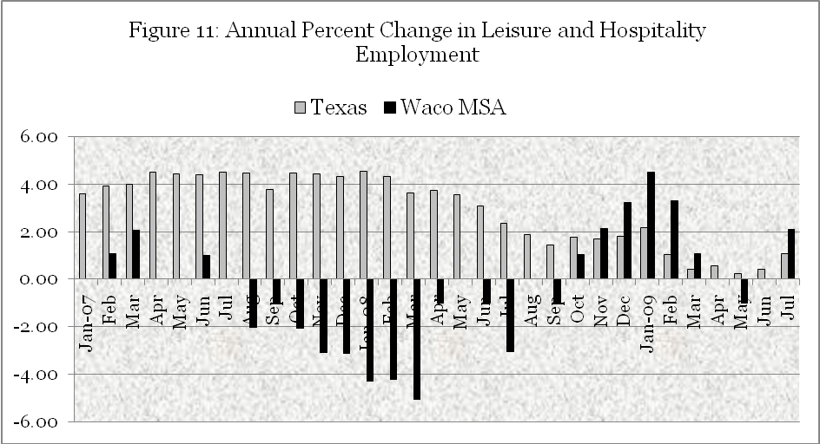
Source: Texas Workforce Commission

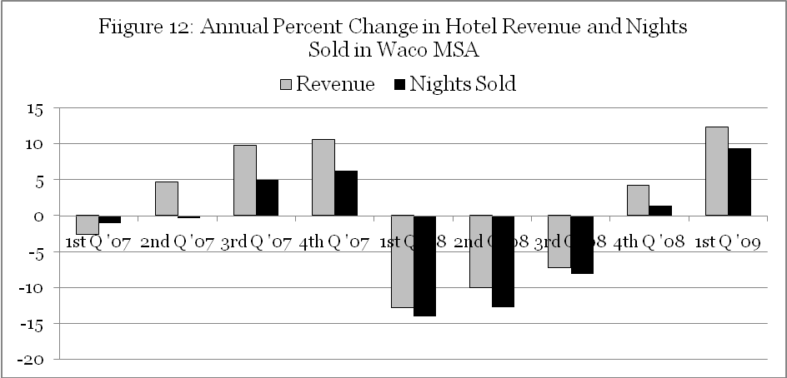
Source: Texas Travel Research Center

Figure 12 shows the percent change in hotel room revenue and nights sold compared with the same quarter of the previous year in the Waco MSA. Waco is a regional destination that has a disproportional number of visitors using automobiles. The reduction in hotel revenue in early 2008 reflects the impact of fewer auto travelers for both business and leisure that were negatively impacted by the increase in gasoline prices in June and July of last year. During this same 2nd quarter in 2008 the percentage decline in seasonally-adjusted sales by arts, entertainment, and recreation establishments also fell below its trend rate since 2003 by 17%. Actual sales increased due to favorable seasonal influences that increase 2nd quarter sales 22.5% above the quarterly average for the year.
A significant contributor to the change in hotel revenue and nights sold was the temporary reduction in number of hotel rooms available early 2008 followed by additional rooms available by the fourth quarter. The Texas Travel Research Center reported that the number of hotels in Waco dropped from 30 in 4th quarter 2007 to 26 in 1st quarter 2008. In fourth quarter 2008 they reported 31 hotels as the number of available rooms returned to the trend levels of growth.
As shown by figure 13, the hotel occupancy rates in the first and fourth quarters of the year are negatively influenced by seasonal forces. The average room rate is higher during the second quarter, although it exhibits less quarterly variation than the occupancy rate. The strong growth rate in revenue in 1st quarter 2009 is largely explained by additional rooms available for rent compared with 1st quarter 2008. Hotel demand in 2010 is projected to increase from additional business travel as the economy recovers and reach trend levels by the middle of 2010.
With the proposed remodeling of the Waco Convention Center, expanding leisure attractions, and higher volumes of traffic along Interstate-35 with Texas’ economic recovery the long-run growth in the leisure and hospitality industry is expected to increase and remain a steady percentage of local employment and income.

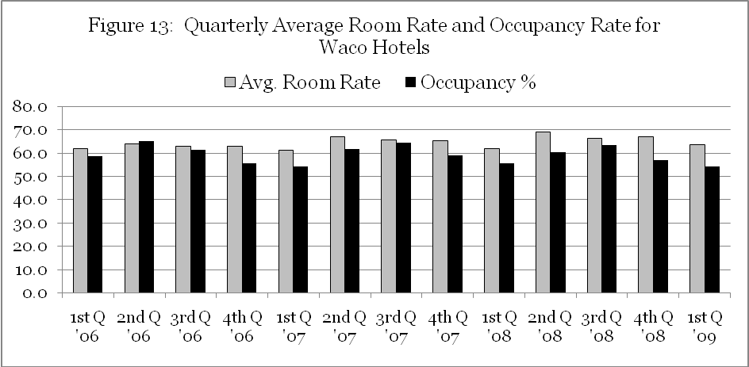
Source: Texas Travel Research Center
___________________________________________________________________
BUSINESS AND PROFESSIONAL SERVICES PERFORMANCE

The demand for business and professional services is sensitive to the cycle since it is derived in part from the level of business activity. Seasonally-adjusted quarterly sales were 33.6% above trend in 2nd quarter 2008, but fell to 31.7% below trend in 1st quarter 2009. (See appendix, table 8.) The annual average growth rate in is seasonally adjusted sales since 2003 is 11.94%, but sales in 1st quarter 2009 were 35.6% lower than actual sales in 1st quarter 2008.
In August 2009 Waco firms employed approximately 8,400 persons in this industry compared with a peak level of about 9,000 persons in April and May of 2008. The loss of jobs in these industries is more frequent among support personnel, but it also is reaching higher income white collar workers. Figure 14 shows that the annual growth rate for Waco area business and professional service jobs reached a peak of 10% in August two years ago and remained positive before decreasing in August—September of last year. Although business and professional service employment recovered slightly in the latter part of the year, the total number of jobs has failed to reach monthly totals of the previous year for each month in 2009 since February.

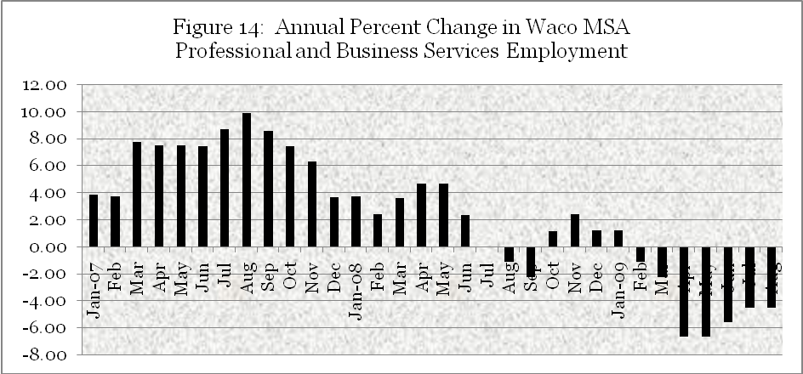
Source: Texas Workforce Commission

The good news is that the number of professional and business service jobs has remained constant over the past four months with the lower percentage change due to an inability to maintain the growth in number of jobs experienced during early 2008. The industry has probably hit bottom with 600 fewer jobs than the peak reached two years ago. Local business and professional service employment has in the past been particularly sensitive to performance in the manufacturing sector.
Although the pace of new employment is likely to be relatively slow, growth momentum should begin to increase as business activity improves from what presently appears to be the trough of the recession.

___________________________________________________________________
EDUCATION AND HEALTH CARE INDUSTRY PERFORMANCE

A bright spot in the Waco economy has been performance in the education and health care services industries in the Waco metro area. Figure 15 shows that over the fourteen months examined since July 2008, employment in health care and education increased from the same month of the previous year. Growth in health and education employment in the 4th quarter 2008 averaged 3.6% higher than the same quarter in 2007, but the annual rate of growth has decreased to only 1% lately.

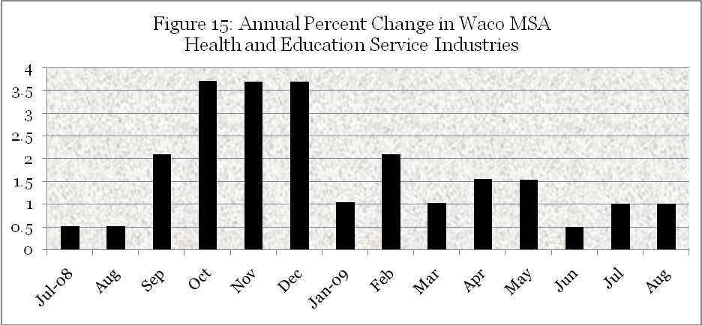

Source: Texas Workforce Commission

Local health care providers consisted of an average of 13,406 workers (excluding social assistance) during 1st quarter 2009, amounting to 13.2% of total nonfarm employment in the metro area. In contrast, the state average for the health care industry is 10.8% on nonfarm employment. The Waco MSA health care employment exceeds the state average by 22% indicating that the sector not only provides strong local health care coverage, but that it also exports services to areas outside of the county. Waco hospital create 5.69% of total area jobs in 1st quarter 2009, compared with 3.78% statewide, a 50.1% differential that reflects even greater net exports of hospital services to surrounding counties.
Although the health care industry is often viewed as recession proof, a slower economy reduces the ability to pay for medical services and slows the demand for elective procedures that adversely affect provider revenues. Slower demand is particularly damaging in highly competitive markets that possess excess capacity previously created to meet normal and peak demands.
Waco’s trend growth in seasonally-adjusted sales by health care and social services establishments grew at an average annual rate of 7.6% from 2003 through first quarter 2009. In 4th quarter 2008, sales in health care and social services fell 13.8% below trend. (See appendix table 9). In 1st quarter 2009 sales in health care and social assistance recovered to 20.2% above trend. 1st quarter 2009 sales outpaced sales in 1st quarter 2008 by 20.1%.
Health services employment increased 1.3% in 1st quarter 2009 in response to the expanding healthcare output in the area. As the economy improves next year, health care employment will rise about 2%.
Educational services workers in 1st quarter 2009 averaged 11,989 in the Waco MSA economy, making up 11.8% of total metro area employment.

Of these workers 3,478 were privately employed workers, primarily by Baylor University, earning an average weekly income of $1,018 that was 46.6% higher than the average weekly wage of the 101,209 total workers in the Waco metro area. The impact of higher education provided by Baylor, MCC, and TSTC is the primary reason that Waco has 9.2% more educational service workers than the state average. Not only do these institutions provide valuable education services to local residents, but they also keep higher education dollars in the Waco economy that otherwise would flow to other regions.
Figure 16 shows that despite U.S. recessionary forces that began in 4th quarter 2007 worker income in Waco’s education service sector increased 8.5% compared with the fourth quarter of the previous year. Making up this increase was an almost 2% increase in employment and over 6.5% increase in average wage income. The increase in wages was not just the result of higher cost of living adjustments but also reflected higher teacher incomes for new and existing personnel.
Employers in educational services are faced with rising income constraints in 2009 that is reflected by slower additions to employment and wages. However, since wages are often based on a contract year on projected inflation beginning in September, teachers and other personnel have benefitted increased purchasing power due to the significant drop in inflation beginning in late 2008 to almost zero during the first quarter of 2009.

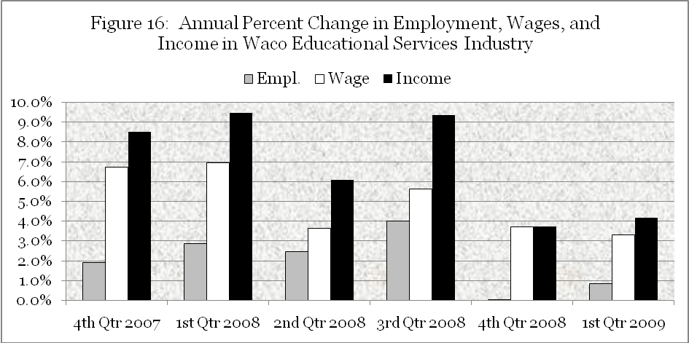
Source: Texas Workforce Commission

___________________________________________________________________OVERVIEW AND SUMMARY

In prior U.S. recessions the economic downturn in the Waco economy lagged the national downturn and was less severe, and the current recession is no exception. The official U.S. business cycle peak signaling the beginning of the recession was February 2007. It is expected that the U.S. economy will reach bottom during the third quarter of this year, and the recession will be officially recognized as the deepest and longest downturn the nation has seen since the Great Depression. Employers have shed jobs at a rapid pace, consumer have pulled back spending, businesses have cancelled equipment purchases, and unsold home dot cities throughout the country. Looking forward to next year there are five areas that are the keys to economic recovery; namely, jobs, housing, consumer spending, business spending, and prices.
The outlook for jobs is probably the worst aspect of the economy in 2009. The September 2009 Waco MSA unemployment rate of 7.1% is 2.3% higher than the September a year ago and exceeding the previously peak rate reached in 1991. The unemployment rate excludes those who have given up on finding jobs or who work part time because they can't get full-time work. The total number of jobs lost in the Waco MSA according to the BLS household survey over the past year amounts to 656 workers or only 0.62 percent of total employment a year ago.

JOBS
Over the same period the Waco MSA labor force increased by 2116 potential workers, amounting to a 1.92 percent increase. The 1.92 percent increase in the labor force is more than double our population growth, indicating that Waco attracted labor from around the state that significantly increased our unemployment rate.
In November 2008 Business Roundtable reported that 60% of U.S. CEOs said they expected to cut workers in the next six months. What has been somewhat surprising is that Texas has experienced a similar brutal rate of job losses as the nation. The rate of job losses in Waco have also increased since March, although the local economy continues to outperform the state average due to its higher average concentration of jobs in health care and education, which are the two bright spots in the labor market.
Even after the economy stabilizes, job losses will probably continue for a while. This jobless recovery pattern will be similar to period following the 2001 recession as wary businesses await more evidence that the economy is on solid footing. Indeed, employers cut jobs for nearly a year after the 2001 recession ended. Employers are expected to trim payrolls well into next year, shoving the national jobless rate to above 10% and the local unemployment rate to near 8%.
In some areas of the country the housing sector is expected to lead their recovery, just as it led the downturn. This is already reflected in rising housing prices over the past few months in several areas that experienced a crash in housing prices when their speculative bubble burst.

HOUSING

The Waco MSA housing price cycle has been relatively stable in response to normal demand and supply conditions without a speculative bubble and a subsequent plunge. However, home prices have edged downward this year as demand has fallen. While the market for housing is expected to reach bottom in late 2009, the rebound is likely to be slow and gradual without significant price changes in 2010.
The home building cycle in Waco has lagged the statewide building cycle in much the same way as other measures of recent local economic performance, such as wage income and gross metro area sales. Waco MSA construction of single family housing continued to increase nine months after new housing starts began to fall in Texas. This led to additional inventories that led to a faster rate of decline in new housing starts this year compared with the state average.
RETAIL SALES

The annual rate of decrease in housing starts over the previous 12-month period reached 50% in July compared to 33% statewide. In August, 41 single-family building permits in the Waco MSA amounted to twice the number issued in August a year ago. This raised the 12-month annual rate of decrease in new permits to 42%. While it’s too early to know for certain, July could be the bottom of the Waco residential construction cycle.
Although September MLS home sales were 12 percent below the rate achieved in September of last year, the both the average selling price and the median selling price increased although the average price increased at a slightly higher rate. This implies that the market for existing home included more units sold in the higher-priced sector which also includes households who are the primary purchasers of new housing. Sellers of lower-price housing are more likely to cut prices to compete with lenders’ selling foreclosed homes which continue to average about 25% higher this year compared with the same period a year ago.
The government’s $8,000 subsidy for first time homebuyers that expires on November 31 and continued low mortgage rates are expected to have some impact but potential buyers are limited by financial constraints and uncertainty regarding future employment and income.
Spending on consumer goods in the Waco economy has recently been at historic low levels compared with its trend growth that has averaged 5.67% annually since 2003 even when including the recent downturn. Two influences that turbo-charged U.S. consumption in recent years—growing household debt and a falling savings rate—have gone into reverse. In late 2008, as households started reducing their debt and saving more, consumption tumbled. Waco’s consumers are making similar decisions as elsewhere in the country. With unemployment and uncertainty about future income, people are paying off debts and building up savings.
In 4th quarter 2008 Waco retail trade fell 6.8% compared with the same quarter of previous year due primarily to the decline in stock values with its huge toll on household net worth combined with all the uncertainty surrounding solutions to the financial crisis. In 1st quarter 2009 consumer spending continued to fall with a quarterly total that was 20.5% lower than the previous quarter and 14.3% lower than the same quarter in 2008, further impacted by loss of wage income for the first time during the downturn.
Appendix table 5 based on time series analysis of quarterly retail sales in Waco since 2002 shows that seasonally-adjusted retail trade fell 7.7% below projected trend growth in 4th quarter 2008 and 10.7% below projected trend growth in 1st quarter 2009. Unit sales tax receipts have fallen progressively lower during the ensuing months through September 2009.
Auto sales in August increased with the government’s “cash for clunkers” subsidy, but the annual rate of unit sales in 2009 is expected to be less than in 2008 when sales volume fell rapidly at the end of the year. Estimates range from 11.5 million to 12.5 million unit sales in 2009, a far cry from the 17 million-a-year sales level in 2001.
One good piece of news that has helped consumer spending has been the drop in prices of commodities over the past year, particularly gasoline and food items. This shows up as a drop in the dollar volume of sales, but it amounts to an increase in real purchasing power that may be used to boost unit retail sales of other goods and services.
The most optimistic outlook in second half of 2009 is that the downward slide in sales will at least slow and perhaps increase slightly in the important 4th quarter of the year. But large chain retailers are not taking any chances. Nearly all chain stores have scaled back plans to open new stores and to even close existing stores, a decision that has already affected some Waco “big box” locations. Retailers are expected to brace for the worse by conservative inventory policies and increased use of marketing incentives to attract customers. Competition will be brutal and will greater price concessions, profit margins will remain slim.
Less revenue has led to the cost savings by businesses that included layoffs of personnel and reduced inventory investment. Fixed capital investment has also plunged as capacity utilization rates increased.
Business
Spending

When considering cyclical influences on business spending traditional concern is directed toward the goods sector, especially manufacturing. Waco manufacturing performance has been impacted by the recession with gross sales 12% below trend in 4th quarter 2008 before improving in 1st quarter 2009. 1st quarter 2009 manufacturing employment was down 5.32% from 1st quarter 2008, even though gross sales improved from the previous quarter after adjusting for seasonal influences. Transportation and warehousing seasonally-adjusted sales in 1st quarter 2009 were 8% below trend. Employment in the business and professional services sector in April and May of this year averaged 6.7% less than during the same months a year ago, even higher than the 6.5% reduction in manufacturing jobs in May 2009 compared with May 2008.
The good news is that while business spending and employment has been cut dramatically in early 2009, it has stabilized more recently. Spending in the goods sector is expected to increase slightly in the form of inventory investment during the second half of the year. Also the Institute for Supply Management's non-manufacturing index increased to 50.9 in September the highest value in over a year. An index above 50 implies that the service sector is rising, although it is too early to determine whether or not gain can be sustained.
Fixed investment is expected to remain low as businesses find ways to repair existing machinery and buildings rather than replace equipment or move. With the low capacity utilization rate firms will not increase their capital expenditure until they see concrete evidence that the economy is on the mend.
Prices continue to fall for a variety of goods. The September 2009 rate of inflation in central Texas is -1.0% compared with last year’s July peak inflation of 6%. Food and energy prices that are largely to blame for last year’s peak inflation have fallen abruptly. The core inflation rate equal to changes in the CPI less food and energy has barely changed over the period.

PRICES
In early 2009 with the economy in a slump there was some talk that the economy could sink into a deflationary spiral that would be hard to stop once it takes hold. If consumers expect prices to decline, they will put off making purchases and further cripple an already weak economy. The recent strengthening of the economy has made the chances of deflation remote, but the Federal Reserve is taking no chances. They have continued to keep interest rates low and plowed money into the financial system.
The concern in some peoples’ minds is not deflation but rising inflation that is often attributed to the Federal Government deficit. Historically, however, there is no correlation between the government deficit and inflation during periods in which the money supply is managed properly. Inflation in prices has been due to money supply growth that exceeded the rate of growth in output when the economy was operating at its potential. While recent actions by the Fed have increased the money base the potential addition to the money supply has not been realized. When the money multiplier increases with expansion in bank lending as the economy expands the Fed will have to reduce the money supply by selling assets from its balance sheet. Traditionally, these have been U.S. Treasury securities, but lately they include a variety of assets including mortgage securities that the Fed would sell in a timely manner in order to maintain their value. The sale of any assets would lower their price and increase interest rates which is the prescribed policy if the economy operating beyond its potential, adding to inflationary pressures.
The rate of price inflation in Central Texas is expected to mirror the inflation rate of the nation. Over the last few years most of the geographic difference in the rate of change in the cost of living has been due to housing costs. Waco’s inflation rate was below the national average due to more stable housing costs during the early stages of the housing bubble. When the bubble broke housing prices plunged and the economic fortunes many areas of the country collapsed, causing more concern over deflation nationwide than apparent locally that was relatively unaffected by changes in housing prices. Now, we may see housing prices recovering faster in depressed markets that could affect relative inflation rates slightly. Food prices and other commodity prices have fallen over the past four months throughout the country. Oil prices are projected to remain relatively stable which is particularly favorable for parts of the country with cold winters that use heating oil to warm their homes. In general, the relatively slow pace of economic recovery and the amount of excess capacity available for increased production will result in moderate inflation this year and next. What happens after 2010 will increasing depend on Federal Reserve policy.
In conclusion, despite the recent stress due to recession, there is gathering evidence that the rate of spending by housing and consumption are at or near their bottom and will begin to increase gradually. Consumers, while cautious about excessive debt, have pent-up demands for durable goods, and they show willingness to respond significant seller incentives. Manufacturing output is projected to improve since inventory investment will be needed to replace depleted levels in response to any increases in final demand. Construction of publicly funded infrastructure, funded by local bond issues and some impact from the federal stimulus package, will enable construction spending to remain above trend values next year. Health care and education services will continue to be sources of employment growth and stability next year. The leisure and hospitality industry will improve with consumer’s willingness to spend discretionary income and additional visitor travel by both leisure and business travelers.
Forbes magazine recently reported the results of a Manpower survey of 28,000 employers that ranks all 201 U.S. metropolitan areas by the differential between the percent of employers planning to add jobs and the percent of planning to reduce jobs during the third quarter. The Waco MSA ranked number three in the country with a positive 10% differential between 19% of employers who plan to hire workers minus 9% who plan to reduce workers. Although the number of jobs added minus number lost is not reported, the survey indicates that local employers are on balance very optimistic about future job growth at a time when many areas of the county are pessimistic.
Although Waco has felt the brunt of the worst U.S. recession since WWII, it has fared well in terms of unemployment, with net job loss starting only in March of this year. Payroll employment will improve as the economy recovers, but growth in the labor force will cause Waco’s seasonally-adjusted unemployment rate to continue to rise to near 8% before showing clear signs of improvement. Still, Waco’s unemployment rates will remain more than 2% lower than the national average and, once again, cement its reputation as having a diverse economy that is resistant to cyclical downturns.

___________________________________________________________________

APPENDIX I

DECOMPOSITION OF QUARTERLY TIMES SERIES OF INDUSTRY GROSS SALES IN WACO MSA INDUSTRIES
The following tables examine time series of quarterly gross sales from first quarter 2003 through first quarter 2009 of industries located in the Waco MSA. Tale 12 examines the sources of variation in quarterly wage income in the Waco MSA over the same period.

Table 1: Quarterly Sales in All Industries in Waco MSA
Table 2: Quarterly Sales in Construction
Table 3: Quarterly Sales of Manufacturing
Table 4: Quarterly Sales of Wholesale Trade
Table 5: Quarterly Sales of Retail Trade
Table 6: Quarterly Sales of Transportation/Warehousing
Table 7: Quarterly Sales of Real Estate/Rental/Leasing
Table 8: Quarterly Sales of Professional/Scientific/Technical Services
Table 9: Quarterly Sales of Health Care/Social Assistance
Table 10: Quarterly Sales of Educational Services
Table 11: Quarterly Sales of Arts/Entertainment/Recreation
Table 12: Quarterly Wage Income for All Industries in Waco MSA
Each table decomposes the components of change over time into the amount of variation due to quarterly seasonal change within each year, the trend rate of growth, and the cyclical-irregular relative. The model described mathematically as Y = T x S x C x I. At the bottom of each table is the average annual growth rate in sales for the industry since 2003.
The seasonal index for each quarter is calculated from the data and divided into actual sales to determine seasonally-adjusted sales. The trend rate of growth is based on a nonlinear (logarithmic) equation that assumes a constant growth rate over time. It was selected because it provided a better “fit” of the data than a linear model. The final column, called “cycle relative” is the ratio of seasonally-adjusted sales to the trend value or C I relative. A cycle relative >1 means that seasonally-adjusted sales exceeded the trend. If, for example, the CI relative was 1.12, then favorable cyclical-irregular forces resulted in actual performance exceeding trend performance by 12%. On the other hand, a cycle relative < 1means that cyclical-irregular forces pulled resulted in actual performance below trend. For example, if the CI relative is 0.92, then actual performance is below trend performance by 0.8%. Using quarterly data eliminate some of the “white noise” variation in monthly changes, but an important irregular influence could result in a change in industry sales that is not specifically due to business cycle.

Table 1: Waco MSA Quarterly Sales for All Industries

Year | Qtr | Gross Sales | Seasonal Index | Seas-adj. Sales | Trend | Cycle Relative
2003 | 1 | 1,729,473,787 | 0.854 | 2,026,084,440 | 1,862,171,251 | 1.088
2003 | 2 | 1,880,414,906 | 0.940 | 1,999,716,165 | 1,882,794,149 | 1.062
2003 | 3 | 1,878,687,873 | 0.955 | 1,967,786,077 | 1,903,645,439 | 1.034
2003 | 4 | 2,700,613,715 | 1.251 | 2,158,188,628 | 1,924,727,649 | 1.121
2004 | 1 | 1,506,886,642 | 0.854 | 1,765,322,840 | 1,946,043,337 | 0.907
2004 | 2 | 1,735,000,513 | 0.940 | 1,845,076,085 | 1,967,595,089 | 0.938
2004 | 3 | 1,779,279,803 | 0.955 | 1,863,663,503 | 1,989,385,519 | 0.937
2004 | 4 | 2,195,962,433 | 1.251 | 1,754,897,831 | 2,011,417,271 | 0.872
2005 | 1 | 1,692,873,493 | 0.854 | 1,983,207,071 | 2,033,693,017 | 0.975
2005 | 2 | 1,875,021,338 | 0.940 | 1,993,980,407 | 2,056,215,458 | 0.970
2005 | 3 | 1,985,643,693 | 0.955 | 2,079,814,358 | 2,078,987,328 | 1.000
2005 | 4 | 2,599,076,446 | 1.251 | 2,077,045,376 | 2,102,011,389 | 0.988
2006 | 1 | 1,886,894,375 | 0.854 | 2,210,503,196 | 2,125,290,433 | 1.040
2006 | 2 | 2,052,373,334 | 0.940 | 2,182,584,344 | 2,148,827,284 | 1.016
2006 | 3 | 2,067,401,701 | 0.955 | 2,165,449,802 | 2,172,624,798 | 0.997
2006 | 4 | 2,904,502,097 | 1.251 | 2,321,125,513 | 2,196,685,860 | 1.057
2007 | 1 | 1,889,740,523 | 0.854 | 2,213,837,468 | 2,221,013,391 | 0.997
2007 | 2 | 2,071,928,331 | 0.940 | 2,203,379,990 | 2,245,610,341 | 0.981
2007 | 3 | 2,108,722,718 | 0.955 | 2,208,730,499 | 2,270,479,693 | 0.973
2007 | 4 | 2,763,956,292 | 1.251 | 2,208,808,688 | 2,295,624,465 | 0.962
2008 | 1 | 2,132,923,712 | 0.854 | 2,498,727,403 | 2,321,047,706 | 1.077
2008 | 2 | 2,361,667,929 | 0.940 | 2,511,501,861 | 2,346,752,501 | 1.070
2008 | 3 | 2,432,479,799 | 0.955 | 2,547,842,007 | 2,372,741,967 | 1.074
2008 | 4 | 2,728,525,181 | 1.251 | 2,180,494,005 | 2,399,019,258 | 0.909
2009 | 1 | 2,076,722,702 | 0.854 | 2,432,887,728 | 2,425,587,561 | 1.003
The average annual growth rate for all industry sales 2003 is 4.47%.

Table 2: Waco MSA Construction Sales
Year | Qtr | Gross Sales | Seasonal Index | Seas-adj. Sales | Trend | Cycle Relative
2003 | 1 | 91,066,698 | 0.837 | 108,834,763 | 102,240,321 | 1.064
2003 | 2 | 115,273,514 | 0.951 | 121,255,219 | 106,038,539 | 1.144
2003 | 3 | 111,936,248 | 1.002 | 111,688,304 | 109,977,861 | 1.016
2003 | 4 | 139,355,896 | 1.210 | 115,135,067 | 114,063,528 | 1.009
2004 | 1 | 91,671,091 | 0.837 | 109,557,080 | 118,300,977 | 0.926
2004 | 2 | 116,117,928 | 0.951 | 122,143,451 | 122,695,848 | 0.995
2004 | 3 | 131,590,693 | 1.002 | 131,299,214 | 127,253,987 | 1.032
2004 | 4 | 166,819,013 | 1.210 | 137,824,941 | 131,981,460 | 1.044
2005 | 1 | 114,874,576 | 0.837 | 137,287,808 | 136,884,559 | 1.003
2005 | 2 | 141,359,862 | 0.951 | 148,695,225 | 141,969,808 | 1.047
2005 | 3 | 143,018,201 | 1.002 | 142,701,409 | 147,243,973 | 0.969
2005 | 4 | 200,800,145 | 1.210 | 165,899,964 | 152,714,073 | 1.086
2006 | 1 | 151,651,949 | 0.837 | 181,240,831 | 158,387,386 | 1.144
2006 | 2 | 145,838,498 | 0.951 | 153,406,264 | 164,271,463 | 0.934
2006 | 3 | 160,406,867 | 1.002 | 160,051,559 | 170,374,132 | 0.939
2006 | 4 | 178,121,503 | 1.210 | 147,162,996 | 176,703,515 | 0.833
2007 | 1 | 114,570,491 | 0.837 | 136,924,392 | 183,268,034 | 0.747
2007 | 2 | 135,544,647 | 0.951 | 142,578,250 | 190,076,425 | 0.750
2007 | 3 | 169,457,861 | 1.002 | 169,082,504 | 197,137,746 | 0.858
2007 | 4 | 222,893,735 | 1.210 | 184,153,565 | 204,461,395 | 0.901
2008 | 1 | 193,214,113 | 0.837 | 230,912,208 | 212,057,116 | 1.089
2008 | 2 | 232,504,884 | 0.951 | 244,569,891 | 219,935,018 | 1.112
2008 | 3 | 265,632,490 | 1.002 | 265,044,102 | 228,105,584 | 1.162
2008 | 4 | 303,643,645 | 1.210 | 250,868,692 | 236,579,685 | 1.060
2009 | 1 | 277,353,833 | 0.837 | 331,468,467 | 245,368,598 | 1.351
The average annual growth rate in construction sales is 15.6% since 2003.

Table 3: Waco MSA Quarterly Manufacturing Sales

Year | Qtr | Gross Sales | Seasonal Index | Seas-adj. Sales | Trend | Cycle Relative
2003 | 1 | 315,712,480 | 0.831 | 379,818,528 | 385115499 | 0.986
2003 | 2 | 358,453,737 | 0.905 | 396,256,687 | 390162504 | 1.016
2003 | 3 | 375,827,238 | 0.922 | 407,784,280 | 395275651 | 1.032
2003 | 4 | 494,657,872 | 1.343 | 368,446,956 | 400455806 | 0.920
2004 | 1 | 297,474,216 | 0.831 | 357,876,948 | 405703848 | 0.882
2004 | 2 | 394,048,082 | 0.905 | 435,604,853 | 411020667 | 1.060
2004 | 3 | 400,943,047 | 0.922 | 435,035,716 | 416407163 | 1.045
2004 | 4 | 518,341,333 | 1.343 | 386,087,631 | 421864251 | 0.915
2005 | 1 | 376,114,884 | 0.831 | 452,485,761 | 427392855 | 1.059
2005 | 2 | 406,037,705 | 0.905 | 448,858,915 | 432993911 | 1.037
2005 | 3 | 426,291,102 | 0.922 | 462,539,147 | 438668371 | 1.054
2005 | 4 | 633,603,528 | 1.343 | 471,940,920 | 444417196 | 1.062
2006 | 1 | 361,920,714 | 0.831 | 435,409,436 | 450241359 | 0.967
2006 | 2 | 387,106,216 | 0.905 | 427,930,889 | 456141850 | 0.938
2006 | 3 | 401,395,186 | 0.922 | 435,526,301 | 462119667 | 0.942
2006 | 4 | 845,373,710 | 1.343 | 629,678,385 | 468175825 | 1.345
2007 | 1 | 394,913,079 | 0.831 | 475,100,967 | 474311350 | 1.002
2007 | 2 | 425,636,156 | 0.905 | 470,524,242 | 480527282 | 0.979
2007 | 3 | 419,848,011 | 0.922 | 455,548,192 | 486824674 | 0.936
2007 | 4 | 660,890,460 | 1.343 | 492,265,648 | 493204595 | 0.998
2008 | 1 | 406,146,770 | 0.831 | 488,615,681 | 499668126 | 0.978
2008 | 2 | 463,395,486 | 0.905 | 512,265,715 | 506216363 | 1.012
2008 | 3 | 458,638,514 | 0.922 | 497,637,098 | 512850416 | 0.970
2008 | 4 | 614,734,094 | 1.343 | 457,885,982 | 519571409 | 0.881
2009 | 1 | 469,840,173 | 0.831 | 565,391,303 | 526380481 | 1.074
The average annual growth rate for manufacturing sales is 5.34% since 2003.

Table 4: Waco MSA Quarterly Sales in Wholesale Trade

Year | Qtr | Gross Sales | Seasonal Index | Seas-adj. Sales | Trend | Cycle Relative
2003 | 1 | 419,217,477 | 0.851 | 492,890,147 | 280,579,459 | 1.757
2003 | 2 | 334,201,069 | 0.943 | 354,253,470 | 280,387,985 | 1.263
2003 | 3 | 172,016,107 | 0.812 | 211,837,407 | 280,196,640 | 0.756
2003 | 4 | 356,060,146 | 1.394 | 255,413,099 | 280,005,427 | 0.912
2004 | 1 | 193,311,947 | 0.851 | 227,284,307 | 279,814,344 | 0.812
2004 | 2 | 225,107,475 | 0.943 | 238,614,150 | 279,623,391 | 0.853
2004 | 3 | 210,695,879 | 0.812 | 259,471,450 | 279,432,569 | 0.929
2004 | 4 | 315,203,990 | 1.394 | 226,105,698 | 279,241,877 | 0.810
2005 | 1 | 242,659,285 | 0.851 | 285,303,875 | 279,051,315 | 1.022
2005 | 2 | 235,168,593 | 0.943 | 249,278,945 | 278,860,883 | 0.894
2005 | 3 | 215,799,610 | 0.812 | 265,756,682 | 278,670,581 | 0.954
2005 | 4 | 371,016,885 | 1.394 | 266,142,037 | 278,480,408 | 0.956
2006 | 1 | 251,477,720 | 0.851 | 295,672,049 | 278,290,366 | 1.062
2006 | 2 | 279,587,979 | 0.943 | 296,363,539 | 278,100,453 | 1.066
2006 | 3 | 238,565,705 | 0.812 | 293,793,071 | 277,910,670 | 1.057
2006 | 4 | 446,210,417 | 1.394 | 320,080,713 | 277,721,017 | 1.153
2007 | 1 | 217,933,602 | 0.851 | 256,232,936 | 277,531,493 | 0.923
2007 | 2 | 254,833,612 | 0.943 | 270,123,885 | 277,342,098 | 0.974
2007 | 3 | 233,149,509 | 0.812 | 287,123,039 | 277,152,832 | 1.036
2007 | 4 | 398,207,010 | 1.394 | 285,646,365 | 276,963,696 | 1.031
2008 | 1 | 248,233,411 | 0.851 | 291,857,590 | 276,774,688 | 1.054
2008 | 2 | 304,169,711 | 0.943 | 322,420,200 | 276,585,810 | 1.166
2008 | 3 | 278,378,053 | 0.812 | 342,821,879 | 276,397,061 | 1.240
2008 | 4 | 366,914,292 | 1.394 | 263,199,118 | 276,208,440 | 0.953
2009 | 1 | 183,484,266 | 0.851 | 215,729,524 | 276,019,948 | 0.782
Average annual growth rate is -0.28% since 2003.

 |  | Table 5: Waco MSA Quarterly Sales in Retail Trade
Year | Qtr | Gross Sales | Seasonal Index | Seas-adj. Sales | Trend | Cycle Relative
2003 | 1 | 526,686,426 | 0.924 | 570,284,537 | 574,491,774 | 0.993
2003 | 2 | 564,555,076 | 0.968 | 582,924,245 | 582,454,235 | 1.001
2003 | 3 | 573,460,015 | 0.965 | 594,137,858 | 590,527,055 | 1.006
2003 | 4 | 670,634,993 | 1.143 | 586,852,954 | 598,711,765 | 0.980
2004 | 1 | 555,602,403 | 0.924 | 601,594,124 | 607,009,915 | 0.991
2004 | 2 | 594,523,085 | 0.968 | 613,867,336 | 615,423,077 | 0.997
2004 | 3 | 603,323,881 | 0.965 | 625,078,556 | 623,952,846 | 1.002
2004 | 4 | 710,536,123 | 1.143 | 621,769,259 | 632,600,838 | 0.983
2005 | 1 | 573,024,710 | 0.924 | 620,458,617 | 641,368,691 | 0.967
2005 | 2 | 612,039,322 | 0.968 | 631,953,506 | 650,258,066 | 0.972
2005 | 3 | 636,606,251 | 0.965 | 659,561,023 | 659,270,648 | 1.000
2005 | 4 | 782,416,861 | 1.143 | 684,669,979 | 668,408,145 | 1.024
2006 | 1 | 627,366,865 | 0.924 | 679,299,113 | 677,672,287 | 1.002
2006 | 2 | 681,363,723 | 0.968 | 703,533,545 | 687,064,830 | 1.024
2006 | 3 | 666,344,871 | 0.965 | 690,371,959 | 696,587,555 | 0.991
2006 | 4 | 842,985,958 | 1.143 | 737,672,214 | 706,242,264 | 1.045
2007 | 1 | 675,056,555 | 0.924 | 730,936,466 | 716,030,787 | 1.021
2007 | 2 | 718,913,188 | 0.968 | 742,304,773 | 725,954,980 | 1.023
2007 | 3 | 719,328,211 | 0.965 | 745,265,774 | 736,016,722 | 1.013
2007 | 4 | 878,278,082 | 1.143 | 768,555,313 | 746,217,920 | 1.030
2008 | 1 | 759,860,682 | 0.924 | 822,760,519 | 756,560,506 | 1.088
2008 | 2 | 778,755,212 | 0.968 | 804,093,902 | 767,046,441 | 1.048
2008 | 3 | 770,842,698 | 0.965 | 798,637,773 | 777,677,711 | 1.027
2008 | 4 | 821,334,038 | 1.143 | 718,725,256 | 788,456,330 | 0.912
2009 | 1 | 650,914,108 | 0.924 | 704,795,552 | 799,384,342 | 0.882
Average trend growth in annual retail sales is 5.67% since 2003.

Table 6: Waco MSA Quarterly Sales in Transportation/Warehousing
Year | Qtr | Gross Sales | Seasonal Index | Seas-adj. Sales | Trend | Cyclical Relative
2003 | 1 | 6,407,635 | 0.553 | 11,596,105 | 8,996,975 | 1.289
2003 | 2 | 4,162,548 | 0.562 | 7,408,362 | 9,097,701 | 0.814
2003 | 3 | 4,628,222 | 0.709 | 6,530,977 | 9,199,555 | 0.710
2003 | 4 | 23,179,276 | 2.177 | 10,647,819 | 9,302,549 | 1.145
2004 | 1 | 5,157,158 | 0.553 | 9,333,076 | 9,406,697 | 0.992
2004 | 2 | 5,636,078 | 0.562 | 10,030,901 | 9,512,010 | 1.055
2004 | 3 | 6,305,824 | 0.709 | 8,898,275 | 9,618,502 | 0.925
2004 | 4 | 27,807,736 | 2.177 | 12,773,986 | 9,726,187 | 1.313
2005 | 1 | 5,584,097 | 0.553 | 10,105,722 | 9,835,077 | 1.028
2005 | 2 | 5,359,263 | 0.562 | 9,538,235 | 9,945,187 | 0.959
2005 | 3 | 5,740,106 | 0.709 | 8,099,979 | 10,056,529 | 0.805
2005 | 4 | 21,989,557 | 2.177 | 10,101,300 | 10,169,117 | 0.993
2006 | 1 | 5,417,714 | 0.553 | 9,804,613 | 10,282,967 | 0.953
2006 | 2 | 5,077,931 | 0.562 | 9,037,529 | 10,398,090 | 0.869
2006 | 3 | 10,337,094 | 0.709 | 14,586,881 | 10,514,503 | 1.387
2006 | 4 | 25,684,769 | 2.177 | 11,798,763 | 10,632,219 | 1.110
2007 | 1 | 6,024,011 | 0.553 | 10,901,848 | 10,751,253 | 1.014
2007 | 2 | 7,044,507 | 0.562 | 12,537,575 | 10,871,619 | 1.153
2007 | 3 | 10,711,097 | 0.709 | 15,114,644 | 10,993,333 | 1.375
2007 | 4 | 14,240,666 | 2.177 | 6,541,707 | 11,116,410 | 0.588
2008 | 1 | 6,368,073 | 0.553 | 11,524,508 | 11,240,865 | 1.025
2008 | 2 | 6,757,795 | 0.562 | 12,027,294 | 11,366,713 | 1.058
2008 | 3 | 7,031,014 | 0.709 | 9,921,605 | 11,493,969 | 0.863
2008 | 4 | 28,471,926 | 2.177 | 13,079,094 | 11,622,651 | 1.125
2009 | 1 | 5,972,388 | 0.553 | 10,808,424 | 11,752,773 | 0.920
Average annual rate of growth in sales is 4.55% since 2003
 |  | Table 7: Waco MSA Sales in Real Estate/Rental/Leasing
Year | Qtr | Gross Sales | Seasonal Index | Seas-adj. Sales | Trend | Cycle Relative
2003 | 1 | 23,167,557 | 0.983 | 23,559,328 | 25,281,997 | 0.932
2003 | 2 | 27,749,093 | 1.023 | 27,114,278 | 25,998,488 | 1.043
2003 | 3 | 27,619,085 | 0.964 | 28,650,871 | 26,735,284 | 1.072
2003 | 4 | 32,970,971 | 1.029 | 32,034,633 | 27,492,961 | 1.165
2004 | 1 | 27,835,729 | 0.983 | 28,306,440 | 28,272,111 | 1.001
2004 | 2 | 27,541,728 | 1.023 | 26,911,657 | 29,073,341 | 0.926
2004 | 3 | 27,430,460 | 0.964 | 28,455,200 | 29,897,279 | 0.952
2004 | 4 | 31,247,984 | 1.029 | 30,360,576 | 30,744,566 | 0.988
2005 | 1 | 28,156,511 | 0.983 | 28,632,647 | 31,615,866 | 0.906
2005 | 2 | 33,274,669 | 1.023 | 32,513,446 | 32,511,858 | 1.000
2005 | 3 | 28,200,210 | 0.964 | 29,253,706 | 33,433,243 | 0.875
2005 | 4 | 35,369,441 | 1.029 | 34,364,989 | 34,380,740 | 1.000
2006 | 1 | 37,420,361 | 0.983 | 38,053,151 | 35,355,089 | 1.076
2006 | 2 | 37,730,316 | 1.023 | 36,867,161 | 36,357,051 | 1.014
2006 | 3 | 37,817,993 | 0.964 | 39,230,787 | 37,387,408 | 1.049
2006 | 4 | 35,980,544 | 1.029 | 34,958,737 | 38,446,966 | 0.909
2007 | 1 | 36,306,814 | 0.983 | 36,920,774 | 39,536,551 | 0.934
2007 | 2 | 45,141,028 | 1.023 | 44,108,339 | 40,657,015 | 1.085
2007 | 3 | 47,124,878 | 0.964 | 48,885,356 | 41,809,233 | 1.169
2007 | 4 | 45,065,930 | 1.029 | 43,786,108 | 42,994,105 | 1.018
2008 | 1 | 49,738,716 | 0.983 | 50,579,813 | 44,212,557 | 1.144
2008 | 2 | 45,715,642 | 1.023 | 44,669,807 | 45,465,539 | 0.982
2008 | 3 | 42,151,893 | 0.964 | 43,726,592 | 46,754,030 | 0.935
2008 | 4 | 46,486,234 | 1.029 | 45,166,077 | 48,079,038 | 0.939
2009 | 1 | 46,806,821 | 0.983 | 47,598,339 | 49,441,596 | 0.963
The average annual growth rate is 11.81%.

Table 8: Waco MSA Quarterly Sales in Professional/Scientific/Technical Services

Year | Qtr | Gross Sales | Seasonal Index | Seas-adj. Sales | Trend | Cycle Relative
2003 | 1 | 12,958,564 | 0.810 | 16,001,122 | 14,937,085 | 1.071
2003 | 2 | 12,770,925 | 0.874 | 14,605,487 | 15,363,825 | 0.951
2003 | 3 | 13,187,775 | 0.833 | 15,828,685 | 15,802,756 | 1.002
2003 | 4 | 27,038,481 | 1.483 | 18,237,236 | 16,254,228 | 1.122
2004 | 1 | 13,928,951 | 0.810 | 17,199,347 | 16,718,597 | 1.029
2004 | 2 | 15,297,184 | 0.874 | 17,494,647 | 17,196,233 | 1.017
2004 | 3 | 14,325,153 | 0.833 | 17,193,828 | 17,687,515 | 0.972
2004 | 4 | 25,567,167 | 1.483 | 17,244,846 | 18,192,832 | 0.948
2005 | 1 | 13,824,807 | 0.810 | 17,070,751 | 18,712,586 | 0.912
2005 | 2 | 14,807,110 | 0.874 | 16,934,173 | 19,247,188 | 0.880
2005 | 3 | 14,378,041 | 0.833 | 17,257,307 | 19,797,064 | 0.872
2005 | 4 | 31,184,258 | 1.483 | 21,033,528 | 20,362,649 | 1.033
2006 | 1 | 16,484,460 | 0.810 | 20,354,867 | 20,944,393 | 0.972
2006 | 2 | 16,649,727 | 0.874 | 19,041,485 | 21,542,756 | 0.884
2006 | 3 | 20,940,217 | 0.833 | 25,133,588 | 22,158,214 | 1.134
2006 | 4 | 34,894,143 | 1.483 | 23,535,816 | 22,791,256 | 1.033
2007 | 1 | 20,076,269 | 0.810 | 24,790,002 | 23,442,382 | 1.057
2007 | 2 | 22,160,520 | 0.874 | 25,343,911 | 24,112,111 | 1.051
2007 | 3 | 21,627,917 | 0.833 | 25,959,003 | 24,800,974 | 1.047
2007 | 4 | 36,817,462 | 1.483 | 24,833,079 | 25,509,517 | 0.973
2008 | 1 | 25,238,703 | 0.810 | 31,164,530 | 26,238,302 | 1.188
2008 | 2 | 31,537,927 | 0.874 | 36,068,397 | 26,987,908 | 1.336
2008 | 3 | 26,033,717 | 0.833 | 31,247,084 | 27,758,929 | 1.126
2008 | 4 | 38,140,596 | 1.483 | 25,725,522 | 28,551,978 | 0.901
2009 | 1 | 16,251,631 | 0.810 | 20,067,372 | 29,367,684 | 0.683
The average annual rate of growth is 11.94%

Table 9: Waco MSA Quarterly Sales in Health Care/Social Assistance

Year | Qtr | Gross Sales | Seasonal Index | Seas-adj. Sales | Trend | Cycle Relative
2003 | 1 | 2,836,762 | 0.667 | 4,251,918 | 4,562,138 | 0.932
2003 | 2 | 3,514,233 | 0.732 | 4,800,287 | 4,646,652 | 1.033
2003 | 3 | 3,277,704 | 0.669 | 4,898,101 | 4,732,730 | 1.035
2003 | 4 | 10,340,270 | 1.932 | 5,353,323 | 4,820,404 | 1.111
2004 | 1 | 3,409,554 | 0.667 | 5,110,455 | 4,909,702 | 1.041
2004 | 2 | 3,308,020 | 0.732 | 4,518,609 | 5,000,653 | 0.904
2004 | 3 | 3,539,534 | 0.669 | 5,289,372 | 5,093,290 | 1.038
2004 | 4 | 10,748,524 | 1.932 | 5,564,683 | 5,187,643 | 1.073
2005 | 1 | 3,707,907 | 0.667 | 5,557,645 | 5,283,744 | 1.052
2005 | 2 | 3,740,337 | 0.732 | 5,109,135 | 5,381,624 | 0.949
2005 | 3 | 4,189,091 | 0.669 | 6,260,050 | 5,481,319 | 1.142
2005 | 4 | 9,675,511 | 1.932 | 5,009,167 | 5,582,860 | 0.897
2006 | 1 | 3,374,769 | 0.667 | 5,058,317 | 5,686,282 | 0.890
2006 | 2 | 3,621,383 | 0.732 | 4,946,649 | 5,791,620 | 0.854
2006 | 3 | 3,390,892 | 0.669 | 5,067,246 | 5,898,909 | 0.859
2006 | 4 | 12,088,580 | 1.932 | 6,258,451 | 6,008,186 | 1.042
2007 | 1 | 3,940,188 | 0.667 | 5,905,803 | 6,119,487 | 0.965
2007 | 2 | 6,046,092 | 0.732 | 8,258,694 | 6,232,850 | 1.325
2007 | 3 | 3,954,132 | 0.669 | 5,908,934 | 6,348,313 | 0.931
2007 | 4 | 11,781,930 | 1.932 | 6,099,693 | 6,465,915 | 0.943
2008 | 1 | 4,705,407 | 0.667 | 7,052,761 | 6,585,695 | 1.071
2008 | 2 | 4,753,228 | 0.732 | 6,492,699 | 6,707,695 | 0.968
2008 | 3 | 4,703,421 | 0.669 | 7,028,649 | 6,831,954 | 1.029
2008 | 4 | 11,581,145 | 1.932 | 5,995,744 | 6,958,516 | 0.862
2009 | 1 | 5,681,864 | 0.667 | 8,516,337 | 7,087,422 | 1.202
Average annual growth rate is 7.6% since 2003.

 | Table 10: Waco MSA Quarterly Sales in Educational Services
Year | Qtr | Gross Sales | Seasonal Index | Seas-adj. Sales | Trend | Cycle Relative
2005 | 1 | 1,434,635 | 0.313 | 4,588,548 | 4,779,011 | 0.960
2005 | 2 | 1,562,024 | 0.258 | 6,064,384 | 4,789,430 | 1.266
2005 | 3 | 6,888,991 | 1.570 | 4,388,095 | 4,799,872 | 0.914
2005 | 4 | 9,416,153 | 1.860 | 5,062,873 | 4,810,337 | 1.052
2006 | 1 | 1,602,033 | 0.313 | 5,123,955 | 4,820,824 | 1.063
2006 | 2 | 1,018,269 | 0.258 | 3,953,316 | 4,831,335 | 0.818
2006 | 3 | 7,149,827 | 1.570 | 4,554,241 | 4,841,868 | 0.941
2006 | 4 | 9,482,210 | 1.860 | 5,098,391 | 4,852,424 | 1.051
2007 | 1 | 1,480,803 | 0.313 | 4,736,212 | 4,863,004 | 0.974
2007 | 2 | 1,103,980 | 0.258 | 4,286,079 | 4,873,606 | 0.879
2007 | 3 | 7,642,608 | 1.570 | 4,868,128 | 4,884,232 | 0.997
2007 | 4 | 9,496,140 | 1.860 | 5,105,881 | 4,894,880 | 1.043
2008 | 1 | 1,433,716 | 0.313 | 4,585,609 | 4,905,552 | 0.935
2008 | 2 | 1,360,884 | 0.258 | 5,283,481 | 4,916,247 | 1.075
2008 | 3 | 8,666,795 | 1.570 | 5,520,507 | 4,926,966 | 1.120
2008 | 4 | 10,031,689 | 1.860 | 5,393,835 | 4,937,707 | 1.092
2009 | 1 | 1,405,321 | 0.313 | 4,494,790 | 4,948,473 | 0.908
Average annual rate of change is 0.86%. (Some quarterly data is unavailable before 2005.)

Table 11: Waco MSA Quarterly Sales in Arts/Entertainment/Recreation

Year | Qtr | Gross Sales | Seasonal Index | Seas-adj. Sales | Trend | Cycle Relative
2003 | 1 | 3,786,009 | 0.907 | 4,172,315 | 4,224,033 | 0.988
2003 | 2 | 4,075,920 | 1.225 | 3,327,467 | 4,298,057 | 0.774
2003 | 3 | 3,817,106 | 0.898 | 4,249,471 | 4,373,378 | 0.972
2003 | 4 | 3,830,486 | 0.969 | 3,951,391 | 4,450,018 | 0.888
2004 | 1 | 3,974,179 | 0.907 | 4,379,685 | 4,528,002 | 0.967
2004 | 2 | 4,755,147 | 1.225 | 3,881,969 | 4,607,353 | 0.843
2004 | 3 | 4,038,112 | 0.898 | 4,495,511 | 4,688,094 | 0.959
2004 | 4 | 4,213,293 | 0.969 | 4,346,281 | 4,770,250 | 0.911
2005 | 1 | 4,691,944 | 0.907 | 5,170,687 | 4,853,846 | 1.065
2005 | 2 | 8,566,800 | 1.225 | 6,993,696 | 4,938,907 | 1.416
2005 | 3 | 5,360,154 | 0.898 | 5,967,301 | 5,025,458 | 1.187
2005 | 4 | 6,247,472 | 0.969 | 6,444,667 | 5,113,526 | 1.260
2006 | 1 | 6,360,291 | 0.907 | 7,009,264 | 5,203,138 | 1.347
2006 | 2 | 8,911,185 | 1.225 | 7,274,842 | 5,294,320 | 1.374
2006 | 3 | 4,638,458 | 0.898 | 5,163,858 | 5,387,099 | 0.959
2006 | 4 | 5,295,476 | 0.969 | 5,462,622 | 5,481,505 | 0.997
2007 | 1 | 4,467,088 | 0.907 | 4,922,888 | 5,577,565 | 0.883
2007 | 2 | 5,784,049 | 1.225 | 4,721,936 | 5,675,309 | 0.832
2007 | 3 | 5,104,534 | 0.898 | 5,682,727 | 5,774,765 | 0.984
2007 | 4 | 6,336,856 | 0.969 | 6,536,872 | 5,875,964 | 1.112
2008 | 1 | 5,119,621 | 0.907 | 5,642,002 | 5,978,937 | 0.944
2008 | 2 | 6,178,820 | 1.225 | 5,044,216 | 6,083,715 | 0.829
2008 | 3 | 5,444,015 | 0.898 | 6,060,661 | 6,190,328 | 0.979
2008 | 4 | 6,079,375 | 0.969 | 6,271,264 | 6,298,810 | 0.996
2009 | 1 | 5,058,202 | 0.907 | 5,574,317 | 6,409,193 | 0.870
Average annual growth rate is 7.19%

Table 12: Quarterly Decomposition of Waco MSA Quarterly Covered Wage Income

Period | Avg | Avg Wkly | Avg Yrly | Seas | Seas-Adj | Trend | Cycle
 | Empl | Wage | Rate Inc. | Index | Yrly Rate Inc. | Yrly Income | Relative
1st Q ‘03 | 96,669 | 560 | 2,815,001,280 | 0.994 | 2,831,237,921 | 2,869,119,864 | 0.987
2nd Q | 97,775 | 559 | 2,842,123,700 | 0.975 | 2,916,044,249 | 2,904,373,470 | 1.004
3rd Q | 97,105 | 572 | 2,888,291,120 | 0.990 | 2,917,574,823 | 2,940,060,245 | 0.992
4th Q | 97,517 | 605 | 3,067,884,820 | 1.041 | 2,946,711,846 | 2,976,185,513 | 0.990
1st Q ‘04 | 97,480 | 572 | 2,899,445,120 | 0.994 | 2,916,168,824 | 3,012,754,662 | 0.968
2nd Q | 99,065 | 571 | 2,941,437,980 | 0.975 | 3,017,941,585 | 3,049,773,144 | 0.990
3rd Q | 99,286 | 588 | 3,035,768,736 | 0.990 | 3,066,547,679 | 3,087,246,483 | 0.993
4th Q | 98,678 | 633 | 3,248,085,048 | 1.041 | 3,119,794,663 | 3,125,180,265 | 0.998
1st Q ‘05 | 100,608 | 605 | 3,165,127,680 | 0.994 | 3,183,383,814 | 3,163,580,150 | 1.006
2nd Q | 101,503 | 606 | 3,198,562,536 | 0.975 | 3,281,753,672 | 3,202,451,864 | 1.025
3rd Q | 100,859 | 626 | 3,283,162,168 | 0.990 | 3,316,449,375 | 3,241,801,204 | 1.023
4th Q | 101,458 | 652 | 3,439,832,032 | 1.041 | 3,303,968,171 | 3,281,634,040 | 1.007
1st Q ‘06 | 100,774 | 639 | 3,348,518,472 | 0.994 | 3,367,832,386 | 3,321,956,312 | 1.014
2nd Q | 102,044 | 623 | 3,305,817,424 | 0.975 | 3,391,798,143 | 3,362,774,034 | 1.009
3rd Q | 102,966 | 631 | 3,378,520,392 | 0.990 | 3,412,774,414 | 3,404,093,294 | 1.003
4th Q | 103,199 | 677 | 3,633,017,596 | 1.041 | 3,489,523,439 | 3,445,920,254 | 1.013
1st Q ‘07 | 102,556 | 665 | 3,546,386,480 | 0.994 | 3,566,841,676 | 3,488,261,153 | 1.023
2nd Q | 104,448 | 637 | 3,459,735,552 | 0.975 | 3,549,719,514 | 3,531,122,304 | 1.005
3rd Q | 104,304 | 658 | 3,568,865,664 | 0.990 | 3,605,049,551 | 3,574,510,102 | 1.009
4th Q | 104,770 | 703 | 3,829,972,120 | 1.041 | 3,678,698,803 | 3,618,431,017 | 1.017
1st Q ‘08 | 101,527 | 698 | 3,685,023,992 | 0.994 | 3,706,278,835 | 3,662,891,599 | 1.012
2nd Q | 103,469 | 667 | 3,588,718,796 | 0.975 | 3,682,057,472 | 3,707,898,480 | 0.993
3rd Q | 103,187 | 686 | 3,680,886,664 | 0.990 | 3,718,206,306 | 3,753,458,371 | 0.991
4th Q | 103,731 | 718 | 3,872,900,616 | 1.041 | 3,719,931,742 | 3,799,578,069 | 0.979
1st Q ‘09 | 101,209 | 694 | 3,652,430,392 | 0.994 | 3,673,497,239 | 3,846,264,451 | 0.955
The average annual growth in wage income was 5.01%.
Source: Texas Workforce Commission

