The Dreaded Head & Shoulder -

Here’s what technical analysts are saying about the turmoil in stocks
Published: Feb 9, 2016 3:24 p.m. ET 5

‘Next target on S&P 500 is 1,600,’ says J.C. Parets
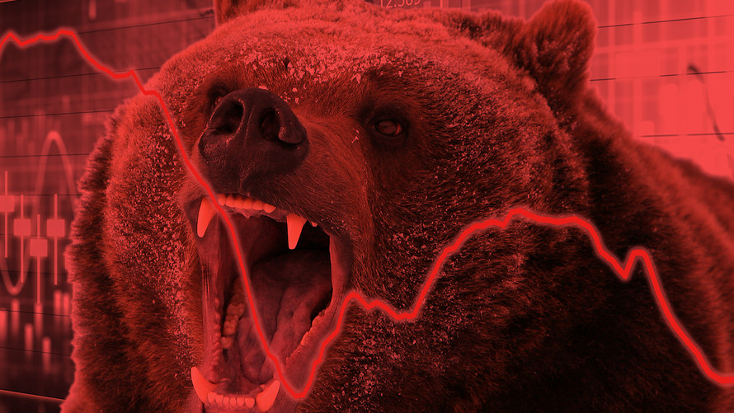MarketWatch photo illustration/Shutterstock
Bearish pattern signals more pain
By

ANORAMAHMUDOVA

REPORTER

Some chart watchers say a recently completed bearish pattern could portend more pain for stock investors over the short term.
These technical strategists are pointing to a so-called head-and-shoulders pattern in the S&P 500 index SPX, +0.35% that has formed over 15 months and was completed last week, as investors fretted about slowing global economic growth and as the U.S. Federal Reserve embarked on a path of normalizing monetary policy.
A head-and-shoulders pattern has three distinct peaks, with one peak in the middle, symbolizing the head, and two smaller peaks on either side representing the shoulders. Another component is the neckline, which is often defined as the trendline between the two troughs separating the head from the shoulders, as the chart below illustrates:
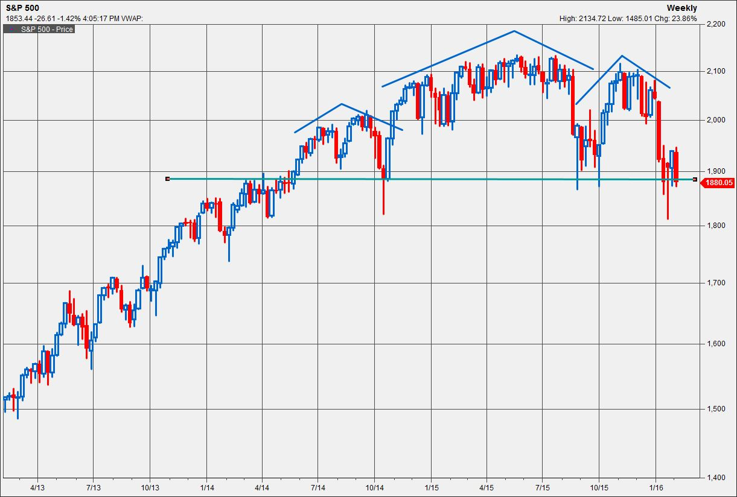

For chartists, a head-and-shoulders pattern typically signals that a bullish trend is about to go through a major reversal. This particular pattern began forming in May 2014, with the left shoulder resulting in a selloff in October 2014. The “head” took almost a year to form, culminating in the all-time high on May 21, 2015, when the S&P 500 closed at 2,130.82. The right shoulder consists of a 12% drop last August, a recovery that failed to hit record highs by a few points and the current selloff.
Technicians believe that breaking through the so-called ‘neckline’ completes the pattern and signals further downside, according to Frank Cappelleri, chief market technician at brokerage firm Instinet. He said the pattern that began forming more than a year ago is now complete.
How bearish could things get for the S&P 500 on the heels of this ugly chart formation?
J.C. Parets, founder of money manager Eagle Bay Capital and a prominent market commentator, suggests the index could fall a further 13%, based on the S&P 500’s level of 1,847 at midday Tuesday. “When [the pattern is] completed and confirmed, it dictates the price target. We think the next price target is 1,600 on the S&P 500,” he said.
Parets said he has been bearish about the stock market since stocks kept scaling all-time highs early last year. “It was a combination of deteriorating breadth and new record highs,” he said. The S&P 500 is down 13% from that record set in May.
By deteriorating breadth, Parets is referring to outsize gains from a handful of large stocks that masked weakness in the broader index. The S&P 500, which is market-cap weighted, finished 2015 down 0.7%, but on an equal-weighted basis, as measured by the Guggenheim S&P 500 Equal Weight ETF RSP, +0.09% stocks fell 4.3% in 2015.
Those big gainers for 2015 include so-called FANG stocks: Facebook Inc. FB, +0.39%Amazon.com AMZN, -0.24% Netflix Inc. NFLX, +4.12% and Google parent Alphabet Inc. GOOG, +0.03% GOOGL, +0.16% Those stocks on average rose 82.7% in 2015. This year, those stocks are down more than 18% on average.
Looking beyond the S&P 500, some indexes already have moved into bear-market territory—commonly defined as a 20% drop from a recent peak.
The Russell 2000 RUT, +0.03% has plunged 26% from its June 23 peak. The Dow Jones Transportation Average DJT, +1.50% has been on a downward path since Dec. 29, 2014, falling 25% since then. The transportation sector is considered a leading indicator of economic downturns, and prolonged weakness in the index is seen as a sign of a slowing economy.
Opinion: What the oldest stock market index is saying now
Although the S&P 500 hasn’t joined those market gauges in bear-market territory, it is facing stiff headwinds. Technical analysts note that rallies over the past few weeks have been relatively small and have failed to stoke buying appetite.
“For the bottom to appear, the declines need to become smaller until buyers come back in and gradually begin buying again. Bottom is not in yet,” Instinet’s Cappelleri said.
The conventional wisdom calls for bargain hunters to step in and buy after prices have moved sharply over a short period without any justification, a condition known as an oversold market. But investor behavior since the start of the year hasn't quite followed the expected patterns, according to Katie Stockton, chief technical strategist at BTIG, another brokerage firm.
“What is the most troubling is the lack of reaction to oversold conditions. That felt like it was in 2008. Is there something we don’t know about? Something that is not yet in news headlines?” asked Stockton.
She remains bearish, expecting any bounce to be short-lived and weak.
To be sure, neither technical analysts nor fundamental strategists are able to call the absolute top and absolute bottom in real time. In fact, by the time some of the signals confirm such calls, it becomes almost too late.
But the chartists are forecasting more pain before a sustainable rebound.

