Leveraged ETF Myths
- May 11th, 2017

- Charlie Bilello

“Myths nourish science, and science nourishes myths.” – Carlo Rovelli (Seven Brief Lesson on Physics)
When it comes to leveraged ETFs, two of the more popular myths are as follows:
“They all go to 0 over time.”
“If you hold them for more than a day, you will lose money.”
Fact or Fiction?
You be the judge…
The 3x Long S&P 500 ETF (UPRO) was launched in June 2009, nearly 8 years ago. Since its inception it has advanced 1,410% versus a gain of 214% for the S&P 500 (SPY).
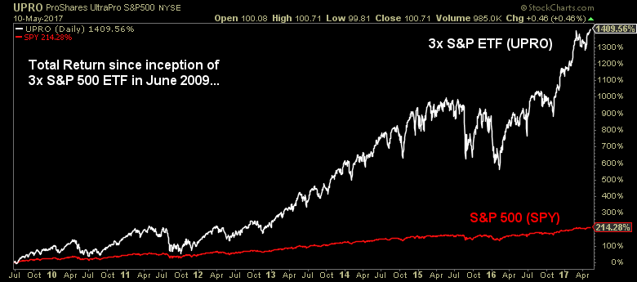
From this one chart we can say two things:
- There is no natural form of decay from leverage over time (they don’t “have to” go to 0).
- The idea that leverage is only suitable for short-term trading is a falsehood (you can certainly hold them for more than a day).
That’s not to say that leverage is without risk – there is much risk in using 3x leverage – just that the source of that risk does not come from some inherent decay.
What does cause significant problems for constant leverage over time? Volatility.
Daily re-leveraging (to 2x, 3x, etc.) combined with high volatility creates compounding issues, often referred to as the “constant leverage trap.” When the path of returns is not trending but alternating back and forth between positive and negative returns (seesawing action), the act of re-leveraging is mathematically destructive. The reason: you are increasing exposure (leveraging from a higher level) after a gain and decreasing exposure (leveraging from a lower level) after a loss, again and again.
The opposite of this harmful scenario is an environment that is friendly to leverage: uptrends with streaks in performance and low volatility.
As we illustrated in Leverage for the Long Run, these concepts are related. When the S&P 500 is in an uptrend (ex: above its 200-day moving average), it tends to have lower volatility and more streaks in performance (consecutive up days). These factors are helpful when using leverage.
It is no coincidence, then, to find out that since UPRO launched in June 2009, the S&P 500 has been in an uptrend 86.5% of the time. This is significantly higher than the long-term average of 71.4% going back to 1928. In turn, annualized volatility of 15.4% has been significantly lower than the long-term average of 18.8%.
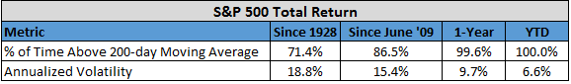
Thus far in 2017, the S&P 500 has been in an uptrend 100% of the time, with annualized volatility dropping down to 6.6%. No surprise, then, that UPRO is faring well, up over 23.2% versus a gain of 7.8% for the unleveraged SPY.
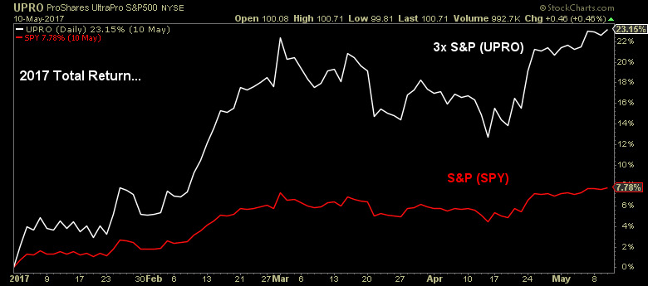
So what’s the catch? Why doesn’t everyone just buy and hold leveraged ETFs like UPRO?
Well, for one thing, they can’t stomach the volatility. This has been one of the lowest volatility periods in market history and UPRO still has annualized volatility of over 45% since its inception.
Even if you could stomach the day-to-day gyrations, you would have a hard time sitting through the drawdowns. Even in an extended period of tranquility for U.S. equities, drawdowns for 3x leverage have been considerable (max of 51.7% back in 2011, many 20+% declines).
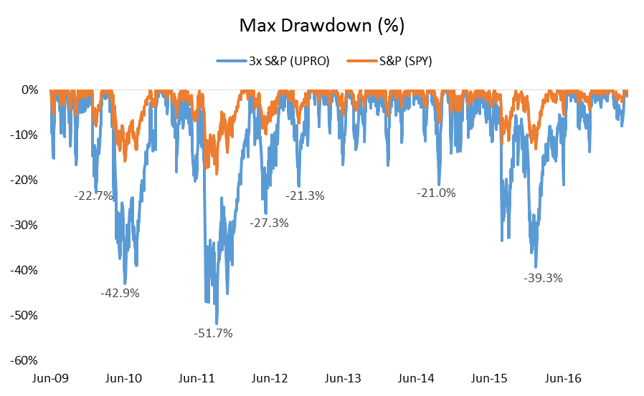
In an average bear market, investors can easily expect a drawdown in excess of 75% using 3x leverage. In a more severe bear market, the damage can be hard to come back from. Had the 3x leveraged ETF been around in 2007-09, it would have lost over 96%. That requires a gain of 2,400% just to break even. While after the 2007-09 bear market the S&P 500 hit a new total return high in April 2012, a 3x leveraged exposure would have to wait until June 2016 to hit new highs. It goes without saying but recovering from large losses takes enormously high gains and can take a long, long time.
And this hypothetical recovery was only possible because of the unusually friendly period for leverage from 2009 through today. In contrast, following the record stock market losses during the Great Depression, a 3x exposure to the S&P 500 would have to wait until 1958 to breakeven, nearly 30 years. How many investors would hold onto something with a 99.9% drawdown which went 29 years without a new high? Needless to say, you could probably count them on one hand. Leveraged buy and hold only magnifies the primary issue with unleveraged buy and hold: that it is hard to hold through large drawdowns.
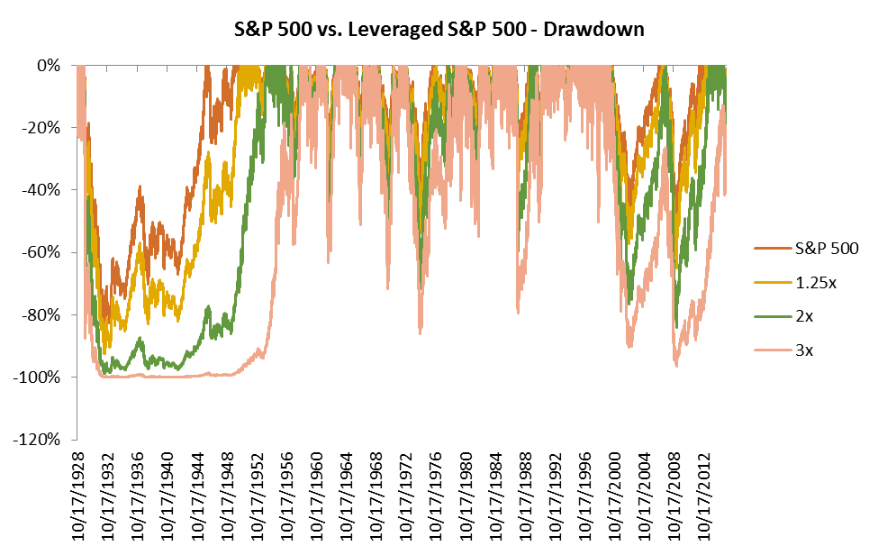
But the point of this post is that while it may be hard to do so, it is not impossible and ETFs like UPRO are not “designed to go to 0.” Given the right environment (uptrends with low volatility), investors can certainly buy and hold a leveraged exposure for years on end. It isn’t easy holding through volatility and large drawdowns, but it is indeed possible.
Is there a limit to leverage?
Absolutely. The math of “eventually coming back” only works if you are not completely wiped out. At 3x leverage, a decline in the S&P 500 of 33.33% would be catastrophic. At 20x leverage, it would only take a 5% loss to ruin you. The S&P 500 has never had a 33.33% loss (worst was 20.5% in October 1987) but a 5% loss happened 11 times in 2008 alone.
With the 4x leveraged S&P 500 ETF already on its way, perhaps it’s only a matter of time before we see a product test the limits. Unlike UPRO which was launched in June 2009, the 4x product will debut 8 years into a bull market in U.S. stocks, in one of the lowest volatility periods in history. When it comes to leverage timing isn’t everything; it’s the only thing. Will be fascinating to watch.
***
Related Posts:
Leverage for the Long Run

