Leverage for the Long Run
A Systematic Approach to Managing Risk and
Magnifying Returns in Stocks

Michael A. Gayed, CFA and Charles V. Bilello, CMT

2016 Charles H. Dow Award Winner

Abstract: Using leverage to magnify performance is an idea that has enticed investors and traders throughout history. The critical question of when to employ leverage and when to reduce risk, though, is not often addressed. We establish that volatility is the enemy of leverage and that streaks in performance tend to be beneficial to using margin. The conditions under which higher returns would be achieved from using leverage, then, are low volatility environments that are more likely to experience consecutive positive returns. We find that Moving Averages are an effective way to identify such environments in a systematic fashion. When the broad U.S. equity market is above its Moving Average, stocks tend to exhibit lower than average volatility going forward, higher average daily performance, and longer streaks of positive returns. When below its Moving Average, the opposite tends to be true, as volatility often rises, average daily returns are lower, and streaks in positive returns become less frequent. Armed with this finding, we developed a strategy that employs leverage when the market is above its Moving Average and deleverages (moving to Treasury bills) when the market is below its Moving Average. This strategy shows better absolute and risk-adjusted returns than a comparable buy and hold unleveraged strategy as well as a constant leverage strategy. The results are robust to various leverage amounts, Moving Average time periods, and across multiple economic and financial market cycles.

Introduction
Using leverage to magnify performance is an idea that has enticed investors and traders throughout history. The concept is simple enough: borrowing funds allows you to buy more of an asset than with cash alone, multiplying the effect of any gains and losses. The critical question of when to employ leverage and when to reduce risk, though, is not often addressed. Under academic theory, one cannot develop a strategy to time the use of leverage due to market efficiency and the randomness of security prices.
We find strong evidence to the contrary. Security prices are non-random and tend to exhibit trends over time as well as volatility regimes under which leverage is more or less beneficial. As such, one can combine these two concepts to create a strategy that employs the use of leverage only during periods which have a higher probability of success. In doing so, one can achieve higher returns with less risk than a comparable buy and hold strategy. This is the primary focus of our paper: systematically determining environments favorable to leverage and developing a strategy to exploit them.
The idea that you can achieve a higher return with less risk stands in direct conflict with the Capital Asset Pricing Model (CAPM). Developed in the early-to-mid 1960s, the CAPM dictates that the expected return for a given security should be determined by its level of systematic risk, or Beta. A linear relationship is said to exist between Beta and return, which is represented in chart form as the Security Market Line (SML). The SML progresses linearly (up and to the right at a 45-degree angle) whereby the higher the Beta, the higher the expected return.
Though still widely regarded as one of the key tenets of Finance, the CAPM has been challenged by a number of studies over the years. Empirical research has shown that anomalies such as the small firm effect, the value effect, and the momentum effect cannot be explained by the CAPM.
The low volatility anomaly has also called into question the presumed absolute relationship between risk and return. Low volatility stocks have exhibited above market performance with lower than market Beta, opposing the risk/return laws of the CAPM. Similarly perplexing is the tendency for high beta stocks to exhibit lower performance than predicted by their level of risk.³
In this paper, we put forward an additional factor that is unexplained by traditional Finance theory: the volatility and leverage anomaly that allows for long-run outperformance using leverage. Key to any study which counters efficient markets is understanding what allows for the anomaly to exist. We propose that the combination of structural and behavioral conservatism in the use of leverage brings with it inefficiencies which are not easily arbitraged away.
In addition to facing margin requirements, certain institutional investors such as pension plans, mutual funds, and endowments are simply unable to borrow money to invest beyond their portfolio’s asset value based on stated mandates and regulatory requirements. For those institutional investors who do not face such restrictions, leverage brings with it a new set of risks, including “costs of margin calls, which can force borrowers to liquidate securities at adverse prices due to illiquidity; losses exceeding the capital invested; and the possibility of bankruptcy.” In the case of hedge funds, for example, the “fragile nature of the capital structure, combined with low market liquidity, creates a risk of coordinated redemptions among investors that severely limits hedge funds arbitrage capabilities. The risk of coordination motivates managers to behave conservatively [in their usage of maximum leverage].”
Leverage aversion is also due to innate behavioral biases. The availability heuristic is a mental rule of thumb which argues that individuals will use the first immediate example that comes to mind when evaluating a topic, or making a decision. Often times, the most extreme negative events are the first things considered. The word leverage, or margin, makes most individuals immediately think of historically catastrophic events, loss, or the risk of ruin, creating a natural aversion to using borrowed money to generate excess returns. Some of the most prominent examples that come to mind include:
- The 1929 stock market crash,
- The 1987 stock market crash,
- The 1998 Long-Term Capital Management blowup,
- The 2007 Quant Quake, and
- The 2007-2009 Financial Crisis
Leverage aversion is understandable given these traumatic events, but it is not “rational” as Finance theory assumes. In theory, when presented with the option to construct an unleveraged portfolio or a leveraged one, mean-variance optimization views the two as equal so long as the expected return and volatility of the two portfolios remains the same. The fact that leverage is used becomes irrelevant, which means there should be no preference between the two portfolios. In practice, however, investors are more likely to avoid the leveraged portfolio despite having the same risk/return characteristics as the unleveraged one.
Prior studies on the use of leverage to enhance risk/return in a portfolio have primarily been centered on low beta stocks and risk parity. These studies suggest there are benefits to leveraging lower beta assets which investors, due to leverage aversion, are either unable or unwilling to do. To the best of our knowledge, however, there has not yet been a study using technical indicators which evaluates the potential timing benefits of using leverage purely on the stock market itself to not just increase absolute return, but also improve risk-adjusted performance.
In this paper, we propose that using widely-referenced Moving Average indicators for evaluating stock market trends can enhance absolute return and generate higher risk-adjusted performance beyond what the CAPM and Modern Portfolio Theory would argue is possible. To do this, however, we first need to dispel mistaken beliefs about leverage and Moving Averages independently to better understand exactly why a strategy which leverages or deleverages based on Moving Averages produces superior results over time.

Volatility and the Importance of Path
While the availability heuristic leads us to think of leverage in terms of a constant source of significant risk, objective quantitative analysis can help us identify what actually causes leverage to result in loss, and under what conditions leverage is beneficial. In this paper, we focus on daily re-leveraging of the multiplier (ex: tracking 1.25x, 2x, or 3x the S&P 500 daily total return), which is the most commonly used time frame in leveraged mutual funds and Exchange Traded Funds (ETFs).
One of the mistaken notions about daily re-leveraging is the idea that there is some form of natural decay. This is the belief that over time the cumulative returns from such rebalancing will end up moving towards zero or at the very least be considerably less than a constant buy and hold strategy. Going back to 1928, we find this is simply not the case. A daily re-leveraged buy and hold of the S&P 500 would have significantly outperformed the unleveraged strategy, by multiples in excess of the leverage factor. We observe this in Table 1, where the 3x leveraged cumulative return since 1928 is an astonishing 290 times that of the unleveraged S&P 500.

Table 1: S&P 500 vs. Daily Leveraged S&P 500, Growth of $1 (October 1928 – October 2015)

Metric
S&P 500
S&P 1.25x
S&P 2x
S&P 3x
Growth of $1
$1,969
$8,060
$169,000
$570,965
290
Multiple vs. Buy/Hold
1
4
86
This clearly illustrates the point that there is no natural form of decay from leverage over time. The idea that leverage is only suitable for very short-term trading is false when looking at how daily leveraging can perform over long-term cycles. That is not to say that leverage is without risk, just that the source of that risk does not come from some inherent decay.
What does cause significant problems for constant leverage over time is volatility. Daily re-leveraging combined with high volatility creates compounding issues, often referred to as the “constant leverage trap.”¹¹ When the path of returns is not trending but alternating back and forth between positive and negative returns (seesawing action), the act of re-leveraging is mathematically destructive. The reason: you are increasing exposure (leveraging from a higher level) after a gain and decreasing exposure (leveraging from a lower level) after a loss, again and again. An example from recent history will make this point clearer.
In August 2011, the S&P 500 experienced extremely high volatility, where over a six-day period the annualized standard deviation was above 75%. The cumulative return for the S&P 500 over these six trading days was a positive 0.51%, but the levered returns fell far short of multiplying this return as we see in Table 2. Using 1.25x leverage, the total return was still positive but less than the unlevered return at 0.46%. When 2x and 3x leverage was applied, the cumulative returns actually turned negative even though the unlevered return was positive.

Table 2: S&P 500 vs. Daily Leveraged S&P 500 (August 8, 2011 – August 15, 2011)
 | Index | 8/8/2011 8/9/2011 8/10/2011 8/11/2011 8/12/2011 8/15/2011 Cumulative Return
 | S&P 500 | -6.65% 4.74% | -4.37% | 4.65% | 0.53% | 2.19% | 0.51%
 | 1.25x | -8.31% 5.93% | -5.47% | 5.81% | 0.66% | 2.73% | 0.46%
 | 2x | -13.30% 9.49% | -8.75% | 9.29% | 1.06% | 4.37% | -0.14%
 | 3x | -19.95% 14.23% | -13.12% | 13.94% | 1.58% | 6.56% | -2.02%
Why is this the case? After the 6.65% decline on August 8, instead of increasing leverage as would occur naturally from a decline in one’s equity, leverage is reset to the lower asset base. Exposure is effectively being reduced ahead of the gain of 4.74% on August 9. Next, after the gain on August 9, instead of decreasing leverage as would occur naturally from an increase in one’s equity, leverage is reset to the higher asset base. Exposure is now increasing ahead of the loss of 4.37% on August 10.
The more leverage that is applied, the more pernicious the constant leverage trap. This is why the 3x leveraged S&P 500 performs worse than the 2x leveraged and the 2x leveraged performs worse than 1.25x leveraged. Additionally, the higher the volatility in the path of returns, the more harmful such compounding issues become, as we will see in the next example.
High volatility and seesawing action are the enemies of leverage while low volatility and streaks in performance are its friends. We can see this clearly in Table 3. With the same unleveraged cumulative return of 19.41%, the four paths illustrated have different leveraged returns. In both Path 1 and Path 2, the S&P 500 is positive for six consecutive days, but the lower volatility Path 1 achieves a higher return. Both Path 1 and Path 2 perform better than the leverage multiplier as the constant re-leveraging benefits from compounding. The opposite is true in Path 3 and Path 4, which have alternating positive and negative returns during the first five days. These paths fall directly into the constant leverage trap and the highest volatility Path 4 is hurt the most when leverage is applied.

Table 3: S&P 500 vs. Daily Leveraged S&P 500 - Path Dependency, Volatility and Leverage
 | S&P 500 | Day 1 Day 2 Day 3 | Day 4 Day 5 Day 6 Cumulative Return |  | Annualized Volatility
 | Path 1 | 3.00% 3.00% 3.00% | 3.00% 3.00% 3.00% | 19.41% | 0.00%
 | Path 2 | 2.00% 4.00% 2.00% | 4.00% 2.00% 4.03% | 19.41% | 17.48%
 | Path 3 | 7.00% -7.00% 7.00% -7.00% 7.00% 12.70% |  | 19.41% | 131.20%
 | Path 4 | 14.00% -14.00% 14.00% -14.00% 14.00% 8.97% |  | 19.41% | 221.40%
 | 2x S&P | Day 1 Day 2 Day 3 Day 4 Day 5 Day 6 Cumulative Return |  |  | Multiple of 1x
 | Path 1 | 6.00% 6.00% 6.00% 6.00% 6.00% 6.00% |  | 41.85% | 2.16
 | Path 2 | 4.00% 8.00% 4.00% 8.00% 4.00% 8.06% |  | 41.78% | 2.15
 | Path 3 | 14.00% -14.00% 14.00% -14.00% 14.00% 25.39% |  | 37.40% | 1.93
 | Path 4 | 28.00% -28.00% 28.00% -28.00% 28.00% 17.94% |  | 28.22% | 1.45
 | 3x S&P | Day 1 Day 2 Day 3 Day 4 Day 5 Day 6 Cumulative Return |  |  | Multiple of 1x
 | Path 1 | 9.00% 9.00% 9.00% 9.00% 9.00% 9.00% |  | 67.71% | 3.49
 | Path 2 | 6.00% 12.00% 6.00% 12.00% 6.00% 12.09% |  | 67.46% | 3.48
 | Path 3 | 21.00% -21.00% 21.00% -21.00% 21.00% 38.09% |  | 52.67% | 2.71
 | Path 4 | 42.00% -42.00% 42.00% -42.00% 42.00% 26.91% |  | 22.24% | 1.15

Volatility and streakiness are related as we will show in the next section. The reason for this in our view is behavioral. High volatility environments tend to be characterized by investor overreaction which is more prone to back-and-forth market movement. In contrast, low volatility environments are more consistent with investor underreaction which in turn results in more streaks or consecutive up days. The autocorrelation exhibited by stocks in low volatility regimes is an important precondition for leveraged strategies to perform well in, as streaks present themselves and leverage best takes advantage of them. As we have shown in this section looking at only six trading days, different return scenarios can have a large impact on how cumulative returns look. As such, during considerably longer stretches of time than those illustrated here, path dependency and volatility only heightens the disparity among path scenarios.
The conclusion here is that the popular belief that leveraging results in decay over time is a myth, as performance over time has nothing to do with time itself, but rather: 1) the behavior of the underlying asset in its overall trend, 2) the path of daily returns (streaks versus seesawing action), and 3) whether the regime under which leverage is utilized is high or low volatility. Given that higher volatility is the enemy of leverage precisely because of the constant leverage trap, we next examine a systematic way of identifying lower volatility regimes with higher streak potential.

The Trend is Your [Downside Protection] Friend
While smoothing out a data series in statistics may not seem like anything groundbreaking, in the world of investing not a day goes by where the market’s Moving Average isn’t referenced. The first analysis of Moving Averages in the stock market dates all the way back to 1930. In their seminal work, “Technical Analysis of Stock Trends,” Edwards and Magee refer to the Moving Average as a “fascinating tool” that “has real value in showing the trend of an irregular series of figures (like a fluctuating market) more clearly.” They go on to define “uptrends” as periods when the price “remains above the Moving Average Line” and “downtrends” as periods when the price “remains below the Moving Average.” As the saying goes, the trend is your friend until it ends, and Moving Averages are among the most popular ways of systematically identifying whether stocks are in an uptrend, or downtrend.
Despite the popular notion that Moving Averages can help an investor make more money by participating in an uptrend, empirical testing suggests this view is not entirely accurate. A trading rule which buys the S&P 500 Index above its 200-day Moving Average and sells the S&P 500 Index (rotating into 3-month Treasury bills) below its 200-day Moving Average illustrates this point. If Moving Averages were about upside returns, they should have resulted in significant outperformance during powerful bull markets like those experienced in the 1990s, 2002 through 2007, and 2009 through 2015.
As shown in Table 4, however, using a simple 200-day Moving Average strategy in these uptrending, Bull Market periods underperforms a buy and hold approach. This analysis assumes no cost to execute.
The differential between the two increases once commissions, slippage, and taxes are incorporated, suggesting the Moving Average strategy in practice would likely significantly underperform.

Table 4: S&P 500 vs. S&P 500 200-day Moving Average Rotation (Selected Bull Markets)
Bull Markets Cumulative Total Return
Time Period S&P 500 200-day MA Rotation
Oct 12, 1990 - Jul 17, 1998 390% 303%
Oct 10, 2002 - Oct 9, 2007 121% 43%
Mar 10, 2009 - Jul 20, 2015 260% 95%

If it’s not about outperforming on the upside, what is the true value using Moving Averages to “follow the trend?” As Jeremy Siegel notes in “Stocks for the Long Run,” the “major gain of the [Moving Average] timing strategy is a reduction in risk.” We can see this in Table 5 which shows how the same strategy performed during Bear Market periods. The outperformance here is substantial, indicating that the Moving Average is more about downside protection than upside participation.

Table 5: S&P 500 vs. S&P 500 200-day Moving Average Rotation (Selected Bear Markets)
Bear Markets Cumulative Total Return
Time Period S&P 500 200-day MA Rotation
Sep 16, 1929 - Jun 1, 1932 -86% -16% Mar 24, 2000 - Oct 9, 2002 -47% -13%
Oct 9, 2007 - Mar 9, 2009 -55% -10%

A Non-Random Walk Down Wall Street
Beyond being an effective risk management tool, Moving Averages also provide important clues about stock market behavior. If stock prices moved in a “random walk” as was asserted by Samuelson and others, trends would not persist and there would be no differentiation in behavior above and below
Moving Averages. We find that is not the case, affirming the work of Lo and MacKinlay in a “NonRandom Walk Down Wall Street.”
Chart 1 shows the annualized volatility of the S&P 500 Index above and below various popular Moving Average time periods, going back to October 1928. As confirmed by Monte Carlo simulations, irrespective of which Moving Average interval is used, the underlying finding remains the same: when stocks trade below their Moving Average, volatility going forward is considerably higher than when stocks trade above their Moving Average.²⁰
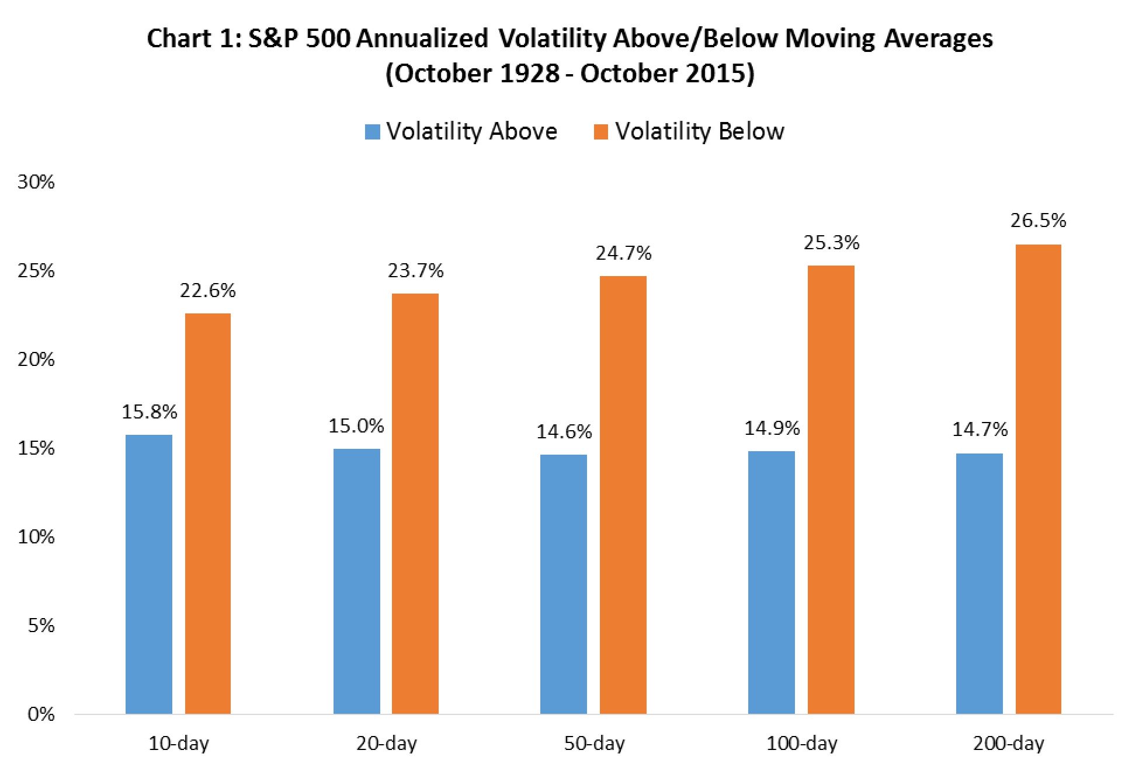
We propose that there is a fundamental underpinning to this stark differentiation in behavior. Since 1928, the U.S. economy has experienced 14 recessions, spending approximately 19% of the time in contraction. In Chart 2, we see that during these recessionary periods, the S&P 500 has traded below its 200-day Moving Average 69% of the time versus only 19% of the time during expansions. Meanwhile, during expansionary periods the S&P 500 has traded above its 200-day Moving Average 81% of the time versus only 31% of the time in recession. The uncertainty in growth and inflation expectations that coincides with periods of economic weakness is in our view what leads to investor overreaction and increased beta volatility.

²⁰ We observe a similar phenomenon in other markets, including Small Cap stocks, Commodities and High Yield
Bonds. The Russell 2000 Index has an annualized volatility of 14.7% above its 200-day moving average versus
26.5% below it (1979-2015). The CRB Commodities Index has an annualized volatility of 14.9% below its 200-day Moving Average versus 18.5% below it (1994-2015). The Merrill Lynch High Yield Index has an annualized volatility of 2.9% above its 200-day Moving average versus 7.2% below it (1990-2015).
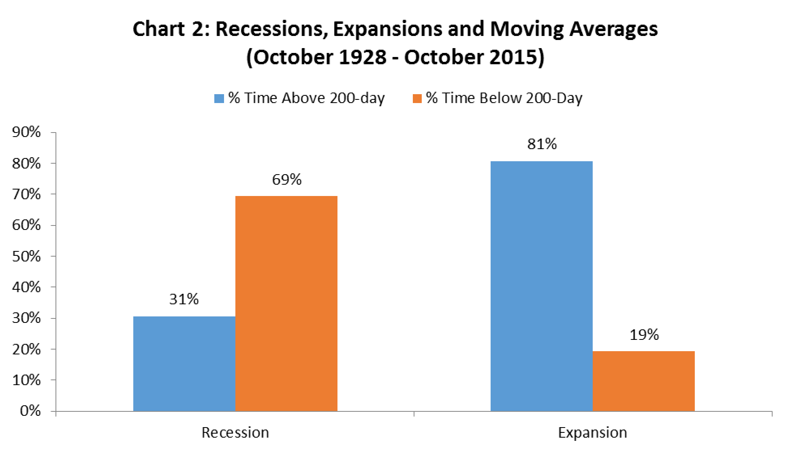
This is important because high volatility and uncertainty have not typically been constructive for equity markets. We can observe this tendency in Chart 3 which shows the significant disparity in S&P 500 returns between periods when it is above and below various Moving Averages.
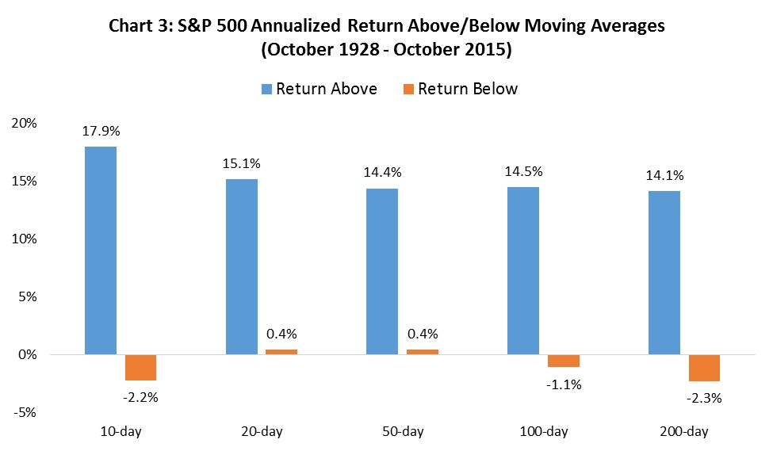
Viewing the Moving Average as a volatility indicator more so than a trend identifier helps explain how Moving Average strategies can underperform in strong equity bull markets. If the market is in an unrelenting up phase, a decline below the Moving Average results in a sell trigger which ends up being a false positive, resulting in missing out on subsequent returns for that moment in time. Over the course of a full economic and market cycle, however, where uptrends are interrupted by periods of higher volatility, the Moving Average can help limit equity exposure to environments which most favor return generation. The key component to exploiting the Moving Average in strategy form is less about being exposed to equities above it, but rather in avoiding higher equity volatility below it.
More so than that, Moving Averages can help investors mitigate the potential for loss aversion to result in sub-optimal portfolio decision making. Chart 4 shows that historically, the worst 1% of trading days have occurred far more often than not below the Moving Average. Included in this list are the two worst days in market history: October 19th in 1987 and October 28th in 1929. Entering both of these historic days, the market was already trading below all of its major Moving Averages (10-day through 200-day). While not of use for true buy and hold investors with an infinite time horizon, to the extent that Moving Averages can help sidestep such extreme down days, the power of the indicator remains in mitigating downside more so than participating in the upside.
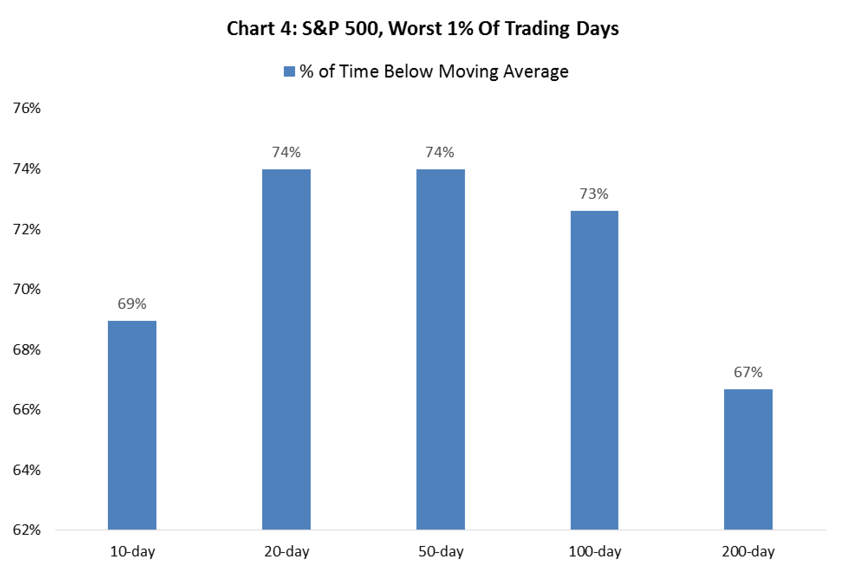
Extreme down days are consistent with investor fear and overreaction, while gradual movements higher are characterized by investor underreaction which is well documented in academic literature related to behavioral finance. Important to this dynamic is the likelihood of consecutive up days depending on whether the market is above or below its Moving Average. Chart 5 illustrates that the S&P 500 is much more likely to experience consecutive up days when it is above its Moving Average than below it.
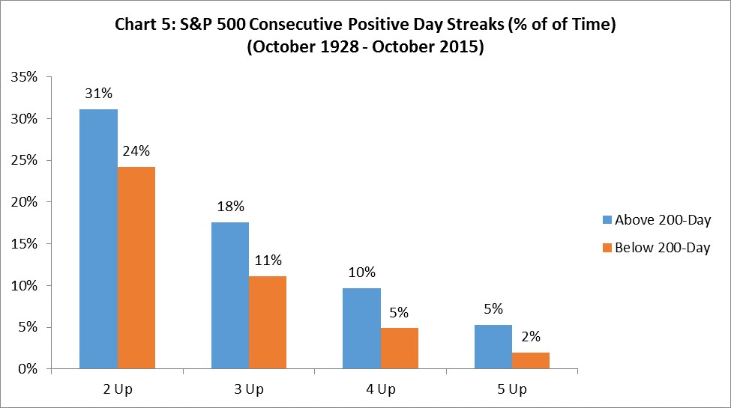
This suggests that we should view the stock market as not simply being in a trend when above the Moving Average, but rather in an environment which favors lower volatility and higher potential for consecutive positive returns. These are the two characteristics which are of critical importance for a strategy which utilizes leverage.

The Leverage Rotation Strategy
We have established that leverage performs best when in a low volatility environment with a higher probability of positive performance streaks. By extension, it performs worst during periods of extreme volatility and choppier asset class behavior.
With this knowledge, our systematic Leverage Rotation Strategy (“LRS”) is as follows:
When the S&P 500 Index closes above its Moving Average, rotate into the S&P 500 and use leverage to magnify returns.
When the S&P 500 Index closes below its Moving Average, rotate into Treasury bills to manage risk.
Before illustrating the results of the LRS, it is important to examine how an unleveraged timing strategy based on the Moving Averages alone performs going back to 1928. The data is summarized in Table 6. Note that the Moving Average rule results in higher risk-adjusted performance and lower drawdowns versus buy and hold, generating significant positive alpha in all Moving Average periods examined (10day through 200-day).

Table 6: Unleveraged Buy and Hold versus Unleveraged Moving Average Timing
(October 1928 – October 2015)
 | Metric | S&P 500 | 10-Day 20-Day 50-Day 100-Day |  | 200-Day
 | Annual Return | 9.1% | 11.7% | 10.4% 10.3% 10.8% | 10.9%
 | Annual Volatility | 18.9% | 12.1% | 11.7% 11.7% 12.2% | 12.4%
 | Sharpe Ratio | 0.30 | 0.69 | 0.60 0.59 0.60 | 0.60
 | Sortino Ratio | 0.43 | 1.03 | 0.88 0.86 0.88 | 0.86
 | Max Drawdown | -86.2% | -49.5% | -46.6% -46.6% -46.5% | -49.5%
 | Beta | 1.00 | 0.41 | 0.38 0.38 0.42 | 0.43
 | Annual Alpha | 0.0% | 6.0% | 4.8% 4.7% 5.0% | 5.0%
 | Avg Trades/Year | 0 | 38 | 26 15 10 | 5
The key finding here is not about absolute return but risk-adjusted performance. To further illustrate this point, the Moving Average rule beats buy-and-hold in absolute performance in only 49% of rolling 3-year periods. This is due to the fact that Moving Averages can whipsaw market participants in sideways or trendless periods. However, the true value here is in terms of risk-adjusted outperformance, where the Moving Average rule generates positive alpha in 69% of rolling 3-year periods.²²
This is of critical importance because of the unspoken flaw in buy and hold: that almost nobody holds through large drawdowns. Chart 6 illustrates drawdowns since 1928 in the S&P 500 (yellow line) and the 200-day timing strategy (blue line). During all large Bear Markets, the 200-day strategy significantly truncates the downside. This is the major value in the Moving Average: minimizing risk and increasing the likelihood of sticking with a strategy over time.
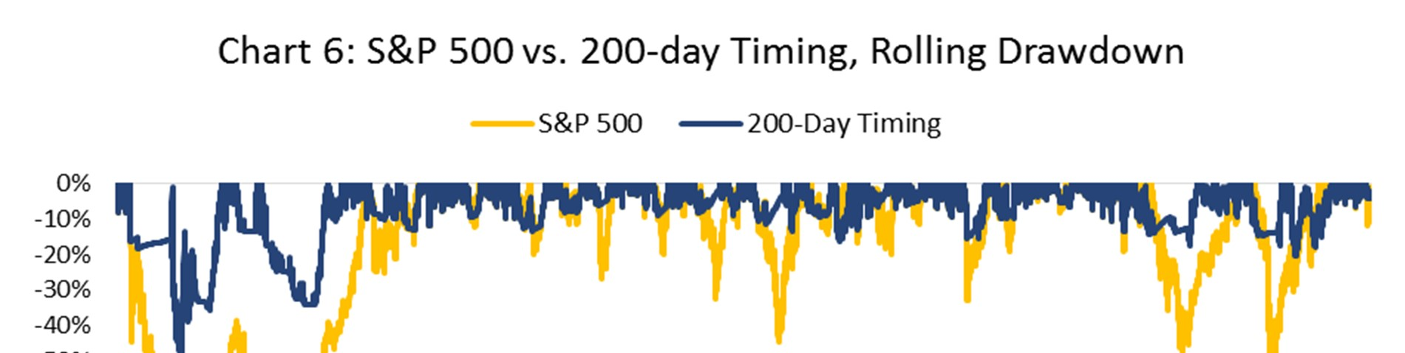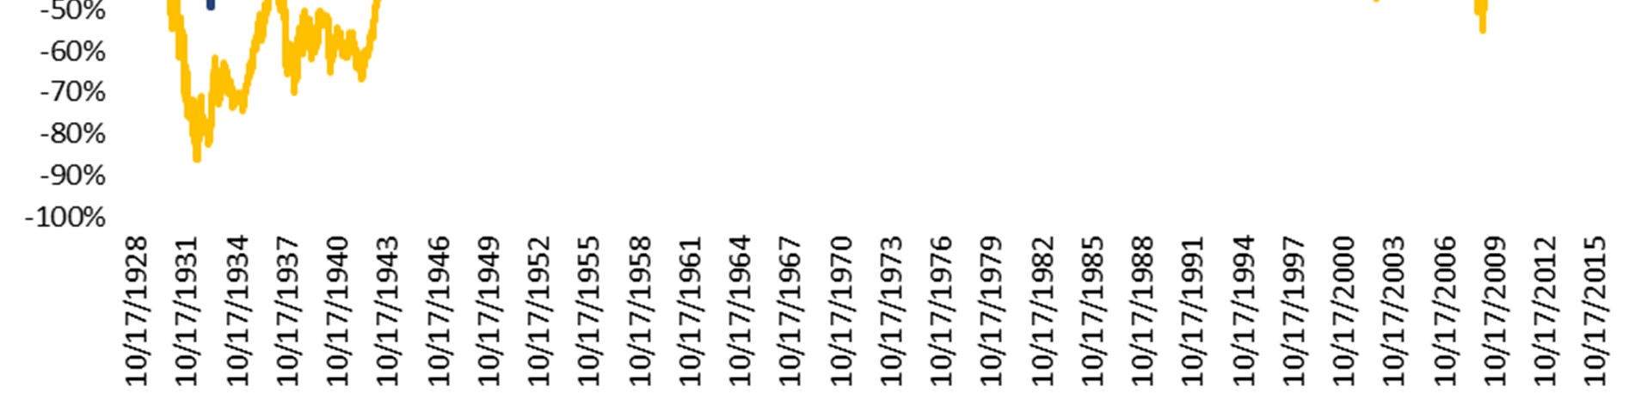
While unleveraged strategies using the Moving Average as a timing indicator suggest one can achieve similar returns to buy-and-hold over time but with less volatility and drawdown, the question of how to generate higher returns using the market itself can only be answered with leverage.
From October 1928 through October 2015, a buy and hold strategy using leverage (with a 1% annual expense) significantly outperforms the unleveraged strategy. There is no free lunch here, though, as the annualized volatility is multiples of the unlevered index, leading to inferior risk-adjusted performance and larger drawdowns (see Table 7).

Table 7: Unleveraged Buy and Hold versus Leveraged Buy and Hold
 | Metric | S&P 500 | S&P 1.25x | S&P 2x | S&P 3x
 | Annual Return | 9.1% | 9.8% | 13.7% | 15.3%
 | Annual Volatility | 18.9% | 23.6% | 37.8% | 56.7%
 | Sharpe Ratio | 0.30 | 0.27 | 0.27 | 0.21
 | Sortino Ratio | 0.43 | 0.39 | 0.39 | 0.30
 | Max Drawdown | -86.2% | -92.4% | -98.8% | -99.9%
 | Beta | 1.00 | 1.25 | 2.00 | 3.00
 | Annual Alpha | 0.0% | -0.8% | -1.1% | -5.3%

While an annualized return of 15.3% for the 3x strategy sounds irresistible, the reality is that few would have stuck with a return path that incurred multiple 50+% drawdowns over time. Leveraged buy and hold, then, only magnifies that major flaw of buy and hold. We can this more clearly in Chart 7.
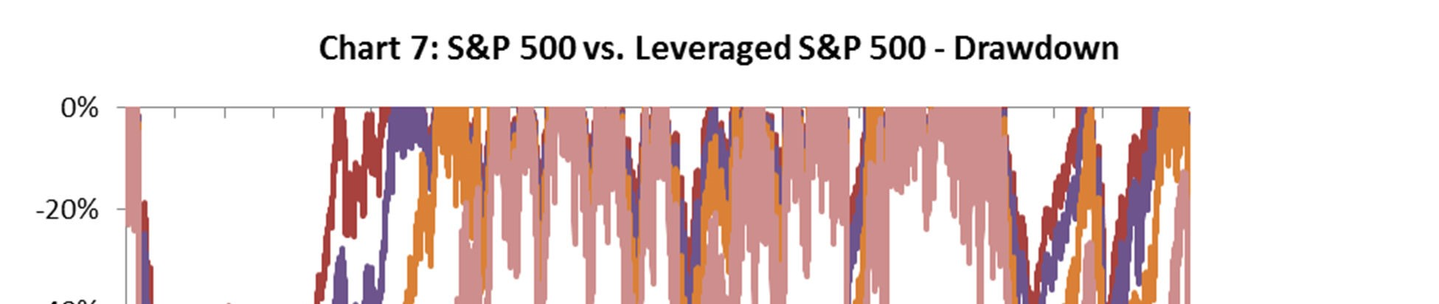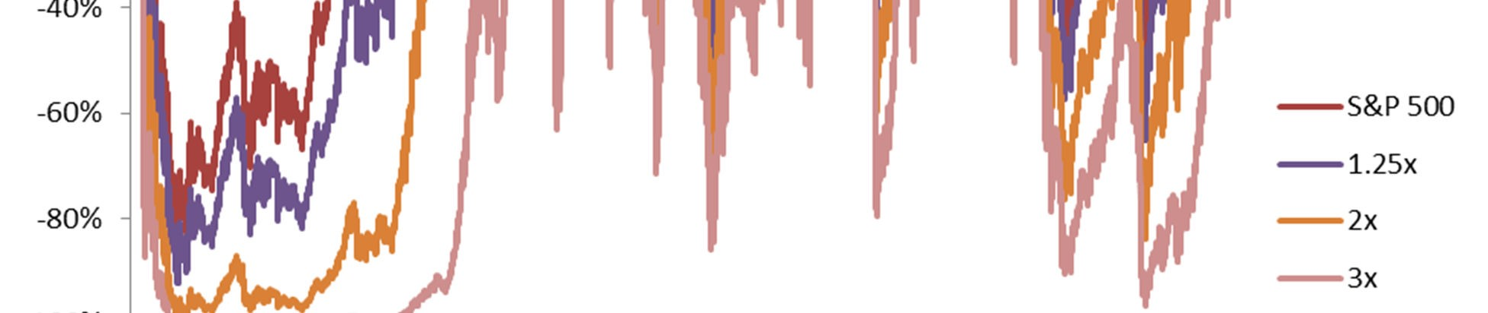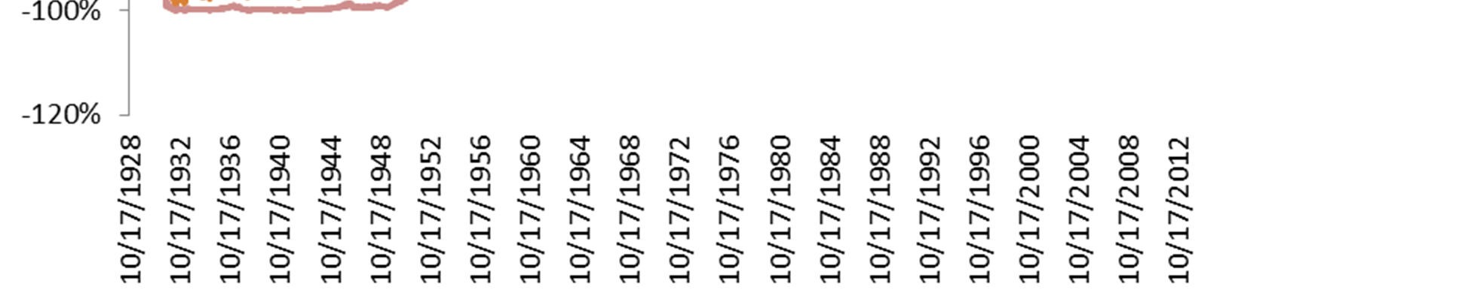
Alternatively, by implementing the Leverage Rotation Strategy, we can harness the power of leverage while increasing the odds of an investor sticking to the strategy over time. Although shorter Moving Average periods achieve similarly strong results, we will narrow our focus here to the 200-day Moving Average as it incurs the fewest transaction costs (average of 5 rotations per year) and is most applicable in time frame to both traders and investors. We will also assume for the purposes of this section a leverage fee of 1% per year, which approximates the current expense ratio for the largest leveraged ETFs.
As shown in Table 8, as compared to a buy and hold of the S&P 500 and leveraged buy and hold, the LRS achieves: 1) improved absolute returns, 2) lower annualized volatility, 3) improved risk-adjusted returns (higher Sharpe/Sortino), 4) lower maximum drawdowns, 5) reduced Beta, and 6) significant positive alpha.

Table 8: Unleveraged Buy and Hold versus Leveraged Rotation Strategies (Oct 1928 – Oct 2015)
With 200-day LRS
Metric S&P 500 S&P 1.25x S&P 2x S&P 3x S&P 1.25x S&P 2x S&P 3x
Annual Return 9.1% 9.8% 13.7% 15.3% 12.5% 19.1% 26.8% Annual Volatility 18.9% 23.6% 37.8% 56.7% 15.5% 24.9% 37.3%
Sharpe Ratio 0.30 0.27 0.27 0.21 0.53 0.51 0.47 Sortino Ratio 0.43 0.39 0.39 0.30 0.83 0.90 0.90
Max Drawdown -86.2% -92.4% -98.8% -99.9% -59.0% -78.7% -92.2%
Beta 1.00 1.25 2.00 3.00 0.54 0.87 1.30
Annual Alpha 0.0% -0.8% -1.1% -5.3% 6.0% 10.8% 16.0%
Avg Trades/Year 0 0 0 0 5 5 5

Chart 8 displays the growth of $10,000 from October 1928 through October 2015. A buy and hold of the S&P 500 grows to over $19 million while the 1.25x, 2x and 3x LRS grow to over $270 million, $39 billion and $9 trillion respectively.
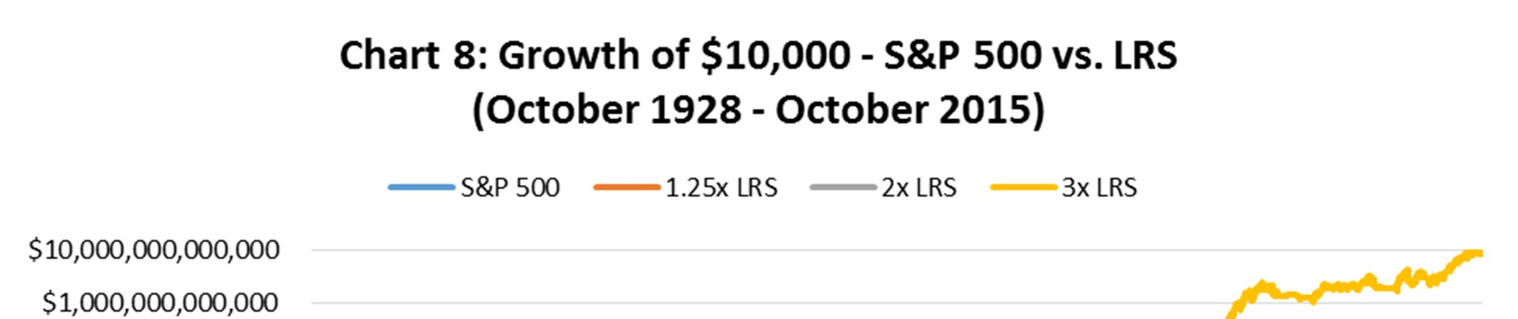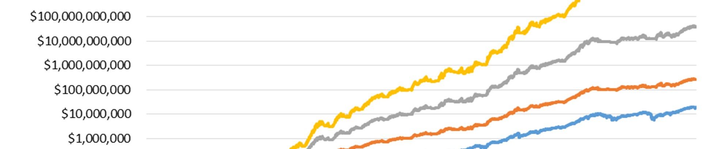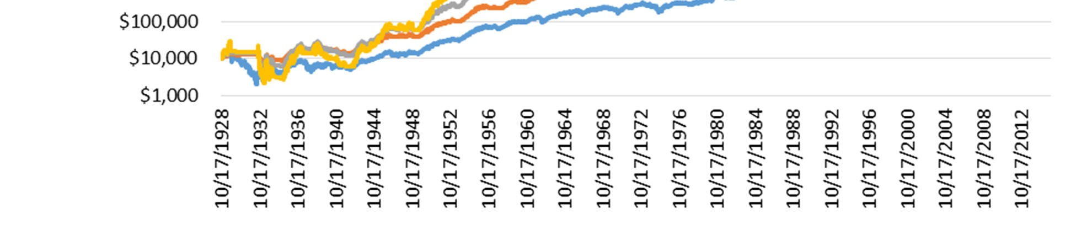
In Chart 9, we see that this outperformance is consistent over time and through multiple economic and financial market cycles. On average, the LRS outperforms the S&P 500 in 80% of rolling 3-year periods.
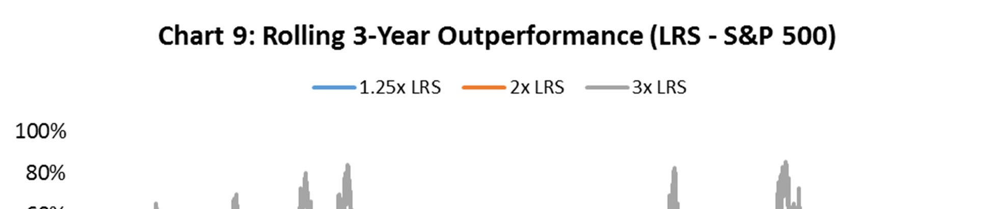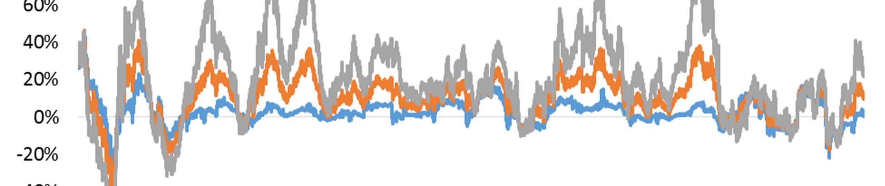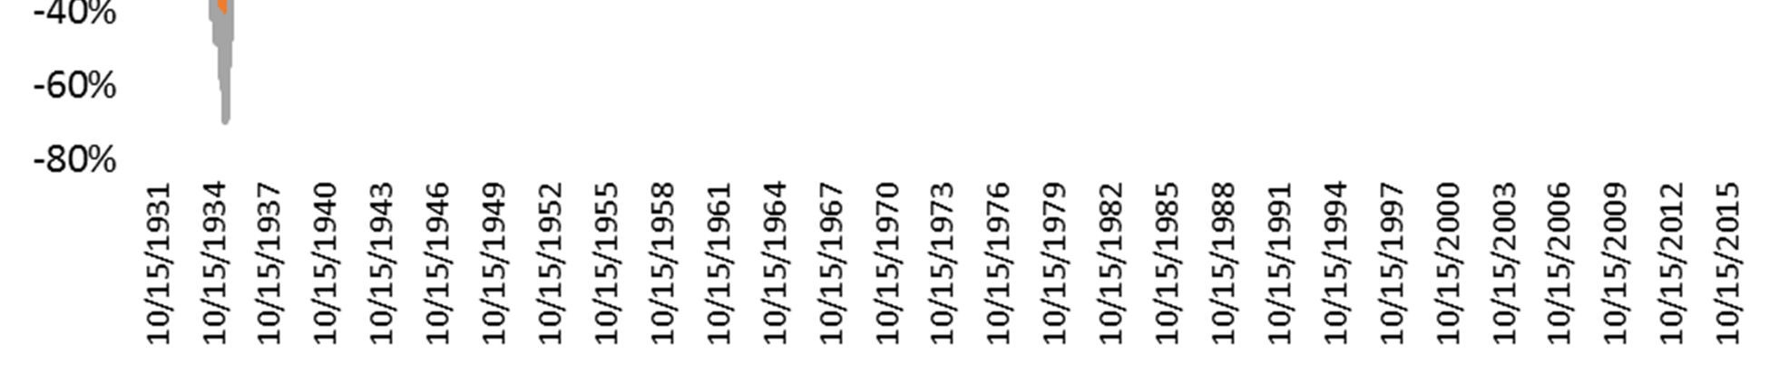
We also see in Table 9 that during the four worst bear markets in U.S. history, all of the Leverage Rotation Strategies have a lower maximum drawdowns than an unleveraged buy and hold of the S&P 500.

Table 9: Maximum Drawdown during Bear Markets, S&P 500 vs. LRS
 | Peak | Trough | S&P 500 | S&P 1.25x | S&P 2x | S&P 3x
 | 9/16/1929 | 6/1/1932 | -86.2% | -22.9% | -35.3% | -49.8%
 | 1/11/1973 | 10/3/1974 | -44.8% | -15.4% | -25.1% | -36.7%
 | 3/24/2000 | 10/9/2002 | -47.4% | -18.4% | -31.0% | -45.8%
 | 10/9/2007 | 3/9/2009 | -55.2% | -13.4% | -21.3% | -31.1%

Another way to view the power of minimizing drawdowns is in the time it takes to reach new highs after a Bear Market. If we look at the worst Bear Markets in history, the LRS reaches new highs ahead of buy and hold in every example, from 1.25x through 3x. After peaking in September 1929, a buy and hold of the S&P 500 did not reach new highs until 1946, while the 1.25x and 2x LRS reached new highs ten years earlier, in 1936. Using constant leverage, the 3x S&P 500 without a rotation strategy did not reach new highs after both the 2000-02 and 2007-09 Bear Markets (N/A in Table 10), illustrating the strong need for timing leverage in different volatility regimes.

Table 10: Bear Markets and New High Dates, S&P 500 vs. LRS
 | Worst 4 Bear Markets |  | New Highs By
 | Bear Market Period | Bull Market Peak | S&P 500 | S&P 1.25x | S&P 2x | S&P 3x
 | 1929-32 (Buy and Hold) | 9/16/1929 | 1/28/1946 | 9/18/1950 | 3/18/1954 | 10/7/1958
 | 1929-32 (200-day LRS) | 9/16/1929 | 1/31/1936 | 4/2/1936 | 10/30/1936 | 1/8/1945
 | 1973-74 (Buy and Hold) | 1/11/1973 | 7/9/1976 | 12/31/1976 | 8/4/1978 | 8/10/1979
 | 1973-74 (200-day LRS) | 1/11/1973 | 2/5/1975 | 2/13/1975 | 3/4/1975 | 3/17/1975
 | 2000-02 (Buy and Hold) | 3/24/2000 | 10/23/2006 | 4/20/2007 | 8/1/2013 | N/A
 | 2000-02 (200-day LRS) | 3/24/2000 | 11/3/2003 | 12/18/2003 | 1/5/2004 | 1/21/2004
 | 2007-09 (Buy and Hold) | 10/9/2007 | 4/2/2012 | 2/8/2013 | 8/1/2013 | N/A
 | 2007-09 (200-day LRS) | 10/9/2007 | 8/21/2009 | 8/21/2009 | 9/8/2009 | 9/10/2009

Modern Day Implementation

Going back to 1928, executing the Leverage Rotation Strategy as outlined would have been hampered by higher transaction costs, increased slippage, and higher costs of leverage. In today’s market, all of these issues have been minimized. Transaction costs and slippage are considerably less and the cost of leverage has decreased substantially. Currently, the lowest cost and most efficient way to replicate the strategies discussed in this paper (for most investors) are through S&P 500 leveraged ETFs.

Conclusion

Since 1928, the highest source of real returns in any asset class by far has come from the stock market. This is true in spite of the Great Depression of 1929 through 1933 and in spite of the 13 recessions thereafter. Through wars, disasters and political turmoil, stocks have been the best vehicle to not only keep up with inflation but far surpass it.

The tremendous wealth generation from stocks over this period, averaging over 9% annualized returns, makes a buy and hold strategy of the S&P 500 extremely difficult to beat. Beyond this, the Efficient Market Hypothesis maintains that it is impossible to consistently outperform the market while Random Walk theory asserts using technical indicators is futile. Finally, the CAPM states that the only way to achieve a higher return is to take more risk.

We challenge each of these theories in this paper. First, we illustrate that Moving Averages and trends contain important information about future volatility and the propensity for streaks in performance. Next, we show that using Moving Averages to time the market achieves a similar to higher return with less risk. Lastly, we show Leverage Rotation Strategies which use a systematic rule to consistently outperform the market over time.

The key to this outperformance is understanding the conditions that help and hurt leverage in the long term. We show that it is volatility and seesawing market action which is most harmful to leverage. On the other hand, low volatility periods with positive streaks in performance are most helpful. Moving Averages are one way of systematically identifying these conditions. When the stock market is in an uptrend (above its Moving Average), conditions favor leverage as volatility declines and there are more positive streaks in performance. When the stock market is in a downtrend (below its Moving Average), the opposite is true as volatility tends to rise.

We find that being exposed to equities with leverage in an uptrend and rotating into risk-free Treasury bills in a downtrend leads to significant outperformance over time. For investors and traders seeking a destination with higher returns who are willing to take more risk at the right time, systematic leverage for the long run is one way of moving there, on average.

Further Research

While outside the scope of this paper, our conclusions have important implications for further areas of research. These include: 1) timing of leverage in asset classes outside of equities, 2) determining if volatility predictors in one asset class can be used to time leverage in another, and 3) determining if other technical indicators which are predictors of volatility yield similar results. We look forward to exploring these issues in upcoming papers.

References

Asness, Clifford S., Andrea Frazzini, and Lasse Heje Pedersen, 2012, Leverage Aversion and Risk Parity, Financial Analysts Journal.
Baker, Nardin L. and Robert A. Haugen, 2012, Low Risk Stocks Outperform within All Observable Markets of the World.
Blitz, David and Pim V. Vliet, 2007, The Volatility Effect: Lower Risk Without Lower Return, Journal of Portfolio Management.
Edwards, Robert D., John Magee, and W.H.C. Bassetti, 2007, Technical Analysis of Stock Trends, CRC Press.
Faber, Mebane T., 2007, A Quantitative Approach to Tactical Asset Allocation, The Journal of Wealth Management.
Fama, Eugene F. and Kenneth R. French, 1992, The Cross-Section of Expected Stock Returns, The Journal of Finance.
Frazzini, Andrea and Lasse Heje Pedersen, 2012, Betting Against Beta, Swiss Finance Institute Research Paper.
Gartley, H. M., 1930, Profits in the Stock Market, Lambert Gann Publishing.
Grinblatt, Mark, and Tobias J. Moskowitz, 2003, Predicting Stock Price Movements from Past Returns: The Role of Consistency and Tax-Loss Selling, The Journal of Financial Economics.
Jacobs, Bruce I. and Kenneth N. Levy, 2013, Introducing Leverage Aversion Into Portfolio Theory and Practice, The Journal of Portfolio Management.
Jacobs, Bruce I. and Kenneth N. Levy, 2012, Leverage Aversion and Portfolio Optimality, Financial Analysts Journal.
Jacobs, Bruce I. and Kenneth N. Levy, 2012, Leverage Aversion, Efficient Frontiers, and the Efficient Region, The Journal of Portfolio Management.
Samuelson, Paul A., 1965, Proof That Properly Anticipated Prices Fluctuate Randomly, Industrial Management Review.
Siegel, Jeremy J., 1998, Stocks for the Long Run, McGraw-Hill Education.
Tang, Hongfei, and Xiaoqing Eleanor Xu, 2011, Solving the Return Deviation Conundrum of Leveraged Exchange-Traded Funds, Journal of Financial and Quantitative Analysis.
Tolonen, Pekka, 2014, Hedge Fund Leverage and Performance: New Evidence From Multiple Leveraged Share Classes, Aalto University.
Trainor Jr., William J., 2011, Solving the Leveraged ETF Compounding Problem, The Journal of Index Investing.

See Fama and French (1992).
See Baker and Haugen (2012). ³ See Blitz and Vliet (2007)
See Jacobs and Levy (2012).
See Tolonen (2014).
See Jacobs and Levy (2013).
See Frazzini and Pedersen (2012).
See Asness, Frazzini, and Pedersen (2012).
Source: S&P 500 Total Return Index (Gross Dividends) data from Bloomberg.
We assume no cost to using leverage in this section but will introduce an assumed cost in the strategy section. ¹¹ See Trainor Jr. (2011).
As referenced in Grinblatt and Moskowitz (2000), autocorrelation across various horizons is well documented throughout academic literature looking at market momentum and trend persistence.
See Gartley (1930).
See Edwards, Magee and Bassetti (2007).
While there are various types of Moving Average (Simple, Exponential, Weighted, etc.), we limit our focus in this paper to the simplest and most frequently used form: the Simple Moving Average. A Simple n-day Moving Average is the unweighted mean of the prior n days. We use daily closing prices of the total return series to calculate the Moving Average for the S&P 500.
All data and analysis presented is total return, inclusive of dividends and interest payments. Source for Treasury bill data: http://mba.tuck.dartmouth.edu/pages/faculty/ken.french/data_library.html.
See Siegel (1998). See also Faber (2006) which notes a similar finding when Moving Average timing is applied to Tactical Asset Allocation.
See Samuelson (1965).
See Lo and MacKinlay (2002).
Average of outperformance using 10-day, 20-day, 50-day, 100-day and 200-day Moving Averages. ²² Average of rolling alpha using 10-day, 20-day, 50-day, 100-day and 200-day Moving Averages.
As of 11/30/15, the largest leveraged S&P 500 ETF with $1.9 billion in assets is the Proshares Ultra S&P 500 ETF (2x). It has an expense ratio of 0.89%. The second largest leveraged S&P 500 ETF with $1.1 billion in assets is the Proshares UltraPro S&P 500 (3x). It has an expense ratio of 0.95%.

